TABLE OF CONTENTS

UNITED STATES

SECURITIES AND EXCHANGE COMMISSION
Washington, D.C. 20549

SCHEDULE 14A

(Rule 14a-101)

SCHEDULE 14A INFORMATION

PROXY STATEMENT PURSUANT TO SECTION 14(a) OF THE SECURITIES
EXCHANGE ACT OF 1934

Filed by the Registrant ☒

Filed by a Party other than the Registrant ☐

Check the appropriate box:

☐ ​ ​ Preliminary Proxy Statement

☐ ​ ​ Confidential, for Use of the Commission Only (as permitted by Rule 14a-6(e)(2))

☒ ​ ​ Definitive Proxy Statement

☐ ​ ​ Definitive Additional Materials

☐ ​ ​ Soliciting Material under sec.240.14a-12

WESTINGHOUSE AIR BRAKE TECHNOLOGIES CORPORATION

(NAME OF REGISTRANT AS SPECIFIED IN ITS CHARTER)

(NAME OF PERSON(S) FILING PROXY STATEMENT, IF OTHER THAN THE REGISTRANT)

Payment of Filing Fee (Check the appropriate box):

☒ ​ ​

☐ ​ ​

☐ ​ ​

No fee required.

Fee paid previously with preliminary materials:

Fee computed on table in exhibit required by Item 25(b) per Exchange Act Rules 14a-6(i)(1) and 0-11.

TABLE OF CONTENTS


TABLE OF CONTENTS
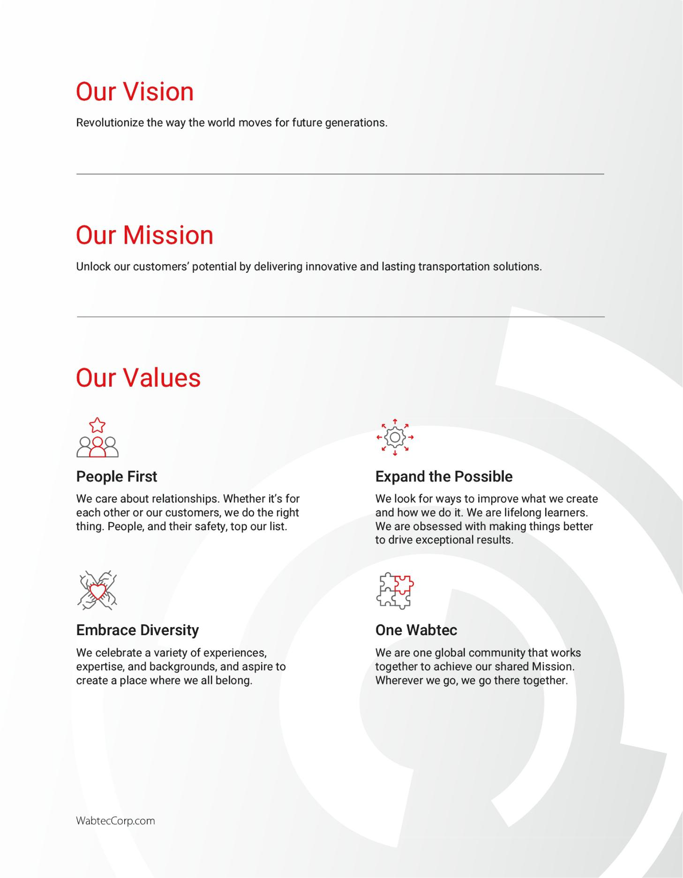

TABLE OF CONTENTS


Letter from the Chair

 | Dear Stockholder: | ​
 | We invite you to attend the 2024 annual meeting of stockholders of Westinghouse
 | Air Brake Technologies Corporation, doing business as Wabtec Corporation, on ​
 | May 16, 2024 at 11:30 a.m. Eastern Time virtually, via a live audio webcast on the
 | Internet at www.virtualshareholdermeeting.com/WAB2024
 | You will be able to attend and participate in the Annual Meeting online by visiting
 | www.virtualshareholdermeeting.com/WAB2024, where you will be able to vote
 | electronically and submit questions. You will need the 16-digit control number on
 | your proxy card to attend the Annual Meeting.
 | For more than 150 years, Wabtec has been at the forefront of developing
 | innovative solutions and technologies that have transformed the global rail industry.
 | The Company's unique portfolio addresses some of the world's most critical
 | challenges to improve efficiency, safety and make a positive impact on people and
 | the planet.
 | With 2023 behind us, I would like to take the opportunity to discuss how the Wabtec
 | Board of Directors has worked on your behalf. As members on the Board, we have
 | a duty to understand the perspectives of our stockholders, provide oversight of
 | material risks and provide long-term guidance to the Company's strategic vision.
 | Your Board is comprised of leaders with extensive global corporate strategy, rail
 | industry, risk management, technology and innovation, corporate finance,
 | regulatory and compliance and ESG experience. Wabtec seeks to maintain a
 | contemporary Board and is committed to refreshment to ensure leadership
 | expertise in areas that are critical to long-term business growth, risk oversight and
 | to support future value creation. We believe a variety of perspectives facilitates
 | effective decision making, helps drive long-term value, and encourages different
 | views on risk, business strategy and innovation.
 | Of note:
 | • Five of nine directors joined the board in the last four years.
 | • 33% of directors are gender diverse.
 | • 22% of directors are ethnically or racially diverse.
 | • Eight of nine directors have served in senior leadership roles and/or on the
 | Boards of significantly sized publicly traded companies.


TABLE OF CONTENTS

 | Your Board is committed to engaging directly with the Company's stockholders. In
 | 2023, Wabtec's held meetings dedicated to strategy, governance, sustainability and
 | social topics with stockholders representing 69% of shares outstanding. The strong
 | engagement and continued open dialogue with our stockholders help make the
 | Company stronger.
 | The Company is continuing to invent solutions and technologies that will drive the
 | industry and the world toward a more efficient and sustainable future. I have the
 | utmost confidence in where the Company is headed. I speak for the entire Board
 | when I say I am highly encouraged by Wabtec’s progress and eager to see all it will
 | accomplish.
 | Whether or not you plan to attend the Annual Meeting, please cast your vote by
 | proxy over the Internet by following the instructions provided in the Notice, by
 | telephone or by requesting a paper proxy card to sign, date and return by mail.
 | Regardless of the method used, please vote your shares so that enough shares ​
 | are represented to allow us to conduct the business of the Annual Meeting. Voting
 | over the Internet, by telephone or by proxy card if you request one does not affect
 | your right to vote while you attend the virtual Annual Meeting.
 | Sincerely yours, | ​
 |  | ​
 | Albert J. Neupaver
 | Chairman of the Board | ​
 | April 4, 2024


TABLE OF CONTENTS

Notice of 2024 Annual Meeting

WHEN:


- ​May 16, 2024

at 11:30 a.m. ET



WHERE:

​ ​ www.virtualshareholder meeting.com/WAB2024

How to Vote

You may vote while attending the virtual meeting or by proxy. You will need the 16-digit number included in your proxy card, voting instruction form or notice.


BY INTERNET:

Voting Items

Purpose |  |  |  | ​ | ​ | Board |  | ​ | ​ | Page
 |  |  |  |  |  | Recommendation |  |  |  | Reference
1 | ​ | ​ | Elect three directors for a term of three years expiring | ​ | ​ |  | FOR | ​ | ​ | 11
1 |  |  | in 2027 |  |  |  | FOR
2 |  |  | Approve an advisory (non-binding) resolution to
2 | ​ | ​ | approve the 2023 named executive officer | ​ | ​ |  | FOR | ​ | ​ | 41
2 |  |  | compensation
3 |  |  | Ratify the appointment of Ernst & Young LLP as our
3 | ​ | ​ | independent registered public accounting firm for the | ​ | ​ |  | FOR | ​ | ​ | 75
3 |  |  | 2024 fiscal year
Misc. Other |  |  |  | ​ | ​ | NA |  | ​ | ​ | NA
Conduct other business if properly raised

Procedures

​ ​



​ ​



​ ​



​ ​

www.proxyvote.com

BY PHONE:

1-800-690-6903

BY MAIL:

completing, signing, dating and mailing a proxy card in the envelope provided

AT THE MEETING:

You may vote while attending the virtual meeting or by proxy.

If you own stock directly, please vote by proxy over the Internet, by telephone or by requesting a proxy card.

If you own stock through a bank, stockbroker or trustee, please vote by following the instructions included in the material that you receive from your bank, stockbroker or trustee.

Only stockholders of record on March 20, 2024 receive notice of, and may vote at, the meeting.

How to Vote: Your vote is important. You may vote while attending the virtual meeting or by proxy. We recommend you vote by proxy even if you plan to attend the virtual meeting. You can change your vote at the virtual meeting if you are a stockholder whose shares are registered in your name. If you are a stockholder whose shares are registered in your name, you may vote your shares at the virtual meeting or by one of the three following methods:

Vote by Internet, by going to the website address www.proxyvote.com and following the instructions for Internet voting shown on the website.

Vote by Telephone, by dialing 1-800-690-6903 and following the instructions for telephone voting shown on the proxy card.

Vote by Proxy Card, by completing, signing, dating and mailing a proxy card in the envelope provided if you requested copies of these proxy materials.

If you vote by Internet or telephone, you do not need to request a proxy card.

Shares registered in your name are generally covered by one Notice. If you hold shares through someone else, such as a bank, stockbroker, or trustee, you will get a Notice from them asking you to vote. Please follow the instructions on their Notice. Please vote with respect to each

Please follow the instructions on your Notice. Please vote with respect to each Notice you receive. Your vote is very important.

Notice you receive.


David L. DeNinno

Executive Vice President, General Counsel and Secretary April 4, 2024


YOUR VOTE IS IMPORTANT

Please vote over the Internet, by telephone, by requesting a proxy card or vote while attending the Annual Meeting.

TABLE OF CONTENTS

Table of Contents

Letter from the Chair |  |  |  |  |  |  |  |  |  |  |  |  | ​ ​ |  | 1
Notice of 2024 Annual Meeting |  |  |  |  |  |  |  |  |  |  |  |  | ​ ​ |  | 3
Company Overview |  |  |  |  |  |  |  |  |  |  |  |  | ​ ​ |  | 5
2023 Performance Snapshot |  |  |  |  |  |  |  |  |  |  |  |  | ​ ​ | 6
Financial and Business Highlights |  |  |  |  |  |  |  |  |  |  |  |  | ​ ​ | 6
Sustainability Highlights |  |  |  |  |  |  |  |  |  |  |  |  | ​ ​ |  | 6
Proxy Statement Summary |  |  |  |  |  |  |  |  |  |  |  |  | ​ ​ | 7
Voting Roadmap |  |  |  |  |  |  |  |  |  |  |  |  | ​ ​ |  | 7
Wabtec Board of Directors at a Glance |  |  |  |  |  |  |  |  |  |  |  |  | ​ ​ | 8
Board Member Highlights |  |  |  |  |  |  |  |  |  |  |  |  | ​ ​ |  | 9
Elements of 2023 Executive Compensation |  |  |  |  |  |  |  |  |  |  |  |  | ​ ​ |  | 9
CEO and NEO Pay Mix |  |  |  |  |  |  |  |  |  |  |  |  | ​ ​ |  | 10
PROPOSAL 1 |  |  |  |  |  |  |  |  |  |  |  |  | ​ ​
 |  |  |  |  |  |  |  |  |  |  |  |  |  | 11
Election of Directors

Compensation Philosophy and Objectives

Executive Compensation Decision-Making Process

2023 NEO Compensation

NEO Pay Summaries

Other Compensation Policies and Practices

Compensation and Talent Management Committee Report

Executive Compensation Tables

Summary Compensation Table

2023 Grants of Plan Based Awards

2023 Outstanding Equity Awards at Fiscal Year-End

Option Exercises and Stock Vested

Nonqualified Deferred Compensation

Potential Payments Upon Termination or Change in Control

Potential Payments Upon Termination and Change-in-Control Provisions

- ​ ₄₆

- ​ 47

- ​ 49

- ​ 57

- ​ 58

​ ​

60

​ ​ | 61
​ ​ | 61
​ ​ | 62
​ ​ | 63
​ ​ | 64
​ ​ | 64
​ ​ | 65
​ ​ | 67

Our Board of Directors

Our 2024 Board Nominees

Director Nomination Process

Corporate Governance

Corporate Governance Highlights

Board Structure and Operations

The Board’s Oversight Role

Stockholder Engagement and Director Communications Other Governance Policies and Practices

​ ​ 12

​ ​ ₁₄

​ ​ 20

​ ​ ₂₃

​ ​ 23

​ ​ ₂₄

​ ​ 30

​ ​ 33

​ ​ 34

CEO Pay Ratio

Pay Versus Performance

2023 Pay Versus Performance Table

Most Important Performance Measures for 2023

Relationship of Compensation Actually Paid to Certain Measures

PROPOSAL 3

Ratify Independent Registered Public Accounting Firm

​ ​ | 68
​ ​ | 70
​ ​ | 70
​ ​ | 72
​ ​ | 72

​ ​

75

Sustainability

Oversight of Sustainability

Sustainability Highlights

Progress Drives Performance

Director Compensation

Overview

2023 Director Compensation

PROPOSAL 2

Advisory Vote to Approve Compensation of Our Named Executive Officers

​ ​ 36

​ ​ 36

​ ​ 37

​ ​ ₃₈

​ ​ 39

​ ​ 39

​ ​ 39

​ ​

41

Fees to the Independent Registered Public Accounting Firm

Audit Committee Pre-Approval Policies and Procedures

Audit Committee Report

Common Stock Ownership

Questions and Answers Relating to the Annual Meeting

Appendix

Cautionary Note About Forward-Looking Statements

​ ​
76
- ​ ₇₆
- ​ ₇₇

- ​ ₇₈

​ ​

80

- ​ A-1

- ​

 | Compensation Discussion and Analysis |  |  |  |  |  |  | ​ ​ 43
 | CD&A Table of Contents |  |  |  |  |  |  | ​ ​ 43
 | Named Executive Officers |  |  |  |  |  |  | ​ ​ ₄₃
 | Executive Summary |  |  |  |  |  |  | ​ ​ 44
 | 4 | / |  |  |  | 2024 Proxy Statement


TABLE OF CONTENTS

Company Overview

REVOLUTIONIZING THE WAY THE WORLD MOVES FOR FUTURE GENERATIONS

Wabtec is a global provider of value-added, technology-based locomotives, equipment, systems, and services for the freight rail and passenger transit industries, as well as the mining, marine and industrial markets. Drawing on more than 150 years of experience, we are leading the way in safety, efficiency, reliability, innovation, and productivity. Whether it’s freight, transit, ports, logistics, mining, industrial, or marine, our expertise, technologies, and people together – accelerate the future of transportation.

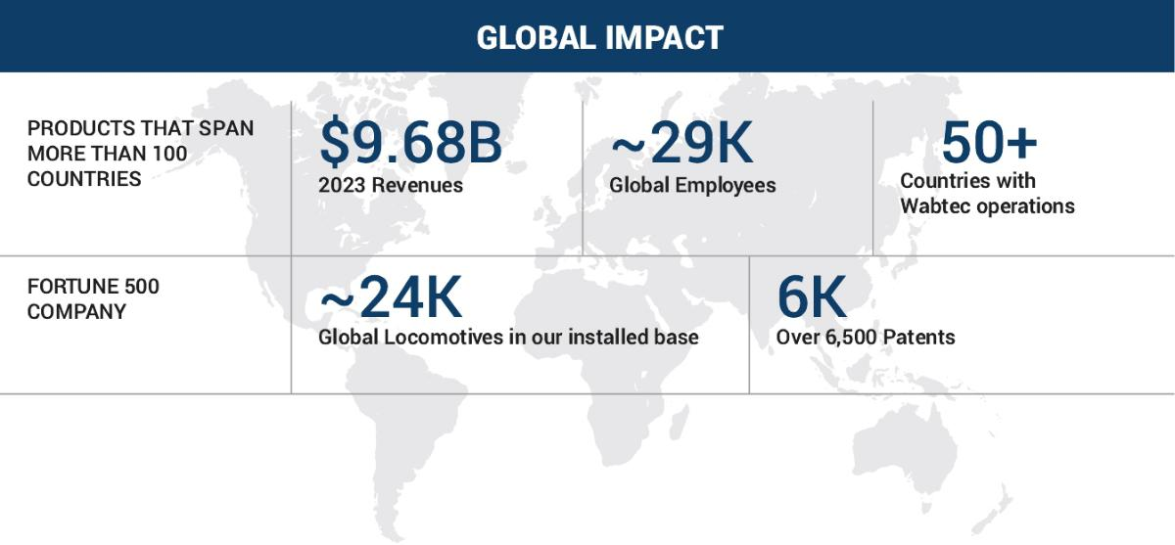

DRIVERS OF PORTFOLIO GROWTH

 | Accelerate | ​ | ​ | Grow and refresh | ​ | ​ | Lead | ​ | ​ | Expand high-margin ​ | ​ | Drive continuous
 | innovation of scalable |  |  | expansive global |  |  | decarbonization |  |  | recurring revenue |  | operational
 | technologies |  |  | installed base |  |  | of rail |  |  | streams |  | improvement
 |  |  |  |  |  |  |  |  |  | 2024 Proxy Statement |  | / | 5

TABLE OF CONTENTS

2023 Performance Snapshot

Financial and Business Highlights

Sales | ​​ | Operating Margin | ​​ | ​Earnings per Share | ​​ | Cash Flow
Sales |  | Operating Margin |  | ​Earnings per Share |  | from Operations


$9.68B | ​ | ​ 13.1% | ​ | ​ $4.53 | ​ | ​ | $1.2B
 |  | GAAP |  | GAAP
Up 15.7% ​ |  | ​ 17.0% | ​ | ​ $5.92 | ​ | ​
Year over Year |  | Adjusted⁽¹⁾ |  | Adjusted⁽¹⁾

- Please refer to the Appendix to this Proxy Statement for a description and reconciliation of these non-GAAP financial measures relative to reported GAAP financial measures.

Sustainability
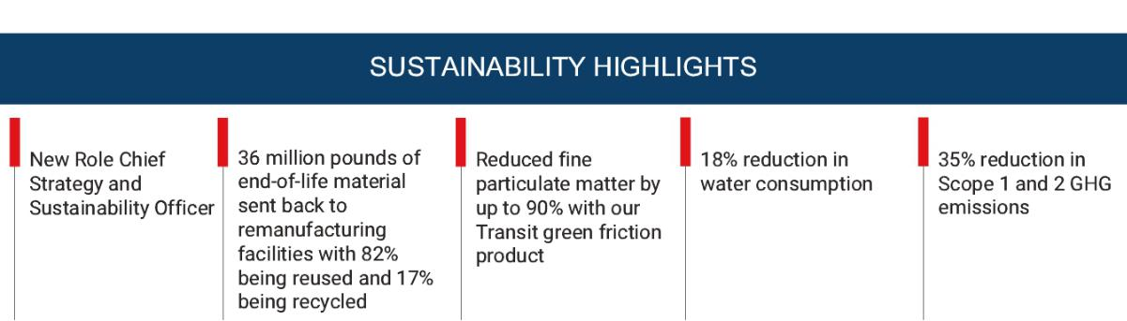

Read more about our sustainability highlights in the Sustainability Highlights section on page 37.

6 |  | / 2024 Proxy Statement

TABLE OF CONTENTS

Proxy Statement Summary

This proxy statement summary highlights certain information contained in this Proxy Statement. You should read the entire Proxy Statement and the 2023 Annual Report carefully before you vote.

Voting Roadmap

Stockholders will be asked to vote on the following matters at the 2024 Annual Meeting:

 | Proposals |  |  |  |  |  |  |  |  |  |  |  | ​ | ​ |  |  | Board |  |  |  |  | ​ | ​ | Page
 |  |  |  |  |  |  |  |  |  |  |  |  |  |  | Recommendation
1 |  |  |  | ​ | ​ |  | Elect three directors for a term of three years expiring in 2027 |  |  |  |  |  | ​ | ​ |  | FOR Each |  |  |  |  |  | ​ | ​ |  |  | 11
 |  |  |  | ​ | ​ |  |  |  |  |  |  |  | ​ | ​ |  |  | Nominee |  |  |  |  | ​ | ​ |  |  | 11
2 |  |  |  | ​ | ​ | Advisory (Non-Binding) Resolution to Approve the 2023 Named Executive Officer |  |  |  |  |  |  | ​ | ​ |  |  | FOR |  |  |  |  | ​ | ​ | 41
 |  |  |  |  |  | Compensation
3 |  |  |  | ​ | ​ | Ratify the appointment of Ernst & Young LLP as our independent registered public |  |  |  |  |  |  | ​ | ​ |  |  | FOR |  |  |  |  | ​ | ​ | 75
 |  |  |  |  |  | accounting firm for the 2024 fiscal year
 |  |  |  |  |  |  |  |  |  | 2024 Proxy Statement |  |  |  |  | / |  |  |  |  |  |  |  |  | 7

TABLE OF CONTENTS

Proxy Statement Summary

 | Proposal | Election of Three Directors
 | 1 | Election of Three Directors |  | See page
 | 1 | The Board recommends a vote FOR each director | ​​
 | 1 | The Board recommends a vote FOR each director |  | 11
 | 1 | nominee.

Wabtec Board of Directors at a Glance
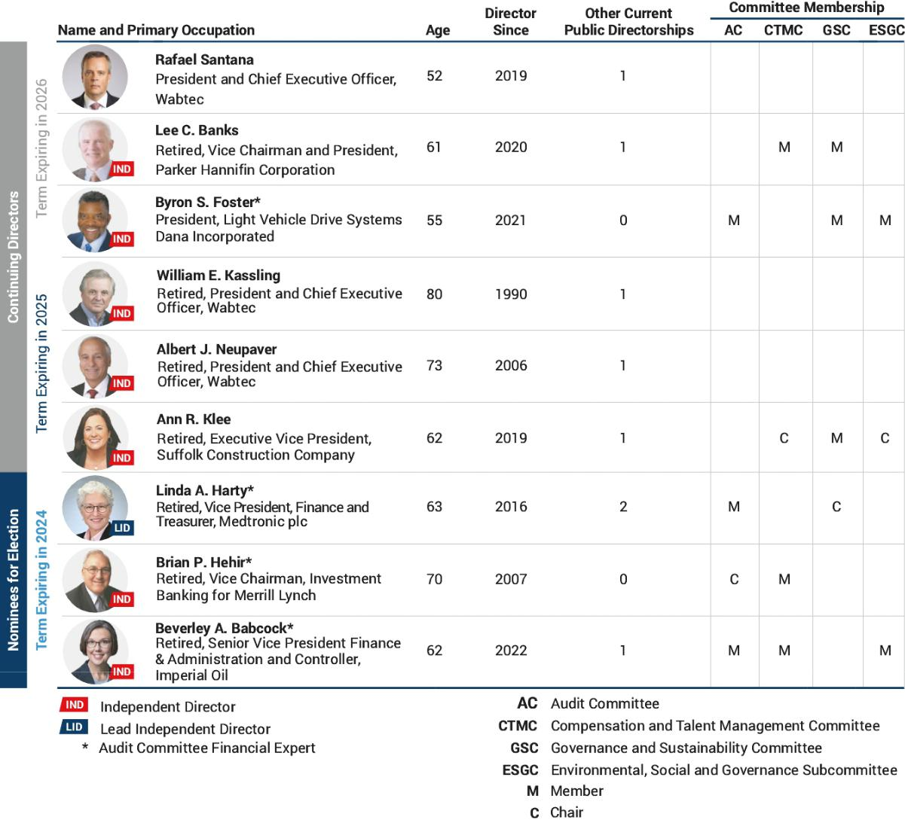

8 |  | / 2024 Proxy Statement

TABLE OF CONTENTS

Proxy Statement Summary

Board Member Highlights
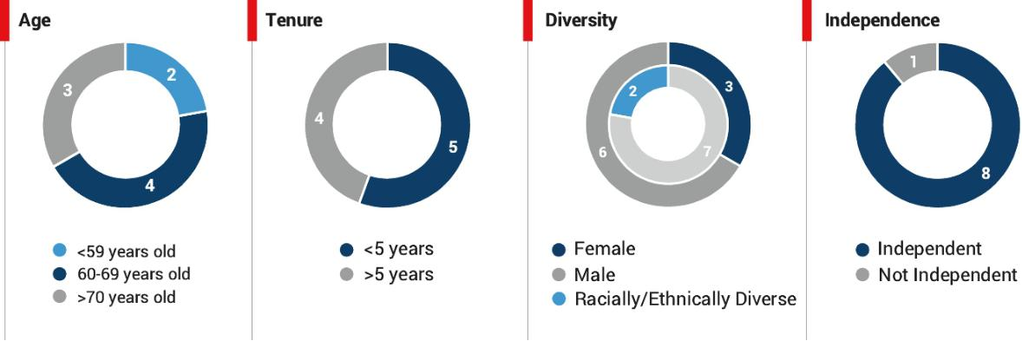

Highly Engaged Board

- All directors attended the 2023 Annual Meeting

- All directors attended at least 75% or more of the Board and Committee meetings in 2023

- Active strategy and risk oversight by the Board and Committees including: business and market risks, cybersecurity risks, human capital management, M&A, and strategic transactions

Refreshment

- 5 new directors appointed in the last 5 years

- 33% gender diversity of the Board (up from 10% gender diversity in 2019)

- 55% of directors represent diversity of gender, race or ethnicity

 | Proposal | Advisory Vote to Approve Compensation of our
 | 2 | Named Executive Officers | ​​ | See page
 | 2 | The Board recommends a vote FOR this proposal. |  | 41

Elements of 2023 Target Executive Compensation

Base Salary


​ ​

​ ​

Performance Period

Annual

​ ​

​ ​

Performance Metrics Tied to Strategy

• Individual contribution to business units • Capabilities

 | Annual Cash |  |  |  |  |  |  | • Earnings Per Share
 | Annual Cash | ​ | ​ |  | Annual | ​ | ​ | • Cash Conversion
 | Incentive |  |  |  | Annual |  |  | • Cash Conversion
 | Incentive |  |  |  |  |  |  | • Personal performance modifier
 | Long-Term |  |  |  |  |  |  | • 3-year average annual return on invested capital
 | Equity | ​ | ​ |  | Three years | ​ | ​ | • 3-year average annual cash conversion
 | Incentives |  |  |  |  |  |  | • Relative stockholder return modifier
 |  |  |  |  |  |  |  | 2024 Proxy Statement / | 9

TABLE OF CONTENTS

Proxy Statement Summary

CEO and NEO Pay Mix
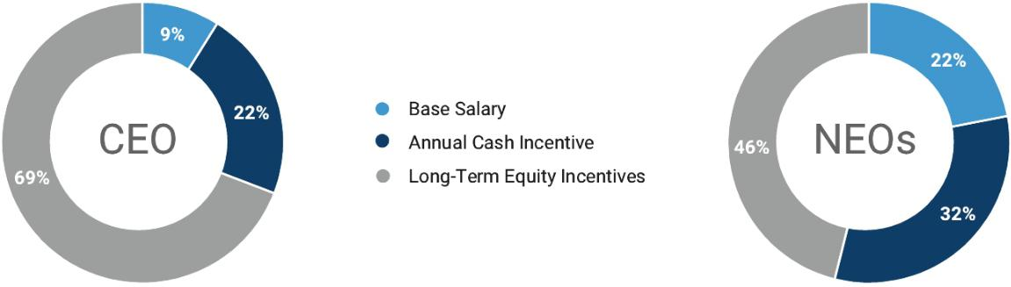

 | Proposal | Ratify Independent Registered Public Accounting
 | 3 | Firm | ​​ | See page
 | 3 |  | The Board recommends a vote FOR this proposal. | 75

The Audit Committee recommends ratification of its appointment of Ernst & Young LLP as the independent registered public accounting firm to audit our financial statements as of and for the fiscal year ending December 31, 2024. Ernst & Young LLP served as the independent registered public accounting firm to audit our financial statements as of and for the fiscal year ended December 31, 2023 and has served as the Company’s independent registered public accounting firm since 2002. The Audit Committee and the Board of Directors believe that the continued retention of Ernst & Young LLP as the Company’s independent registered public accounting firm is in the best interests of the Company and its stakeholders.

10 |  | / 2024 Proxy Statement

TABLE OF CONTENTS


Proposal
- Election of Directors

Wabtec’s Board of Directors currently has nine members. The Board is divided into three classes whose terms of office end in successive years. Linda A. Harty, Brian P. Hehir, and Beverley A. Babcock are incumbent directors whose terms of office are expiring and have been nominated to serve for new terms ending in 2027. All nominations were made by the Governance and Sustainability Committee (the “Governance Committee”), as further described on page 25, and approved by the entire Board of Directors. The Governance Committee is engaged in an ongoing board refreshment process consistent with the process set forth in its charter.

Majority Voting for Directors and Vote Required

Under our amended and restated by-laws, each director is elected by the majority of the votes cast at the Annual Meeting in an uncontested election (i.e., an election where the number of nominees is not greater than the number of directors to be elected). For this purpose, a “majority of the votes cast” means that the number of shares voted “for” a director’s election exceeds 50 percent of the number of votes cast with respect to that director’s election. Votes “cast” exclude abstentions and broker non-votes. In a contested election (i.e., in the event the number of director nominees for election at a meeting of stockholders exceeds the number of directors to be elected at that meeting), each director to be so elected will be elected by a plurality of the votes cast. Each director nominee has agreed to provide a letter of resignation to the Board should such nominee fail to receive the required number of votes. The Board may accept such resignation at its discretion.

Your proxy will be voted “for” the election of these nominees unless you vote “against” a nominee. If any nominee is unable or unwilling to stand for election, your proxy authorizes us to vote for a replacement nominee if the Board names one.

See the guidelines set forth on page 11 regarding the election of directors by the vote of the majority of the votes cast at the Annual Meeting.


- The Board recommends you vote FOR each of the following director nominees; Linda A. Harty, Brian P. Hehir, and Beverley A. Babcock.

2024 Proxy Statement / | 11

TABLE OF CONTENTS

Proposal 1: Election of Directors

Our Board of Directors

Board Skills and Qualifications
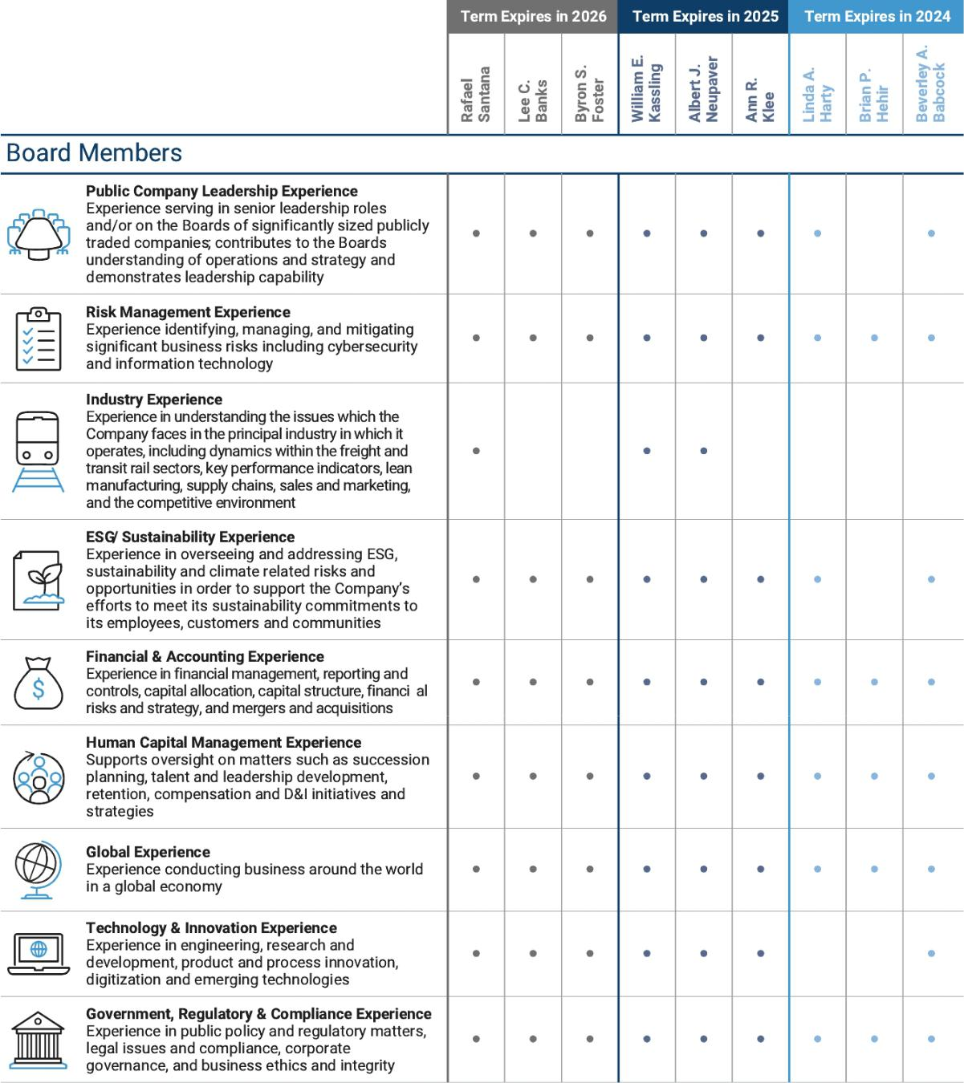

12 |  | / 2024 Proxy Statement

TABLE OF CONTENTS

Proposal 1: Election of Directors
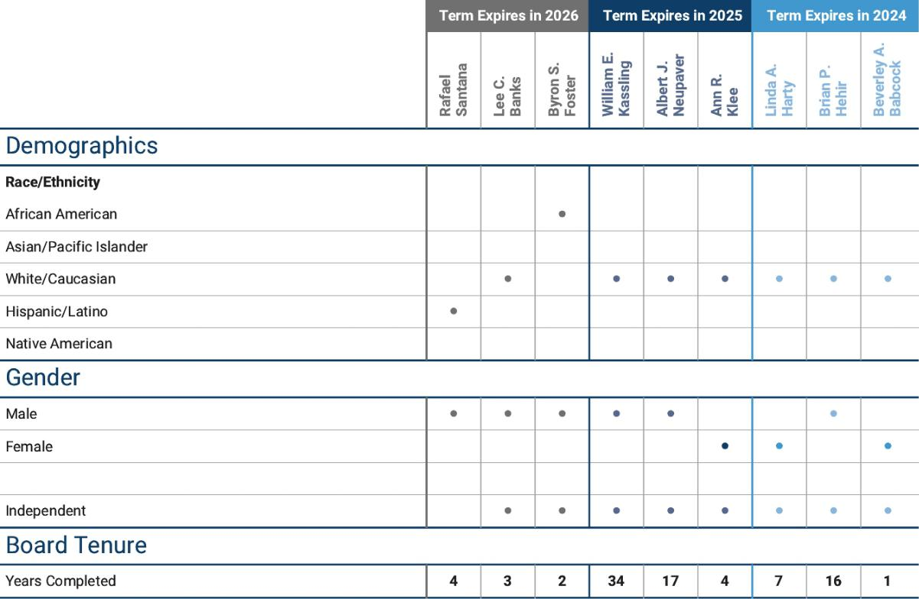

2024 Proxy Statement / | 13

TABLE OF CONTENTS

Proposal 1: Election of Directors

Biographies of our Directors

Director Nominees to Serve for Three-Year Term

The biographical information below highlights the specific experience, qualifications, attributes, and background that led the Board to conclude that each director nominee should serve on the Board. The Governance Committee and the Board also determined that each director nominee possesses certain intangible attributes and skills and is qualified to serve as a director.

Linda A. Harty |  | Biographical Information
 |  | • Vice President, Finance & Treasurer of Medtronic, plc, a global leader in medical
 |  | technology services and solutions from February 2010 to April 2017.
 |  | • Prior to 2010, Ms. Harty held executive and management positions with Cardinal
 |  | Health, RTM Restaurant Group, BellSouth, ConAgra Foods and Kimberly-Clark.
 |  | Current Other Directorships
 |  | • Member of the Board of Directors of Parker-Hannifin Corporation since 2007
 |  | serving on the Audit Committee and as a member of the Corporate Governance
 |  | Committee.
 |  | • Member of the Board of Directors of Chart Industries, Inc., since 2021, serving
Age: 63 |  | on the Nominations and Corporate Governance Committee (Chair), Audit
​ | ​ | Committee, and formerly on the Compensation Committee.
Director Since: 2016
LEAD INDEPENDENT DIRECTOR |  | Past Other Directorships

• From 2017 until March 1, 2023, served as a member of the Board of Directors of

Audit Committee Financial Expert Syneos Health and served on the Audit Committee and Compensation and Management Development Committee.
Committees:
Audit |  |  |  | Specific Qualifications, Attributes, Skills and Experience
Governance and Sustainability |  |  |  | • Extensive financial expertise, particularly in the areas of treasury, tax, decision
(Chair) |  |  |  | support and acquisitions in multiple complex and global industries.
 |  |  |  | • Service on other public company boards.
 |  |  |  | • Certified Public Accountant (inactive).
14 |  |  | / 2024 Proxy Statement

TABLE OF CONTENTS

 |  |  |  |  | Proposal 1: Election of Directors
 | Brian P. Hehir |  |  |  | Biographical Information
 |  |  |  |  | • Vice Chairman of Investment Banking for Merrill Lynch from 1999 to 2008.
 |  |  |  |  | • Former Chair of the Georgetown University School of Nursing and Health
 |  |  |  |  | Studies Board of Visitors.
 |  |  |  |  | Past Other Directorships
 |  |  |  |  | • Former member of the Board of Directors of Catholic Health Services of Long
 |  |  |  |  | Island.
 |  |  |  |  | Specific Qualifications, Attributes, Skills and Experience
 |  |  | ​ | ​ | • Extensive career in global financial markets with over 30 years of experience
 | Age: 70 |  |  |  | working in investment banking, financing, corporate advisory services and
 | Director Since: 2007 |  |  |  | capital markets.
 | INDEPENDENT DIRECTOR |  |  |  | • Experience in risk management and regulatory oversight through his
 |  |  |  |  | background in highly regulated industries.
 | Audit Committee Financial Expert
 | Committees:
 | Audit (Chair)
 | Compensation and Talent
 | Management
 | Beverley A. Babcock |  |  |  | Biographical Information
 |  |  |  |  | • Senior Vice President Finance & Administration and Controller, Imperial Oil from
 |  |  |  |  | 2015 to 2018.
 |  |  |  |  | • Vice President, Corporate Financial Services, ExxonMobil from 2011 to 2015
 |  |  |  |  | and a variety of executive leadership roles at ExxonMobil including Vice
 |  |  |  |  | President of Corporate Financial Services and Assistant Controller from 2000 to
 |  |  |  |  | 2015.
 |  |  |  |  | Current Other Directorships
 |  |  |  |  | • Member of the Board of Directors, Olin Corporation since 2019, serving on the
 |  |  |  |  | Executive Committee and Audit Committee (Chair).
 | Age: 62 |  | ​ | ​ • Member of the Board of Directors since 2018, Forte Foundation—a consortium
 | Director Since: 2022 |  |  |  | of leading companies and top business schools working together to launch
 |  |  |  |  | women into fulfilling, significant careers in business.
 | INDEPENDENT DIRECTOR |  |  |  | • Co-Chair Women Corporate Directors—Houston Chapter.
 | Audit Committee Financial Expert |  |  |  | Specific Qualifications, Attributes, Skills and Experience
 | Committees: |  |  |  | • Extensive experience in senior finance and accounting leadership positions at
 |  |  |  |  | complex and global companies of significant size.
 | Audit |  |  |  | complex and global companies of significant size.
 |  |  |  |  | • Service on other public company boards.
 | Compensation and Talent |  |  |  | • Service on other public company boards.
 |  |  |  |  | • Member, Good Standing of the Chartered Professional Accountants of Ontario
 | Management
 |  |  |  |  | and Canada.
 | Environmental, Social and |  |  |  | and Canada.
 | Governance Subcommittee
 |  |  |  |  | 2024 Proxy Statement / | 15



TABLE OF CONTENTS

Proposal 1: Election of Directors

Directors Continuing in Office

Six directors are serving terms that end after the 2024 Annual Meeting. The biographical information below highlights the specific experience, qualifications, attributes, and background that led the Board to conclude that each director should serve on the Board. The Governance Committee and the Board also determined that each director possesses certain intangible attributes and skills and is qualified to serve as a director.

Continuing Directors with Three-Year Term Expiring in 2025

William E. Kassling |  |  |  |  |  | Biographical Information
 |  |  |  |  |  | • Vice Chair of Wabtec since August 2020.
 |  |  |  |  |  | • Lead Director of Wabtec from May 2013 to August 2020.
 |  |  |  |  |  | • Chairman of Wabtec from prior to 1997 to May 2013.
 |  |  |  |  |  | • Chief Executive Officer and/or President of Wabtec from prior to 1997 to May
 |  |  |  |  |  | 2014 and from May 2004 to January 2006
 |  |  |  |  |  | Current Other Directorships
Age: 80 |  |  |  |  | ​ | ​• Member, Board of Directors, Kensington Capital Acquisition Corp. V.
Director Since: 1990 |  |  |  |  |  | • Director, Pittsburgh Penguins Inc., Texas Rangers, The Crosby Group, and the
INDEPENDENT DIRECTOR |  |  |  |  |  | Wabtec Foundation.
Vice Chair of the Board
Committees: |  |  |  |  |  | Specific Qualifications, Attributes, Skills and Experience
None |  |  |  |  |  | • Extensive experience as an officer and director of Wabtec with significant rail
 |  |  |  |  |  | and transportation industry knowledge, expertise regarding public company
 |  |  |  |  |  | management, corporate governance, human capital management, strategy and
 |  |  |  |  |  | M&A.
 |  |  |  |  |  | • Service on other public company boards.
16 |  |  | / | 2024 Proxy Statement


TABLE OF CONTENTS

 |  | Proposal 1: Election of Directors
Albert J. Neupaver |  | Biographical Information
 |  | • Chairman or Executive Chairman of the Board of Wabtec since May 2014.
 |  | • President and Chief Executive Officer of Wabtec from February 2006 until May
 |  | 2014.
 |  | • President of the Electromechanical Group of AMETEK, Inc. from 1998 to
 |  | February 2006.
 |  | Current Other Directorships
 |  | • Member of the Board of Directors Koppers Holdings Inc. since 2009.
 |  | • Director, Carnegie Science Center, Executive Board Member of UPMC
Age: 73 |  | Children’s Hospital Foundation, Board Member of Heinz History Center,
 |  | Member of the Board of Trustees of Carnegie Museums, Director, the Wabtec
Director Since: 2006 |  | Foundation.
 | ​ | ​
INDEPENDENT DIRECTOR |  | Past Other Directorships
(as of June 2023) |  | • Member of Robbins & Myers, Inc. Board of Directors from January 2009 to
Chairman of the Board
 |  | February 2013.
Committees: |  | • Member of Genesee & Wyoming Inc. Board of Directors from October 2015 to
 |  | December 2019.
None |  | December 2019.
 |  | Specific Qualifications, Attributes, Skills and Experience
 |  | • Extensive experience as an officer and director of Wabtec with significant rail
 |  | and transportation industry knowledge, expertise regarding public company
 |  | management, corporate governance, human capital management, strategy and
 |  | M&A.
 |  | • Led Wabtec to unprecedented growth throughout the business cycle during his
 |  | tenure in executive leadership roles at the Company.
 |  | • Service on other public company boards.
 |  | 2024 Proxy Statement / | 17

TABLE OF CONTENTS

Proposal 1: Election of Directors

Ann R. Klee |  |  | Biographical Information
 |  |  | • Executive Vice President, Suffolk Construction Company from February 2020 to
 |  |  | March 2021.
 |  |  | • Vice President, General Electric Company from 2008 to September 2019.
 |  |  | • Partner and Co-Chair of the Environmental and Natural Resources Group of
 |  |  | Crowell & Moring LLP.
 |  |  | • General Counsel to the U.S. Environmental Protection Agency from 2004-2006.
 |  |  | • Counselor and Special Assistant to the Secretary of the U.S. Department of the
 |  |  | Interior and as Chief Counsel to the U.S. Senate’s Environment and Public
 |  |  | Works Committee.
Age: 62 |  | ​ | ​
 |  |  | Current Other Directorships
Director Since: 2019 |  |  | • Member of the Board of Directors of Sotera Health Company since 2020 serving
 |  |  | on the Nominating and Corporate Governance Committee (Chair) and Audit
INDEPENDENT DIRECTOR |  |  | Committee.
Committees: |  |  | • Member of the Board of Directors, Center for Climate and Energy Solutions.
Compensation and Talent |  |  | Specific Qualifications, Attributes, Skills and Experience
Management (Chair) |  |  | Specific Qualifications, Attributes, Skills and Experience
 |  |  | • Significant experience in environmental law, corporate governance and
Environmental, Social and
 |  |  | regulatory and compliance matters.
Governance Subcommittee (Chair) |  |  | regulatory and compliance matters.
 |  |  | • Industry expert in the fields of sustainability and ESG matters.
Governance and Sustainability
 |  |  | • Service on other public company boards.


Continuing Directors with Three-Year Term Expiring in 2026

Rafael Santana |  | Biographical Information
 |  | • President and Chief Executive Officer of Wabtec since July 2019.
 |  | • President and Chief Executive Officer of GE Transportation, a division of
 |  | General Electric (GE) Company, from November 2017 to February 2019.
 |  | • Mr. Santana joined GE in 2000 and held a variety of global leadership roles in
 |  | GE’s Transportation, Power, and Oil & Gas businesses.
 |  | Current Other Directorships
​ | ​ | • Member of the Board of Directors of Travelers Insurance since 2022.
Age: 52 |  | Specific Qualifications, Attributes, Skills and Experience
Age: 52 |  | • 25 years of global executive leadership experience in Fortune 300 companies.
Director Since: 2019
Director Since: 2019 |  | • Extensive experience with international operations, product management,
CHIEF EXECUTIVE OFFICER |  | human capital management, commercial expertise, expertise regarding public
CHIEF EXECUTIVE OFFICER |  | company management, corporate governance, strategy and M&A.


 | Committees: |  |  | • Deep understanding of the transportation and rail industry with more than
 | None |  |  | 10 years of experience in the sector.
 | 18 |  | / | 2024 Proxy Statement

TABLE OF CONTENTS

 |  |  |  | Proposal 1: Election of Directors
 | Lee C. Banks |  |  | Biographical Information
 |  |  |  | • Vice Chairman and President of Parker-Hannifin Corporation from
 |  |  |  | August 2021 through retirement in December 2023.
 |  |  |  | • President and Chief Operating Officer of Parker-Hannifin from February 2015
 |  |  |  | to August 2021.
 |  |  |  | • Executive Vice President and Operating Officer of Parker-Hannifin from 2008 to
 |  |  |  | 2015 and Senior Vice President and Operating Officer of Parker-Hannifin from
 |  |  |  | 2006 to 2008.
 |  |  |  | Past Other Directorships
 |  |  | ​ | ​
 |  |  |  | • Member, Board of Directors of Parker Hannifin Corporation
 | Age: 61
 | Director Since: 2020 |  |  | Specific Qualifications, Attributes, Skills and Experience
 | INDEPENDENT DIRECTOR |  |  | • Senior Executive with extensive experience as President and Chief Operating
 |  |  |  | Officer leading a Fortune 250 Company and expertise regarding public company
 | Committees |  |  | management.
 |  |  |  | • Significant industrial executive management, human capital management and
 | Compensation and Talent
 |  |  |  | operational experiences in leading complex, multi-national manufacturing
 | Management |  |  | and operational footprints.
 | Governance and Sustainability |  |  | • Service on other public company boards.
 | Byron S. Foster |  |  | Biographical Information
 |  |  |  | • President, Light Vehicle Drive Systems at Dana Incorporated since July 2021.
 |  |  |  | • Senior Vice President and Chief Commercial, Marketing and Communications
 |  |  |  | Officer of Dana Incorporated from February 2021 to July 2021.
 |  |  |  | • Chief Executive Officer of Shield T3 from June 2020 to February 2021.
 |  |  |  | • Executive Vice President of Adient PLC from 2016 to 2019.
 |  |  |  | • Prior to 2016, Mr. Foster served in various senior executive commercial and
 |  |  |  | operational roles at Johnson Controls, Inc.
 |  |  |  | Specific Qualifications, Attributes, Skills and Experience
 | Age: 55 |  | ​ | ​ • Extensive human capital management, operational, supply chain, and
 |  |  |  | commercial experience in the industrial sector.
 | Director Since: 2021 |  |  | • Experienced senior leader in global operations and commercial businesses
 | INDEPENDENT DIRECTOR |  |  | focused on growth, profitability and technical innovation.
 | Audit Committee Financial Expert
 | Committees:
 | Audit
 | Environmental, Social and
 | Governance Subcommittee
 | Governance and Sustainability
 |  |  |  | 2024 Proxy Statement / | 19



TABLE OF CONTENTS

Proposal 1: Election of Directors

Director Nomination Process

Overview of Nomination Process

The Company’s Corporate Governance Guidelines provide that individuals are selected to join the Board based on their business or professional experience, background, personal characteristics, diversity (inclusive of gender, race, and ethnicity), and their array of talents and perspectives. The Board believes that a diverse membership with varying perspectives and breadth of experience is an important Board attribute and will enhance the quality of the Board’s deliberations and decisions.

The Board has a comprehensive, ongoing director succession planning process designed to provide for a highly independent, well-qualified Board, with the diversity, experience and background to be effective and to provide strong oversight. The Board regularly evaluates the needs of the Company and adds new attributes, viewpoints and experiences to the Board, as necessary to best position the Company to navigate through a constantly changing business environment. Candidates for nomination to the Board are recommended by the Governance Committee, which, under its charter (the “Governance Charter”), has the responsibility to identify and recommend to the Board individuals qualified to become members of the Board. The Governance Charter outlines the Governance Committee’s commitment to find nominees for membership on the Board of Directors who are of the highest possible caliber and who can provide insightful, intelligent and effective guidance to the management of Wabtec.

In considering director nominees, the Governance Committee conducts inquiries into the background and qualifications of possible candidates and actively recruits qualified individuals. The Governance Committee does not have specific minimum qualifications that must be met for a prospective director candidate to be nominated. However, in evaluating candidates for the Board, the Governance Committee considers the entirety of each candidate’s credentials.

The Governance Committee does not have a specific diversity policy with respect to identifying director candidates, however, a goal of the Governance Committee is ensuring that the Board of Directors consists of individuals from diverse backgrounds (including diversity of gender, race, and ethnicity) and experience who, collectively, provide meaningful counsel to management. The Committee also considers the candidate’s character, integrity, understanding of strategy and policy-setting, and reputation for working well with others.

In connection with this evaluation, the Governance Committee determines whether to interview the prospective nominee. After completing this evaluation and interview, the Governance Committee makes a recommendation to the full Board as to the persons who should be nominated by the Board, and the Board determines the nominees after considering the recommendation and report of the Governance Committee. If candidates are recommended by the Company’s stockholders, such candidates are evaluated using the same criteria. With respect to the nomination of continuing directors for re-election, the individual’s contributions to the Board are also considered.

The Governance Committee has considered and recommended to the Board that each of the nominees presented in this proxy statement has the qualities, skillsets, and attributes that are important to an effective Board.

On an annual basis, the Governance Committee (i) assesses the effectiveness of its approach, (ii) reviews its Governance Charter and the Corporate Governance Guidelines, and (iii) reviews the effectiveness of the Board and each Committee of the Board.

20 |  | / 2024 Proxy Statement

TABLE OF CONTENTS

Proposal 1: Election of Directors

Board Diversity

The Board’s overall diversity is a significant consideration in the director nomination process. Our Board of Directors, including this year’s nominees, consists of individuals who bring valuable diversity to the Board in terms of gender, ethnicity, race, industries represented, experience, age, and tenure. The Directors and nominees range in age from 52 to 80. Five of our Directors (including nominees) (55% of our directors) represent diversity of gender, race or ethnicity. Five of our Directors (55% of our Directors including nominees) have served on the Board for less than five years. The Company believes that diversity of tenure also facilitates effective Board oversight. Directors with long tenures provide the Board with a deep knowledge of the Company and the industry, while newer directors provide fresh perspectives.

Board Changes | ​​ | Diversity of newly added | ​​ | Skills of newly
since 2019 |  | Directors since 2019 |  | added Directors

5

NEW DIRECTORS HAVE BEEN ADDED TO THE BOARD

3

DIRECTORS HAVE RETIRED OR DID NOT SEEK RE-ELECTION TO THE BOARD

​ | ​ | 2 | ​ | ​
 |  | NEW DIRECTORS ARE
 |  | RACIALLY/ETHNICALLY DIVERSE
​ | ​ | 2 | ​ | ​
 |  | NEW DIRECTORS ARE FEMALE

- ESG/ SUSTAINABILITY EXPERIENCE

  - HUMAN CAPITAL MANAGEMENT EXPERIENCE



2024 Proxy Statement / | 21

TABLE OF CONTENTS

Proposal 1: Election of Directors

Director Independence

Our Corporate Governance Guidelines require a majority of the Board to be independent and sets forth the Board’s current independence criteria. For a Director to be considered an “Independent Director”, the Board must annually determine that he or she has no material relationship with the Company (either directly or as a partner, shareholder or officer of an organization which has such a relationship with the Company). The basis for the Company’s determination of independence is based on the applicable New York Stock Exchange (the “NYSE”) and SEC rules, however no Director is considered to be an Independent Director if he or she:

- has in the last three years been employed by the Company;

- has in the last three years been affiliated with or employed by a present or former auditor of the Company or of an affiliate of the Company;

- has in the last three years been part of an interlocking directorate in which an executive officer of the Company sits on the compensation committee of another company which concurrently employs the director;

- has in the last three years received more than $120,000 in direct compensation from the Company, other than director fees and deferred compensation, and with respect to Audit Committee members, accepted directly or indirectly any consulting, advisory, or other compensatory fee from the Company or any of its subsidiaries;

- is currently employed by a company that in any of the last three years has received payments from or made payments to the Company in an amount that exceeds the greater of $1 million or 2% of such other company’s gross revenue; or

- has an immediate family member who falls within any of the above categories, except that an immediate family member may be an employee of, but not a partner of, the auditor of the Company and not impair the director’s independence if such immediate family member does not personally work on the Company’s audit.

The Board has reviewed the independence of its members considering these standards and any other commercial, legal, accounting and familial relationships between the directors and Wabtec and determined that all of its members were independent during 2023, with the exception of Mr. Santana due to his position as the Company’s Chief Executive Officer.

None of such independent directors has a material relationship with Wabtec and each such director meets the Board’s categorical independence standards and the independence requirements of the NYSE. The Board’s Audit Committee, Compensation Committee, and Governance Committee are composed entirely of directors who meet the independence requirements of the NYSE. Each member of the Audit Committee and the Compensation Committee also meets the additional independence standards for such committee members required by the SEC.

22 |  | / 2024 Proxy Statement

TABLE OF CONTENTS

Corporate Governance

Corporate Governance Highlights
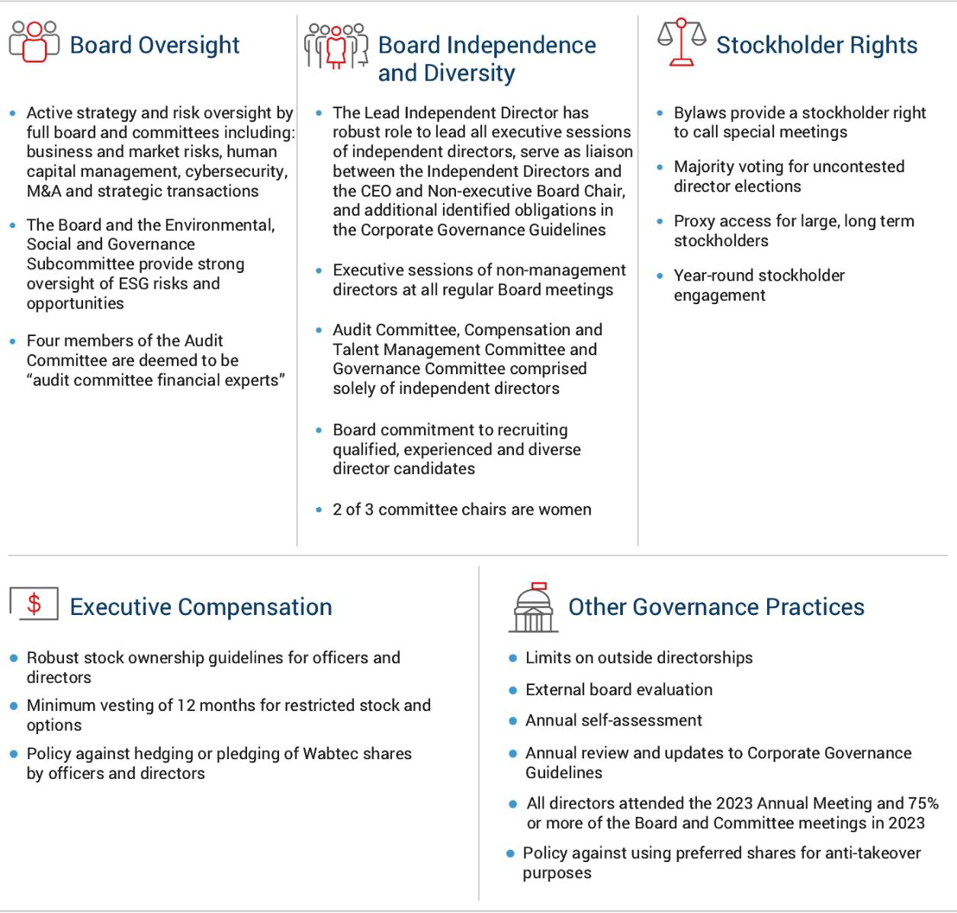

2024 Proxy Statement / | 23

TABLE OF CONTENTS

Corporate Governance

Board Structure and Operations

Board Leadership Structure

The Company currently has a non-executive, independent Chair of the Board, a separate Chief Executive Officer, and a Lead Independent Director. Over the past several years, the Board has continued to take action to strengthen the role of the Lead Independent Director, including amendments to the Corporate Governance Guidelines to formalize the role of the Lead Independent Director. The Chief Executive Officer, who is also a director, is responsible for setting the strategic direction for the Company along with the day to day leadership and performance of the Company.

The Board believes that this structure currently is in the best interests of Wabtec and provides clear leadership responsibility and accountability, while providing for effective corporate governance and oversight by an independent Board of strong and seasoned Directors. The Board evaluates this leadership structure annually.

Duties of Chair and Lead Independent Director

​ ​

Albert J. Neupaver

​ ​

Chairman of the Board The Chairman of the Board:

• articulates Wabtec’s long-term strategic priorities, performance and operating results,

• ensures management is effectively providing the proper information to the Board to facilitate effective oversight,

• provides leadership to the Board ensuring that the Board is focused on performance, value creation, accountability, and risks facing the Company,
• sets the agenda for Board meetings, | ​​
• approves materials sent to the Board,
• provides input with respect to the Board agenda,
• facilitates discussion between the Board and executive
management, and

• executes good board governance and oversight over best practices.

Linda A. Harty

Lead Independent Director The Lead Director:

• presides at all meetings of the Board at which the Board Chair is not present, presides at all executive sessions of independent Directors,

• serves as liaison between the independent Directors and the CEO,

• provides input on information sent to the Board, • approves meeting agendas for the Board,

• provides input on meeting schedules to assure that there is sufficient time for discussion of all agenda items,

• has authority to call meetings of independent Directors,

• communicates with major stockholders or other stakeholders,

• participates in the periodic evaluation process of the Board, Board Committees, and CEO, and

• participates in the selection process for Board candidates.

Executive Sessions

The non-management Directors hold regular executive sessions without management in order to promote open discussion among the non-management Directors. The Board generally holds such executive sessions at every regularly scheduled Board meeting. At least one executive session each year is required to be attended only by independent directors.

24 |  | / 2024 Proxy Statement

TABLE OF CONTENTS

Corporate Governance

Committees of the Board

The standing Board Committees that help the Board fulfill its duties include the Governance Committee, the Audit Committee, the Compensation and Talent Management Committee (the “Compensation Committee”), and an Environmental, Social, and Governance Subcommittee (the “ESG Subcommittee”).

The Governance and Sustainability Committee

Committee Members: |  |  |  |  |  |  | ​ | A current copy of the charter is
 |  |  |  |  |  |  |  | available on Wabtec’s website at:
 |  |  |  |  |  |  |  | http://www.wabteccorp.com ->
 |  |  |  |  |  |  |  | investor relations -> corporate
 |  |  |  |  |  |  |  | governance
​ | ​ |  | ​ | ​ | ​ | ​ | ​
 |  |  |  |  |  |  | ​
 |  |  |  |  |  |  |  | Number of Meetings: 4
Linda A. Harty, ​ | ​ | Lee C. Banks | ​ | ​ | Byron S. Foster ​ | ​ | Ann R. Klee ​
Chair


The principal functions of the Governance Committee are to:

- identify individuals qualified to become members of the Board of Directors;

- select nominees for the membership of the Board of Directors who are of the highest possible caliber and are able to provide insightful, intelligent and effective guidance to the management of the Company;

- Recommend Director nominees to the full Board from time to time, including with respect to any vacancies that may occur;

- consider and make recommendations for the Company’s strategies related to corporate responsibility;

- develop and recommend corporate governance principles to the Board of Directors;

- lead the Board of Directors in adhering to its corporate governance obligations and principles;

- strive to ensure that the governance of the Company is in full compliance with law, reflects generally accepted principles of good corporate governance, encourages flexible and dynamic management without undue burdens and effectively manages the risks of the business and operations of the Company.

The members of the Governance Committee are independent, as independence for such members is defined in the listing standards of the NYSE and the rules of the SEC.

2024 Proxy Statement / | 25

TABLE OF CONTENTS

Corporate Governance

Environmental, Social and Governance Subcommittee

Subcommittee Members:




​ ​ ​ ​

Ann R. Klee, | ​​ | Beverley A. Babcock | ​​ | Byron S. Foster
Chair

To further our Board of Directors’ commitment to oversight and accountability of environmental and social issues, the Board established the Environmental, Social and Governance Subcommittee (the “ESG Subcommittee”) of the Governance Committee, chaired by Board member Ms. Klee and including Board members Ms. Babcock and Mr. Foster. The ESG Subcommittee supports Wabtec’s on-going commitment to environmental, social and governance (“ESG”) matters relevant to Wabtec including complying with all applicable laws and regulations affecting the health and safety of our employees and stakeholders, as well as protection of the environment (including climate) and other public policy matters. The ESG Subcommittee met four times as part of the Governance Committee meetings.

The principal functions of the ESG Subcommittee are to:

- set the Company’s general strategy relating to ESG matters;

- oversee the Company’s evolving reporting and disclosure requirements with respect to ESG matters;

- oversee communications with investors and other stakeholders, including oversight of the annual Sustainability Report;

- oversee the Company’s programs and practices to promote and provide safe, healthy and secure workplaces;

- monitor the Company’s compliance with legal and regulatory requirements as well as industry standards and guidelines applicable to environmental and health and safety matters;

- monitor the Company’s ESG performance and health and safety compliance and related risks;

- review and discusses with management and the Board of Directors environmental and health and safety matters, and

- perform such other responsibilities as may be assigned or delegated to it by the Governance Committee.

Additional details regarding the ESG Subcommittee’s duties and responsibilities can be found in the Governance Committee Charter located at http://www.wabteccorp.com -> investor relations -> corporate governance.

26 |  | / 2024 Proxy Statement

TABLE OF CONTENTS

 |  |  |  |  |  |  |  | Corporate Governance
The Audit Committee
 | Committee Members: |  |  |  |  |  | ​ | A current copy of the charter is
 |  |  |  |  |  |  |  | available on Wabtec’s website at:
 |  |  |  |  |  |  |  | http://www.wabteccorp.com ->
 |  |  |  |  |  |  |  | investor relations -> corporate
 |  |  |  |  |  |  |  | governance
 | ​ | ​ | ​ | ​ | ​ | ​ | ​
 |  |  |  |  |  |  | ​
 |  |  |  |  |  |  |  | Number of Meetings: 7
 | Brian P. Hehir, ​ | ​ | Beverley A. ​ | ​ Byron S. Foster | ​ | ​ | Linda A. Harty ​
 | Chair |  | Babcock


The principal functions of the Audit Committee are to:

- oversee the Company’s financial reporting process on behalf of the Board and regularly report the results of its activities to the Board;

- oversee the systems of internal accounting and financial controls;

- oversee the performance of the Company’s internal audit function and independent auditors;

- assess the independent auditor’s qualifications and independence;

- oversee the Company’s compliance with ethics policies and legal and regulatory requirements; and

- oversee the Company’s enterprise risk management review with respect to issues including cybersecurity, data privacy, geopolitical risks and others (as more fully set forth on P. 31) and assessment.

The Audit Committee is empowered to investigate any matter brought to its attention with full access to all books, records, facilities, and personnel of the Company and has the authority to engage independent counsel and other advisers, including accountants, as it determines necessary to carry out its duties.

The Audit Committee has established procedures for the receipt, retention and treatment of complaints received by the Company regarding accounting, internal controls or auditing matters and the confidential anonymous submission by employees of concerns regarding questionable accounting or auditing matters.

The members of the Audit Committee are independent, as defined in the rules of the SEC and in the listing standards of the NYSE. The Board has determined that each of Ms. Babcock, Ms. Harty, Mr. Foster and Mr. Hehir qualifies as an “audit committee financial expert” as defined in the regulations of the SEC.

2024 Proxy Statement / | 27

TABLE OF CONTENTS

Corporate Governance

The Compensation and Talent Management Committee

Committee Members: |  |  |  |  |  |  | ​ | A current copy of the charter is
 |  |  |  |  |  |  |  | available on Wabtec’s website at:
 |  |  |  |  |  |  |  | http://www.wabteccorp.com ->
 |  |  |  |  |  |  |  | investor relations -> corporate
 |  |  |  |  |  |  |  | governance
​ | ​ | ​ | ​ |  | ​ | ​ | ​
 |  |  |  |  |  |  | ​
 |  |  |  |  |  |  |  | Number of Meetings: 8
Ann R. Klee, ​ | ​ | Beverley A. ​ | ​ | Lee C. Banks | ​ | ​ | Brian P. Hehir ​
Chair |  | Babcock


The principal functions of the Compensation Committee are to:

- review and approve goals and objectives for the Chief Executive Officer and recommending the Chief Executive Officer’s compensation;

- review and approve incentive compensation plans and equity-based plans;

- review and recommend compensation of all executive officers and non-employee directors;

- provide input to the Board regarding management succession planning for the CEO and executive officers;

- oversee the Company’s human capital management strategies and programs including with respect to diversity, equity and inclusion;

- review and approve stock ownership guidelines and monitoring director and officer compliance with such ownership guidelines;

- oversee the implementation and administration of any clawback policy allowing the Company to recoup compensation paid to the executive officers of the Company in accordance with applicable law and NYSE requirements;

- consider the results of advisory votes to approve executive compensation and the frequency of such votes; and

- review and monitor and evaluate ESG strategies and initiatives related to compensation and benefit plans.

For 2023, the members of the Compensation Committee are: Ms. Klee (Chair), Ms. Babcock, Mr. Banks, and Mr. Hehir, all of whom were independent, as independence for such members is defined in the rules of the SEC and the listing standards of the NYSE. The Governance Committee recommends the Compensation Committee members who are approved by the full Board of Directors.

The Chief Executive Officer and Chief Human Resources Officer suggest guidelines in discussions with the Compensation Committee regarding executive compensation. They provide recommendations and information regarding the competitiveness of the industry, key employees, performance of individuals, succession planning and other relevant data to the Compensation Committee. The Chief Executive Officer is not present during any discussions concerning his own compensation. The Compensation Committee also has the authority to retain compensation consultants, advisors and legal counsel as it deems necessary and has the sole authority to approve such consultants’ fees, which are payable by the Company.

Compensation and Talent Management Committee Interlocks and Insider Participation

During 2023, the members of the Compensation Committee were Ms. Klee, Ms. Babcock, Mr. Banks and Mr. Hehir. Wabtec had no interlocking relationships during 2023 in which (i) an executive officer of Wabtec served as a member of the compensation committee of another entity, one of whose executive officers served on the Compensation Committee of Wabtec; (ii) an executive officer of Wabtec served as a director of another entity, one of whose executive officers served on the Compensation Committee of Wabtec; or (iii) an executive officer of Wabtec served as a member of the compensation committee of another entity, one of whose executive officers served as a director of Wabtec. No member of the Compensation Committee was at any time during the 2023 fiscal year or at any other time an officer or employee of the Company.

28 |  | / 2024 Proxy Statement

TABLE OF CONTENTS

Corporate Governance

Director Engagement

Meetings
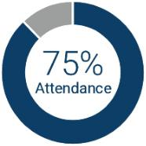

Wabtec’s business is managed under the oversight of our Board which conducts business through meetings of its members and its Committees. The Board met seven times during 2023. It is the Company’s policy that all Directors attend the annual meeting of stockholders if reasonably
​ ​
possible. All of our directors attended the 2023 annual meeting of stockholders. In addition, all directors attended more than 75% of all meetings of the Board and the Committees on which they served in 2023.

Board Education and Onboarding

The Company is committed to providing an initial orientation to board service with the Company and continuing education covering such operational, financial and legal issues as may be appropriate given each Board member’s background, experience and education. Without limiting the foregoing, each Board member is encouraged to propose and attend at least one supplemental educational program per year as he or she thinks appropriate for him or herself and make one annual visit to a Company facility. The Board visited our facilities in Germantown, Maryland and Pittsburgh, Pennsylvania as part of our regularly scheduled Board and Committee meetings in 2023. Directors also have regular access to senior management.

2024 Proxy Statement / | 29

TABLE OF CONTENTS

Corporate Governance

Board Evaluation Process

Through the oversight of the Governance Committee, the Board performs a self-evaluation of its performance at least annually to determine whether the Board and its Committees are functioning effectively and following the Company’s Corporate Governance Guidelines. The Board also engages an independent external consultant to provide an evaluation of the Board’s performance at least every three years. In 2023, the Board engaged an external consultant to conduct a board assessment. The external board assessment included individual director interviews to better understand and capture the unique, diverse, and multi-faceted skillsets of each director. The Board, along with each Committee, also conducted an internal self-assessment to review its effectiveness.
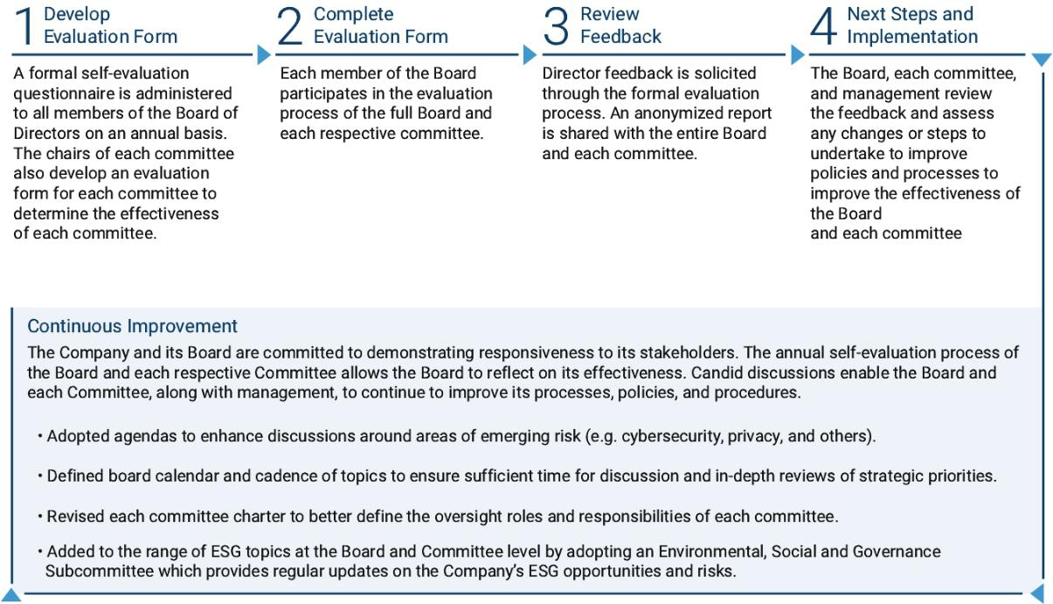

The Board’s Oversight Role

Oversight of Strategy

The Board annually reviews the Company’s strategic priorities and material risks facing the business. At a regular and scheduled cadence, senior management presents business updates to the Board for each of the freight and transit segments related to the Company’s corporate strategy and operating plans. The presentations include strategic plans for the short, mid-term, and long term prospects while highlighting economic or market factors, financial and operational outlooks, and geopolitical factors. Various growth strategies are also presented to the Board, including strategic M&A, effective capital allocation, share repurchase activity, debt positions, and dividend history and strategies. Outside advisors also play a role in identifying, evaluating, and analyzing risks facing the business. These outside advisors include our independent registered public accounting firm, external legal counsel, independent compensation consultants, and transportation or other industry experts.

Oversight of Risk Management

As part of its responsibilities set forth in its charter, the Audit Committee is responsible for discussing Wabtec’s major risk exposures and the steps management has taken to monitor and control those exposures with management, including the Company’s risk assessment and risk management policies. In this regard, Wabtec’s management prepares a comprehensive risk assessment report, described below, and reviews that report with the Audit Committee twice each year.

30 |  | / 2024 Proxy Statement

TABLE OF CONTENTS

Corporate Governance


The Board

• is responsible for overseeing and monitoring the material risks facing the Company.

• annually reviews Wabtec’s strategic plan which addresses, among other things, the risks and opportunities facing the Company.

• has delegated certain risk management oversight responsibility to the Board Committees. Each Committee reports to the full Board.
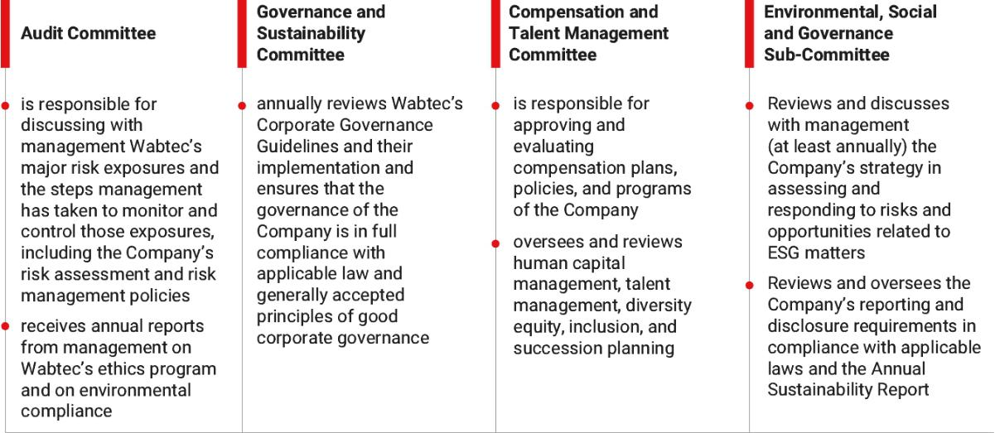

Management

- prepares a comprehensive enterprise risk assessment report and reviews that report with the Audit Committee twice each year, which identifies (i) the material business risks (including strategic, operational, cybersecurity, financial reporting and compliance risks) facing the Company as a whole, as well as for each business unit and for corporate common services and (ii) the controls that respond to, monitor, and mitigate those risks.

- regularly evaluates these controls, and periodically reports to the Audit Committee regarding the controls’ design and effectiveness.

Enterprise Risk Management Process

The Company’s Enterprise Risk Management (“ERM”) program provides a routine and structured process to help identify and address the most significant strategic risks to the Company in non-siloed manners. In 2023, the Company conducted its annual global risk survey to identify the top five enterprise risks to the Company over the next three years. The risk data was consolidated into risk categories which were ranked based on total scores and risk priority score (likelihood x severity). Risk owners were then identified for each risk category to be responsible and accountable for outlining risk mitigation strategies. Senior management provides routine updates to the Board on the progress and development of risk mitigation strategies. The top risk categories identified for 2023 include: (i) cybersecurity and privacy, (ii) geo-political uncertainty, (iii) supply chain disruption, (iv) product safety, quality, and reliability, and (v) technology.

2024 Proxy Statement / | 31

TABLE OF CONTENTS

Corporate Governance

Oversight of Compensation Risk

The Compensation Committee recently conducted a risk assessment and extensively reviewed the elements of compensation to determine whether any portion of compensation encouraged excessive risk taking and concluded:

- significant weighting towards long-term incentive compensation discourages short-term risk taking;

- rolling three-year performance targets discourage short-term risk taking;

- incentive awards are capped by the Compensation Committee which discourages excessive risk taking; and

- equity ownership guidelines discourage excessive risk taking.

Oversight of Cybersecurity Risk

Our Board understands the importance of maintaining a secure environment for our products, data and systems that effectively supports our business objectives and customer needs. The Company has adopted a comprehensive approach with respect to acceptable use, risk management, data privacy, education and awareness, security incident management and reporting, identity and access management, third-party management, security (with respect to physical assets, products, networks and systems), security monitoring and vulnerability identification. The Company also maintains a global incident response plan and regularly conducts exercises to help with our overall preparedness. The Company takes measures to improve and update our cybersecurity program, including independent third party assessments, penetration testing and scanning of our systems for vulnerabilities. The Company pairs with assessors, consultants, auditors, and other third-party service providers and advisers to assist in monitoring cybersecurity risks.

Cybersecurity risks are overseen by the Audit Committee. The Company provides ongoing and continuing reports to the Audit Committee, which reports include information about cyber-risk management, the effectiveness of the Company’s cybersecurity framework, and benchmarking the Company against its industry peers. In addition to these regularly scheduled updates, the Audit Committee and the Company maintain an ongoing dialogue regarding the Company’s cybersecurity risk and posture. Risk is assessed utilizing internal key performance indicators and external evaluations to determine the Company’s cybersecurity score in comparison to its peer group.

The Company has instituted a Cybersecurity Awareness Month program and the Cybersecurity Champion Network for continuous improvement via trainings and continued awareness on emerging cybersecurity risks. Our Board also participates in all enterprise annual security awareness training and phishing campaigns.

Oversight of Management Succession Planning

Under our Corporate Governance Guidelines, the performance of the CEO is reviewed annually by the Board. The Compensation Committee reviews and makes periodic reports to the Board regarding management succession planning and talent management efforts. The Governance Committee has oversight of CEO succession planning.

32 |  | / 2024 Proxy Statement

TABLE OF CONTENTS

Corporate Governance

Stockholder Engagement and Director Communications

Stockholder Engagement

Ongoing engagement with our stockholders is important to us. We value our stockholders’ views, and their input is important to us. Our Investor Relations and Finance teams are dedicated to leading our engagement efforts and collaborating with Wabtec’s management teams and subject matter experts in order to provide appropriate resources for engagement with our stockholders. We believe our engagements with stockholders have been constructive and have provided management and the Board with insights on issues and initiatives that are important to our stockholders and other stakeholders.
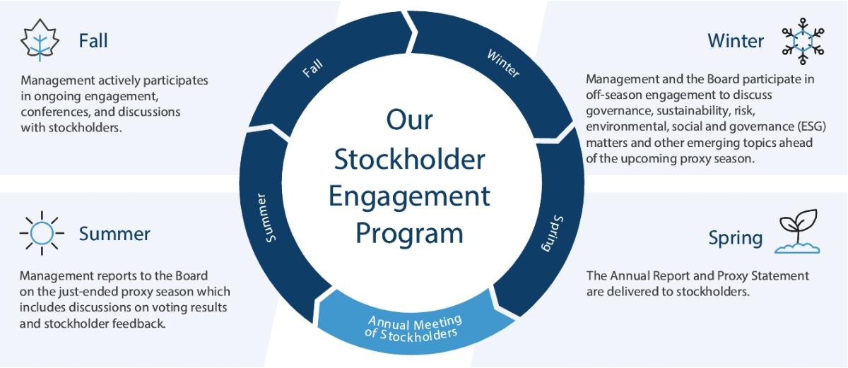

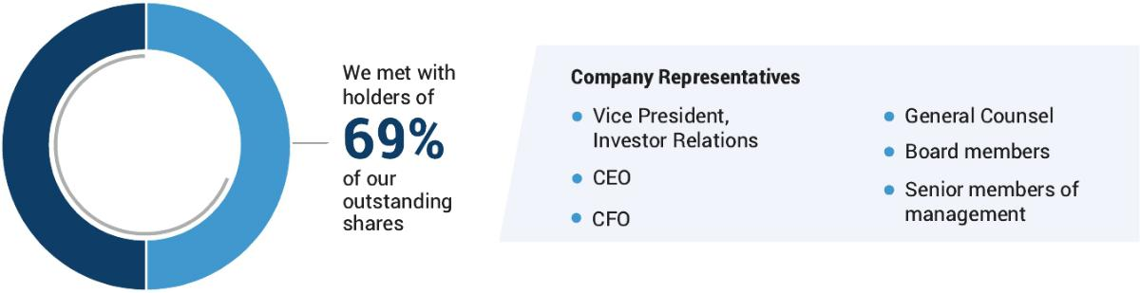

2024 Proxy Statement / | 33

TABLE OF CONTENTS

Corporate Governance

We communicate with our stockholders through a variety of means, including direct interface, investor presentations, investor conferences, company hosted events, analyst meetings, one-on-one meetings, our website, and publications we issue. We also initiate formal outreach efforts in the months prior to our annual meeting of stockholders. Through that process, we contact stockholders and invite them to engage in discussions with our senior management team and subject matter experts on a variety of topics, including the stockholders’ priorities and interests, our Proxy Statement disclosures, stockholder proposals, and company strategy. In 2023, conversations with stockholders focused on the following key areas:


• ongoing conflict between Russia and Ukraine and the resultant sanctions on Russia and Belarus;

• business strategy;

• financial performance;

• Company culture and ongoing integration and restructuring efforts;

• executive compensation;

• financial impacts from lower carload volumes;

• status/impact of Erie strikes;

• acquisition contributions to 2023
​​ | financials;

• order pipeline and cadence of multi-year backlog;

• operating leverage in Freight and Transit segments;

• capital allocation;


• corporate governance practices;

• next generation technology (hydrogen/ battery locomotives);

• impact from regulations and potential emission changes in
​ ​ California;

• Board composition; and

• other topics, including climate-related risks and opportunities.

Following our Annual Meeting, our engagement efforts continue so that we may follow up on matters brought to our attention and/or discuss new issues of interest. We also respond routinely to individual stockholders and other stakeholders who inquire about our business. Input from our stockholders helps us formulate an appropriate action plan for addressing certain issues.

Communication with the Board

The Board provides a process for interested parties to send communications to the Board or any of the directors of Wabtec. Communications to the Board or any director should be sent c/o the Secretary of Wabtec, 30 Isabella Street, Pittsburgh, PA 15212. All such communications except for spam, junk mail, mass mailings, solicitations, resumes, job inquiries, surveys or other matters unrelated to the Company, will be compiled by the Secretary of Wabtec and submitted to the Board or the individual director at the next regularly scheduled meeting of the Board. Interested parties may also communicate directly with the Lead Independent Director at the email address nonmanagementdirectors@wabtec.com.

Governance Policies and Practices

Corporate Governance Guidelines, Code of Conduct and Business Ethics and Compliance Program Charter

Wabtec has adopted Corporate Governance Guidelines and a Code of Conduct and Business Ethics that are applicable to all directors, officers and employees, each of which includes the provisions required under applicable SEC and NYSE regulations. Copies of our Corporate Governance Guidelines and Code of Conduct and Business Ethics are posted on our website at http://www.wabteccorp.com -> investor relations -> corporate governance.

34 |  | / 2024 Proxy Statement

TABLE OF CONTENTS

Corporate Governance

Business Relationships and Related Party Transactions

Pre-existing Relationships

Pursuant to the terms of Wabtec’s amended and restated by-laws, William E. Kassling will be nominated to be a member of the Board so long as he is able and willing to serve and beneficially owns a certain percentage of Wabtec common stock.

Related Party Transaction Approval Policy

Our Board has adopted a written policy regarding related party transactions, a copy of which is available on Wabtec’s website at http://www.wabteccorp.com. Under this policy, the Governance Committee must review and approve in advance all related party transactions that are required to be disclosed pursuant to Item 404 of Regulation S-K promulgated by the SEC. If advance approval is not feasible, the Governance Committee must approve or ratify the transaction at its next scheduled meeting. Transactions required to be disclosed pursuant to Item 404 include any transaction or series of similar transactions, arrangements or relationships in which Wabtec or any of its subsidiaries was, is, or will be a participant, the amount involved exceeds $120,000 and in which any of the following persons had, has or will have a direct or indirect material interest:

- any director, director nominee, or executive officer of Wabtec;

- any holder of more than five percent of Wabtec’s common stock;

- any Immediate Family Member (as defined in the policy) of any of the foregoing persons; and

- any entity which is controlled by someone listed above.

In reviewing related party transactions, the Governance Committee evaluates all material facts about the transaction, including the nature of the transaction, the benefit provided to Wabtec, whether the transaction is on commercially reasonable terms that would have been available from an unrelated third-party and any other factors necessary to its determination that the transaction is fair to Wabtec.

2023 Related Party Transactions

During 2023, Wabtec sourced approximately $23 million worth of goods from Dana Incorporated. One of our directors,

Mr. Foster, currently serves as an executive officer of Dana Incorporated and his interest in this transaction is limited to such capacity. The Board’s Governance Committee has reviewed and approved this transaction.

During 2023, Wabtec sourced approximately $32 million worth of goods from Parker-Hannifin Corporation. One of our directors, Mr. Banks served as an executive officer of Parker-Hannifin Corporation and his interest in this transaction is limited to such capacity. The Board’s Governance Committee has reviewed and approved this transaction.

2024 Proxy Statement / | 35

TABLE OF CONTENTS

Corporate Governance

Sustainability

At Wabtec, we are committed to a strong environmental, social, and governance framework that ensures not only our own long-term success, but also leads our industry and stakeholders to a sustainable, cleaner, safer, and more inclusive transportation future. To that end, our sustainability priorities are embedded into our governance framework, stakeholder engagement, strategic decision making, and our evolving portfolio of products and services that we deliver for customers. This commitment starts at the top of the organization as both our Board of Directors and executive leadership team are actively engaged in Wabtec’s ESG strategy development and oversight.

This commitment helps to shape Wabtec’s sustainability vision:

Wabtec is committed to sustainable value creation. Our strategy is to contribute to a better, more sustainable world through our unique business offerings, leading technologies, and sustainable business practices. These help us capitalize on market opportunities and reduce safety and environmental risks, while creating value for our customers, employees, and other stakeholders.

Oversight of Sustainability

Our ESG governance framework starts with our Board of Directors, who oversee the execution of the Company’s ESG strategy within their oversight of Wabtec’s overall business, risks and opportunities. The Board, under the leadership of the Governance Committee and its ESG Subcommittee, oversees our sustainability strategy and execution against our ESG goals; reviews climate-related risks and opportunities; enhances enterprise risk strategy and management systems; addresses Environmental, Health, and Safety (EHS) matters; and shapes public policy and advocacy efforts. In 2023, Wabtec elevated our commitment by creating a new role — Chief Strategy and Sustainability Officer who manages the Company’s overall strategic sustainable efforts.
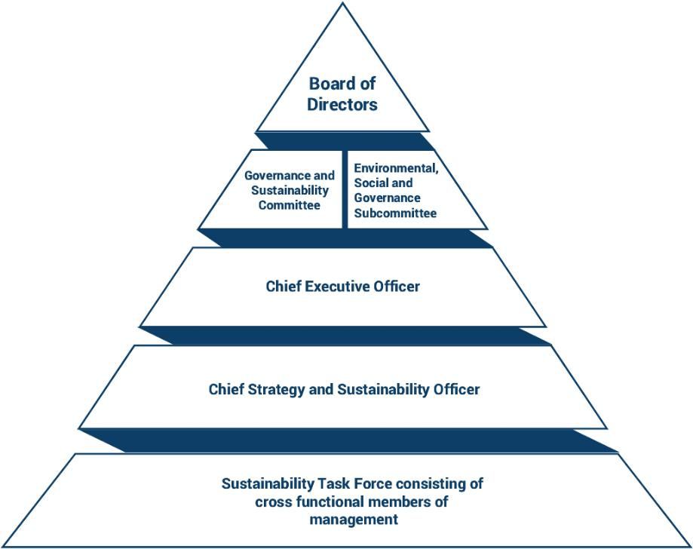

36 |  | / 2024 Proxy Statement

TABLE OF CONTENTS

Corporate Governance

Internally, the Wabtec Sustainability Task Force meets quarterly to advance the Company’s sustainability strategy. This team is comprised of leaders across all functions and business segments, including EHS, Operations, Engineering, Finance, Sourcing, Legal, and Human Resources. They are responsible for implementing actions within those functions that support Wabtec’s ESG framework and strategy.

These processes complement, and are complemented by, our broader ERM process, which is our primary vehicle for assessing and managing operational, strategic, financial, and compliance risk. Guarding against ESG risks is a critical risk area evaluated as part of this process.

Sustainability Highlights

Wabtec continues to make progress delivering on its sustainability goals:

- Created new executive role, Chief Strategy and Sustainability Officer.

- Joined the United Nations Global Compact in 2022 demonstrating our existing and ongoing commitment to universal sustainability principles.

- Set new near-term absolute greenhouse gas (GHG) reduction goal to reduce our Scope 1 and 2 emissions by 50% by 2030, from a 2019 baseline.

- Disclosed Wabtec’s Scope 3 greenhouse gas emissions across our full value chain for the first time.

- Partnered with the rail industry to accelerate the development, validation, and adoption of lower carbon fuels and alternative clean energy technologies.

- Largely on-track to achieve Wabtec’s 2030 sustainability goals.
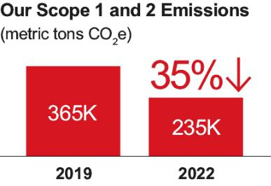

2024 Proxy Statement / | 37

TABLE OF CONTENTS

Corporate Governance

Progress Drives Performance

Wabtec is committed to continued progress on the sustainability areas we believe are critical to long-term success.

The recent publication of our 2023 Sustainability Report reflects our efforts to enhance our sustainability reporting and transparency. Our reporting process not only helps us manage and measure our progress, but also helps us engage with internal and external stakeholders around the world.


- More than 24,000 locomotives globally traveled over 1.8 billion miles and helped end customers eliminate over 138 million metric tons of GHG emissions by choosing rail over truck transportation.

- Approximately 336 million pounds of end-of-life material was sent back to global remanufacturing facilities, with 82% being reused or remanufactured and 18% recycled, leaving less than 1% waste.

- Reduced fine particulate matter emissions by up to 90% with our Transit Green Friction product deployed on metro train braking systems.

- Awarded Norfolk Southern’s inaugural Thoroughbred Sustainability Partner Award, recognizing partner companies who are leaders in the categories of energy efficiency, innovation, and environmental stewardship.


- 35% reduction in Scope 1 and 2 GHG emissions compared to 2019 baseline, on track toward our 2030 goal of 50% reduction.

- 18% reduction in water consumption compared to 2019 baseline.

- 20% reduction in the total recordable injury and illness rate compared to 2019 baseline.

- Significant year-over-year progress on all diversity, equity, and inclusion targets.

- 11% increase in female representation globally.

- 2023 Best Place to work for Disability Inclusion: Disability Equality Index



Our 2023 Sustainability Report provides information on our continued progress to improve our performance on environmental, social, and governance matters, and to drive a better future for people and the planet. The report also shares notable actions taken by Wabtec to advance its sustainability strategy. The report can be found at https://www.wabteccorp.com/sustainability.

38 |  | / 2024 Proxy Statement

TABLE OF CONTENTS

Corporate Governance

Director Compensation

Overview

Elements of Director Compensation
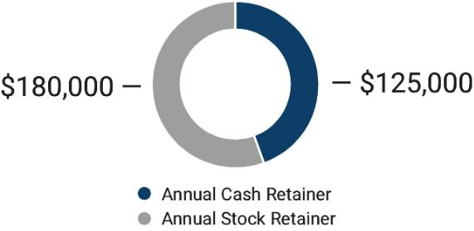

Each director is paid a cash retainer of $125,000 and an annual stock retainer of $180,000. In addition, each director serving in certain positions receives additional cash retainers as detailed below.

Additional Compensation

Chairman Lead Audit Compensation Governance
​ ​ ​ ​ ​ ​ ​ ​
of the Board Independent Director Committee Chairperson Committee Chairperson Committee Chairperson

$200,000 | ​ | ​ | $35,000 | ​​ | $25,000 | ​​ | $25,000 | ​​ | $20,000

2023 Director Compensation

The following table provides information concerning the compensation of our non-employee directors for the period January 1, 2023 through December 31, 2023:

 |  |  |  | Stock
​ | ​ | Fees Earned or ​ | ​ | Awards​ | ​
Name |  | Paid in Cash ($) |  | ($)^{1,2} | Total ($)

Albert J. Neupaver, Chair

​ ​ $325,000​ ​ $180,013​ ​ $505,013

Beverley A. Babcock

​ ​ $125,000​ ​ $180,013​ ​ $305,013

Lee C. Banks ​ ​ $125,000​ ​ $180,013​ ​ $305,013

Byron S. Foster

Linda A. Harty

William E. Kassling

Brian P. Hehir

Ann R. Klee

​ | ​ | $125,000​ | ​ | $180,013​ | ​ | $305,013
​ | ​ | $180,000​ | ​ | $180,013​ | ​ | $360,013
​ | ​ | $125,000​ | ​ | $180,013​ | ​ | $305,013
​ | ​ | $150,000​ | ​ | $180,013​ | ​ | $330,013
​ | ​ | $150,000​ | ​ | $180,013​ | ​ | $330,013

- Reflects the aggregate grant date fair value dollar amount calculated in accordance with ASC 718 related to the awards of stock to the non-employee directors under the 1995 Non-Employee Directors’ Fee and Stock Option Plan.

- The annual award of the $180,013 stock retainer was made on May 16, 2023, with each non-employee director being granted 1,857 restricted shares of Wabtec common stock with a grant date fair market value of $96.94 per share. Such restricted shares generally vest 12 months from the date of grant. If a director voluntarily resigns or is otherwise terminated within 12 months from the grant date of the restricted shares, the director will forfeit the restricted shares. See “Common Stock Ownership” for a description of outstanding awards held by the non-employee directors.

2024 Proxy Statement / | 39

TABLE OF CONTENTS

Corporate Governance

All directors are reimbursed for their out of pocket expenses incurred in connection with attendance at meetings and other activities related to the Board or its Committees. The Company offers a Deferred Compensation Plan for non-employee directors. Under the terms of the plan, eligible directors may defer the annual stock and/or cash retainer, provided that any deferral of the stock retainer will be subject to the same vesting and forfeiture conditions as if the stock retainer had not been deferred. Deferred amounts, including any applicable earnings credited on the deferrals, will be paid out to the director following his termination of service with the Board. Ms. Babcock has deferred 1550 shares.

The Compensation Committee reviews director compensation on an annual basis. At the May Compensation Committee meeting, the Board’s external compensation consultant provides the Compensation Committee with a market analysis detailing: i) cash retainers, ii) equity compensation, and iii) Board leadership retainers. The market analysis provides market data, trends and findings from both peer group and general industry data. Upon review and discussion of the data, the Compensation Committee recommends and the Board approves the compensation cash retainer, Board leadership retainers, and equity compensation for the upcoming year.

Director Compensation Policies and Practices

Stock Ownership Guidelines

Wabtec has established stock ownership guidelines to encourage Board members to own and retain shares of stock. Non-employee Board members are required to accumulate shares having a value equal to six times their cash retainer. Directors are given five years to satisfy these guidelines. Shares that count toward the holding requirement include any shares owned by the director in Wabtec’s share administration platform, the deferred compensation plan, personal accounts, or any unvested restricted shares. All directors except for Mr. Foster and Ms. Babcock have met the ownership guidelines. Mr. Foster and Ms. Babcock are within the 5-year compliance period and are on-track to meet the compliance requirement.

40 |  | / 2024 Proxy Statement

TABLE OF CONTENTS


Proposal Advisory Vote To Approve

- Compensation Of Our Named Executive Officers

As required under the Dodd-Frank Wall Street Reform and Consumer Protection Act (the “Dodd- Frank Act”), we are providing our stockholders with the opportunity to cast a non-binding vote to approve our executive compensation programs and arrangements in accordance with Section 14A of the Exchange Act. In 2023, our stockholders indicated their approval of the Board of Directors’ recommendation that we solicit an advisory vote such as this on an annual basis. Our Board of Directors has adopted a policy that is consistent with that preference and, accordingly, we are providing our stockholders with an opportunity to vote on this proposal at this Annual Meeting.

As described in greater detail under the heading “Compensation Discussion and Analysis,” on page 43 we seek to closely align the interests of our named executive officers with the interests of our stockholders. Our compensation programs are designed to reward our named executive officers for the achievement of short-term and long-term strategic and operational goals and the achievement of increased total stockholder return, while at the same time avoiding the encouragement of unnecessary or excessive risk-taking. The overall objectives of our executive compensation program are to (i) enable us to attract, motivate and retain key executive talent essential to the achievement of our short-term and long-term business objectives; (ii) provide compensation competitive with others in our industry; (iii) reward senior executive officers in a “pay for performance” manner for accomplishment of pre-defined business goals and objectives; and (iv) align the interests of our executives with those of our stockholders. A significant portion of total executive compensation is variable compensation linked to corporate, business unit and individual performance. Our objective is to provide a significant portion of an executive’s total compensation in a form that is contingent upon achieving established performance goals that are intended to align the executives’ interests with those of our stockholders. In regard to compensation based on performance, our objective is to provide a significant portion of such compensation in the form of equity awards.

Under the Dodd-Frank Act and the related SEC rules, your vote on this resolution is an advisory or “non-binding” vote. This means that the purpose of the vote is to provide stockholders with a method to give their opinion to the Board of Directors of the Company about certain issues, like executive compensation. None of the Board, its Committees or the Company is required by law to take any action in response to the stockholder vote. However, the Board values our stockholders’ opinions, and the Board intends to evaluate the results of this year’s vote carefully when making future decisions regarding compensation of the named executive officers. The stockholder advisory vote in connection with our 2023 annual meeting received approximately 93% approval by our stockholders, indicating support of our compensation programs and policies. We believe that providing our stockholders with the opportunity to cast an advisory vote on our executive compensation program on an annual basis will further enhance communication with our stockholders, and it meets our obligations under the Dodd-Frank Act and the SEC’s rules.

We are required to seek a stockholder vote on the frequency of the advisory vote to approve our executive compensation programs and arrangements (the “SOP Frequency Vote”) every six years. As noted above, in 2023, we conducted a SOP Frequency Vote, and our stockholders indicated their approval of the Board’s recommendation that we solicit an advisory vote to approve named executive officer compensation on an annual basis. The next SOP Frequency Vote is expected to be held at our 2029 annual meeting of stockholders.

Vote Required

This proposal is adopted if a majority of the shares present in person or by proxy vote for the proposal. Because the total shares voted “for,” “against,” or “abstain” are counted to determine the minimum votes required for approval, if you abstain from voting, it has the same legal effect as if you vote against. If a broker limits the number of shares voted on the proposal on its proxy card or indicates that the shares represented by the proxy card are not being voted on the proposal, it is considered a broker non-vote. Broker non-votes are not counted as a vote or used to determine the favorable votes required to approve the proposal.

2024 Proxy Statement / | 41

TABLE OF CONTENTS

Proposal 2: Advisory Vote To Approve Compensation Of Our Named Executive Officers

The Board recommends that you approve the following resolution:

RESOLVED, that the stockholders approve the 2023 compensation of the named executive officers, as disclosed in this Proxy Statement pursuant to Item 402 of Regulation S-K of the SEC, including the Compensation Discussion and Analysis, the compensation tables and other narrative executive compensation disclosures.


The Board recommends you vote FOR the approval of the 2023 compensation of our named executive officers, as disclosed in this Proxy Statement pursuant to Regulation S-K of the SEC.

42 |  | / 2024 Proxy Statement

TABLE OF CONTENTS

Compensation Discussion and Analysis

CD&A Table of Contents


 | Named Executive Officers |  |  |  |  |  |  |  |  |  |  | ​ | ​ | 43 ​ |  |  | ​ |  | 2023 NEO Compensation |  |  |  |  |  |  |  |  |  |  | ​ | ​ |  | 49
 | Executive Summary |  |  |  |  |  |  |  |  |  |  | ​ | ​ | 44 ​ |  |  | ​ |  | Base Salary |  |  |  |  |  |  |  |  |  |  | ​ | ​ |  | 49
 | 2023 Performance Highlights |  |  |  |  |  |  |  |  |  |  | ​ | ​ |  | 44 ​ |  | ​ |  | Annual Incentive Compensation |  |  |  |  |  |  |  |  |  |  | ​ | ​ |  | 50
 | 2023 Compensation Highlights |  |  |  |  |  |  |  |  |  |  | ​ | ​ |  | 45 ​ |  | ​ |  | Long-Term Incentive Compensation |  |  |  |  |  |  |  |  |  |  | ​ | ​ |  | 53
 | Say-on-Pay Results |  |  |  |  |  |  |  |  |  |  | ​ | ​ |  | 45 ​ |  | ​ |  | Additional Benefits and Perquisites |  |  |  |  |  |  |  |  |  |  | ​ | ​ |  | 56
 | Compensation Governance Best Practices |  |  |  |  |  |  |  |  |  |  | ​ | ​ |  | 46 ​ |  | ​ |  | NEO Pay Summaries |  |  |  |  |  |  |  |  |  |  | ​ | ​ |  | 57
 | Compensation Philosophy and Objectives |  |  |  |  |  |  |  |  |  |  | ​ | ​ |  | 46 ​ |  | ​ |  | Other Compensation Policies and Practices |  |  |  |  |  |  |  |  |  |  | ​ | ​ |  | 58
 | Executive Compensation Decision-Making Process |  |  |  |  |  |  |  |  |  |  | ​ | ​ |  | 47 ​ |  | ​ |  | Stock Ownership Guidelines |  |  |  |  |  |  |  |  |  |  | ​ | ​ |  | 58
 | Roles and Responsibilities |  |  |  |  |  |  |  |  |  |  | ​ | ​ |  | 47 ​ |  | ​ |  | Clawback​ | Policy |  |  |  |  |  |  |  |  |  | ​ | ​ |  | 59
 | Peer Group |  |  |  |  |  |  |  |  |  |  | ​ | ​ |  | 48 ​ |  | ​ |  | Prohibition on Hedging |  |  |  |  |  |  |  |  |  |  | ​ | ​ |  | 59


Named Executive Officers

Our named executive officers (“NEOs”) for 2023 are:


​ ​ ​ ​ ​ ​ ​ ​

Rafael Santana | John Olin | David L. DeNinno | Pascal Schweitzer | Eric Gebhardt
President and Chief ​ ​ | Executive Vice ​ ​ | Executive Vice | ​​President, Transit⁽¹⁾ ​ ​ | Executive Vice
Executive Officer | President and Chief | President, General |  | President and Chief
 | Financial Officer | Counsel and Secretary |  | Technology Officer

- Pascal Schweitzer was named President, Transit in April 2023. Previously, Mr. Schweitzer served as President, Freight Services from February 2019 to April 2023.

2024 Proxy Statement / | 43

TABLE OF CONTENTS

Compensation Discussion and Analysis

Executive Summary

This Compensation Discussion and Analysis should be read in conjunction with the tabular and narrative disclosures beginning on page 61 of this Proxy Statement. See “Compensation Philosophy and Objectives” on page 46 and the tables that follow for more information regarding our executive compensation programs.

In 2023, the Company reviewed and set executive base salaries, modified its annual cash incentive plan design and issued equity under the Company’s long-term incentive plan.

2023 Performance Highlights

In 2023, the Company delivered strong financial performance as evidenced by higher year-over-year increases in revenues, operating margin expansion and earnings per share growth. The Company had strong execution in a volatile environment with increased sales driven by strong Freight and Transit growth. The Company had strong cash generation enabling investment for future growth while maximizing shareholder returns.

Sales | ​​ | Operating Margin | ​​ | Earnings per Share | ​​ | Cash Flow
Sales |  | Operating Margin |  | Earnings per Share |  | from Operations


$9.68B 13.1%

​ ​ GAAP

Up 15.7% 17.0%

Year over Year Adjusted⁽¹⁾
​ ​

Increased sales were driven

by strong growth across the

Freight and Transit

segments

$4.53
​ ​ _{GAAP} ​ ​

$5.92

Adjusted⁽¹⁾
​ | ​ | ​ | ​

GAAP EPS up 30.9% Year over Year

Adjusted EPS up 21.8% Year over Year from higher Freight and Transit sales

$1.2B

Operating cash flow driven by higher net income tempered by higher working capital to support strong sales growth across the portfolio

- Please refer to the Appendix to this Proxy Statement for a description and reconciliation of these non-GAAP financial measures relative to reported GAAP financial measures.

44 |  | / 2024 Proxy Statement

TABLE OF CONTENTS

Compensation Discussion and Analysis

2023 Compensation Highlights

Elements of Compensation

​​ | Weighting | ​​ | 2023​ | Performance Metrics


Base Salary | ​​

Annual Cash
​ ​

Incentive

Long-Term Equity
​ ​

Incentives

• Individual contribution to business results ​ ​ • Tenure

• Capabilities and qualifications


• Earnings per share (75%)

- ​• Cash conversion (25%)

• Personal performance modifier (0%-120%)


• 60% performance units and 40% time-vesting

restricted stock

For performance units:

- ​* 3-year average annual return on invested capital (50%)

• 3-year average annual cash conversion (50%)

• Subject to relative total stockholder return

(RTSR) modifier (+/- 20%)

Say-on-Pay Results

The Compensation Committee reviewed the results of the 2023 stockholder advisory vote on executive officer compensation and incorporated the results as one of the many factors considered in connection with the discharge of its responsibilities. At our 2023 annual meeting of Stockholders, approximately 93% of the votes cast approved the compensation program described in the Company’s 2023 proxy statement. The Compensation Committee interpreted this level of support as affirmation of the design and objectives of our executive compensation programs and therefore did not make any significant changes to such programs as a direct result of such vote. The Compensation Committee continues to monitor best practices among the Company’s peer group and industry standards related to executive compensation programs.

2024 Proxy Statement

​ ​
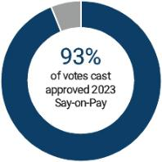

/ | 45

TABLE OF CONTENTS

Compensation Discussion and Analysis

Compensation Governance Best Practices

The Compensation Committee has implemented the following best practices with respect to the executive compensation program:

What we do: | ​ | ​ | What we don’t do:

✔ Review the executive compensation programs each year and the Company’s long-term business strategy, the results of the most recent say-on-pay advisory vote and contemporary market practices as periodically provided by our independent consultant.

✔ Use the Company’s stock price and other value-creating

financial metrics such as earnings before interest and taxes (EBIT) margin, earnings per share (EPS), cash conversion, return on invested capital (ROIC) and relative total stockholder (RTSR) return in our executive incentive programs.

✔ Annually review the risks associated with our compensation programs and mitigate the risks by:

- • capping incentive payouts earned under our annual

cash incentive award plan and capping the number of ​ ​ performance units earned under the long-term incentive plan;

- • maintaining stock ownership guidelines for executive management and non-employee directors;

- • maintaining a clawback policy that applies to our cash and equity incentive awards;

- • maintaining a policy that prohibits the pledging of Company stock; and

- • maintaining a policy that prohibits the hedging of Company stock.

✔ Require both a qualified change in control and involuntary or “good reason” employment termination (double trigger) for any cash severance to be paid under our change in control agreements.

✘ Gross-up for income or excise taxes on perquisites or severance benefits related to a change in control.

✘ Provide executives with an enhanced executive retirement program but rather provide a defined contribution or defined benefit plan similar to that provided to all employees in the country where such employees reside.

✘ Provide dividends or dividend equivalents on unearned performance shares.

✘ Re-price or backdate stock options.

Compensation Philosophy and Objectives

This Compensation Discussion and Analysis describes the material elements of compensation awarded to, earned by, or paid to each of our executive officers who served as named executive officers during 2023. This discussion focuses primarily on the fiscal year 2023 information contained in the following tables and related footnotes.

The overall objectives of our executive compensation program are to (i) enable us to attract, motivate and retain key executive talent essential to the achievement of our short-term and long-term business objectives; (ii) provide compensation competitive with others in our industry; (iii) reward senior executive officers in a “pay for performance” manner for accomplishment of pre-defined business goals and objectives; and (iv) align the interests of our executives with those of our stockholders. A significant portion of total executive compensation is variable compensation linked to corporate, business unit and individual performance. Our objective is to provide a significant portion of an executive’s total compensation in a form that is contingent upon achieving established performance goals. With respect to compensation based on performance, our objective is to provide a significant portion of such compensation in the form of equity awards.

In setting base salaries at the beginning of the year, the Compensation Committee generally reviews benchmark information about compensation levels in Wabtec’s industry and among its peer group based on the position and responsibility of the particular executive provided by the Compensation Committee’s independent consultant. The Compensation Committee

46 |  | / 2024 Proxy Statement

TABLE OF CONTENTS

Compensation Discussion and Analysis

uses benchmarking to establish base salaries as discussed below. The bonus for 2023 is a cash award determined by the Compensation Committee and Board based on pre-established performance factors. These factors are established at the beginning of the year and include (i) a financial performance indicator measuring EPS and cash conversion; and (ii) a modifier for personal objectives based on EBIT Margin and revenue growth (each, as defined below). Long-term incentives in the form of restricted stock and performance units are granted to provide the opportunity for long-term compensation based upon the performance of Wabtec and its ability to meet its long-term goals and objectives.

Executive Compensation Decision-Making Process

Roles and Responsibilities

Compensation Committee | Executive officer compensation is administered by the Compensation Committee. The
 | Compensation Committee approved the 2023 compensation programs for executive officers,
 | including base salaries, cash bonuses and equity awards described in this Compensation
 | Discussion and Analysis and recommended them to the full Board, which then approved them.
 | Our Board of Directors delegates to the Compensation Committee the direct responsibility for,
 | among other matters:
​ | ​
 | • reviewing and approving goals and objectives for the Chief Executive Officer and
 | recommending the Chief Executive Officer’s compensation to the Board for approval;
 | • reviewing and recommending compensation of all non-employee directors and executive
 | officers; and
 | • reviewing and recommending incentive compensation plans and equity-based plans.
Role of Compensation | Pursuant to its charter, the Compensation Committee is authorized to engage compensation
Experts | consultants to assist it with its duties. The Compensation Committee has the sole authority to
 | engage any outside counsel or other experts or consultants to assist it in the evaluation of
 | compensation of our directors and executive officers, including the sole authority to approve
 | such consultants’ fees and other retention terms. The Compensation Committee may also
 | obtain advice from legal, accounting, human resources and other advisors as it deems
 | necessary. The Compensation Committee engaged the consulting firm of Pay Governance
 | through August 2023 and Exequity for the remainder of 2023. During their engagements, Pay
 | Governance or Exequity provided the following services: (i) reviewed and assessed the
​ | ​ Company’s current compensation practices for executives; (ii) reviewed the current Peer
 | Group and made recommendations to update the Peer Group; (iii) reviewed and provided a
 | pay for performance assessment of the Chief Executive Officer compensation; (iv) provided
 | plan design and performance metric benchmarking of the Peer Group and relevant industry
 | data; (v) provided data and recommendations on changes to the annual cash incentive
 | program; and (vi) provided data and recommendations associated with the long term incentive
 | program. In 2023, Pay Governance reviewed and assessed the competitiveness of
 | compensation provided to non-employee members of the Company’s Board of Directors. This
 | review included benchmarking of the Peer Group and relevant industry data. The Committee
 | has evaluated its relationship with each of Pay Governance and Exequity and has determined
 | that no conflict of interest exists with respect to the services that either consultant provides.

Role of Our Executive The Chief Executive Officer and the Executive Vice President, Chief Human Resources Officer

Officers in the suggest guidelines in discussions with the Compensation Committee regarding executive

Compensation Process compensation. They provide recommendations and information regarding the competitiveness

- ​of the industry, key employees, performance of individuals, succession plans and other relevant data to the Compensation Committee. Neither the Chief Executive Officer nor the Executive Vice President, Chief Human Resources Officer is present during any discussions concerning his or her own compensation.

2024 Proxy Statement / | 47

TABLE OF CONTENTS

Compensation Discussion and Analysis

Peer Group

Our philosophy is to position target total compensation opportunity within a reasonable range of the median of that paid to executives of our Peer Group with similar responsibilities. To ensure that the Company is able to attract and retain highly talented and diverse executives, the Company benchmarks executive compensation using a reputable compensation survey of similar-sized companies and also uses available proxy disclosure compensation information for a group of similar-sized manufacturing companies. This Peer Group provided insights to the Compensation Committee as it made compensation decisions for 2023.

Our Peer Group represents a group of manufacturing companies who generally align with the following criteria:

- large industrial companies in Global Industry Classification Standard (“GICS”) sectors generally representing machinery, electrical equipment, auto components, aerospace and defense, and road and rail;

- revenues that range from approximately 0.4 to 2.5 times that of the Company;

- market capitalization of 0.25 to 4.0 times the Company; and

- capital intensive businesses.

This Peer Group was used in making 2023 compensation decisions:

AGCO Corporation | ​ | ​ | Illinois Tool Works Inc. | ​ | ​ | Terex Corporation
AMETEK, Inc. | ​ | ​ | Ingersoll Rand, Inc. | ​ | ​ | Textron, Inc.
BorgWarner Inc. | ​ | ​ | Norfolk Southern Corporation | ​ | ​ | The Timken Company
CSX Corporation | ​ | ​ | Oshkosh Corporation | ​ | ​ | The TransDigm Group
Dover Corporation | ​ | ​ | Parker Hannifin Corporation | ​ | ​ | Xylem, Inc.
Eaton Corporation | ​ | ​ | Rockwell Automation, Inc. | ​ | ​
Emerson Electric Co. | ​ | ​ | Stanley Black & Decker, Inc. | ​ | ​

Note that for the 2023-2025 performance units that were granted to the NEOs as part of the 2023 long-term incentive compensation awards, the Company utilized the XLI index and not its peer group (for previous cycles) for purposes of the relative total stockholder return portion of that award. See the Long-term Incentive Compensation section below for additional detail.

Wabtec Peer Comparison

The table below summarizes key scoping factors for the Company in relation to companies comprising the Peer Group. At the time the Compensation Committee reviewed comparative pay data in early December 2022, median trailing twelve month (“TTM”) revenues as of November 30, 2022 for this array of companies was $11.9 billion and median market capitalization as of November 30, 2022 was $21.9 billion, as compared to TTM revenues and market capitalization for Wabtec of $8.1 billion and $18.4 billion, respectively.

 |  |  |  |  |  | Revenue
 |  |  |  |  |  | (TTM as
 |  |  |  | ​ | ​ | of​ | ​ | Revenue​ | ​ | Revenue​ | ​ | Market​ | ​ | Market​ | ​ | Market
 |  |  |  |  |  | 11/30/22, |  | (FY 2022, |  | (FY 2023, |  | Capitalization |  | Capitalization |  | Capitalization
 |  |  |  |  |  | in |  | in |  | in |  | (as of 11/30/22, |  | (as of 12/31/22, |  | (as of 12/31/23,
 |  |  |  |  |  | millions) |  | millions) |  | millions) |  | in millions) |  | in millions) |  | in millions)
 | Wabtec |  |  | ​ | ​ | $ 8,129​ | ​ | $ 8,362​ | ​ | $ 9,677​ | ​ | $18,385​ | ​ | $18,152​ | ​ | $22,735
 | Wabtec Percentile Rank |  |  | ​ | ​ | 42%​ | ​ | 41%​ | ​ | 44%​ | ​ | 37%​ | ​ | 38%​ | ​ | 40%
 | Peer Group 75th Percentile |  |  | ​ | ​ | $14,177​ | ​ | $14,329​ | ​ | $14,911​ | ​ | $47,512​ | ​ | $47,088​ | ​ | $55,791
 | Peer Group Median |  |  | ​ | ​ | $11,908​ | ​ | $12,635​ | ​ | $12,156​ | ​ | $21,854​ | ​ | $21,157​ | ​ | $31,307
 | Peer Group 25th Percentile |  |  | ​ | ​ | $ 5,870​ | ​ | $ 6,033​ | ​ | $ 7,120​ | ​ | $11,022​ | ​ | $10,730​ | ​ | $12,066
48 |  |  | / | 2024 Proxy Statement

TABLE OF CONTENTS

Compensation Discussion and Analysis

During the fourth quarter of 2023, the Compensation Committee, with the assistance of its independent consultant, reviewed and amended the Peer Group. The Compensation Committee removed BorgWarner, Inc. and Terex Corporation. The Compensation Committee added Jacobs Solutions, Inc. and Snap-on Incorporated. Changes to the Peer Group were made to better align with the criteria above and were primarily driven by industry alignment and financial comparability considerations. Compensation data from this revised peer group will be considered for the purpose of setting 2024 target total executive compensation opportunities.

2023 NEO Compensation

Our 2023 compensation program elements were primarily structured to reward our executive officers for achieving certain financial and business objectives. Wabtec’s philosophy is to position the aggregate of the compensation elements within a reasonable range of the median of that paid to executives in Wabtec’s peer group with similar responsibilities assuming target performance. Actual compensation earned will vary above or below target based on performance.

The principal elements of our executive compensation program are base salary, annual cash incentives, and long-term equity incentives in the form of awards of restricted stock and performance units. Stock options were granted in prior years, but are no longer part of the long-term incentive design. Our other benefits and perquisites consist of life and health insurance benefits, social and health club dues, and a qualified 401(k) savings plan (including company matching contributions).

Base Salary

Base salaries for our executive officers are reviewed annually and reflect the executive’s role and responsibility relative to the competitive market. In defining the competitive market, the Company uses two different benchmarks, compensation information representing our Peer Group and broader benchmark compensation data based on a survey of companies that are similarly sized in terms of revenue. Individual salaries may be above or below the competitive median based on the individual’s contribution to business results, length of time in role, capabilities and qualifications, potential and the importance of the individual’s position to our success. The Compensation Committee is dedicated to ensuring competitive compensation for each of Wabtec’s key employees and believes that current base salaries are in line with comparable industry practices. The base salaries and merit increases of our named executive officers for 2023 were as follows:

 | ​ | ​ |  | ​ | ​ |  | ​ | ​ Base salary
Name and Position |  |  | 2022 Base Salary |  | 2023 Base Salary⁽¹⁾ |  |  | changes %
Rafael Santana | ​ | ​ |  | ​ | ​ |  | ​ | ​
President and Chief Executive Officer |  |  | $1,242,308 |  | $1,325,000 |  |  | 6%​
John Olin | ​ | ​ | $ | ​ | ​ | 765,000​ | ​ | ​
Executive Vice President and Chief Financial Officer |  |  | $ | 750,000​ | $ | 765,000​ |  | 2%​
David L. Deninno | ​ | ​ | $ | ​ | ​ | 650,000​ | ​ | ​
Executive Vice President, General Counsel and Secretary |  |  | $ | 637,692​ | $ | 650,000​ |  | 2%​
Pascal Schweitzer | ​ | ​ |  | ​ | ​ | 614,525² | ​ | ​
President, Transit |  |  | $ | 537,692 | $ | 614,525² |  | 14%
Eric Gebhardt | ​ | ​ | $ | ​ | ​ | 625,000​ | ​ | ​
Executive Vice President and Chief Technology Officer |  |  | $ | 612,692​ | $ | 625,000​ |  | 2%​

- Base salaries are reviewed annually for all of Wabtec’s named executive officers. Increases to base salary are awarded at the beginning of the pay period following review in February by the Compensation Committee. Base salary increases are awarded upon analysis of market data and the executive’s individual performance. Any increases are effective as of February 20, 2023.

- Mr. Schweitzer started 2023 in the United States on a U.S. salary. In February 2023 his U.S. salary was increased to $550,000 annually. In April 2023 Mr. Schweitzer returned to Europe on a Swiss-based compensation package. His base salary was changed to 525,250 CHF. The 2023 salary for Mr. Schweitzer includes the combined salary in both locations. For Mr. Schweitzer, all compensation amounts paid in CHF were converted to U.S. dollars using the exchange rate in effect as of the last day of the fiscal year.

2024 Proxy Statement / | 49

TABLE OF CONTENTS

Compensation Discussion and Analysis

Annual Incentive Compensation

Our annual incentive award plan is intended to: (i) compensate participants based on the extent to which personal, strategic and financial performance targets are achieved and (ii) reward participants for performance on those activities that are most directly under their control and for which they are held accountable. Corporate, business unit and individual performance goals under the annual incentive plan are linked to our annual business plan and budget. The actual amount of cash bonuses is a function of the Company’s overall financial performance, the participant’s individual performance and Board approval.

The table below shows the target amount for each NEOs’ 2023 annual bonus opportunity expressed as a percentage of base salary (which percentages for each NEO remained the same as 2022) salary:

NEOs Cash Bonus Targets (% of Base Salary)
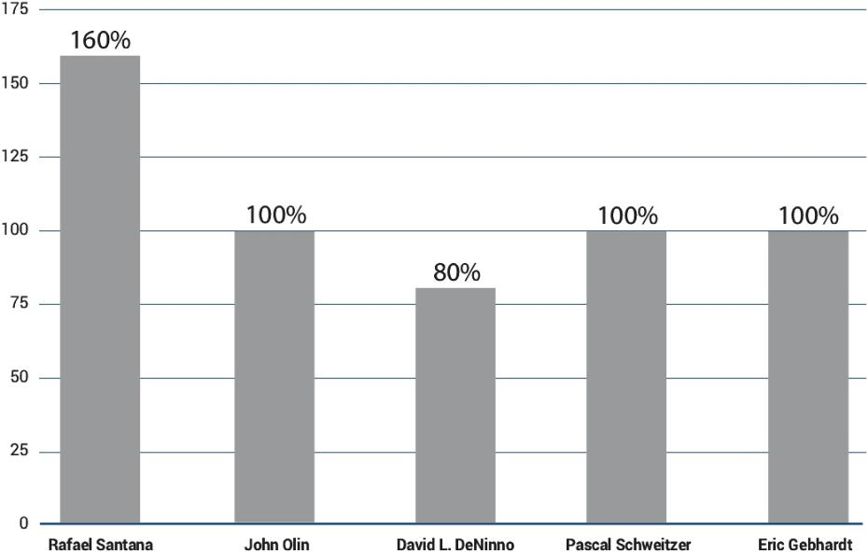

Overall, total target cash compensation (the sum of salary and target cash bonus) for our executive officers is intended to be competitive with market practice for similar executive positions in similar companies when performance goals under the annual cash bonus plan are achieved.

Cash bonuses are earned based on financial and personal performance in accordance with the following formula:
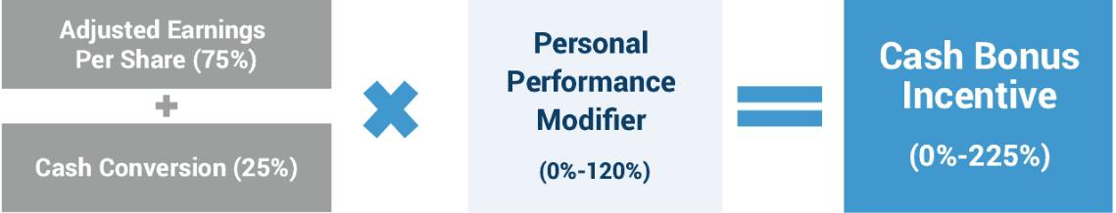

50 |  | / 2024 Proxy Statement

TABLE OF CONTENTS

Compensation Discussion and Analysis

For 2023, the Company adjusted the cash bonus incentive program by changing the weightings of the metrics and the components which comprise the personal performance modifier. In addition, the Compensation Committee determined that Mr. Santana and the entire executive team continued to be measured on the same goals. Cash bonuses for 2023 were based upon the following success factors:

Factor | ​ | ​Weighting | ​ | ​ | Description | ​ | ​
Financial Performance
EPS |  | 75% |  |  | Adjusted earnings per diluted share calculated as U.S. GAAP
 | ​ | ​ | ​ | ​ | earnings per diluted share, adjusted for non-cash amortization | ​ | ​
 |  |  |  |  | expense and certain restructuring costs
Cash Conversion |  | 25% |  |  | Cash conversion means (A) the Company’s cash from
 | ​ | ​ | ​ | ​ | operations divided by (B) the sum of the Company’s net income ​ |  | ​
 |  |  |  |  | plus depreciation and amortization adjusted for certain
 |  |  |  |  | restructuring costs
Personal Modifier
Personal Performance |  | 0%-120% |  |  | The personal performance modifier serves as a multiplier to the
Modifier |  | modifier |  |  | financial performance results. The modifier may be based on
 |  |  |  |  | individual goals such as goals related to EBIT, acquisitions, or
 |  |  |  |  | other individual goals for the executive and can be achieved
 |  |  |  |  | anywhere between 0% and 120% of the financial performance
 |  |  |  |  | result. The two goals used in the personal performance modifier
 |  |  |  |  | for 2023 are EBIT Margin and revenue growth, each weighed
 | ​ | ​ | ​ | ​ | equally. | ​ | ​

EBIT Margin means our “adjusted earnings before interest and

taxes” calculated as our U.S. GAAP income from operations,

adjusted for non-cash amortization expense and certain

restructuring costs, divided by consolidated revenue.

Revenue growth means the percentage increase in the

Company’s gross revenues from fiscal year 2022 to 2023.

The cash bonus formula is based on the product of the participant’s base salary, the participant’s target cash bonus percentage, financial performance and the personal modifier. If both the financial performance and the applicable personal performance results are achieved, the NEOs will earn 100% of their target cash bonus. Each financial metric includes a threshold level of performance, generally, 80% of the target goal at which a minimum 25% payout will be made. Performance below the threshold level would result in no payout on the financial metric. Each financial metric also includes a maximum level of performance, generally 125% of the target goal, at which a maximum 225% payout will be made on that financial metric. To calculate the payout percentages, the goal achievement percentage is first determined. Once the goal achievement percentage is determined, the actual payout percentage is calculated using linear interpolation. There are two payout lines: One for goal achievement between 80% and 100%, resulting in a payout between 25% and 100% and a second for goal achievement between 100% and 125%, resulting in a payout between 100% and 225%. The outcome of the financial metrics is then multiplied by the personal performance modifier. The personal modifier has a range 80% to 120%. The maximum payment under the plan including the personal performance modifier is 225%. We believe that this philosophy encourages Wabtec and our executives to establish ambitious goals and that the program promotes teamwork, productivity and profitability. Target cash bonuses and performance factors were approved by the Compensation Committee at its meeting in February 2023.

2024 Proxy Statement / | 51

TABLE OF CONTENTS

Compensation Discussion and Analysis

The table below provides both the 2023 financial performance goals and our performance achieved with respect to adjusted EPS and Cash Conversion (adjusted for certain restructuring costs) for our corporate wide executives including each of the NEOs:

Measure | ​​ | ​ | ​ | ​ | ​ | ​​ | 2023 | ​​ | Payout Factor | ​​ | Performance
Measure |  | Threshold |  | Target |  | Maximum | Performance |  | Payout Factor |  | Achieved
Financial
_{EPS}(1) | ​​ |  |  |  |  | ​​ | $5.92 | ​​ | 158.49% | ​​ | 118.87%
Cash Conversion | ​​ |  |  |  |  | ​​ | 91% | ​​ | 107.41% | ​​ | 26.85%
Total Financial |  | ​ | ​ |  |  | ​​ |  | ​​ |  | ​​ | 145.72%
Discretionary |  |  |  |  |  |  |  |  |  |  | (4.0%)
Adjustment⁽²⁾ | ​​ | ​ | ​ | ​ | ​ | ​​ |  | ​​ |  | ​​ | (4.0%)
Overall Financial | ​​ | ​ | ​ | ​ | ​ | ​​ |  | ​​ |  | ​​ | 141.72%
Result |  |  |  |  |  |  |  |  |  |  | 141.72%
Personal
EBIT Margin⁽¹⁾ % | ​​ |  |  |  |  | ​​ | 17% | ​​ | 112.0% | ​​ | 56.00%
Revenue Growth | ​​ |  |  |  |  | ​​ | 15.7% | ​​ | 120.0% | ​​ | 60.00%
Individual Multiplier | ​​ |  |  |  |  | ​​ |  | ​​ |  | ​​ | 116.00%
 | ​​ |  |  |  |  | ​​ |  | ​​ | Total | ​​ | 164.40%
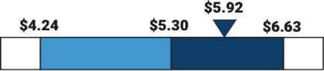
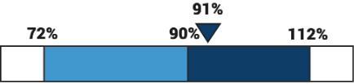
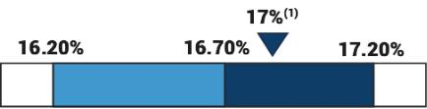
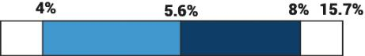

- This is a non-GAAP financial measure. See page A-1 for a reconciliation to the most directly comparable financial measure calculated under GAAP. The actual 2023 bonus awards as a result of this performance for the NEOs are shown under the “Non-equity Incentive Plan Compensation” column of the Summary Compensation Table on page 61.

- This discretionary adjustment was determined by the Compensation Committee based on its review of various market factors and Company-wide incentive compensation decisions.

52 |  | / 2024 Proxy Statement

TABLE OF CONTENTS

 |  |  |  |  |  |  |  |  |  |  |  |  | Compensation Discussion and Analysis
 | ​ | ​ |  | NEO Cash Bonus |  |  | ​
 |  |  |  | Targets
 |  |  |  |  |  |  |  |  |  |  |  |  | Bonus $ ​ |  |  | ​Actual NEO
 |  |  |  |  |  |  |  | ​ |  | ​ | ​ |  | Bonus $ ​ | ​ | ​ | ​Actual NEO
 |  |  |  | % of |  |  |  |  |  |  |  |  | Before |  |  | Cash
 | ​ | ​ |  | Base ​ | ​ |  | ​ |  |  | Financial |  | Individual |  |  | Individual | Bonus
Name and Position |  |  |  | Salary |  | Dollars |  |  |  | Payout % |  |  | Modifier |  | Modifier | Awards
Rafael Santana | ​ | ​ |  | ​ | ​ |  | ​ | ​ |  | ​ | ​ |  | ​ | ​ | ​ | ​
President and Chief Executive Officer |  |  |  | 160% | $2,120,000 |  |  |  |  | 141.72% |  | $3,004,464 |  |  | 116.0% | $3,485,178
John Olin | ​ | ​ |  | ​ | ​ | 765,000 | ​ | ​ |  | ​ | ​ |  | ​ | ​ | ​ | ​
Executive Vice President and Chief Financial Officer |  |  |  | 100% | $ | 765,000 |  |  |  | 141.72% |  | $1,084,158 |  |  | 116.0% | $1,257,623
David L. Deninno
Executive Vice President, General Counsel and | ​ | ​ |  | ​ | ​ |  | ​ | ​ |  | ​ | ​ |  | ​ | ​ | ​ | ​
Secretary |  |  |  | 80% | $ | 520,000 |  |  |  | 141.72% |  | $ | 736,944 |  | 116.0% | $ 854,855
Pascal Schweitzer | ​ | ​ |  | ​ | ​ | 623,981¹ | ​ | ​ |  | ​ | ​ |  | ​ | ​ | ​ | ​
President, Transit |  |  |  | 100% | $ | 623,981¹ |  |  |  | 141.72% |  | $ | 884,306 |  | 116.0% | $1,025,795
Eric Gebhardt | ​ | ​ |  | ​ | ​ | 625,000 | ​ | ​ |  | ​ | ​ | $ | ​ | ​ | ​ | ​
Executive Vice President and Chief Technology Officer |  |  |  | 100% | $ | 625,000 |  |  |  | 141.72% |  | $ | 885,750 |  | 116.0% | $1,027,470

- Represents Mr. Schweitzer’s base salary as of 12/31/2023 converted to USD

Long-Term Incentive Compensation

Our Compensation Committee administers our long-term incentive compensation under our 2011 Stock Incentive Plan, pursuant to which we grant restricted stock and performance units.

Our long-term incentive compensation program seeks to align the interests of our executives with those of our stockholders. We have typically granted our executives long term equity awards in February or March of the applicable year, which for 2023 consisted of performance units weighted 60% and restricted stock weighted 40%. We did not grant options in 2023, (similar to 2022), but in prior years we have awarded options to purchase our common stock to executive officers at the fair market value of our common stock at the grant date.

The grant size of each NEO’s long-term incentive awards is based on the Compensation Committee’s judgment and assessment of various factors, including individual performance, the individual’s responsibilities and position with our Company, market practice and values for similar roles within our peer group and other general industries. The Compensation Committee’s external compensation consultant provides both management and the Compensation Committee a market analysis on an annual basis. The analysis is then reviewed by the CEO and Chief Human Resources Officer who subsequently recommend long-term incentive award grant values to the Compensation Committee. Awards are then reviewed and ultimately approved by the Compensation Committee. Neither the CEO nor the Chief Human Resources Officer make recommendations to their own pay. Equity awards made in 2023 to the NEOs are detailed under the table “2023 Grants of Plan Based Awards” on page 62. For 2023, Wabtec changed the methodology used to calculate the number of restricted shares and target number of performance units. Previously, the Company divided the target value of the awards by our closing average price on the grant date, but for 2023, to avoid the impact of single-day stock price volatility, the Company divided the target value by the 30-day trailing average share price as of the date of grant. The following provides additional information about those awards.

Restricted Stock (40%)

On March 2, 2023, we granted restricted stock to all NEOs as part of their long-term compensation with the Company, which vests in equal installments over three years. The grant date fair value of those awards is reflected in the Summary Compensation Table on page 61.

Performance Units (60%)

On March 2, 2023, we also granted performance units to all NEOs. A performance unit is equal to a share of Wabtec common stock. This program is designed to reward executives for meeting or exceeding pre-established, objective financial performance goals over a three-year performance period. The program is structured as a rolling three-year plan; each year starts a new three-year performance cycle with the most recently commenced cycle being 2023-2025.

2024 Proxy Statement / | 53

TABLE OF CONTENTS

Compensation Discussion and Analysis

The performance unit awards for the 2023-2025 cycle, like the awards for the 2021-2023 and 2022-2024, use three metrics:
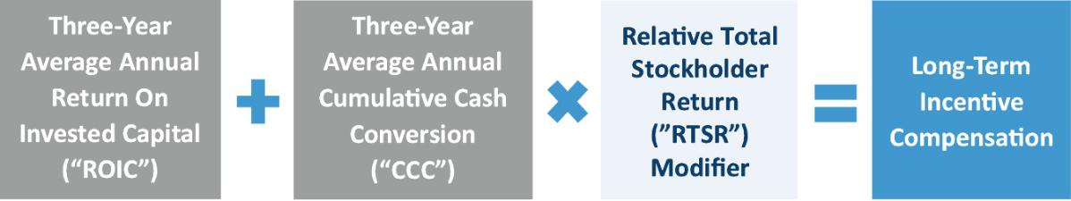

ROIC and CCC results are each weighted 50%. The combined results from the two goals are then subject to modification upward or downward based on Wabtec’s RTSR results versus the defined Peer Group. For the 2023 – 2025 performance awards, the modifier was increased from +/-10% to +/-20%. For purposes of these awards:

- ROIC means for a year (A) the Company’s Adjusted EBITDA after tax, divided by (B) the sum of the Company’s year-end net debt plus shareholders’ equity. For this purpose, Adjusted EBITDA means the Company’s income from operations plus other income plus depreciation and amortization, as adjusted for restructuring costs and set forth in the Company’s annual earnings release.

- CCC means for a year (A) the Company’s cash from operations divided by (B) the sum of the Company’s net income plus depreciation and amortization, as adjusted for certain restructuring costs.

- RTSR measures the percentile ranking of the Company’s total stockholder return ((“TSR”) which means changes in stock price plus dividends) for the performance period against the total stockholder return of the XLI Index for the 2023-2025 grant. The XLI Index mirrors the S&P 500 Industrials Index and is comprised of 72 companies, including Wabtec. The change was made to more accurately represent industry and investor peers.

If Wabtec achieves the maximum three-year cumulative ROIC and CCC results, a participant can earn a maximum number of performance units, equal to 200% of the target level. The RTSR modifier cannot increase the payout above 200% of the target. If Wabtec achieves the threshold three-year ROIC and CCC cumulative goals, a participant can earn a threshold number of performance units, equal to 25% of the target level, which would be subject to modification up or down based on RTSR. Payouts calculated under the ROIC and CCC metrics range from 25% of target for actual performance at 75% of target to 200% of target for performance at or above 125% of target. No performance units would be earned for performance below the three-year cumulative ROIC and CCC thresholds.

The long-term incentive program is intended to encourage the long-term stability of Wabtec’s management by establishing ambitious goals designed to promote the long-term productivity and profitability of the Company. If a program participant leaves the Company voluntarily, or is terminated for cause, they are not eligible to receive any performance units he or she may have earned under the program. If a program participant leaves the Company for death, disability, termination without cause, or retirement, the awards continue to vest, subject to actual performance results for the full performance period. These goals were based on a range of considerations including expected demand in Wabtec’s key end-user markets, investor expectations and management’s business plan which includes year over year growth.

Long-Term Incentive Payouts (2021-2023 Performance Units)

Payouts under our 2021 — 2023 performance unit plan are summarized below.

Actual Peer Group Total Stockholder Return over the three-year period ranged from 15.29% at the 25th Percentile to 39.10%
at the 75th Percentile. The Company’s TSR of 69.10% over the same three-year period fell above the 75th Percentile resulting in a modification of +10.0%.

 |  |  | ​ | ​ | 25th ​ | ​ | 35th ​ | ​ | 45th ​ | ​ |  | 55th ​ | ​ |  | 65th ​ | ​ | 75th ​ | ​
 |  |  |  |  | Percentile |  | Percentile |  | Percentile | Percentile |  |  |  | Percentile |  |  | Percentile | Actual
 | Total Stockholder |  | ​ | ​ | ​ | ​ | ​ | ​ | ​ | ​ |  | ​ | ​ | 34​ | ​ | ​ | ​ | ​
 | Return (“TSR”) |  |  |  | 15​.29% |  | 17​.07% |  | 25​.66% | 26​ | .91% |  |  | 34​ | .31% |  | 39​.10% | 69​.10%
 |  |  |  |  | Less than ​ |  | ₂₅th_{%-} ​ ​ |  | ₃₆th_{%-} ​ ​ | ₄₆th_{%-} ​ |  | ₅₆th_{%-}​ |  |  | ₆₆th_{%-}​ |  | 75th%
 |  |  | ​ | ​ | Less than ​ | ​ |  |  | ₃₆th_{%-} ​ ​ | ₄₆th_{%-} ​ | ​ |  |  | ​ | ₆₆th_{%-}​ | ​ | or​ | ​
 |  |  |  |  | 25th% |  | 35th% |  | 45th% | 55th% |  | 65th% |  |  | 75th% |  | greater | Actual
 | Modifier |  | ​ | ​ | -10.0% ​ | ​ | -7.5% ​ | ​ | -5.0% ​ ​ | 0.0% ​ | ​ | 5.0% ​ |  | ​ | 7.5% ​ | ​ | 10.0% ​ | ​10​.0%
54 |  |  |  | / | 2024 Proxy Statement

TABLE OF CONTENTS

Compensation Discussion and Analysis

Actual ROIC and CCC performance for the 2021 – 2023 performance period exceeded the target goals resulting in a payout under the plan of 132.0% of target. When applying the impact of the RTSR modifier at +10.0% (impact of +13.2%), a payout of 145.3% of target was earned under the plan.

​​ | ​​ | ​​ | ​​ | ​​ | ​​ | Weighted
Measure | Threshold | Target | Maximum | Actual | Payout | Payout
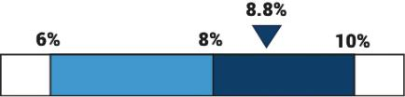

ROIC | ​​ | ​​ | 8.8 | ​​ | 136% | ​​ | 68.2%
(50% Weighting)
CCC | ​​ | ​​ | 96.2 | ​​ | 128% | ​​ | 63.9%
(50% Weighting)
Total Before Modifier | ​​ |  |  |  |  | ​​ | 132.1%
Modifier (+10.0%) | ​​ |  |  |  |  | ​​ | +13.2%
Total Payout | ​​ |  |  |  |  | ​​ | 145.3%
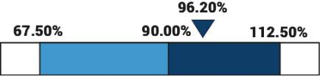

Based on these results, for the 2021-2023 performance period, the NEOs received the payouts as set forth below in March of 2024.

Rafael Santana |  | ​ | ​ | ​69,095 shares of Wabtec Common stock with a value at payout of $9,304,850
David L. DeNinno |  | ​ | ​ | ​11,755 shares of Wabtec Common stock with a value at payout of $1,583,016
Pascal​ | Schweitzer | ​ | ​ | ​9,117 shares of Wabtec Common stock with a value at payout of $1,227,763
Eric Gebhardt |  | ​ | ​ | ​7,199 shares of Wabtec Common stock with a value at payout of $969,471

Mr. Olin did not receive grants in the 2021 fiscal year as he was not employed by the Company at that time.

Additional Equity Award Policies

Additional equity awards may be made throughout the year to new hires, current employees in connection with promotions, and key management obtained through acquisitions. We vary the relative amounts of equity granted in a given year based on a number of factors including the overall performance of the Company, the stock price and retention of key management. Employees eligible for the long-term incentive program include those who are determined by the Compensation Committee to be in key policy-setting and decision-making roles, and to have responsibilities that contribute significantly to achieving our earnings goals.

Any awards made under the 2011 Stock Incentive Plan may be subject to forfeiture at the discretion of the Compensation Committee if between the date of grant and the third anniversary of any exercise, payment or vesting of the award, the participant:

- engages in the operation or management of a business (whether as owner, partner, officer, director, employee or otherwise) which is in competition with the Company or any of its subsidiaries;

- induces or attempts to induce any customer, supplier, licensee or other individual, corporation or other business organization having a business relationship with the Company or any of its subsidiaries to cease doing business with the Company or any of its subsidiaries or in any way interferes with the relationship between any such customer, supplier, licensee or other person and the Company or any of its subsidiaries;

- solicits any employee of the Company or any of its subsidiaries to leave the employment thereof or in any way interferes with the relationship of such employee with the Company or any of its subsidiaries; or

- makes any statements or comments, orally or in writing, of a defamatory or disparaging nature regarding the Company or any of its subsidiaries (including but not limited to regarding any of their respective businesses, officers, directors, personnel, products or policies).

2024 Proxy Statement / | 55

TABLE OF CONTENTS

Compensation Discussion and Analysis

Such forfeiture does not apply following the occurrence of a change of control event unless the award agreement specifically so provides or as required by applicable law.

Additional Benefits and Perquisites

Perquisites and Other Personal Benefits

Supplemental benefits are offered to select executive officers with the goal of attracting and retaining key executive talent. Those perquisites may include life and health insurance benefits, executive physicals, car and housing allowances, and social and health club dues.

Retirement Benefits

The Company maintains a qualified defined contribution program which includes a Company match on participant contributions, which is provided to executives in the United States on the same basis as is provided to other salaried employees of the Company who reside in the United States. The Company also maintains various defined benefit plans which are provided to executives on the same basis as are provided to other employees of the Company who reside or work outside the United States.

Deferred Compensation Plan

The Company sponsors a deferred compensation plan for executive officers and non-employee directors. Under the terms of the plan, eligible executive officers may elect to defer their base salary, cash bonus and/or long-term incentive payout. The Deferred Compensation Plan was re-designed in 2023. During 2023, the plan was changed from crediting interest based on a fixed rate (for 2023) to participant-selected investment options that mirror those provided under the Company’s 401(k) plan (starting in 2024). Additional plan details are provided in the Deferred Compensation section. Mr. Olin elected to defer 15% of his base salary during 2023. No other NEOs deferred compensation for 2023.

Post-Termination Compensation

The Company has entered into Severance and Employment Continuation Agreements with each of the NEOs that include severance protection for certain types of involuntary termination of employment, including following a change in control. The Company entered into these agreements to provide our NEOs with a competitive compensation package and to ensure that management properly considers potential transactions that could result in their job loss. See “Potential Payments Upon Termination or Change in Control” for additional details about these agreements, as well as termination treatment provisions in our equity award agreements.

Tax Implications of Executive Compensation

Section 162(m) of the Internal Revenue Code of 1986, as amended (the “Code”), limits the deductibility of compensation in excess of $1 million paid to certain covered employees (generally including the NEOs) in any calendar year. As a result, compensation paid in excess of $1 million to our named executive officers generally will not be deductible. The Compensation Committee designs compensation programs that are intended to be in the best long-term interests of the Company and our stockholders, with deductibility of compensation being one of a variety of considerations taken into account.

Accounting Considerations with Regard to Compensation Practices. The Compensation Committee reviews on an on-going basis the impact of our compensation programs on Wabtec’s financial statements, including the accounting treatment of equity-based compensation, and the Compensation Committee’s decisions may be influenced by such factors.

56 |  | / 2024 Proxy Statement

TABLE OF CONTENTS

Compensation Discussion and Analysis

NEO Pay Summaries

In 2023, our NEO compensation, based on actual amounts awarded for salary, bonus, and grant values for restricted stock and performance units was allocated as follows (and as more fully set forth on the Summary Compensation Table on p. 61):

Rafael Santana

President and Chief Executive Officer

2023 Performance and Compensation
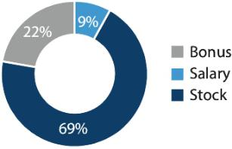

John Olin

Executive Vice President and Chief Financial Officer

2023 Performance and Compensation
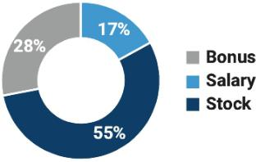

David L. DeNinno

Executive Vice President, General Counsel and Secretary

2023 Performance and Compensation
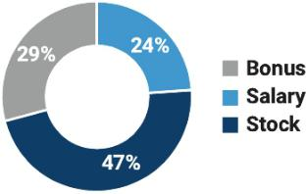

2024 Proxy Statement / | 57

TABLE OF CONTENTS

Compensation Discussion and Analysis

Pascal Schweitzer

President, Transit

2023 Performance and Compensation
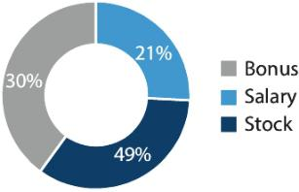

Eric Gebhardt

Executive Vice President and Chief Technology Officer

2023 Performance and Compensation
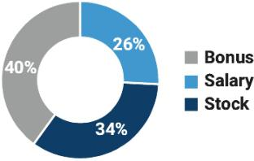

Other Compensation Policies and Practices

Stock Ownership Guidelines

Wabtec has established stock ownership guidelines to encourage our key employees to own and retain shares of stock. The guidelines are as follows:

Position | ​ | ​ | Required Shares Value
President and CEO | ​ | ​ | 7x base salary
Other NEOs | ​ | ​ | 3x base salary
U.S. based senior leaders | ​ | ​ | ½x base salary
Non-U.S. based senior leaders | ​ | ​ | ¼x base salary

The stock ownership guidelines include: (i) all vested shares held in personal accounts, (ii) any unvested restricted stock,

- shares held in retirement accounts, and (iv) unvested restricted stock units for non U.S.-participants. Stock options or unvested performance units do not count towards the stock ownership guidelines.

The aforementioned employees are given five years to satisfy these guidelines. The Compensation Committee is responsible for administering and monitoring compliance with this guideline, including establishing parameters for determination. As of December 31, 2023, each of the named executive officers has met their required stock ownership described above (including any shares deferred pursuant to the deferred compensation plan), except for those individuals within their first five years of service with the Company, all of whom are on track to meet their ownership guidelines. As of January 31, 2024, our directors and executive officers as a group owned approximately 1.1% of our common stock.

58 |  | / 2024 Proxy Statement

TABLE OF CONTENTS

Compensation Discussion and Analysis

Clawback Policy

Our Board of Directors maintains a Clawback Policy that is administered by the Compensation Committee. The Clawback Policy requires the Company to reasonably promptly recoup certain incentive-based compensation (without regard to taxes paid) that was erroneously awarded or paid to executive officers during the applicable three-year recovery period upon the Board, a Committee of the Board, or the officers of the Company concluding that the Company is required to prepare an accounting restatement of the Company’s financials as a result of material noncompliance by the Company under applicable securities laws. Incentive-based compensation potentially subject to recovery under the mandatory accounting restatement provisions of the Clawback Policy is generally limited to any compensation granted, earned or vested based wholly or in part on the attainment of one or more financial reporting measures.

The Clawback Policy does not condition such clawback on the fault of the executive officer, but the Company is not required to recover amounts in limited circumstances set forth in the Clawback Policy where the Compensation Committee has made a determination that recovery would be impracticable. Operation of the mandatory accounting restatement provisions of the Clawback Policy is subject to a brief phase-in process during the first few years after its effectiveness. The Company may not indemnify any such executive officer against the loss of such recovered compensation in the event of a mandatory accounting restatement. The Clawback Policy is intended to comply with the requirements of the Dodd-Frank Wall Street Reform and Consumer Protection Act and related SEC and NYSE implementing rules.

Prohibition on Hedging

The Company considers it improper and inappropriate for any of its directors and officers, including the named executive officers, to engage in short-term or speculative transactions in Wabtec securities or in other transactions that may (i) lead to inadvertent violations of insider trading laws, (ii) reduce an officer’s or director’s incentive to improve Wabtec’s performance,

- focus the officer’s or director’s attention on short-term performance at the expense of long-term objectives, or (iv) otherwise engage in transactions to hedge or offset any decrease in the market value of Wabtec’s stock. To that end, the Company has adopted and maintains a policy covering transactions involving all Wabtec stock held by its officers or directors, including but not limited to stock held directly or indirectly by such officer or director and stock or other equity granted to an officer or director as part of their compensation.

Transactions Prohibited | ​ | ​ | Permitted Transactions

The following transactions are prohibited by Wabtec officers and directors:

- ​ During a quiet period and with the prior approval of the Wabtec Legal

Department, directors and officers are permitted to:

✘ Short sales of Wabtec stock;

✘ Buying and selling publicly traded Wabtec options; ✘ Standing orders to buy or sell Wabtec stock;

✘ Hedging or monetization transactions such as zero cost collars, forward sale contracts involving Wabtec stock;

✘ Pledges of Wabtec stock as collateral for loans or margin accounts; or

✘ Enter into, amend, or terminate Rule 10b5-1 plans to buy or sell Wabtec stock during quiet periods or when in possession of material, non-public information.

✔ Conduct cashless exercises of options if no Wabtec securities are sold in the market to fund such exercise;

✔ Continue regular and matching contributions in benefit plans;

✔ Make gifts of Wabtec securities unless the recipient intends to sell the

 | securities during the quiet period and the donor has knowledge of such
​​ | intent to sell during the quiet period; and

✔ Conduct transactions in previously approved and adopted Rule 10b5-1 plans.

2024 Proxy Statement / | 59

TABLE OF CONTENTS

Compensation and Talent Management Committee Report

The Compensation Committee of the Board of Directors has reviewed and discussed the Compensation Discussion and Analysis included on pages 43 through 59 of this Proxy Statement with management.

Based on this review and discussion, the Compensation Committee recommends to the Board of Directors that the Compensation Discussion and Analysis be included in this Proxy Statement, and incorporated by reference in our Annual Report on Form 10-K for the year ended December 31, 2023 filed with the SEC.

Respectfully submitted,

Compensation and Talent Management Committee

Ms. Klee (Chair)

Ms. Babcock

Mr. Banks

Mr. Hehir

60 |  | / 2024 Proxy Statement

TABLE OF CONTENTS

Executive Compensation Tables

Summary Compensation Table

 |  |  |  |  |  |  |  |  |  |  |  |  |  |  |  |  |  |  |  |  |  | Change in
 |  |  |  |  |  |  |  |  |  |  |  |  |  |  |  |  |  |  |  |  |  | Pension Value
 |  |  |  |  |  |  |  |  |  |  |  |  |  |  |  |  |  |  |  |  |  | and Non-
 | ​ | ​ |  |  | ​ | ​ |  |  | ​ | ​ |  |  | ​ | ​ |  | ​ | ​ | Non-Equity ​ |  |  | ​ | Qualified ​ | ​ | All ​ |  | ​
 |  |  |  |  |  |  |  |  |  |  |  |  |  |  |  | Option |  | Incentive Plan |  |  |  | Deferred |  | Other
Name and Principal |  |  |  |  |  |  |  |  |  |  |  | Stock |  |  | Awards |  |  | Compensation |  |  |  | Compensation |  | Compensation
Position |  |  |  | Year |  |  | Salary ($) |  |  |  | Awards ($)¹ |  |  |  |  | ($) |  |  | ($)² |  |  | Earnings³ |  | ($)⁵ |  |  |  | Total ($)
Rafael Santana |  | ​ |  | 2023​ |  | ​ | $​1,325,000​ |  |  | ​ | $10,655,185​ |  |  | ​ | $ | 0​ | ​ | $​3,485,178​ |  |  | ​ | ​ | ​ | $ 27,877​ | ​ | ​ | $15,493,240
President and Chief
President and Chief |  |  |  | 2022​ |  |  | $1,242,308​ |  |  |  | $ | 8,200,042​ |  |  | $ | 0​​ |  | $2,222,200​ |  |  |  |  |  | $ 20,922​ | ​​$11,685,472
Executive Officer | ​ | ​ |  |  |  | ​ |  |  |  | ​ | $ | 8,200,042​ | ​ | ​ | $ | 0​​ | ​ |  |  |  | ​ | ​ | ​ | $ 20,922​
 |  | ​ |  | 2021​ ​ $1,200,000​ ​ $ |  |  |  |  |  |  |  | 6,415,184​ | ​ | ​ | $​786,364​ |  | ​ | $2,606,580​ |  |  | ​ | ​ | ​ | $ 19,110​ | ​​$11,027,238
John Olin |  | ​ |  | 2023​ |  | ​ | $ | 765,000​ |  | ​ | $ | 2,523,752​ |  | ​ | $ | 0​ | ​ | $​1,257,623​ |  |  | ​ | $2,427​ | ​ | $ 30,597​ | ​ | ​ | $ | 4,579,399​
Executive Vice
Executive Vice |  |  |  | 2022​ |  |  | $ | 750,000​ |  |  | $ | 2,000,056​ |  |  | $ | 0​ |  | $ | 833,325​ |  |  |  |  | $ 25,000​ |  |  | $ | 3,608,381​
President and Chief | ​ | ​ |  |  |  | ​ | $ | 750,000​ | ​ | ​ | $ | 2,000,056​ | ​ | ​ | $ | 0​ | ​ | $ | 833,325​ | ​ | ​ | ​ | ​ | $ 25,000​ | ​ | ​ | $ | 3,608,381​
Financial Officer
Financial Officer |  | ​ |  | 2021​ |  | ​ | $ | 259,615​ |  | ​ | $ | 1,000,032​ |  | ​ | $ | 0​ | ​ | $ | 368,968​ |  | ​ | ​ | ​ | $115,957​ ​ $ |  |  |  | 1,744,572
David L. DeNinno |  | ​ |  | 2023​ |  | ​ | $ | 650,000​ |  | ​ | $ | 1,388,053​ |  | ​ | $ | 0​ | ​ | $ | 854,855​ | ​ | ​ | ​ | ​ | $ 56,846​ | ​ | ​ | $ | 2,949,754​
Executive Vice
President, General | ​ | ​ |  | 2022​ |  | ​ | $ | 637,692​ |  | ​ | $ | 1,249,965​ |  | ​ | $ | 0​​ | ​ | $ | 568,883​ | ​ | ​ | ​ | ​ | $ 52,420​ | ​ | ​ | $ | 2,508,960
Counsel and
Secretary |  | ​ |  | 2021​ |  | ​ | $ | 625,000​ |  | ​ | $ | 1,091,463​ | ​ | ​ | $133,804​ |  | ​ | $ | 724,050​ | ​ | ​ | ​ | ​ | $ 48,769​ | ​ | ​ | $ | 2,623,086
Pascal Schweitzer⁽⁴⁾ |  | ​ |  | 2023​ |  | ​ | $ | 614,525​ | ​ | ​ | $ | 1,716,155​ |  | ​ | $ | 0​ | ​ | $​1,025,795​ |  |  | ​ | ​ | ​ | $398,159​ |  | ​ | $ | 3,754,634​
President, Transit
President, Transit | ​ | ​ |  | 2022​ |  | ​ | $ | 537,692​ |  | ​ | $ | 1,000,028​ | ​ | ​ | $ | 0​​ | ​ | $ | 599,994​ | ​ | ​ | ​ | ​ | $176,765​ ​ $ |  |  |  | 2,314,479​
 |  | ​ |  | 2021​ |  | ​ | $ | 525,000​ |  | ​ | $ | 846,452​ | ​ | ​ | $103,766​ |  | ​ | $ | 721,980​ | ​ | ​ | ​ | ​ | $174,419​ ​ $ |  |  |  | 2,371,617
Eric Gebhardt |  | ​ |  | 2023​ |  | ​ | $ | 625,000​ | ​ | ​ | $ | 858,130​ | ​ | ​ | $ | 0​ | ​ | $1,027,470​ |  |  | ​ | ​ | ​ | $ 36,110​ | ​ | ​ | $ | 2,546,710
Executive Vice
Executive Vice |  |  |  | 2022​ |  |  | $ | 612,692​ |  |  | $ | 749,998​ |  |  | $ | ​0​ |  | $ | 683,327​ |  |  |  |  | $ 40,506​ |  |  | $ | 2,086,523
President and Chief | ​ | ​ |  | 2022​ | ​ | ​ | $ |  |  | ​ | $ | 749,998​ | ​ | ​ | $ | ​0​ | ​ | $ | 683,327​ | ​ | ​ | ​ | ​ | $ 40,506​ | ​ | ​ | $ | 2,086,523
Technology Officer
Technology Officer |  | ​ |  | 2021​ |  | ​ | $ | 600,000​ |  | ​ | $ | 668,277​ |  | ​ | $ 81,908​ |  | ​ | $ | 868,860​ |  | ​ | ​ | ​ | $269,746​ |  | ​ | $ | 2,488,791

- Reflects the aggregate grant date fair value dollar amount computed in accordance with FASB ASC Topic 718 (“ASC 718”), related to the awards of a) restricted stock made to the named executive officers in March 2023 under the 2011 Stock Incentive Plan; and

b) performance units granted to the named executive officers in 2023 for the 2023-2025 performance period. The value of the 2023 performance units awards set forth in the table above is based on probable achievement of the applicable target performance goals. The value of that award based on achievement of maximum performance level would be: for Mr. Santana – $12,786,222; for Mr. Olin - $3,028,460; for Mr. DeNinno – $1,665,621; for Mr. Schweitzer - $2,463,237; and for Mr. Gebhardt - $1,029,588.

- Reflects amounts earned by the named executive officers for fiscal years 2023, 2022, and 2021 under Wabtec’s annual incentive award plan. Payment of bonuses earned for 2023 performance was made in March 2024.

- Amount disclosed for Mr. Olin represents the above-market earnings on his 2023 deferrals to the deferred compensation plan, which earned a return for the year based on the prime rate plus 1%, (total of 8.5%).

- For Mr. Schweitzer, all compensation amounts paid in CHF were converted to U.S. dollars using the exchange rate in effect as of the last day of the fiscal year.

- The following table sets forth a detailed breakdown of the items which compose “All Other Compensation” for each named executive officer in 2023:

 |  |  |  |  |  |  |  |  | Imputed
 |  |  |  |  |  |  | Social, | Company | Group
​​ | ​​ | Tax | ​​ | ​​ | ​​ | ​​ | Health​ ​ | Matching​ ​ | Term Life​ | ​
 |  | Tax |  | Education |  |  | Club Dues | Contribution | Insurance
 |  | Equalization |  | and Housing |  | Pension | and Other | to 401(k) | Premium | Executive
 |  | Payments |  | Allowances | Relocation | contribution | Perks | Plan | Payments | Physicals

Rafael Santana^{(a)}

John Olin

David L. DeNinno

Pascal Schweitzer^{(b)}

Eric Gebhardt

​ | ​ | 2023​ | ​ | $ | ₀​ | ​ | $ | ₀​ | ​ | $ | ₀​ | ​ | $ | ₀​ | ​ | $ | ₀​ | ​ | $19,800​ |  | ​ | $ | 2,622​ | ​ | $5,455
​ | ​ | 2023​ | ​ | $ | 0​ | ​ | $ | 0​ | ​ | $ | 0​ | ​ | $ | 0​ | ​ | $ | 0​ | ​ | $19,800​ |  | ​ | $ | 4,524​ | ​ | $6,273
​ | ​ | 2023​ | ​ | $ | 0​ | ​ | $ | 0​ | ​ | $ | 0​ | ​ | $ | 0​ | ​ | $17,520​ |  | ​ | $19,800​ |  | ​ | $14,071​ |  | ​ | $5,455
​ | ​ | 2023​ | ​ | $ 62,121​ |  | ​ | $25,061​ |  | ​ | $153,312​ |  | ​ | $135,936​ |  | ​ | $21,355​ |  | ​ | $ | 0​ | ​ | $ | 374​ | ​ | $ | 0
​ | ​ | 2023​ | ​ | $ | 0​ | ​ | $ | 0​ | ​ | $ | 0​ | ​ | $ | 0​ | ​ | $11,740​ |  | ​ | $19,800​ |  | ​ | $ | 4,570​ | ​ | $ | 0

2024 Proxy Statement / | 61

TABLE OF CONTENTS

Executive Compensation Tables

- The Company leases a private jet primarily for business travel. During 2023, Mr. Santana also had one personal flight on the private jet for which he reimbursed the Company the aggregate incremental cost of the flight to the Company, and as a result there is no compensation included above for that personal use.

- Mr. Schweitzer was an expatriate and is therefore provided additional annual benefits tied to his assignment. Those benefits include housing and utilities in the host country and tax preparation. We also provide Mr. Schweitzer with tax equalization payments to eliminate any adverse tax impact due to his overseas assignment. During 2023, Mr. Schweitzer moved back to Switzerland from the United States, The relocation amount detailed includes payments to a third party relocation provider for the movement of household goods and the payment of temporary housing related to the move. Also included is a one-time $20,000 relocation allowance paid to Mr. Schweitzer to cover any incidental expenses incurred as a result of his relocation.

2023 Grants of Plan Based Awards

This table shows the plan-based awards granted to the named executive officers in 2023.

​ ​

​ ​

Name

Grant Date

 |  | Estimated Possible |  |  |  |  |  |  |  | Estimated Future
​ | ​ |  | Payouts Under |  |  | ​ |  | ​ |  | Payouts Under |  | ​ |  |  |  | Grant
 |  | Non-Equity Incentive |  |  |  |  |  |  |  | Equity Incentive |  |  |  |  |  | Grant
 |  |  |  |  |  |  |  |  |  |  |  |  |  |  | All Other | Date
 |  |  | Plan Awards ¹ |  |  |  |  |  |  | Plan Awards ² |  |  |  |  | All Other | Date
 |  |  |  |  |  |  |  |  |  |  |  |  | ​ |  | Stock ​ ​ | Fair
 |  |  |  |  |  |  |  |  |  |  |  |  |  |  | Awards: | Value of
 |  |  |  |  |  |  |  |  |  | 25% |  | 200% |  |  | Number of | Stock
​ | ​Threshold​ |  | ​ | Target​ ​ | Maximum​ |  |  | ​ |  | Threshold​ ​ Target​ ​ Maximum​ |  |  |  |  | Units | Awards
 |  | ($) |  | ($) |  | ($) |  |  |  | (#) | (#) | (#) |  |  | (#)³ | ($)⁴

Mr. Santana | ​ |  | ​ | ​ | $0​ | ​ | $2,120,000​ | ​ | $4,770,000​ | ​ |  | ​ | ​ | ​ | ​ |  | ​ | ​ |  | ​ | ​
​ | ​ | 3/2/2023​ | ​ | ​ | ​ | ​ | ​ | ​ | ​ | ​ | 15,213​ | ​ | ​60,852​ | ​ | ​ | 121,704​ | ​ | ​ |  | ​ | ​ | $​6,393,111
 | ​ | 3/2/2023​ | ​ | ​ | ​ | ​ | ​ | ​ | ​ | ​ |  | ​ | ​ | ​ | ​ |  | ​ | ​ | 40,568​ | ​ | ​ | $​4,262,074

Mr. Olin

​ |  | ​ | ​ | $0​ | ​$ | 765,000​ | ​ | ​ | $​1,721,250​ | ​ | ​ | ​ | ​ | ​ | ​ | ​ | ​ | ​
​​ | 3/2/2023​ | ​ | ​ | ​ | ​ |  | ​ | ​ | ​ | ​ | ​ 3,603​ | ​14,413​ | ​ | ​ | ​ 28,826​ | ​ | ​ | ​ | $​1,514,230
​ | 3/2/2023​ | ​ | ​ | ​ | ​ |  | ​ | ​ | ​ | ​ | ​ | ​ | ​ | ​ | ​ | ​ | ​ 9,609​ | ​ | $1,009,522

Mr. DeNinno | ​ |  | ​ | ​ | $0​ | ​ | $ | 520,000​ | ​ | ​ | $1,170,000​ | ​ | ​ | ​ | ​ | ​ | ​ | ​ | ​ | ​
​ | ​ | 3/2/2023​ | ​ | ​ | ​ | ​ |  |  | ​ | ​ | ​ | ​ | ​ 1,982​ | ​ | ​ 7,927​ | ​ | ​ 15,854​ | ​ | ​ | ​ | $ | 832,811​
 | ​ | 3/2/2023​ | ​ | ​ | ​ | ​ |  |  | ​ | ​ | ​ | ​ | ​ | ​ | ​ | ​ | ​ | ​ | ​ 5,285​ | ​ | $ | 555,242​
Mr. Schweitzer | ​ |  | ​ | ​ | $0​ | ​ | $ | 623,981​ | ​ | ​ | $​1,403,958​ | ​ | ​ | ​ | ​ | ​ | ​ | ​ | ​ | ​
​ | ​ | 3/2/2023​ |  | ​ | ​ | ​ |  |  | ​ | ​ | ​ | ​ | 2,931​ | ​ | 11,723​ | ​ | 23,446​ | ​ | ​ | ​ | $1,231,618
 | ​ | 3/2/2023​ |  | ​ | ​ | ​ |  |  | ​ | ​ | ​ | ​ | ​ | ​ | ​ | ​ | ​ | ​ | 4,612​ | ​ | $ | 484,537
Mr. Gebhardt | ​ |  | ​ | ​ | $0​ | ​ | $ | 625,000​ | ​ | ​ | $​1,406,250​ | ​ | ​ | ​ | ​ | ​ | ​ | ​ | ​ | ​
​ | ​ | 3/2/2023​ | ​ | ​ | ​ | ​ |  |  | ​ | ​ | ​ | ​ | ​ 1,225​ | ​ | ​ 4,900​ | ​ | ​ 9,800​ | ​ | ​ | ​ | $ | 514,794​
 | ​ | 3/2/2023​ | ​ | ​ | ​ | ​ |  |  | ​ | ​ | ​ | ​ | ​ | ​ | ​ | ​ | ​ | ​ | ​ 3,268​ | ​ | $ | 343,336​

- Reflects the possible payments under Wabtec’s annual incentive award plan.

- Reflects the grant of performance units with the three-year performance period of 2023-2025 approved by the Compensation Committee in February 2023 under Wabtec’s 2011 Stock Incentive Plan. These columns reflect the range of payouts possible for this grant. A performance unit is equal to a share of Wabtec common stock. Payouts for these awards, if any, will be made by March 31, 2026. See the Compensation Discussion and Analysis, “Long-Term Incentive Compensation” for additional details on the performance goals.

- Reflects the grant of restricted stock to the named executive officers on March 2, 2023 under Wabtec’s 2011 Stock Incentive Plan. One-third of the shares vested on March 1, 2024 and the remaining shares will vest in equal increments on March 1, 2025 and March 1, 2026.

4

62

Reflects the grant date fair value computed in accordance with ASC 718 based on the average closing price of $105.06 as noted in the Compensation Discussion and Analysis, the number of shares was determined by dividing the target value of the awards by the 30-day trailing share price of $104.0727.

/ 2024 Proxy Statement

TABLE OF CONTENTS

Executive Compensation Tables

2023 Outstanding Equity Awards at Fiscal Year-End

This table provides information concerning unexercised options, unvested stock and equity incentive plan awards outstanding as of December 31, 2023 for the named executive officers.

​ | ​ |  |  | Option Awards |  |  |  |  | ​ |  | ​ |  |  | Stock Awards
 |  |  |  |  |  |  |  |  |  |  |  |  |  |  |  |  |  |  |  |  |  | Equity
 |  |  |  |  |  |  |  |  |  |  |  |  |  |  |  |  |  |  |  |  |  | Incentive
 |  |  |  |  |  |  |  |  |  |  |  |  |  |  |  |  |  |  | Equity |  |  | Plan
 |  |  |  |  |  |  |  |  |  |  |  |  |  |  |  |  |  |  | Incentive |  |  | Awards:
 |  |  |  |  |  |  |  |  |  |  |  |  |  |  |  |  |  |  | Plan |  |  | Market or
 |  |  |  |  |  |  |  |  |  |  |  |  |  |  |  |  |  |  | Awards: |  |  | Payout
 |  |  |  |  |  |  |  |  |  |  |  |  |  |  |  |  |  |  | Number of |  |  | Value of
​ | ​ |  | ​ ​ |  |  | ​ ​ | ​ | ​ | ​ |  | ​ | ​ | ​ | Market ​ | ​ |  | ​ | ​ | Unearned ​ |  | ​ | Unearned
 |  |  |  |  |  |  |  |  |  |  |  | Number of |  | Value of |  |  |  |  | Shares, |  |  | Shares,
 |  | Number of |  | Number of |  |  |  |  |  |  |  | Shares or |  | Shares or |  |  |  |  | Units or |  |  | Units or
 |  | Securities |  | Securities |  |  |  |  |  |  |  | Units of |  | Units of |  |  |  |  | Other |  |  | Other
 |  | Underlying |  | Underlying |  |  |  |  |  |  |  | Stock That |  | Stock |  |  |  |  | Rights That |  |  | Rights That
 |  | Unexercised |  | Unexercised |  |  | Option |  | Option |  |  | Have Not |  | That |  |  |  |  | Have Not |  |  | Have Not
 |  | Options (#) |  | Options (#) |  |  | Exercise |  | Expiration |  |  | Vested |  | Have Not |  |  |  |  | Vested |  |  | Vested
Name |  | Exercisable |  | Unexercisable¹ |  |  | Price ($) |  | Date |  |  | (#) |  | Vested ($) |  |  |  |  | (#)² |  |  | (#)²
Rafael | ​ | 9,800​ ​ |  |  | 0​ ​ |  | $70.635​ | ​ | 3/6/2029​ |  | ​ | 10,480⁴​ | ​ | ​$1,329,912​ | ​ | ​2021​ |  | ​ | 182,959​ | ​ | ​ | $23,217,435
Santana |  | 27,591​ |  | ​ | 0​ ​ |  | $78.33​ |  | 2/7/2030​ |  |  | 23,560⁶​ |  | $​2,989,764​ ​ |  | 2022​
​ | ​ | 27,591​ | ​ ​ | ​ |  |  | $78.33​ | ​ |  |  | ​ | 23,560⁶​ | ​ |  |  | 2022​ | ​ | ​ |  | ​ | ​
 | ​ | 20,962​ | ​ ​ | 10,480​ |  | ​ ​ | $81.21​ | ​ | 2/11/2031​ |  | ​ | 40,568⁷​ | ​ | $​5,148,079​ ​ |  | 2023​ | ​ | ​ |  | ​ | ​ |  | ​
John Olin | ​ |  | ​ ​ |  |  | ​ ​ | ​ | ​ | ​ |  | ​ | 11,109⁵​ | ​ | $​1,409,732​ | ​ | 2021​ | ​ | ​ | ​ 27,343​ |  | ​ | $ 3,469,827​
​
 | ​ |  | ​ ​ |  |  | ​ ​ | ​ | ​ | ​ |  | ​ | ​ 5,746⁶​ | ​ | $ 729,167​ | ​ | 2022​ |  | ​ |  | ​ | ​
​ | ​ |  | ​ ​ |  |  | ​ ​ | ​ | ​ | ​ |  | ​ | 9,609⁷​ | ​ | $1,219,382​ | ​ | 2023​ |  | ​ |  | ​ | ​ | ​

David L.

DeNinno

​ | 875​ | ​ |  | 0​ | ​ | $87.03​ | ​ | 2/10/2025​ | ​ | ​ 1,783⁴​ | ​ | $​ | 226,263​ ​ 2021​ |  | ​ | ​ | ​ 27,763​ | ​$ 3,253,096​
​ | 2,100​ | ​ |  | ₀​ | ​ | $61.33​ | ​ | 2/9/2026​ | ​ | ​ 3,591⁶​ | ​ | $​ | 455,698​ ​ 2022​ |  | ​ | ​ | ​ | ​
​ | 2,625​ | ​ |  | 0​ | ​ | $87.05​ | ​ | 2/7/2027​ | ​ | ​ 5,285⁷​ | ​ | $​ | 670,667​ ​ 2023​ |  | ​ | ​ | ​ | ​
​ | 4,200​ | ​ |  | 0​ | ​ | $71.79​ | ​ | 2/6/2028​ | ​ | ​ ​ |  |  | ​ ​ | ​ | ​ | ​ | ​ | ​
​
​ | 5,600​ | ​ |  | ₀​ | ​ | $70.635​ | ​ | 3/6/2029​ | ​ | ​ ​ |  |  | ​ ​ | ​ | ​ | ​ | ​ | ​
​ | 5,208​ | ​ | ​ | 0​ | ​ | $78.33​ | ​ | 2/7/2030​ | ​ | ​ ​ |  |  | ​ ​ | ​ | ​ | ​ | ​ | ​
​ | ​ 3,567​ | ​ | ​ 1,783​ |  | ​ | $81.21​ | ​ | 2/11/2031​ | ​ | ​ ​ |  |  | ​ ​ | ​ | ​ | ​ | ​ | ​

Pascal

Schweitzer

​ | ​ 3,567​ ​ | ​ | 0​ ​ | $78.33​ | ​ | 2/7/2030​ | ​ | 1,383⁴​ ​ $ |  |  | 175,503​ ​ 2021​ ​ |  |  |  | 27,305​ | ​ | $ 3,465,005
​ ​ | ​ 2,766​ ​ | ​ 1,383​ ​ |  | $81.21​ | ​ | 2/11/2031​ | ​ | 2,873​ | ​ | $ | 364,584​ | ​ | 2022​ | ​ | ​ | ​ | ​
​ | ​ ​ |  | ​ ​ | ​ | ​ | ​ | ​ | 4,612​ | ​ | $ | 585,263​ | ​ | 2023​ | ​ | ​ | ​

Eric

Gebhardt

​ | ​ 2,184​ ​ | 1,091​ ​ | $81.21​ | ​ | 2/11/3031​ | ​ | 1,091⁴​ | ​ | $ | 138,448​ | ​ | 2021​ | ​ | 16,948​ | ​ | $ 2,150,701​
​ | ​ ​ | ​ ​ | ​ | ​ | ​ | ​ | 15,000³​ | ​ | $1,903,500​ |  | ​ | 2020​ | ​ | ​ | ​
​
​ | ​ ​ | ​ ​ | ​ | ​ | ​ | ​ | 2,154⁶​ | ​ | $ | 273,343​ | ​ | 2022​ | ​ | ​ | ​
​ | ​ ​ | ​ ​ | ​ | ​ | ​ | ​ | 3,268⁷​ | ​ | $ | 414,709​ | ​ | 2023​ | ​ | ​ | ​ | ​

- Option awards granted to the NEOs prior to March 1, 2019 vest one-fourth per year beginning on March 1 of the year after the grant date. Option awards granted to the NEOs after March 1, 2019 vest one-third per year beginning on March 1 of the year after the grant date.

- This represents the aggregate number of actual performance units granted relative to the 2021-2023 long-term incentive plan, the target performance units that would be paid out upon the Company meeting financial goals relative to the 2022-2024 long-term incentive plan and the target performance units that would be paid out upon the Company meeting financial goals relative to the 2023-2025 long-term incentive plan multiplied by the fair market value of Wabtec common stock price as of December 31, 2023.

- This represents the number of restricted shares of Wabtec stock that were granted to the executive as a special award in 2020 under the 2011 Stock Incentive Plan that remained unvested as of December 31, 2023. This award will vest in full on October 13, 2024.

- This represents the number of restricted shares of Wabtec stock that were granted in 2021 to the executive under the 2011 Stock Incentive Plan and that remain unvested as of December 31, 2023. One-third of this award vested on March 1, 2022, one-third of this award vested on March 1, 2023 and one-third of this award will vest on March 1, 2024.

- This represents the number of restricted shares of Wabtec stock that were granted to the executive as a special award in 2020 under the 2011 Stock Incentive Plan that remained unvested as of December 31, 2022. This award will vest in full on August 30, 2024.

2024 Proxy Statement / | 63

TABLE OF CONTENTS

Executive Compensation Tables

- This represents the number of restricted shares of Wabtec stock that were granted in 2022 to the executive under the 2011 Stock Incentive Plan and that remain unvested as of December 31, 2023. One-third of this award vested on March 1, 2023, additional one-thirds of this award will vest on each of March 1, 2024 and March 1, 2025.

- This represents the number of restricted shares of Wabtec stock that were granted in 2023 to the executive under the 2011 Stock Incentive Plan and that remain unvested as of December 31, 2023. One-third of this award will vest on March 1, 2024, and one-third of this award will vest on each of March 1, 2025 and March 1, 2026.

Option Exercises and Stock Vested

This table provides information concerning vesting of stock, including restricted stock, restricted stock units and similar instruments, during 2023 for the named executive officers on an aggregate basis.

 | ​ | ​ | Option Awards |  | ​ |  | ​ | Stock Awards
 |  |  | Number of |  |  |  |  | Number of |  | Value
 | ​ | ​ | Shares ​ | ​ | Value ​ |  | ​ | Shares ​ | ​ | Value
 |  |  | Acquired on |  | Realized on |  |  | Acquired on |  | Realized on
Name |  |  | Exercise (#) |  | Exercise ($) |  |  | Vesting (#) |  | Vesting ($)^{1,2}
Rafael Santana | ​ | ​ | 0​ | ​ | $0​ |  | ​ | ​90,567​ | ​ | $9,428,320
John Olin | ​ | ​ | 0​ | ​ | $0​ |  | ​ | ​ 2,874​ | ​ | $ 301,475​
David L. DeNinno | ​ | ​ | 0​ | ​ | $0​ |  | ​ | ​15,136​ | ​ | $1,501,868
Pascal Schweitzer | ​ | ​ | 0​ | ​ | $0​ |  | ​ | ​10,736​ | ​ | $1,067,369
Eric Gebhardt | ​ | ​ | 0​ | ​ | $0​ |  | ​ | ​ 2,170​ | ​ | $ 227,628​

- Calculated by multiplying the number of shares of restricted stock that vested by the market price of Wabtec’s common stock on the vesting date.

- This includes a payout of awards with a 2020-2022 performance period granted under the long-term incentive plan.

Nonqualified Deferred Compensation

 |  |  |  |  |  |  |  |  | Aggregate |  |  |  | Aggregate
 |  |  |  |  |  |  | Registrant |  | Aggregate |  | Aggregate |  | Balance at
 | ​ | ​ | ​ | ​ | Executive​ | ​ | Contributions​ | ​ | Earnings​ | ​ | Withdrawals/​ | ​ | December
 |  |  |  |  | Contributions |  | in Last FY |  | in Last FY |  | Distributions |  | 31,
Name |  |  | Plan Name |  | in Last FY⁽¹⁾ |  | ($) |  | _{($)}(2) |  | ($) |  | 2023 ($)
John Olin | ​ | ​ | Wabtec Plan​ | ​ | $​114,900​ | ​ | ​ | ​ | $4,817​ | ​ | ​ | ​ | $119,307

- This entire amount was included as compensation in the Summary Compensation Table for the last completed fiscal year.

- Amount disclosed for Mr. Olin represents the total earnings on his 2023 deferrals to the deferred compensation plan, which earned a return for the year based on the prime rate plus 1%, (total of 8.5%). $2,427 of the earnings were from “above market” earnings under SEC rules which amount was included in the Summary Compensation Table for the last completed fiscal year.

Wabtec sponsors a deferred compensation plan (the “DC plan”) for certain executive officers and non-employee directors. Under the DC plan, executive officers may contribute pre-tax up to (i) 75% of their base salary, (ii) up to 100% of their cash bonus, and (iii) up to 100% of their performance units. Each participant must re-enroll and make contribution elections on an annual basis. Under the DC plan, distributions may occur at retirement or at specified times chosen by the plan participant. A plan participant may also apply for distribution of their account balance in the event of unforeseeable emergencies. Upon death, all account balances are paid to the plan participant’s beneficiary in a lump sum. The DC plan allows for payments via lump sum or in installments (from two to ten years). The DC plan was redesigned during 2023. For 2023 deferrals, the only investment option paid the prime rate plus 1%. With the plan redesign, the prime plus 1% was eliminated as an investment option on any new deferrals and all participants were offered investment options that mirror those offered in Wabtec’s 401(k) plan. Any earnings in the DC plan are based on the performance (either positive or negative) of the investments selected by the plan participant. The totality of investment options are chosen by the sole discretion of the Company and are reviewed at least annually. Assets are not formally funded and at all times a plan participant remains an unsecured, general creditor of the Company.

Mr. Olin elected to defer 15% of his base salary during 2023. None of the named executive officers other than Mr. Olin currently have any benefits under this plan.

64 |  | / 2024 Proxy Statement

TABLE OF CONTENTS

Executive Compensation Tables

Potential Payments Upon Termination or Change in Control

Our severance and change-in-control protections are designed to be fair and competitive. These protections are intended to retain executives in the event they need to consider actions that may impact job security or ease an executive’s transition at retirement. These benefits help us compete for talent and are within the range of competitive practice at similar companies.

Severance and Employment Continuation Agreements

We have entered into Severance and Employment Continuation Agreements (the “Continuation Agreements”) with each of the named executive officers effective December 5, 2022. The Continuation Agreements supersede and replace in their entirety any prior agreements. The severance payments and benefits under the Continuation Agreements will also be in lieu of any severance payments and benefits under any severance plans of the Company, provided that any more favorable equity vesting provisions included in award agreements will control.

The Continuation Agreements, which have an indefinite term, provide that each named executive officer will receive severance payments and certain benefits in the event of the executive’s termination by the Company without cause (as defined in the Continuation Agreements) or by the executive for good reason (as defined in the Continuation Agreements). The severance payments and benefits payable to each executive upon such termination of employment will vary based on whether or not the termination of employment occurs during the period from the date of a change in control (as defined in the Continuation Agreements) through the second anniversary of such date (the “Change in Control Period”).

If such termination of employment does not occur during a Change in Control Period, the severance payments and benefits will be as follows:

- a lump sum cash severance payment equal to: (A) for Mr. Santana, two times the sum of his base salary and target annual bonus; and (B) for each of the other named executive officers, the sum of (1) the named executive officer’s base salary plus 1/52 of the named executive officer’s base salary for each full year of the named executive officer’s service with the Company and (2) the named executive officer’s target annual bonus; provided that the amount in clause (1) will not exceed one and one-half times the named executive officer’s base salary (the “Cash Severance Payment”);

- a lump sum payment equal to: (A) for Mr. Santana, twenty-four times the full monthly premium cost to the Company of group medical, dental, vision, life, and long-term disability coverage for Mr. Santana; and (B) for each of the other named executive officers, the Company’s portion of the monthly premium cost of the named executive officer’s medical, dental and vision coverage multiplied by the number of full months of base salary that is represented by the base salary in the Severance Payment described above (the “Benefits Payment”);

- a pro rata portion of the named executive officer’s annual bonus for the year in which the termination date occurs based on actual performance of the Company and the number of days the named executive officer is employed during such year, payable at the same time and on the same terms as annual bonuses paid to other executives of the Company (the “Pro-Rated Annual Bonus”);

- a lump sum payment equal to: (A) $100,000 for Mr. Santana; and (B) $50,000 for each of the other named executive officers, for transition cost assistance (the “Transition Payment”); and

- certain minimum equity vesting requirements as follows: for Mr. Santana, full vesting, and for each of the other named executive officers, pro rata vesting (based on the portion of the vesting period that has elapsed as of the termination date of all Post-2021 Equity Grants (as defined in the Continuation Agreements), subject to actual performance results for the full performance period for any awards with performance-based vesting conditions, and provided that any such vested grants that are options or stock appreciation rights will remain exercisable for three years or until the end of the applicable term, if earlier.

If such termination of employment occurs during a Change in Control Period, the severance payments and benefits will be similar to those described above but in some cases in larger amounts, as follows:

- the Cash Severance Payment will be equal to the sum of the named executive officer’s base salary and target annual bonus multiplied by (A) for Mr. Santana, three; and (B) for each of the other named executive officers, two;

- the Benefits Payment will be equal to the applicable monthly benefits cost described above for the named executive officer multiplied by (A) for Mr. Santana, thirty-six; and (B) for each of the other named executive officers, twenty-four;

- the Pro-Rated Annual Bonus;

- the Transition Payment; and

2024 Proxy Statement / | 65

TABLE OF CONTENTS

Executive Compensation Tables

- the minimum equity vesting provisions described above for Post-2021 Equity Grants, except the vesting for both

Mr. Santana and the other named executive officers will be full, rather than prorated, performance-vesting awards will have performance goals deemed achieved at maximum levels, and the awards in all cases will be subject to the provisions of the 2011 Stock Incentive Plan regarding treatment of awards upon a change in control of the Company (i.e., depending on whether awards are assumed or replaced by the buyer in the transaction).

The severance payments and benefits are conditioned on the named executive officer signing and not revoking a general release of claims. The Continuation Agreements contain restrictive covenants, including non-competition and non-solicitation covenants during the named executive officer’s employment and for the one-year period following the named executive officer’s termination date, and confidentiality and non-disparagement covenants.

Any amounts paid to a named executive officer under a Continuation Agreement will be reduced to the maximum amount that can be paid without being considered an excess parachute payment under Internal Revenue Code Section 280G and subject to the excise tax under Internal Revenue Code Section 4999, but only if the net after-tax benefit of the reduced amount to the Executive is higher than the net after-tax benefit of the unreduced amount.

Termination Treatment in Equity Award Agreements

The vesting and settlement of equity awards in various termination scenarios is subject to the terms of the underlying 2011 Stock Incentive Plan and the respective grant agreements, as well as the minimum vesting requirements of the Continuation Agreements described above. The 2011 Stock Incentive Plan and grant agreements may provide for more favorable vesting conditions which apply to the named executive officers than required by the Continuation Agreements. The following summarizes treatment of equity awards for the named executive officers upon termination of employment or change in control (referred to as a “Section 11 Event” in the 2011 Stock Incentive Plan):

- Death/Disability: Awards vest in full, subject to actual performance results for the full performance period for any performance units or other performance-vesting awards.

- Retirement/Severance with Less Than 65 Retirement Points: A prorated portion of outstanding options and restricted shares or units will become vested on the executive’s next scheduled vesting date. Also, a pro-rated portion of performance units or other performance-vesting awards will remain outstanding and become vested at the end of the applicable performance period (based on actual performance results). For Mr. Santana, in case of severance, vesting will be treated as described below as if he had 65 or more retirement points (i.e., full, rather than prorated vesting).

- Retirement/Severance with 65 or More Retirement Points: The entire unvested portion of outstanding options and restricted shares or units will continue to vest per their original vesting schedule, and the full amount of performance units or other performance-vesting awards will remain outstanding and become vested at the end of the applicable performance period (based on actual performance results).

- Change in Control (No Severance): For awards granted before 2022, the 2011 Stock Incentive Plan provided full vesting upon the change in control event, with performance units or other performance-vesting awards earned at maximum.

- Change in Control with Severance: The 2011 Stock Incentive Plan was amended in 2022 to remove automatic vesting upon a change in control. For awards granted in 2022 and later, if the awards remain outstanding (or are assumed or replaced by the surviving entity) following a change in control and the executive’s employment is terminated without cause or for good reason during the one-year period following such event, the awards will become fully vested, with performance units or other performance-vesting awards earned at maximum. If awards do not remain outstanding (and are not assumed or replaced by the surviving entity) following a change in control, the awards will become fully vested upon the change in control.

“Severance” means a termination without cause or with good reason under the Continuation Agreements. Under the award agreements, “retirement” means a named executive officer’s termination of employment (other than due to death, disability, or cause) if (i) the named executive officer has given the Company at least one year’s advance written notice of the intent to retire, and (ii) at the date of termination of employment the named executive officer is at least age fifty-five (55) and has at least five (5) years of service. “Retirement points” means the sum of a named executive officer’s age and years of service. As of the end of the last fiscal year, with respect to the NEOs, only Mr. DeNinno had 65 retirement points.

66 |  | / 2024 Proxy Statement

TABLE OF CONTENTS

Executive Compensation Tables

Amounts of Potential Payments Upon Termination or Change in Control

Consistent with SEC requirements, the following table shows the estimated amounts that would have been payable or would have become vested upon the events described above, assuming such event had occurred on December 31, 2023. Amounts for equity awards in the table are based on the average closing price (calculated by averaging the highest and lowest price) of our common stock on December 29, 2023 (the last trading day in 2023) of $126.99 per share, and in case of stock options as reduced by the applicable exercise price. Performance units are included in the table assuming maximum performance.

Potential Payments Upon Termination and Change-in-Control Provisions¹

 | Involuntary
 | Termination
 | w/o Cause or | Termination
​ ​ | ​​Resignation ​ ​ | due to ​ ​
 | for Good | Change in
Type of Payment or | Reason | Control
Benefit | ($)⁽⁴⁾ | ($)

Change in ​ ​ | Termination​ | ​ | ​​Termination
Control (no | Due to | Termination | Due to
termination) | Retirement | Due to Death | Disability
($)⁵ | ($) | ($) | ($)

Mr. Santana
​

​

​

​

​

​

​

​

​

​

Continuation Agreement

Cash Severance Payment

Benefits Payment⁽²⁾

Prorated Annual
Bonus⁽⁶⁾

Transition Payment

Equity Awards⁽³⁾ Performance Shares Restricted Stock Options

​ | ​ | ​ | ​ | ​ | ​ | ​ | ​ | ​ | ​ | ​ | ​
​ | ​ | ​ | ​ | ​ | ​ | ​ | ​ | ​ | ​ | ​ | ​ | 0
 |  | 6,890,000 |  | 10,335,000 |  | 0 |  | 0 |  | 0 |  | 0
​ | ​ | 42,201​ | ​ | 63,302​ | ​ | ₀​ | ​ | ₀​ | ​ | ₀​ | ​ | 0
​ | ​ | ​ | ​ | ​ | ​ | ​ | ​ | ​ | ​ | ​ | ​ | 3,485,178
 |  | 3,485,178 |  | 3,485,178 |  | 0 |  | 0 |  | 3,485,178 |  | 3,485,178
​ | ​ | 100,000​ | ​ | 100,000​ | ​ | 0​ | ​ | 0​ | ​ | 0​ | ​ | 0
​ | ​ | ​ | ​ | ​ | ​ | ​ | ​ | ​ | ​ | ​ | ​
​ | ​ | 37,675,374​ | ​ | 37,675,374​ | ​ | 8,756,195​ | ​ | ₀​ | ​ | 37,675,374​ | ​ | 37,675,374
​ | ​ | 10,373,305​ | ​ | 10,373,305​ | ​ | 2,229,690​ | ​ | 0​ | ​ | 10,373,305​ | ​ | 10,373,305
​ | ​ | 479,774​ | ​ | 479,774​ | ​ | 479,774​ | ​ | 0​ | ​ | 479,774​ | ​ | 479,774

Mr. Olin
​

​

​

​

​

​

​

​

​

​

Continuation Agreement

Cash Severance Payment

Benefits Payment⁽²⁾

Prorated Annual
Bonus⁽⁶⁾

Transition Payment

Equity Awards⁽³⁾ Performance Shares Restricted Stock Options

​ | ​ | ​ | ​ | ​ | ​ | ​ | ​ | ​ | ​ | ​ | ​
​ | ​ | ​ | ​ | ​ | ​ | ​ | ​ | ​ | ​ | ​ | ​ | 0
 |  | 1,559,423 |  | 3,118,846 |  | 0 |  | 0 |  | 0 |  | 0
​ | ​ | 18,017​ | ​ | 36,033​ | ​ | 0​ | ​ | 0​ | ​ | 0​ | ​ | 0
​ | ​ | ​ | ​ | ​ | ​ | ​ | ​ | ​ | ​ | ​ | ​ | 1,257,623
 |  | 1,257,623 |  | 1,257,623 |  | 0 |  | 0 |  | 1,257,623 |  | 1,257,623
​ | ​ | 50,000​ | ​ | 50,000​ | ​ | 0​ | ​ | 0​ | ​ | 0​ | ​ | 0
​ | ​ | ​ | ​ | ​ | ​ | ​ | ​ | ​ | ​ | ​ | ​
​ | ​ | 3,403,170​ | ​ | 6,944,575​ | ​ | 0​ | ​ | 0​ | ​ | 6,944,575​ | ​ | 6,944,575
​ | ​ | 1,819,637​ | ​ | 3,360,663​ | ​ | 1,410,732​ | ​ | ₀​ | ​ | 3,360,663​ | ​ | 3,360,663
​ | ​ | ₀​ | ​ | ₀​ | ​ | ₀​ | ​ | ₀​ | ​ | ₀​ | ​ | 0

Mr. DeNinno
​

​

​

​

​

​

​

​

​

​

Continuation Agreement

Cash Severance Payment

Benefits Payment⁽²⁾

Prorated Annual
Bonus⁽⁶⁾

Transition Payment

Equity Awards⁽³⁾ Performance Shares Restricted Stock Options

​ | ​ | ​ | ​ | ​ | ​ | ​ | ​ | ​ | ​ | ​ | ​
​ | ​ | ​ | ​ | ​ | ​ | ​ | ​ | ​ | ​ | ​ | ​ | 0
 |  | 1,307,500 |  | 2,615,000 |  | 0 |  | 0 |  | 0 |  | 0
​ | ​ | 18,017​ | ​ | 36,033​ | ​ | 0​ | ​ | 0​ | ​ | 0​ | ​ | 0
​ | ​ | ​ | ​ | ​ | ​ | ​ | ​ | ​ | ​ | ​ | ​ | 854,855
 |  | 854,855 |  | 854,855 |  | 0 |  | 854,855 |  | 854,855 |  | 854,855
​ | ​ | 50,000​ | ​ | 50,000​ | ​ | ₀​ | ​ | ₀​ | ​ | ₀​ | ​ | 0
​ | ​ | ​ | ​ | ​ | ​ | ​ | ​ | ​ | ​ | ​ | ​
​ | ​ | 5,558,450​ | ​ | 5,558,450​ | ​ | 1,492,738​ | ​ | 5,558,450​ | ​ | 5,558,450​ | ​ | 5,558,450
​ | ​ | 1,353,586​ | ​ | 1,353,586​ | ​ | 226,423​ | ​ | 1,353,586​ | ​ | 1,353,586​ | ​ | 1,353,586
​ | ​ | 81,626​ | ​ | 81,626​ | ​ | 81,626​ | ​ | 81,626​ | ​ | 81,626​ | ​ | 81,626

Mr. Schweitzer
​

​

​

​

​

​

​

​

​

​

Continuation Agreement

Cash Severance Payment

Benefits Payment⁽²⁾

Prorated Annual
Bonus⁽⁶⁾

Transition Payment

Equity Awards⁽³⁾ Performance Shares Restricted Stock Options

​ | ​ | ​ | ​ | ​ | ​ | ​ | ​ | ​ | ​ | ​ | ​
​ | ​ | ​ | ​ | ​ | ​ | ​ | ​ | ​ | ​ | ​ | ​ | 0
 |  | 1,439,957 |  | 2,879,913 |  | 0 |  | 0 |  | 0 |  | 0
​ | ​ | 21,101​ | ​ | 22,753​ | ​ | 0​ | ​ | 0​ | ​ | 0​ | ​ | 0
​ | ​ | ​ | ​ | ​ | ​ | ​ | ​ | ​ | ​ | ​ | ​ | 1,025,795
 |  | 1,025,795 |  | 1,025,795 |  | 0 |  | 0 |  | 1,025,795 |  | 1,025,795
​ | ​ | 50,000​ | ​ | 50,000​ | ​ | 0​ | ​ | 0​ | ​ | 0​ | ​ | 0
​ | ​ | ​ | ​ | ​ | ​ | ​ | ​ | ​ | ​ | ​ | ​
​ | ​ | 2,686,625​ | ​ | 3,235,451​ | ​ | 1,593,471​ | ​ | 0​ | ​ | 3,235,451​ | ​ | 3,235,451
​ | ​ | 461,567​ | ​ | 1,126,147​ | ​ | 175,627​ | ​ | 0​ | ​ | 1,126,147​ | ​ | 1,126,147
​ | ​ | 52,761​ | ​ | 63,314​ | ​ | 63,314​ | ​ | 0​ | ​ | 63,314​ | ​ | 63,314

2024 Proxy Statement / | 67

TABLE OF CONTENTS

Executive Compensation Tables

 | Involuntary
 | Termination
 | w/o Cause or | Termination
​​ | ​​Resignation ​ ​ | due to ​ ​ | Change in ​ ​ | Termination​ | ​ | ​​Termination
 | for Good | Change in | Control (no | Due to | Termination | Due to
Type of Payment or | Reason | Control | termination) | Retirement | Due to Death | Disability
Benefit | _{($)}(4) | ($) | ($)⁵ | ($) | ($) | ($)

Mr. Gebhardt
​

​

​

​

​

​

​

​

​

​

Continuation Agreement

Cash Severance Payment

Benefits Payment⁽²⁾

Prorated Annual
Bonus⁽⁶⁾

Transition Payment

Equity Awards⁽³⁾ Performance Shares Restricted Stock Options

​ | ​ | ​ | ​ | ​ | ​ | ​ | ​ | ​ | ​ | ​ | ​
​ | ​ | ​ | ​ | ​ | ​ | ​ | ​ | ​ | ​ | ​ | ​ | 0
 |  | 1,286,058 |  | 2,572,115 |  | 0 |  | 0 |  | 0 |  | 0
​ | ​ | 21,101​ | ​ | 42,201​ | ​ | 0​ | ​ | 0​ | ​ | 0​ | ​
​ | ​ | ​ | ​ | ​ | ​ | ​ | ​ | ​ | ​ | ​ | ​ | 1,027,470
 |  | 1,027,470 |  | 1,027,470 |  | 0 |  | 0 |  | 1,027,470 |  | 1,027,470
​ | ​ | 50,000​ | ​ | 50,000​ | ​ | 0​ | ​ | 0​ | ​ | 0​ | ​ | 0
​ | ​ | ​ | ​ | ​ | ​ | ​ | ​ | ​ | ​ | ​ | ​
​ | ​ | 2,147,700​ | ​ | 3,390,146​ | ​ | 914,095​ | ​ | 0​ | ​ | 3,390,146​ | ​ | 3,390,146
​ | ​ | 1,760,244​ | ​ | 2,316,933​ | ​ | 2,043,396​ | ​ | 0​ | ​ | 2,316,933​ | ​ | 2,316,933
​ | ​ | 41,622​ | ​ | 49,946​ | ​ | 49,946​ | ​ | 0​ | ​ | 49,946​ | ​ | 49,946

- The table assumes the event (termination, death, disability, CIC) occurs as of December 29, 2023 and a stock price of $126.99.

- The Benefits Payment represents: for Mr. Santana, the full cost of all medical, dental, vision, disability and life insurance benefits; for all other NEO’s, the employer provided cost for medical, dental and vision.

- The Performance Awards reflect unvested awards for the performance period: 2021-2023, 2022-2024, and 2023-2025. The value included for the 2021- 2023 Performance Awards reflect settlement at 145.3% of target. The 2022-2024 and 2023-2025 awards are assumed to settle at maximum payout of 200%. The Restricted Stock and Options reflect unvested awards as summarized in the Outstanding Equity Awards section.

- The value of Equity Awards for termination without cause and resignation for good reason are calculated as of December 31, 2023, however the final settlement is not accelerated and occurs according to the timing in the awards agreements.

- This scenario does not include termination of employment and strictly includes the value of single trigger vesting related to pre-2022 Equity Awards.

- The Prorated Annual Bonus reflects the actual bonus amounts earned for 2023 and paid in March 2024.

CEO Pay Ratio

As required by Section 953(b) of the Dodd-Frank Wall Street Reform and Consumer Protection Act, and Item 402(u) of SEC Regulation S-K, we are providing the following information about the relationship of the annual total compensation of our employees and the annual total compensation of Mr. Santana, our Chief Executive Officer.

For 2023, our last completed fiscal year:

- the annual total compensation of our median employee of our company (other than our CEO) was $48,924; and

- the annual total compensation of our CEO, as reported in the Summary Compensation Table presented on page 61, was $15,493,240.

Based on this information, for 2023, the ratio of the annual total compensation of Mr. Santana, our Chief Executive Officer, to the median of the annual total compensation of all employees was approximately 317 to 1.

To identify the median employee among of all our employees (excluding the CEO), as well as to determine the annual total compensation of the “median employee” for this purpose, the methodology and the material assumptions, adjustments, and estimates that we used were as follows:

- We selected December 31, 2023 as the date upon which we would identify the median employee.

- We determined that, as of December 31, 2023, our employee population for pay ratio disclosure purposes consisted of approximately 28,020 individuals (excluding contingent workers and 825 individuals who became our employees as the result of the LKZ acquisition that closed in December 2023). We did not use any statistical sampling techniques.

- To identify the median employee from our employee population, we used total target cash compensation reflected in our payroll records for those employees.

- In making these determinations, we annualized the compensation of all permanent employees who were hired in 2023 but did not work for us or our consolidated subsidiaries for the entire fiscal year. We did not make any cost-of-living adjustments in identifying the median employee.

68 |  | / 2024 Proxy Statement

TABLE OF CONTENTS

Executive Compensation Tables

- With respect to the annual total compensation of the median employee, we identified and calculated the elements of such employee’s compensation for 2023 in accordance with the requirements of Item 402I(2)(x) of SEC Regulation S-K, resulting in annual total compensation of $48,924.

- We did not otherwise adjust or annualize the median employee’s or the CEO’s compensation for purposes of determining the pay ratio noted above

The CEO pay ratio reported above is a reasonable estimate calculated in a manner consistent with SEC rules based on the methodologies and assumptions described above. SEC rules for identifying the median employee and determining the CEO pay ratio permit companies to employ a wide range of methodologies, estimates and assumptions. As a result, the CEO pay ratios reported by other companies, which may have employed other permitted methodologies or assumptions and which may have a significantly different work force structure from ours, are likely not comparable to our CEO pay ratio.

2024 Proxy Statement / | 69

TABLE OF CONTENTS

Pay Versus Performance

As required by Section 953(a) of the Dodd-Frank Wall Street Reform and Consumer Protection Act, and Item 402(v) of Regulation S-K, we are providing the following information about the relationship between executive compensation actually paid and certain financial performance of the Company. For further information about our approach to rewarding our NEOs in a “pay for performance” manner for accomplishment of pre-defined business goals and objectives, refer to the Compensation Discussion and Analysis section of this Proxy Statement.

2023 Pay Versus Performance Table

 |  |  |  |  |  |  |  | Value of Initial
 |  |  |  |  | Average |  | ​ | Fixed $100 Investment |  | ​
 |  |  |  |  | Average |  |  | Based On:
 |  |  |  |  | Summary
 | ​ ​ | ​ ​ | Compensation | ​ ​ | Compensation​ ​ | Average ​ |  | Total | Peer Group |  | ​ | ​ | ​
 |  | Summary | Compensation |  | Table Total | Compensation |  | Total |  |  |  | Net Income
 |  | Compensation | Actually |  | for Non-PEO | Actually Paid | ​ | Shareholder​ ​ | Total Shareholder ​ |  |  | Net Income
Year |  | Table Total for PEO¹ | Paid to PEO² |  | NEOs³ | to Non-PEO NEOs⁴ |  | Return⁵ | Return⁶ |  |  | (millions)⁷ |  | EPS⁸
(a) | ​ ​ | (b)​ ​ | (c)​ ​ |  | (d)​ ​ | (e)​ | ​ | (f)​ ​ |  | (g)​ | ​ | (h)​ | ​ | (i)
2023 | ​ ​ | $15,493,240​ ​ | $26,664,494​ ​ |  | $3,457,624​ ​ | $5,595,542​ | ​ | $186​ ​ |  | $211​ | ​ | $815​ | ​ | $5.92
2022 | ​ ​ | $11,685,472​ ​ | $14,962,045​ ​ |  | $2,629,586​ ​ | $3,049,535​ | ​ | $131​ ​ |  | $133​ | ​ | $633​ | ​ | $4.86
2021 | ​ ​ | $11,027,238​ ​ | $​15,961,883​ ​ |  | $3,806,454​ ​ | $3,565,170​ | ​ | $120​ ​ |  | $150​ | ​ | $558​ | ​ | $4.26
2020 | ​ ​ | $11,044,419​ ​ | $ 9,083,133​ | ​ ​ | $2,847,857​ ​ | $1,487,328​ | ​ | $ 95​ ​ |  | $120​ | ​ | $414​ | ​ | $3.79

- The dollar amounts reported in column (b) are the amounts of total compensation reported for Rafael Santana (our Principal Executive Officer ”PEO“) for each corresponding year in the “Total” column of the Summary Compensation Table. Refer to “Executive Compensation— Executive Compensation Tables—Summary Compensation Table.”

- The dollar amounts reported in column (c) represent the amount of “compensation actually paid” to Mr. Santana, as computed in accordance with Item 402(v) of Regulation S-K. The dollar amounts do not reflect the actual amount of compensation earned by or paid to Mr. Santana during the applicable year. In accordance with the requirements of Item 402(v) of Regulation S-K, the following adjustments were made to Mr. Santana’s total compensation for each year to determine the compensation actually paid:

 | Reported Summary | Reported Value of ​ ​ | Equity Award ​ ​ | Compensation
​​ | Compensation Table ​ ​ | Reported Value of ​ ​ | Equity Award ​ ​ | Actually Paid
Year | Total for PEO | Equity Awardsª | Adjustment^{b} | to PEO

2023

2022

2021

2020

​ | ​ | $15,493,240​ | ​ | $(10,655,185)​ | ​ | $21,826,440​ | ​ | $​26,664,494
​ | ​ | $11,685,472​ | ​ | $ (8,200,042)​ | ​ | $11,476,615​ | ​ | $14,962,045
​ | ​ | $11,027,238​ | ​ | $ (7,201,548)​ | ​ | $​12,136,195​ | ​ | $15,961,883
​ | ​ | $11,044,419​ | ​ | $ (5,832,485)​ | ​ | $ ​3,871,198​ | ​ | $ 9,083,133

- The grant date fair value of equity awards represents the total of the amounts reported in the “Stock Awards” and “Option Awards” columns in the Summary Compensation Table for the applicable year.

- The equity award adjustments for each applicable year include the addition (or subtraction, as applicable) of the following: (i) the year-end fair value of any equity awards granted in the applicable year that are outstanding and unvested as of the end of the year; (ii) the amount of change as of the end of the applicable year (from the end of the prior fiscal year) in fair value of any awards granted in prior years that are outstanding and unvested as of the end of the applicable year; (iii) for awards that are granted and vest in same applicable year, the fair value as of the vesting date; (iv) for awards granted in prior years that vest in the applicable year, the amount equal to the change as of the vesting date (from the end of the prior fiscal year) in fair value; (v) for awards granted in prior years that are determined to fail to meet the applicable vesting conditions during the applicable year, a deduction for the amount equal to the fair value at the end of the prior fiscal year; and (vi) the dollar value of any dividends or other earnings paid on stock or option awards in the applicable year prior to the vesting date that are not otherwise reflected in the fair value of such award or included in any other component of total compensation for the applicable year. The valuation assumptions used to calculate fair values did not materially differ from those disclosed at the time of grant. The amounts deducted or added in calculating the equity award adjustments are as follows:

70 |  | / 2024 Proxy Statement

TABLE OF CONTENTS

 |  |  |  |  |  |  |  |  |  |  |  |  |  | Pay Versus Performance
 |  |  |  |  |  |  |  |  |  |  |  |  |  | Value of
 |  |  |  |  |  |  |  |  |  |  |  | Fair Value |  | Dividends
 |  |  |  |  |  |  |  |  |  |  |  | at the End |  | or other
 |  |  |  |  |  |  |  |  |  |  |  | of the Prior |  | Earnings Paid
 |  |  |  |  |  |  |  |  |  | Year over Year |  | Year of |  | on Stock or
 | ​ | ​ |  | ​ | ​ | ​ | ​ | Fair Value ​ | ​ | Change in ​ | ​ | Equity ​ | ​ | Option ​ | ​
 |  |  |  |  |  | Year over Year |  | as of Vesting |  | Fair Value of |  | Awards |  | Awards not
 |  |  |  |  |  | Change in |  | Date of |  | Equity Awards |  | that Failed |  | Otherwise
 |  |  |  | Year End |  | Fair Value of |  | Equity Awards |  | Granted in |  | to Meet |  | Reflected in |  | Total
 |  |  | Fair Value |  |  | Outstanding |  | Granted and |  | Prior Years |  | Vesting |  | Fair Value |  | Equity
 |  |  |  | of Equity |  | and Unvested |  | Vested |  | that Vested |  | Conditions in |  | or Total |  | Award
Year |  |  |  | Awards |  | Equity Awards |  | in the Year |  | in the Year |  | the Year |  | Compensation |  | Adjustments
2023 | ​ | ​ | $14,084,958​ |  | ​ | $ 7,765,458​ | ​ | $—​ | ​ | $ (74,368)​ | ​ | $—​ | ​ | 50,392​ | ​ | $21,826,440
2022 | ​ | ​ | $ | 9,319,998​ | ​ | $ 2,184,162​ | ​ | $—​ | ​ | $ (70,543)​ | ​ | $—​ | ​ | $42,998​ | ​ | $11,476,615
2021 | ​ | ​ | $ | 9,065,366​ | ​ | $ 2,976,341​ | ​ | $—​ | ​ | $ 61,792​ | ​ | $—​ | ​ | $32,696​ | ​ | $12,136,195
2020 | ​ | ​ | $ | 5,441,403​ | ​ | $(1,379,240)​ | ​ | $—​ | ​ | $(221,467)​ | ​ | $—​ | ​ | $30,502​ | ​ | $ 3,871,198

- The dollar amounts reported in column (d) represent the average of the amounts reported for the Company’s named executive officers (NEOs) as a group (excluding Mr. Santana, who has served as our CEO since July 2019) in the “Total” column of the Summary Compensation Table in each applicable year. The names of each of the NEOs (excluding Mr. Santana) included for purposes of calculating the average amounts in each applicable year are as follows: (i) for 2023, John Olin, David L. DeNinno, Pascal Schweitzer, and Eric Gebhardt; (ii) for 2022, John Olin, David L. DeNinno, Pascal Schweitzer, and Eric Gebhardt; (iii) for 2021, John Olin, David L. DeNinno, Pascal Schweitzer, Eric Gebhardt, Patrick D. Dugan; and for 2020, Patrick D. Dugan, David L. DeNinno, Pascal Schweitzer, Nicole Theophilus, Albert J. Neupaver, and Scott E. Wahlstrom.

- The dollar amounts reported in column (e) represent the average amount of “compensation actually paid” to the NEOs as a group (excluding Mr. Santana), as computed in accordance with Item 402(v) of Regulation S-K. The dollar amounts do not reflect the actual average amount of compensation earned by or paid to the NEOs as a group (excluding Mr. Santana) during the applicable year. In accordance with the requirements of Item 402(v) of Regulation S-K, the following adjustments were made to average total compensation for the NEOs as a group (excluding Mr. Santana) for each year to determine the compensation actually paid, using the same methodology described above in Note 2:

 |  |  | Average |  |  |  |  |  | Average
 |  |  | Reported Summary |  | Average |  |  |  | Compensation
 | ​ | ​ | Compensation Table ​ | ​ | Reported ​ | ​ | ​ | ​ | Actually Paid
 |  |  | Total for |  | Value of Equity |  | Average Equity |  | to Non-PEO
Year |  |  | Non-PEO NEOs |  | Awards |  | Award Adjustmentsª |  | NEOs
2023 | ​ | ​ | $3,457,624​ | ​ | $(1,621,522)​ | ​ | $3,759,440​ | ​ | $5,595,542
2022 | ​ | ​ | $2,629,586​ | ​ | $(1,250,011)​ | ​ | $1,669,960​ | ​ | $3,049,535
2021 | ​ | ​ | $3,806,454​ | ​ | $(1,917,786)​ | ​ | $1,676,503​ | ​ | $3,565,170
2020 | ​ | ​ | $2,847,857​ | ​ | $(1,531,362)​ | ​ | $ 170,833​ | ​ | $1,487,328

- The amounts deducted or added in calculating the total average equity award adjustments are as follows:

 |  |  |  |  |  |  |  |  |  |  |  |  |  |  |  | Average Value
 |  |  |  |  |  |  |  |  |  |  | Year over |  |  |  |  | of Dividends
 |  |  |  |  |  |  |  |  |  |  | Year Average |  |  | Average Fair |  | or other
 |  |  |  |  |  |  |  | Average Fair |  |  | Change in Fair |  |  | Value at the |  | Earnings Paid
 |  |  |  |  | Year over |  |  | Value as |  |  |  | Value |  | End of the Prior |  | on Stock or
 | ​ | ​ | ​ | ​ | Year Average ​ |  | ​ | of Vesting ​ |  | ​ | of Equity ​ |  | ​ | Year of Equity ​ | ​ | Option Awards ​ |  | ​
 |  |  |  |  | Change in |  |  | Date of |  |  | Awards |  |  | Awards that |  | not Otherwise
 |  |  | Average |  | Fair Value of |  |  | Equity Awards |  |  | Granted in |  |  | Failed to |  | Reflected in |  |  | Total
 |  |  | Year End Fair |  | Outstanding |  |  | Granted and |  |  | Prior Years |  |  | Meet Vesting |  | Fair Value |  |  | Average
 |  |  | Value of |  | and Unvested |  |  | Vested in |  |  | that Vested |  |  | Conditions |  | or Total |  |  | Equity Award
Year |  |  | Equity Awards |  | Equity Awards |  |  | the Year |  |  | in the Year |  |  | in the Year |  | Compensation |  |  | Adjustments
2023 | ​ | ​ | $2,583,295​ | ​ | $1,173,276​ |  | ​ | $ | —​ | ​ | ($ | 3,079)​ | ​ | $—​ | ​ | $ | 5,948​ | ​ | $3,759,440
2022 | ​ | ​ | $1,420,738​ | ​ | $ | 244,469​ | ​ | $ | —​ | ​ | $ | 290​ | ​ | $—​ | ​ | $ | 4,463​ | ​ | $1,669,960
2021 | ​ | ​ | $1,016,773​ | ​ | $ | 373,430​ | ​ | $175,446​ |  | ​ | $ 104,296​ |  | ​ | $—​ | ​ | $ | 6,558​ | ​ | $1,676,503
2020 | ​ | ​ | $1,409,472​ | ​ | $ | (905,176)​ | ​ | $ | 55,683​ | ​ | $(399,355)​ |  | ​ | $—​ | ​ | $10,209​ |  | ​ | $ 170,833

- Cumulative TSR for the Company is calculated by dividing the sum of the cumulative amount of dividends for the measurement period, assuming dividend reinvestment, and the difference between the Company’s share price at the end and the beginning of the measurement period by the Company’s share price at the beginning of the measurement period based on a deemed fixed investment of $100 at the beginning of such period.

2024 Proxy Statement / | 71

TABLE OF CONTENTS

Pay Versus Performance

- Represents the weighted peer group TSR, weighted according to the respective companies’ stock market capitalization at the beginning of each period for which a return is indicated. The peer group used for this purpose is our peer group of manufacturing companies which consists of the following publicly traded companies: AGCO, AMETEK, Borg Warner, CSX, Dover, Emerson Electric, Fortive Corporation, Greenbriar Companies, Howmet Aerospace Inc., Illinois Tool Works, Ingersoll-Rand, Norfolk Southern, Oshkosh, Parker-Hannifin Corporation, Rockwell Automation, Terex, Textron, Trinity and Xylem. There was no change from the group used for 2022. Howmet Aerospace Inc. was formerly known as Arconic, Inc. (included in the 2022 group) and changed its name as the result of a separation of its business.

- The dollar amounts reported represent the amount of net income excluding non-controlling interest reflected in the Company’s audited financial statements for the applicable year.

- EPS means our “adjusted earnings per diluted share” calculated as U.S. GAAP earnings per diluted share, adjusted for non-cash amortization expense and certain restructuring costs.

Most Important Performance Measures for 2023

As described in greater detail in the Compensation Discussion and Analysis, the Company’s executive compensation program includes linking pay of our NEOs to Company, business unit and individual performance as a key objective. The metrics that the Company uses for both our annual cash incentive awards and for performance units that are part of our long-term incentive compensation awards are selected based on an objective of incentivizing our NEOs to increase the value of our enterprise for our long-term stockholders.

For 2023, the most important financial performance measures used by the Company to link executive compensation actually paid to the NEOs, for the most recently completed fiscal year, to the Company’s performance are as follows:

EPS

Annual Cash Conversion

Cumulative Cash Conversion

Return on Invested Capital

Relative TSR

Relationship of Compensation Actually Paid to Certain Measures

As described in more detail in the Compensation Discussion and Analysis, the Company’s executive compensation program reflects a variable pay-for-performance philosophy. While the Company utilizes several performance measures to align executive compensation with Company performance, all of those Company measures are not presented in the 2023 Pay Versus Performance Table. Moreover, the Company generally seeks to incentivize long-term performance, and therefore does not specifically align the Company’s performance measures with compensation that is actually paid (as computed in accordance with Item 402(v) of Regulation S-K) for a particular year. In accordance with Item 402(v) of Regulation S-K, the Company is providing the following descriptions of the relationships between information presented in the 2023 Pay Versus Performance Table.

We believe the table above shows the alignment between compensation actually paid to the NEOs and the Company’s performance, consistent with our compensation philosophy as described in our Compensation Discussion and Analysis. Specifically, a large portion of the NEOs’ compensation is tied to the value of our stock and, as such, the CEO and non-CEO “compensation actually paid” each year was aligned with our TSR performance and increased when our TSR performance increased, but declined when our TSR performance declined. The charts below show, for the past four years, the relationship of the Company’s TSR relative to its peers as well as the relationship between the CEO and non-CEO “compensation actually paid” and (i) the Company’s TSR and the Company’s Peer Group’s TSR; (ii) the Company’s net income; and (iii) EPS.

72 |  | / 2024 Proxy Statement

TABLE OF CONTENTS

Pay Versus Performance
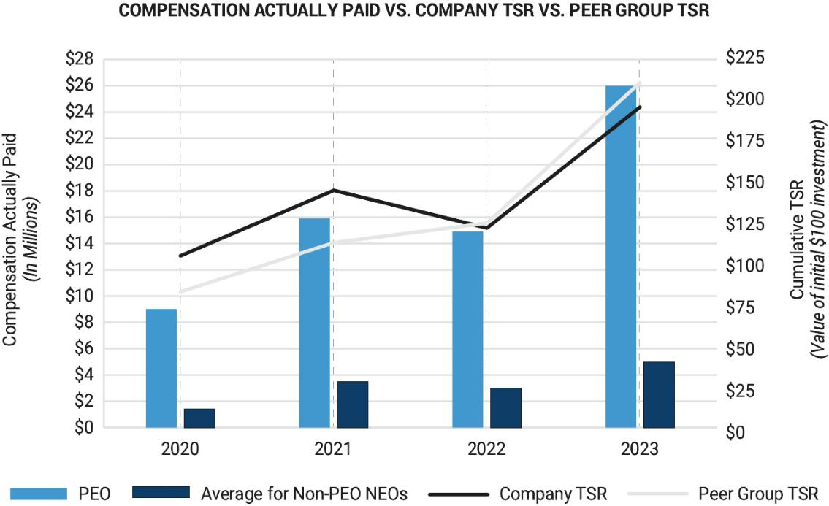

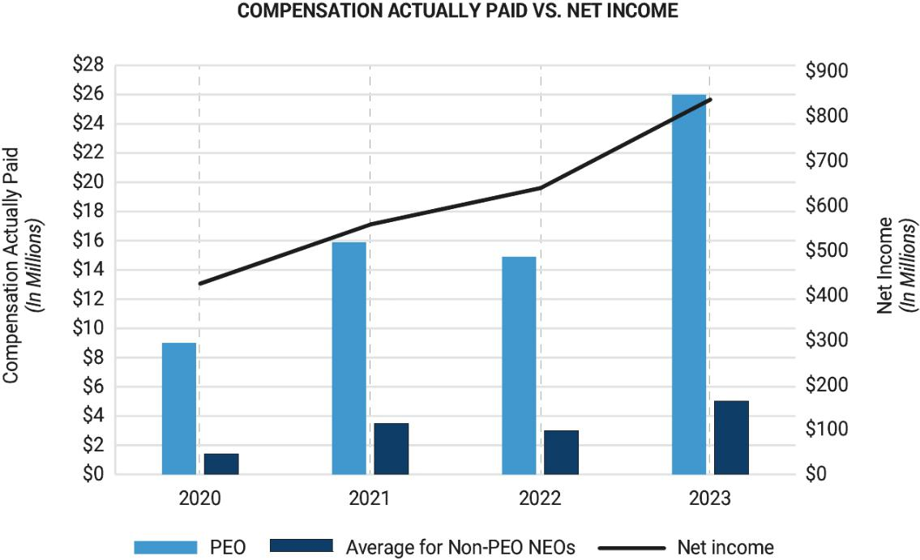

2024 Proxy Statement / | 73

TABLE OF CONTENTS

Pay Versus Performance
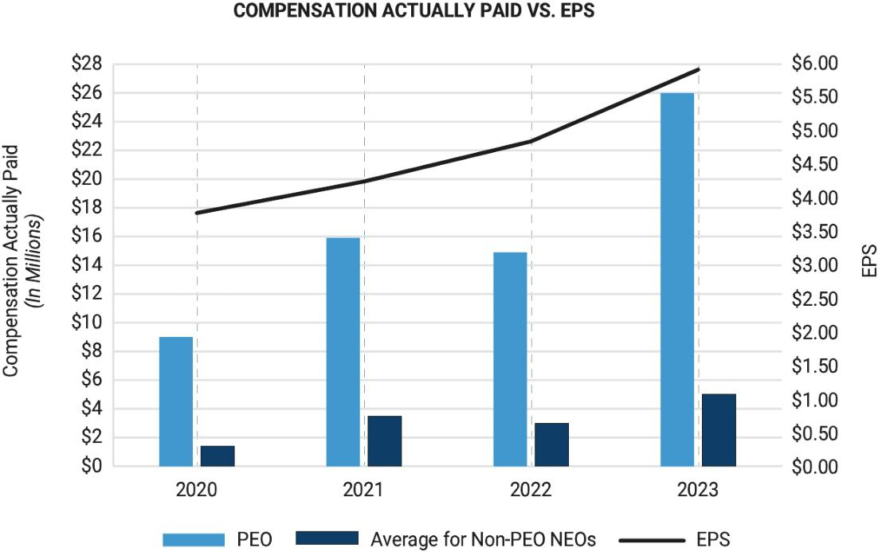

74 |  | / 2024 Proxy Statement

TABLE OF CONTENTS

 | Proposal | Ratify Independent Registered Public
 | 3 | Accounting Firm

The Audit Committee has appointed Ernst & Young LLP as the independent registered public accounting firm to audit our financial statements for the fiscal year ending December 31, 2024. Although you are not required to ratify this appointment, we ask that you do. If you do not, the Audit Committee will take the vote into consideration when determining whether or not to retain Ernst & Young LLP. Ernst & Young LLP served as our independent registered public accounting firm for the fiscal year ended December 31, 2023. and has served as the Company’s independent registered public accounting firm since 2002. Even if the selection of Ernst & Young LLP is ratified by stockholders, the Audit Committee in its discretion may select a different independent registered public accounting firm at any time during the year if it determines that such a change would be in the best interests of the Company and its stockholders.

A representative of Ernst & Young LLP is expected to be present at the Annual Meeting to answer appropriate questions and make a statement if the representative so desires.

Vote Required

This proposal is adopted if a majority of the shares present in person or by proxy vote for the proposal. Because the total shares voted “for,” “against,” or “abstain” are counted to determine the minimum votes required for approval, if you abstain from voting, it has the same legal effect as if you vote against. If a broker limits the number of shares voted on the proposal on its proxy card or indicates that the shares represented by the proxy card are not being voted on the proposal, it is considered a broker non-vote. Broker non-votes are not counted as a vote or used to determine the favorable votes required to approve the proposal.


The Board recommends you vote FOR this proposal.

2024 Proxy Statement / | 75

TABLE OF CONTENTS

Proposal 3: Ratify Independent Registered Public Accounting Firm

Audit Matters

Fees to the Independent Registered Public Accounting Firm

The following table shows the aggregate fees for services provided by Ernst & Young LLP for the fiscal years ended

December 31, 2023 and December 31, 2022:

 | ​ | ​ |  | 2023​ |  | ​ |  | 2022
Audit Fees | ​ | ​ | $8,483,014​ |  |  | ​ | $8,151,652
Audit-Related Fees | ​ | ​ | $ | 530,467​ | ​ | ​ | $ | 115,247
Tax Fees | ​ | ​ | $ | 460,914​ | ​ | ​ | $ | 93,676
All Other Fees | ​ | ​ | $ | 0​​ |  | ​ | $ | 0
Total Fees | ​ | ​ | $​9,474,395​ |  |  | ​ | $8,360,575

Audit Fees

Audit fees include fees for audit services in connection with Wabtec’s annual financial statements, including the audit of internal control over financial reporting, the reviews of Wabtec’s quarterly reports on Form 10-Q, comfort letters, consents, and other services relating to Securities and Exchange Commission filings and statutory audits required internationally.

Audit-Related Fees

Audit-related fees include fees for services performed within the respective year primarily related to due diligence in connection with mergers and acquisitions and non-financial statement audits.

Tax Fees

Tax fees include fees for services related to tax compliance, including tax return preparation, tax advice and tax planning.

All Other Fees

This category includes the aggregate fees billed for products and services provided by the independent accountants that are not reported above under “Audit Fees,” “Audit-Related Fees,” or “Tax Fees.” The Audit Committee considered the compatibility of the non-audit-related services provided by and fees paid to Ernst & Young LLP in 2023 and determined that such services and fees are compatible with the independence of Ernst & Young LLP.

Audit Committee Pre-Approval Policies and Procedures

The Audit Committee is responsible for the appointment, compensation and oversight of the work of the independent registered public accounting firm. As part of this responsibility, the Audit Committee is required to pre-approve the audit and non-audit services performed by the independent registered public accounting firm to assure that the provision of such services does not impair the independent registered public accounting firm’s independence.

The annual audit services engagement terms and fees are subject to the specific pre-approval of the Audit Committee. All other permitted services, including those described under “Fees to the Independent Registered Public Accounting Firm” above are also pre-approved by the Audit Committee.

The Audit Committee has delegated its pre-approval authority to its Chair if the fee to be approved does not exceed $500,000 as well as adjustments to any general pre-approval fee threshold up to $50,000. All services provided by Ernst & Young LLP for fiscal year 2023 were pre-approved by the Audit Committee.

76 |  | / 2024 Proxy Statement

TABLE OF CONTENTS

Proposal 3: Ratify Independent Registered Public Accounting Firm

Audit Committee Report

The Audit Committee is responsible for reviewing the Company’s financial reporting process on behalf of the Board of Directors. Management of the Company has the primary responsibility for the financial statements and the reporting process, including the system of internal controls. In the performance of its oversight function, the Audit Committee meets with management periodically to consider the adequacy of the Company’s internal controls and the objectivity of its financial reporting. The Audit Committee meets privately with the independent registered public accountants, who have unrestricted access to the Audit Committee. Specifically, the Audit Committee has reviewed and discussed with management and the independent registered public accountants the Company’s consolidated financial statements as of and for the fiscal year ended December 31, 2023.

The Audit Committee has also discussed with the independent registered public accountants the matters required to be discussed by the applicable requirements of the Public Company Accounting Oversight Board and the Securities and Exchange Commission.

Furthermore, the Audit Committee received and reviewed the written disclosures and the letter from the independent registered public accountants required by applicable requirements of the Public Company Accounting Oversight Board regarding the independent accountant’s communications with the Audit Committee concerning independence and have discussed with the independent registered public accountants their independence.

Based on the review and discussions referred to above, the Audit Committee recommended to the Board of Directors that Wabtec’s audited financial statements, as of and for the fiscal year ended December 31, 2023, be included in the Company’s Annual Report on Form 10-K, for the year ended December 31, 2023, to be filed with the Securities and Exchange Commission.

Respectfully submitted,

The Audit Committee

Brian P. Hehir (Chair)

Beverley A. Babcock

Byron S. Foster

Linda A. Harty

2024 Proxy Statement / | 77

TABLE OF CONTENTS

Common Stock Ownership

Director and Executive Officer Stock Ownership

Under the proxy rules of the SEC, a person beneficially owns Wabtec common stock if the person has the power to vote or dispose of the shares, or if such power may be acquired, by exercising options or otherwise, within 60 days. The table below shows the number of shares of Wabtec common stock beneficially owned as of January 31, 2024 by our directors, nominees for director, Chief Executive Officer, Chief Financial Officer and the other named executive officers, and the directors and executive officers as a group. Each person has sole voting power and sole dispositive power with respect to the shares listed unless indicated otherwise. No directors or executive officers have pledged shares of Wabtec common stock.

Named Executive Officer ​ ​ Shares Owned​ ​ Percent of Class

Rafael Santana | ​ | ​ | ​165,216⁽¹⁾⁽²⁾​ | ​
John Olin | ​ | ​ | ​ 39,014⁽¹⁾​ | ​
David L. DeNinno | ​ | ​ | ​ _{91,493}(1)(2)​ | ​
Pascal Schweitzer | ​ | ​ | ​ _{29,845}(1)(2)​ | ​
Eric Gebhardt | ​ | ​ | ​ _{24,788}(1)(2)​ | ​

*

*

*

*

*

Director/Nominee ​ ​ Shares Owned​ ​ Percent of Class

Beverley​ | A. Babcock | ​ | ​ |  | 1,857⁽⁵⁾​ | ​
Lee C. Banks |  | ​ | ​ | ​ | 10,715⁽¹⁾​ | ​
Byron S. Foster |  | ​ | ​ |  | 5,336⁽¹⁾​ | ​
Linda A. Harty |  | ​ | ​ | ​ | 11,869⁽¹⁾​ | ​
Brian P. Hehir |  | ​ | ​ | ​ _{32,735}(1)(3)​ |  | ​
William E. Kassling |  | ​ | ​ | ​ 753,279⁽¹⁾⁽⁴⁾​ |  | ​
Ann R. Klee |  | ​ | ​ |  | 9,691⁽¹⁾​ | ​
Albert J. Neupaver |  | ​ | ​ | ​ 678,104⁽¹⁾⁽²⁾​ |  | ​
Directors and Executive Officers as a Group (24 persons) |  | ​ | ​ | ​1,999,717⁽¹⁾⁽²⁾​ |  | ​

*

*

*

*

*

*

*

*

1​.1%

- Less than 1%. Note that all Percent of Class calculations are based on the issued and outstanding shares of Wabtec common stock as of the March 20, 2024 record date.

- Includes restricted shares as follows: Mr. Santana – 74,608; Mr. Olin – 26,464, Mr. DeNinno – 10,659; Mr. Schweitzer – 4,256, and Mr.Gebhardt – 21, 513. Each other non-employee director held 1,857 restricted shares, and all directors and executive officers as a group – 196,052. The restricted stockholders have sole voting power with respect to the restricted shares but do not have sole or shared dispositive power until the restricted shares vest.

- Includes options that are exercisable on or within 60 days of January 31, 2023 as follows: Mr. Santana – 68,833; Mr. DeNinno – 25,958; Mr. Schweitzer – 7,716; Mr. Gebhardt – 3,275; and Mr. Neupaver – 82,692; and all directors and executive officers as a group – 211,988.

- Includes 28,535 shares owned by Mr Hehir. Also includes 4,200 shares held by the Brian P. Hehir and Janet S. Hehir Foundation for which Mr. Hehir serves as a trustee.

- Includes 78,345 shares owned by Mr. Kassling. Also includes 671,654 shares owned by Davideco, a Delaware corporation, and 3,280 shares owned by Mr. Kassling’s wife. Mr. Kassling disclaims beneficial ownership of the shares held by his wife.
- Does not include 1,550 shares which have been deferred.

78 |  | / 2024 Proxy Statement

TABLE OF CONTENTS

Common Stock Ownership

Security Ownership of Certain Beneficial Owners

The following table shows stockholders who are known to Wabtec to be beneficial owners of more than 5% of Wabtec’s common stock as of March 20, 2024.

Name and Address of Beneficial Owner |  |  | ​ | ​ | Beneficial Ownership¹​ | ​ | Percentage of Class
​The Vanguard Group
100 Vanguard Boulevard |  |  | ​ | ​ | ​ | ​
Malvern, PA 19355 |  |  |  |  | ​20,014,239 |  | ​11.1%
BlackRock,​ |  | Inc.
50 Hudson Yards |  |  | ​ | ​ | ​ | ​
New York, NY 10001 |  |  |  |  | 12,015,588 |  | 6.7%
Wellington​ | Management Group, LLP
280 Congress Street |  |  | ​ | ​ | ​ | ​
Boston, MA 02210 |  |  |  |  | 9,760,215 |  | 5.4%
T. Rowe Price Associates, Inc.
100 E. Pratt Street |  |  | ​ | ​ | ​ | ​
Baltimore, MD 21202 |  |  |  |  | 9,026,373 |  | 5%

- Under SEC regulations, a person who has or shares voting or investment power with respect to a security is considered a beneficial owner of the security. Voting power is the power to vote or direct the voting of shares, and investment power is the power to dispose of or direct the disposition of shares. Unless otherwise indicated in the other footnotes below, each person has sole voting power and sole investment power as to all shares listed opposite such person’s name.

- Based solely upon the Schedule 13G/A filed February 13, 2024, The Vanguard Group has sole dispositive power with respect to 19,258,382 shares, shared dispositive power with respect to 755,857 shares, and shared voting power with respect to 224,923 shares, and sole voting power with respect to zero shares.

- Based solely upon the Schedule 13G/A filed February 6, 2024, Blackrock, Inc. has sole dispositive power with respect to 12,015,588 shares, sole voting power with respect to 10,641,948 shares, and shared voting or dispositive power with respect to zero shares.

- Based solely upon the Schedule 13G/A filed February 8, 2024, Wellington Management Group LLP has shared dispositive power with respect to 9,760,215 shares, shared voting power with respect to 8,493,434 shares, and sole voting or dispositive power with respect to zero shares.

- Based solely upon the Schedule 13G/A filed February 14, 2024, T Rowe Price Associates, Inc. has sole voting power with respect to 4,590,180 shares, sole dispositive power with respect to 9,024,635 shares and shared voting or dispositive power with respect to zero shares.

2024 Proxy Statement / | 79

TABLE OF CONTENTS

Questions and Answers Relating to the Annual Meeting

Questions and Answers Relating to the Annual Meeting

We have provided you this booklet and proxy materials on or about April 4, 2024 because the Board of Directors of the Company is soliciting your proxy to vote at the Company’s 2024 Annual Meeting of stockholders.

Who is entitled to vote?

Holders of our common stock as of the close of business on March 20, 2024, the record date for this Annual Meeting (the “Record Date”), may vote at the Annual Meeting. As of the Record Date, there were 176,822,250 shares of our common stock outstanding. Stockholders are not permitted to cumulate votes with respect to the election of directors. Each share of common stock is entitled to one vote for each director nominee and on each proposal.

Registered Stockholders . If shares of our common stock are registered directly in your name with our transfer agent, you are considered a “registered stockholder” with respect to those shares and the Notice was provided to you directly by us. As the registered stockholder, you have the right to grant your voting proxy directly to the individuals listed on the proxy card or to vote live at the Annual Meeting.

Beneficial Owners. If you hold shares of our common stock in a brokerage account or by a bank or other nominee, you are considered to be the “beneficial owner” of shares that are held in “street name,” and the Notice was forwarded to you by your broker or nominee, who is considered the registered stockholder with respect to those shares. As the beneficial owner, you have the right to direct your broker, bank or other nominee as to how to vote your shares. Beneficial owners are also invited to attend the Annual Meeting. However, since a beneficial owner is not the stockholder of record, you may not vote your shares of our common stock live at the Annual Meeting unless you follow your broker’s procedures for obtaining a legal proxy. If you request a printed copy of our proxy materials by mail, your broker, bank or other nominee will provide a voting instruction form for you to use.

What do I need to be able to attend the Annual Meeting online?

We will be hosting our Annual Meeting via live webcast only. Any stockholder can attend the Annual Meeting live online at www.virtualshareholdermeeting.com/WAB2024. The webcast will open at 11:15 a.m. Eastern Time on May 16, 2024, and the meeting will start shortly thereafter at 11:30 a.m. Eastern Time. Stockholders may vote and ask questions while attending the Annual Meeting online. In order to be able to attend the Annual Meeting, you will need the 16-digit control number, which is located on your Notice or proxy card (if you received a printed copy of the proxy materials).

How many votes are needed for approval of each proposal?

Proposal 1. As required by Wabtec’s amended and restated by-laws, each director is to be elected by a majority of votes cast with respect to that director’s election. Each stockholder will have one vote per share to vote for each Director nominee.

Proposal 2: The approval of Proposal 2 requires a favorable vote of a majority of the shares present and entitled to vote on the Proposal.

Proposal 3: The approval of Proposal 3 requires a favorable vote of a majority of the shares present and entitled to vote on the Proposal.

80 |  | / 2024 Proxy Statement

TABLE OF CONTENTS

Questions and Answers Relating to the Annual Meeting

Approval of any other matter that properly comes before the Annual Meeting requires the favorable vote of a majority of shares present and entitled to vote on the matter unless the matter requires more than a majority vote under statute or our amended and restated by-laws. We do not expect any business to come before the Annual Meeting other than the proposals described in this Proxy Statement.

Abstentions and broker non-votes are not counted for purposes of the election of directors. For all other matters, an abstention will have the same effect as a vote against the proposal.

If your shares are held by a broker, the broker will ask you how you want your shares to be voted. If you give the broker instructions, your shares will be voted as you direct. If you do not give instructions, one of two things can happen, depending on the type of proposal. For the ratification of the independent auditor (Proposal 3), the broker may vote your shares in its discretion. For all other proposals, the broker may not vote your shares at all if you do not give instructions, and such broker non-votes will have no effect on the outcome of the vote with respect to such proposals.

What is the quorum requirement?

A quorum is the minimum number of shares required to be present at the Annual Meeting to properly hold an annual meeting of stockholders and conduct business under our amended and restated by-laws and Delaware law. The presence, in person at the virtual meeting or by proxy, of a majority of the issued and outstanding shares of our common stock entitled to vote on the Record Date will constitute a quorum at the Annual Meeting. Abstentions and broker non-votes are counted as shares present and entitled to vote for purposes of determining a quorum. As of the Record Date, March 20, 2024, we had 176,822,250 shares outstanding.

How do I vote?

If you are a registered stockholder, there are four ways to vote:

​ ​ (1)​ ​

​ ​ (2)​ ​

​ ​ (3)​ ​

​ ​ (4)​ ​

By Internet (Before the Annual Meeting): You may vote over the Internet at www.proxyvote.com, 24 hours a day, seven days a week, until 11:59 p.m. Eastern Time on May 15, 2024 or until 11:59 p.m. Eastern Time on May 13, 2024 if you hold your shares in a Plan. You will need the 16-digit control number included on your Notice or proxy card (if you received a printed copy of the proxy materials);

By Telephone: You may vote by toll-free telephone at 1-800-690-6903, until 11:59 p.m. Eastern Time on May 15, 2024 or until 11:59 p.m. Eastern Time on May 13, 2024 if you hold your shares in a Plan. You will need the 16-digit control number included on your Notice or proxy card (if you received a printed copy of the proxy materials);

By Mail: If you received printed proxy materials, you may submit your vote by completing, signing and dating each proxy card received and returning it promptly in the postage-paid envelope we have provided. Proxies submitted by U.S. mail must be received before the start of the Annual Meeting; or

By Internet (During the Annual Meeting): You may vote during the Annual Meeting by going to www.virtualshareholdermeeting.com/WAB2024. You will need the 16-digit control number included on your Notice or proxy card (if you received a printed copy of the proxy materials). If you previously voted via the Internet (or by telephone or mail), you will not limit your right to vote online at the Annual Meeting.

If you are a beneficial owner, please follow the instructions from your broker, bank or other nominee to vote by Internet, telephone or mail. Beneficial owners may not vote via the Internet at the Annual Meeting unless they receive a legal proxy from their respective brokers, banks or other nominees.

2024 Proxy Statement / | 81

TABLE OF CONTENTS

Questions and Answers Relating to the Annual Meeting

Can I change my vote?

Yes. If you are a registered stockholder, you can change your vote or revoke your proxy any time before the Annual Meeting by:

- notifying our Corporate Secretary, in writing, at Wabtec Corporation, 30 Isabella Street, Pittsburgh, PA 15212;

- voting again using the telephone or Internet before 11:59 p.m. Eastern Time on May 15, 2024 or before 11:59 p.m. Eastern Time on May 13, 2024 if you hold your shares in a Plan (your latest telephone or Internet proxy is the one that will be counted); or

- attending the virtual Annual Meeting and voting with the ballot provided in the virtual meeting portal. Simply logging into the Annual Meeting online will not, by itself, revoke your proxy.

If you are a beneficial owner, you may revoke any prior voting instructions by contacting your broker, bank or nominee.

What is the effect of giving a proxy?

Proxies are solicited by and on behalf of our Board. Mr. Neupaver and Mr. DeNinno have been designated as proxy holders by our Board. When proxies are properly dated, executed and returned, the shares represented by such proxies will be voted at the Annual Meeting in accordance with the instructions of the stockholder. If no specific instructions are given, however, the shares will be voted in accordance with the recommendations of our Board as described above. If any matters not described in this Proxy Statement are properly presented at the Annual Meeting, the proxy holders will use their own judgment to determine how to vote the shares. If the Annual Meeting is adjourned, the proxy holders can vote the shares on the new Annual Meeting date as well, unless you have properly revoked your proxy instructions, as described above.

What is the effect of abstentions and broker non-votes?

A “broker non-vote” occurs where a broker has not received voting instructions from the beneficial owner and for which the broker does not have discretionary power to vote on a particular matter. Brokerage firms and other intermediaries holding shares of our common stock in street name for their customers are generally required to vote such shares in the manner directed by their customers. In the absence of timely directions, your broker will have discretion to vote your shares on our sole “routine” matter, the proposal to ratify the appointment of Ernst & Young LLP as our independent registered public accounting firm for our fiscal year ending December 31, 2024. Absent direction from you, your broker will not have discretion to vote on Proposal 1 (election of directors) or Proposal 2 (Say-On-Pay Advisory Vote), which are “non-routine” matters.

Abstentions and broker non-votes are counted as shares present and entitled to vote for purposes of determining a quorum.

With regards to Proposal 1 (election of directors), abstentions and broker non-votes are not considered votes cast and will have no effect on the outcome of the vote.

For Proposal 2 and Proposal 3, an abstention will have the same effect as a vote against each applicable proposal. For Proposal 2 and Proposal 3 broker non-votes will have no effect on the outcome of the vote with respect to each Proposal.

Why did I receive a Notice of Internet Availability of Proxy Materials instead of a full set of proxy materials?

In accordance with the rules of the U.S. Securities and Exchange Commission (the “SEC”), we have elected to furnish our proxy materials, including this Proxy Statement and our 2023 Annual Report, primarily via the Internet. On April 4, 2024, we mailed to our stockholders a Notice that contains instructions on how to access our proxy materials on the Internet, how to vote at the meeting and how to request printed copies of the proxy materials and 2023 Annual Report. Stockholders may request to receive all future proxy materials in printed form by mail or electronically by e-mail by following the instructions contained in the Notice. We encourage stockholders to take advantage of the availability of our proxy materials on the Internet to help reduce the environmental impact and cost of our annual meetings of stockholders.

82 |  | / 2024 Proxy Statement

TABLE OF CONTENTS

Questions and Answers Relating to the Annual Meeting

Where can I find the voting results of the Annual Meeting?

We will announce preliminary voting results at the Annual Meeting. We will also disclose voting results on a Current Report on Form 8-K that we will file with the SEC within four business days after the Annual Meeting. If final voting results are not available to us in time to file a Current Report on Form 8-K within four business days after the Annual Meeting, we will provide preliminary voting results in the Current Report on Form 8-K and will provide the final results in an amendment to the Current Report on Form 8-K as soon as they become available.

Why is the Annual Meeting being held virtually?

The Annual Meeting will be held entirely online this year. We have embraced the latest technology to provide ease of access, real-time communication and cost savings for our stockholders and our Company. Hosting a virtual meeting provides easy access for our stockholders and facilitates participation because stockholders can participate from any location around the world.

How are proxies solicited for the Annual Meeting?

Our Board is soliciting proxies for use at the Annual Meeting. All expenses associated with this solicitation will be borne by us. We will reimburse brokers or other nominees for reasonable expenses that they incur in sending our proxy materials to you if a broker, bank or other nominee holds shares of our common stock on your behalf. In addition, our directors and employees may also solicit proxies in person, by telephone or by other means of communication. Our directors and employees will not be paid any additional compensation for soliciting proxies.

How does the Board recommend that you vote your shares?

The Board recommends that you vote:

FOR PROPOSAL 1

FOR PROPOSAL 2

FOR PROPOSAL 3

​ ​

​ ​

​ ​

ELECTION OF LINDA A. HARTY, BRIAN P. HEHIR, AND BEVERLEY A. BABCOCK

APPROVAL OF AN ADVISORY (NON-BINDING) RESOLUTION TO APPROVE THE 2023 NAMED EXECUTIVE OFFICER COMPENSATION

RATIFY THE APPOINTMENT OF ERNST & YOUNG LLP AS OUR INDEPENDENT REGISTERED PUBLIC ACCOUNTING FIRM FOR THE 2024 FISCAL YEAR

Householding

The SEC has adopted rules that permit companies and intermediaries such as brokers to satisfy delivery requirements for Notices and other proxy materials with respect to two or more stockholders sharing the same address by delivering a single Notice and set of proxy materials addressed to those stockholders. This process, which is commonly referred to as “householding,” potentially provides extra convenience for stockholders and cost savings for companies. We and some brokers household proxy materials, delivering a single copy of our Notice and proxy materials to multiple stockholders sharing an address unless contrary instructions have been received from the affected stockholders. Once stockholders have received notice from their broker or us that materials will be sent in the householding manner to the stockholder’s address, householding will continue until we or the broker are otherwise notified or until the stockholder revokes such consent. If, at any time, (i) stockholders sharing an address and receiving multiple copies of our Notice and other proxy materials wish to opt in to householding and receive a single copy of our proxy materials or (ii) stockholders no longer wish to participate in householding and would prefer to receive a separate Notice or other proxy materials in the future, they should notify their broker if shares are held in a brokerage account; if holding registered shares, they should call (866) 540-7095 or write to the following address: 51 Mercedes Way, Edgewood, NY 11717 .

Any beneficial owner who has received a single copy of a Notice or other proxy materials at a shared address can request to receive a separate copy of such materials for this 2024 Annual Meeting by written or oral request and we will promptly deliver a separate copy in the format requested. To receive separate copies of those materials for this or for future meetings, please request by telephone, internet, e-mail or mail by following the instructions found on the Notice that you have received or by making your request in writing to your broker or to us, as appropriate.

2024 Proxy Statement / | 83

TABLE OF CONTENTS

Questions and Answers Relating to the Annual Meeting

Other Business

We do not expect any business to come before the Annual Meeting other than the proposals described in this Proxy Statement. If other business is properly raised, your proxy authorizes its holder to vote according to their best judgment.

Expenses of Solicitation

Officers and employees may solicit proxies in person by telephone or facsimile. Wabtec pays no costs for proxy solicitation to any third party. Wabtec will pay approximately $50,000 to Broadridge Financial Solutions, Inc. (exclusive of mailing fees) for sending the Notice, providing the Internet site for our proxy materials and providing proxy materials to any stockholder who requests them. We will also reimburse other nominees, custodians or fiduciaries who forward these materials to stockholders for their reasonable expenses in doing so.

How to Submit Stockholder Proposals and Nominations for Next Year?

To be included in the proxy for the 2025 annual meeting, stockholder proposals must be submitted by December 5, 2024. Only proposals submitted on time may be eligible for inclusion in our Proxy Statement.

Our amended and restated by-laws require that notice of business to be properly brought before the 2025 Annual Meeting of stockholders must be submitted to us between January 4, 2025 and February 3, 2025. Only matters for which we receive timely notice and in accordance with our amended and restated by-laws may be brought before the 2025 Annual Meeting.

The Governance Committee will consider director nominees recommended by stockholders. Stockholders wishing to recommend a director candidate for consideration by the Governance Committee can do so by writing the Secretary of Wabtec at 30 Isabella Street, Pittsburgh, PA 15212 and providing the information required under our amended and restated by-laws, including, but not limited to the candidate’s name, biographical data and qualifications. Any such recommendation should be accompanied by a written statement from the individual of their consent to be named as a candidate and, if nominated and elected, to serve as a director. No candidates for Board membership have been put forward by stockholders for election at the 2024 Annual Meeting of stockholders.

Our amended and restated by-laws require that for a stockholder to recommend a director nominee, notice in writing must be delivered to the Secretary of Wabtec no later than the 60th day and no earlier than the 90th day prior to the first anniversary of the previous year’s annual meeting proxy statement. Our amended and restated by-laws also permit a stockholder, or a group of up to 20 stockholders, that has owned at least three percent of our outstanding Common Stock continuously for at least three years to nominate and include in our proxy statement candidates for our Board, subject to certain requirements set forth in our amended and restated by-laws. Each stockholder, or group of stockholders, may nominate candidates for director, up to a limit of the greater of two or 20 percent of the number of directors on the Board. Any nominee must meet the qualification standards listed in our amended and restated by-laws.

An eligible stockholder, or eligible group of stockholders, that wants to nominate a candidate for election to the Board pursuant to the proxy access provisions of our amended and restated by-laws must follow the procedures stated in Article II, Section 10 of our amended and restated by-laws. These procedures include the requirement that your nomination must be delivered to Wabtec’s Secretary not later than the close of business on the 120th day or earlier than the close of business on the 150th day prior to the first anniversary of the preceding year’s annual meeting. If the date of the annual meeting is more than 30 days before or more than 60 days after such anniversary date, your notice must be delivered not later than the 120th day prior to such annual meeting or, if later, the 10th day following the day we publicly announce the date of the 2025 annual meeting of stockholders.

In addition to satisfying the foregoing requirements under amended and restated by-laws, to comply with the universal proxy rules, stockholders who intend to solicit proxies in support of director nominees other than Wabtec’s nominees must provide notice that sets forth the information required by Rule 14a-19 under the Exchange Act (including a statement that such stockholder intends to solicit the holders of shares representing at least 67% of the voting power of the Company’s shares entitled to vote on the election of directors in support of director nominees other than Wabtec’s nominees), which notice must be postmarked or transmitted electronically to Wabtec at its principal executive offices no later than 60 calendar days prior to the anniversary date of the 2024 Annual Meeting (for the 2025 Annual Meeting, no later than March 18, 2025). However, if the date of the 2025 Annual Meeting is changed by more than 30 calendar days from such anniversary date, then notice must be provided by the later of 60 calendar days prior to the date of the 2025 Annual Meeting or the 10th calendar day following the day on which public announcement of the date of the 2025 Annual Meeting is first made by Wabtec.

Stockholders are urged to review all applicable rules and consult legal counsel before submitting a nomination or proposal to Wabtec.

84 |  | / 2024 Proxy Statement

TABLE OF CONTENTS

Appendix

Set forth below is the calculation of the non-GAAP performance measures included in this proxy statement. We believe that these measures provide useful supplemental information to assess our operating performance and to evaluate period-to-period comparisons. Non-GAAP financial measures should be viewed in addition to, and not as an alternative for, Wabtec’s reported results prepared in accordance with GAAP. Non-GAAP financial measures have inherent material limitations as performance measures because they add back certain expenses incurred by us to GAAP financial measures, resulting in those expenses not being taken into account in the applicable non-GAAP financial measure. Because not all companies use identical calculations, our presentation of non- GAAP financial measures may not be comparable to other similarly titled measures of other companies.

Wabtec Corporation Reconciliation of Reported Results to Adjusted Results

 |  | ​ | ​ |  |  |  |  |  |  |  |  |  |  |  |  | 2023 Actual Results
 |  |  |  |  |  |  |  |  |  |  |  |  |  |  |  | Interest
 | ($ in millions) | ​ | ​ |  | Net ​ |  | ​ | Gross​ |  | ​ | Operating​ |  | ​ | ^{Income}_{from}​ | ​ | Other&​ |  | ​ | ​ | ​ |  | Net​ ​ Noncontrolling​ |  |  |  |  | ​ | ^{Wabtec}_{Net}​ |  |  | ​ |  | EPS
 | ($ in millions) |  |  |  | Sales |  |  | Profit |  |  | Expenses |  |  | Operations |  | Exp |  |  | Tax |  | Income |  |  |  | Interest |  |  | income |  |  |  |  | EPS
 | Reported Results | ​ | ​ |  | $9,677​ |  | ​ | $2,944​ |  | ​ | $(1,678)​ |  | ​ | $1,266​ | ​ | $(174)​ |  | ​ | $(267)​ | ​ | $ | 825​ |  | ​ | $(10)​ |  | ​ | $ | 815​ |  | ​ | $ | 4.53
 | Restructuring and
 | Portfolio Optimization | ​ | ​ |  |  | ​ | ​ |  | ​ | ​ |  | ​ | ​ | ​ | ​ |  | ​ | ​ | ​ | ​ |  |  | ​ | ​ |  | ​ | ​ |  |  | ​ | ​
 | costs |  |  |  | — |  |  | 38 |  |  | 41 |  |  | 79 |  | — |  |  | (17) |  |  | 62 |  |  | — |  |  |  | 62 |  |  | $ | 0.34
 | Gain on LKZ Investment ​ |  | ​ |  | —​ |  | ​ | —​ |  | ​ | —​ |  | ​ | —​ | ​ | (35)​ |  | ​ | —​ | ​ |  | (35)​ |  | ​ | —​ |  | ​ |  | (35)​ |  | ​ | $ (0.19)
 | Non-cash Amortization | ​ | ​ |  | — | ​ | ​ | — | ​ | ​ | 298 | ​ | ​ | ​ | ​ | — | ​ | ​ | ​ | ​ |  | 224 | ​ | ​ | — | ​ | ​ |  | 224 | ​ | ​ | $ | 1.24
 | expense |  |  |  | — |  |  | — |  |  | 298 |  |  | 298 |  | — |  |  | (74) |  |  | 224 |  |  | — |  |  |  | 224 |  |  | $ | 1.24
 | Adjusted Results | ​ | ​ |  | $9,677​ |  | ​ | $2,982​ |  | ​ | $(1,339)​ |  | ​ | $1,643​ | ​ | $(209)​ |  | ​ | $(358)​ | ​ | $1,076​ |  |  | ​ | $(10)​ |  | ​ | $1,066​ |  |  | ​ | $ | 5.92
 | Fully Diluted Shares
 | Outstanding (in | ​ | ​ |  |  | ​ | ​ |  | ​ | ​ |  | ​ | ​ | ​ | ​ |  | ​ | ​ | ​ | ​ |  |  | ​ | ​ |  | ​ | ​ |  |  | ​ | ​
 | millions) |  |  |  |  |  |  |  |  |  |  |  |  |  |  |  |  |  |  |  |  |  |  |  |  |  |  |  |  |  |  | 179.5
 | Reported EBIT Margin | ​ | ​ |  |  | ​ | ​ |  | ​ | ​ |  | ​ | ​ | ​ | ​ |  | ​ | ​ | ​ | ​ |  |  | ​ | ​ |  | ​ | ​ |  |  | ​ | ​ | 13.1%
 | Adjusted Operating | ​ | ​ |  |  | ​ | ​ |  | ​ | ​ |  | ​ | ​ | ​ | ​ |  | ​ | ​ | ​ | ​ |  |  | ​ | ​ |  | ​ | ​ |  |  | ​ | ​ | 17.0%
 | Margin
 |  |  |  |  |  |  |  |  |  |  |  |  |  |  |  |  |  |  | 2024 Proxy Statement |  |  |  |  |  | / |  |  |  |  |  |  |  | A-1

TABLE OF CONTENTS
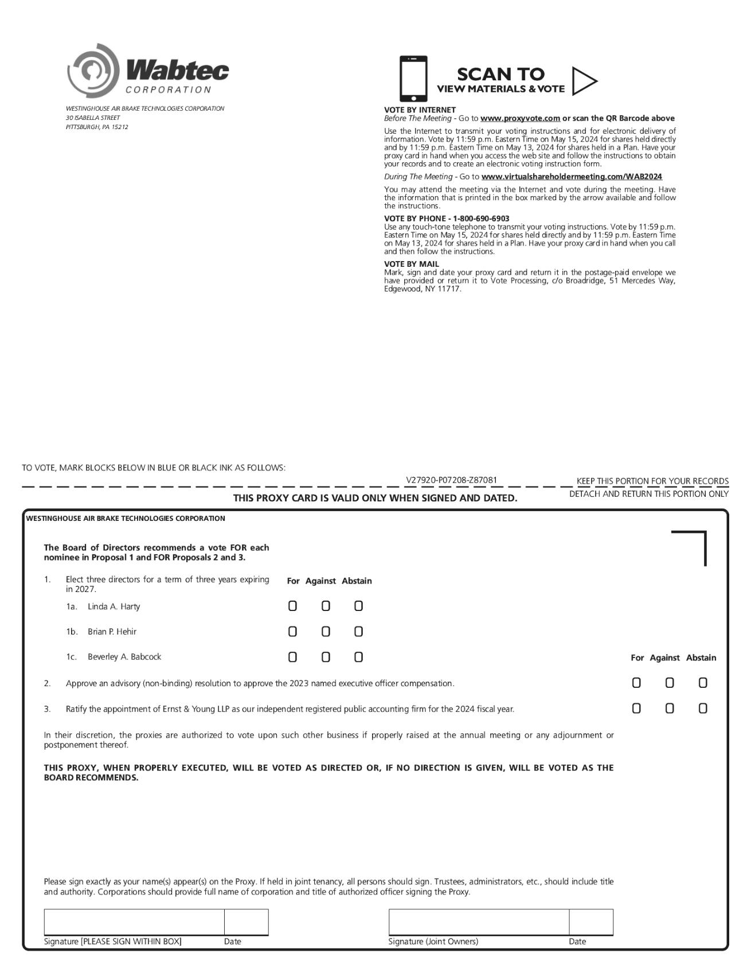

TABLE OF CONTENTS


