UNITED STATES
SECURITIES AND EXCHANGE COMMISSION
WASHINGTON, D.C. 20549
____________________________________
FORM 8-K
____________________________________
CURRENT REPORT
PURSUANT TO SECTION 13 OR 15(D)
OF THE SECURITIES EXCHANGE ACT OF 1934
Date of Report (Date of Earliest Event Reported): October 21, 2026
____________________________________
WESTINGHOUSE AIR BRAKE TECHNOLOGIES
CORPORATION
(Exact name of registrant as specified in its charter)
____________________________________
Delaware
(State or other jurisdiction
of incorporation or organization)
033-90866 |  |  |  |  |  |  |  |  | 25-1615902
(Commission  File No.) |  |  |  |  |  |  |  |  | (I.R.S. Employer  Identification No.)
30 Isabella Street |  |  |  |  |  |  |  |  | 15212
Pittsburgh, PA |  |  |  |  |  |  |  |  | (Zip code)
(Address of principal executive offices)
412-825-1000
(Registrant’s telephone number, including area code)
Not Applicable
(Former name or former address, if changed since last report)
____________________________________
Check the appropriate box below if the Form 8-K filing is intended to simultaneously satisfy the filing obligation of the registrant under any of the following provisions (see General Instruction A.2.):
☐ |  |  | Written communications pursuant to Rule 425 under the Securities Act (17 CFR 230.425)
☐ |  |  | Soliciting material pursuant to Rule 14a-12 under the Exchange Act (17 CFR 240.14a-12)
☐ |  |  | Pre-commencement communications pursuant to Rule 14d-2(b) under the Exchange Act (17 CFR 240.14d-2(b))
☐ |  |  | Pre-commencement communications pursuant to Rule 13e-4(c) under the Exchange Act (17 CFR 240.13e-4(c))
Securities registered pursuant to Section 12(b) of the Act:
Class |  |  | Trading Symbol(s) |  |  | Name of each exchange on which registered
Common Stock, $.01 par value per share |  |  | WAB |  |  | New York Stock Exchange
Indicate by check mark whether the registrant is an emerging growth company as defined in Rule 405 of the Securities Act of 1933 (§230.405 of this chapter) or Rule 12b-2 of the Securities Exchange Act of 1934 (§240.12b-2 of this chapter).
Emerging growth company ☐
If an emerging growth company, indicate by check mark if the registrant has elected not to use the extended transition period for complying with any new or revised financial accounting standards provided pursuant to Section 13(a) of the Exchange Act. ☐

Item 2.02 |  |  | Results of Operations and Financial Condition
On October 21, 2026, Westinghouse Air Brake Technologies Corporation (the “Company”) issued a press release reporting, among other things, the Company’s 2026 third quarter results. A copy of this press release is attached as Exhibit 99.1 to this Current Report on Form 8-K and is incorporated into this Item 2.02 by reference. The Company is also furnishing an investor presentation relating to its third quarter of 2026 (the “Presentation”), which will be used by the management team for presentations to investors and others. A copy of the Presentation is attached hereto as Exhibit 99.2 and incorporated into this Item 2.02 by reference. The Presentation is also available on the Company’s website at www.wabteccorp.com.
In accordance with General Instruction B.2 of Form 8-K, the information furnished pursuant to this Item 2.02 in this Current Report on Form 8-K, including Exhibits 99.1 and 99.2, shall not be deemed “filed” for the purposes of Section 18 of the Securities Exchange Act of 1934, as amended, or otherwise subject to the liability of that section, nor shall it be deemed incorporated by reference in any filing under the Securities Act of 1933, as amended, except as shall be expressly set forth by specific reference in such a filing.

Item 7.01. |  |  | Regulation FD Disclosure
On October 21, 2026, the Company issued a press release which, among other things, provided earnings guidance for fiscal year 2026. A copy of the press release is attached to this report as Exhibit 99.1 and the paragraph under the heading “2026 Financial Guidance” which discusses 2026 guidance is incorporated into this Item 7.01 by reference. The Company also furnished a Presentation relating to its third quarter of 2026, which is incorporated into this Item 7.01 by reference. A copy of the Presentation is attached to this report as Exhibit 99.2.
In accordance with General Instruction B.2 of Form 8-K, the information furnished pursuant to this Item 7.01 in this Current Report on Form 8-K, including Exhibits 99.1 and 99.2, shall not be deemed “filed” for the purposes of Section 18 of the Securities Exchange Act of 1934, as amended, or otherwise subject to the liability of that section, nor shall it be deemed incorporated by reference in any filing under the Securities Act of 1933, as amended, except as shall be expressly set forth by specific reference in such a filing.

Item 9.01. |  |  | Financial Statements and Exhibits
(d) Exhibits.
The following exhibits are furnished with this report on Form 8-K:
Exhibit No. |  |  | Description
99.1 |  |  | Press release dated October 21, 2026
99.2 |  |  | Wabtec Earnings Presentation, Third Quarter 2026
104 |  |  | Cover Page Interactive Data File (embedded within the Inline XBRL document)
Caution Concerning Forward-Looking Statements
This communication contains “forward-looking” statements as that term is defined in Section 27A of the Securities Act of 1933 and Section 21E of the Securities Exchange Act of 1934, as amended by the Private Securities Litigation Reform Act of 1995. All statements, other than historical facts, including statements regarding Wabtec’s plans, objectives, expectations and intentions; Wabtec’s expectations about future sales, earnings and cash conversion; Wabtec’s projected expenses and cost savings associated with its Integration 2.0 and 3.0 initiatives and its portfolio optimization; Wabtec’s 5-year outlook; Wabtec’s expectations for evolving global industry, market and macro-economic conditions and their impact on Wabtec’s business; synergies and other expected benefits from Wabtec’s acquisitions; Wabtec’s expectations for production and demand conditions; and any assumptions underlying any of the foregoing, are forward looking statements. Forward-looking statements concern future circumstances and results and other statements that are not historical facts and are sometimes identified by the words “may,” “will,” “should,” “potential,” “intend,” “expect,” “endeavor,” “seek,” “anticipate,” “estimate,” “overestimate,” “underestimate,” “believe,” “could,” “project,” “predict,” “continue,” “target” or other similar words or expressions. Forward-looking statements are based upon current plans, estimates and expectations that are subject to risks, uncertainties and assumptions. Should one or more of these risks or uncertainties materialize, or should underlying assumptions prove incorrect, actual results may vary materially from those indicated or anticipated by such forward-looking statements. The inclusion of such statements should not be regarded as a representation that such plans, estimates or expectations will be achieved. Important factors that could cause actual results to differ materially from such plans, estimates or expectations include, among others, (1) changes in general economic and/or industry specific conditions, including the impacts of significant recent shifts in trade policies (including the actual or threatened imposition of tariffs and retaliatory tariff measures) as well as tax programs, inflation, supply chain disruptions, foreign currency exchange and industry consolidation and market reactions to these factors;

(2) changes in the financial condition or operating strategies of Wabtec's customers; (3) unexpected costs, charges or expenses resulting from acquisitions and potential failure to realize synergies and other anticipated benefits of acquisitions, including as a result of integrating acquired targets into Wabtec; (4) inability to retain and hire key personnel; (5) evolving legal, regulatory and tax regimes; (6) changes in the expected timing of projects; (7) a decrease in freight or passenger rail traffic; (8) an increase in manufacturing costs; (9) actions by third parties, including government agencies; (10) the impacts of epidemics, pandemics, or similar public health crises on the global economy and, in particular, our customers, suppliers and end-markets, (11) potential disruptions, instability, and volatility in global markets as a result of global military action, acts of terrorism or armed conflict, including Russia’s invasion of Ukraine and ongoing military conflicts in the Middle East; (12) cybersecurity and data protection risks and (13) other risk factors as detailed from time to time in Wabtec’s reports filed with the SEC, including Wabtec’s annual report on Form 10-K, periodic quarterly reports on Form 10-Q, current reports on Form 8-K and other documents filed with the SEC. The foregoing list of important factors is not exclusive. Any forward-looking statements speak only as of the date of this communication. Wabtec does not undertake any obligation to update any forward-looking statements, whether as a result of new information or development, future events or otherwise, except as required by law. Readers are cautioned not to place undue reliance on any of these forward-looking statements.

SIGNATURES
Pursuant to the requirements of Securities Exchange Act of 1934, the Company has duly caused this report to be signed on its behalf by the undersigned thereunto duly authorized.
WESTINGHOUSE AIR BRAKE TECHNOLOGIES CORPORATION
By: |  |  | /s/ JOHN A. OLIN
 |  |  | John A. Olin
Executive Vice President and
Chief Financial Officer
(Duly Authorized Officer and Principal Financial Officer)
DATE: |  |  | October 21, 2026



Exhibit 99.1

Wabtec Reports Strong Third Quarter 2026 Results
Raised and Tightened Adjusted EPS Guidance

SALES |  |  |  |  |  |  |  |  | GAAP DILUTED  EARNINGS PER SHARE |  |  |  |  |  |  |  |  | ADJUSTED DILUTED  EARNINGS PER SHARE
3Q’26 |  |  | 3Q YTD ’26 |  |  |  |  |  | 3Q’26 |  |  | 3Q YTD ’26 |  |  |  |  |  | 3Q’26 |  |  | 3Q YTD ’26
$3.12B |  |  | $9.25B |  |  |  |  |  | $2.42 |  |  | $6.86 |  |  |  |  |  | $2.83 |  |  |  |  |  | $8.29
+8.1% YOY |  |  | +12.8%YOY |  |  |  |  |  | +33.7% YOY |  |  | +21.6% YOY |  |  |  |  |  | +22.0% YOY |  |  |  |  |  | +20.5% YOY

Q3 2026 HIGHLIGHTS

“Wabtec delivered another strong quarter, evidenced by sales growth, margin expansion and a 22% increase in adjusted EPS,” said Rafael Santana, Wabtec’s Chairman and CEO.
“The strength of our performance reflects our momentum across the portfolio, disciplined execution by our teams, and the continued success of our strategic actions. These actions enhance our growth profile, expand margins, and increase the earnings power of the company.
“Our teams continue to translate healthy customer demand into profitable growth while investing in technologies that will advance the future of transportation. These investments are strengthening our competitive position and reinforcing Wabtec as a leading Industrial Technology Company”
Rafael Santana Chairman and CEO

•Sales Growth of 8.1% to $3.12 Billion Driven by Both the Freight and Transit Segments

•GAAP Operating Margin at 20.0%; Adjusted Operating Margin Up 1.9 pts to 22.9%

•GAAP Earnings Per Share of $2.42, Up 33.7%; Adjusted Earnings Per Share of $2.83, Up 22.0%

•Raised and Tightened 2026 Adjusted Earnings Per Share Guidance; up 22% at the midpoint

PITTSBURGH, October 21, 2026 – Wabtec Corporation (NYSE: WAB) today reported third quarter 2026 GAAP earnings per diluted share of $2.42, up 33.7% versus the third quarter of 2025. Adjusted earnings per diluted share were $2.83, up 22.0% versus the same quarter a year ago. Third quarter sales were $3.12 billion and cash from operations was $455 million.

2026 Third Quarter Consolidated Results
Wabtec Corporation Consolidated Financial Results
$ in millions except earnings per share and percentages; margin change in percentage points (pts) |  |  | Third Quarter
 |  |  | 2026 |  |  | 2025 |  |  | Change
Net Sales |  |  | $3,120 |  |  | $2,886 |  |  | 8.1 |  | %
GAAP Gross Margin |  |  | 37.3 |  | % | 34.7 |  | % | 2.6 pts
Adjusted Gross Margin |  |  | 37.4 |  | % | 35.6 |  | % | 1.8 pts
GAAP Operating Margin |  |  | 20.0 |  | % | 17.0 |  | % | 3.0 pts
Adjusted Operating Margin |  |  | 22.9 |  | % | 21.0 |  | % | 1.9 pts
GAAP Diluted EPS |  |  | $2.42 |  |  | $1.81 |  |  | 33.7 |  | %
Adjusted Diluted EPS |  |  | $2.83 |  |  | $2.32 |  |  | 22.0 |  | %
Cash Flow from Operations |  |  | $455 |  |  | $367 |  |  | $88
Operating Cash Flow Conversion |  |  | 82 |  | % | 83 |  | %

•Sales increased 8.1% compared to the year-ago quarter driven by higher sales in the Freight and Transit segments, which includes the acquisitions of Frauscher Sensor Technologies and Dellner Couplers.
•GAAP operating margin was higher than the prior year at 20.0%, and adjusted operating margin was higher than the prior year at 22.9%. Both GAAP and adjusted operating margins benefited from sales growth and improved gross margins in the quarter.
•GAAP EPS and adjusted EPS increased from the year-ago quarter primarily due to higher sales, operating margin expansion, and non-operational benefits primarily related to currency fluctuations.

2026 Third Quarter Freight Segment Results
Wabtec Corporation Freight Segment Financial Results
Net sales $ in millions; margin change in percentage points (pts) |  |  | Third Quarter
 |  |  | 2026 |  |  | 2025 |  |  | Change
Net Sales |  |  | $2,237 |  |  | $2,093 |  |  | 6.9 |  | %
GAAP Gross Margin |  |  | 38.5 |  | % | 35.8 |  | % | 2.7 pts
Adjusted Gross Margin |  |  | 38.5 |  | % | 37.0 |  | % | 1.5 pts
GAAP Operating Margin |  |  | 23.0 |  | % | 19.8 |  | % | 3.2 pts
Adjusted Operating Margin |  |  | 26.4 |  | % | 24.5 |  | % | 1.9 pts

•Freight segment sales for the third quarter were up 6.9%. Services sales were up 6.7% driven by core services demand and higher modernization deliveries, while Equipment sales were up 0.3% due to increased mining sales, which were partially offset by lower locomotive deliveries. Digital sales were up 24.2% driven by the acquisition of Frauscher Sensor Technologies and strong core digital demand. Components sales were up 5.3% driven by industrial, maintenance of way, and international demand which offset lower North America rail build and portfolio optimization efforts.
•GAAP and adjusted operating margin benefited from gross margin improvements and lower operating expenses as a percentage of revenue.

2026 Third Quarter Transit Segment Results
Wabtec Corporation Transit Segment Financial Results
Net sales $ in millions; margin change in percentage points (pts) |  |  | Third Quarter
 |  |  | 2026 |  |  | 2025 |  |  | Change
Net Sales |  |  | $883 |  |  | $793 |  |  | 11.3 |  | %
GAAP Gross Margin |  |  | 34.5 |  | % | 31.7 |  | % | 2.8 pts
Adjusted Gross Margin |  |  | 34.6 |  | % | 31.8 |  | % | 2.8 pts
GAAP Operating Margin |  |  | 16.4 |  | % | 14.5 |  | % | 1.9 pts
Adjusted Operating Margin |  |  | 18.1 |  | % | 15.5 |  | % | 2.6 pts

•Transit segment sales for the third quarter were up 11.3% driven by the acquisition of Dellner Couplers, and higher OE and aftermarket sales which was partially offset by unfavorable foreign currency exchange. Sales were up 12.5% on a constant currency basis.
•GAAP and adjusted operating margins were up as a result of improved gross margins which were partially offset by higher operating expenses as a percentage of revenue.

Backlog
Wabtec Corporation Consolidated Backlog Comparison
Backlog $ in millions |  |  | September 30,
 |  |  | 2026 |  |  | 2025 |  |  | Change
12-Month Backlog |  |  | $8,992 |  |  | $8,267 |  |  | 8.8 |  | %
Total Backlog |  |  | $31,435 |  |  | $25,577 |  |  | 22.9 |  | %

•The Company’s multi-year backlog continues to provide strong visibility. At September 30, 2026, the 12-month backlog was $0.73 billion higher than the prior year period. At September 30, 2026, the multi-year backlog was $5.86 billion higher than the prior year period, and excluding foreign currency exchange, the multi-year backlog was $5.46 billion higher, up 21.4%.

Cash Flow and Liquidity Summary
•During the third quarter, the Company generated cash from operations of $455 million versus $367 million in the year ago period. The increase in cash was driven by higher net income.
•At the end of the quarter, the Company had cash, cash equivalents and restricted cash of $0.49 billion and total debt of $6.38 billion. At September 30, 2026, the Company’s total available liquidity was $2.09 billion, which includes $0.48 billion in cash and cash equivalents plus $1.61 billion available under current credit facilities.
•During the quarter, the Company repurchased $305 million of Wabtec shares and paid $52 million in dividends.

2026 Financial Guidance
•Wabtec raised and tightened its 2026 adjusted EPS guidance range to $10.85 - $11.05, raising it $0.20 at the midpoint, or up 22.0% versus prior year.
•For the full year 2026, Wabtec continues to expect revenues to be between $12.30 billion to $12.60 billion, up 11.5% at the midpoint versus prior year.

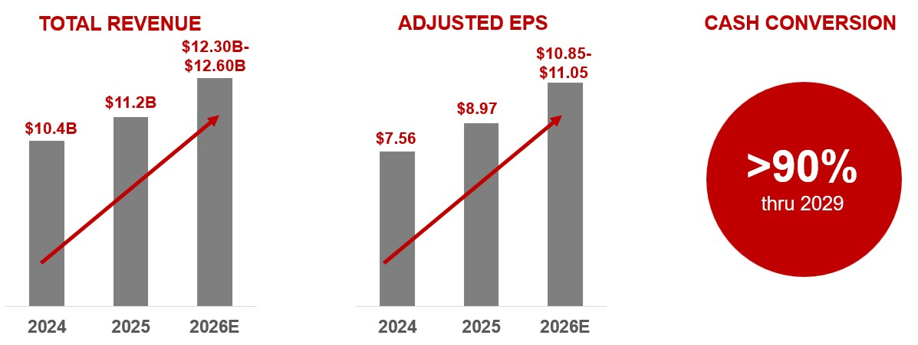

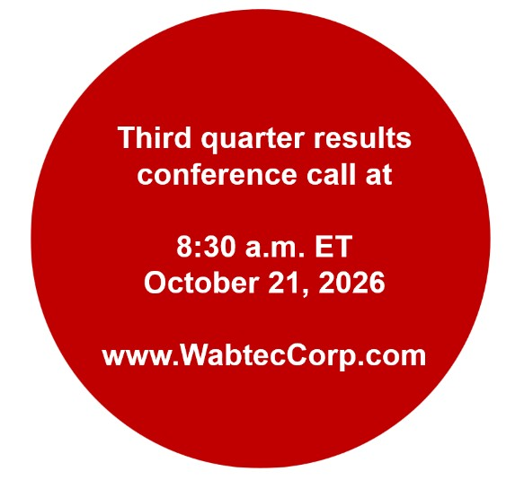

About Wabtec
Wabtec Corporation (NYSE: WAB) is revolutionizing the way the world moves for future generations. The company is a leading global provider of equipment, systems, digital solutions and value-added services for the freight and transit rail industries, as well as the mining, marine and industrial markets. Wabtec has been a leader in the rail industry for over 155 years and has a vision to achieve a sustainable rail system in the U.S. and worldwide. Visit Wabtec’s website at www.wabteccorp.com.

Forecasted GAAP Earnings Reconciliation
Wabtec is not presenting a quantitative reconciliation of our forecasted GAAP earnings per diluted share to forecasted adjusted earnings per diluted share because it is unable to predict with reasonable certainty and without unreasonable effort the impact and timing of restructuring-related and other charges, including acquisition-related expenses and the outcome of certain regulatory, legal and tax matters. The financial impact of these items is uncertain and is dependent on various factors, including timing, and could be material to our Consolidated Statements of Earnings.

Conference Call Information
Wabtec will host a call with analysts and investors at 8:30 a.m. ET, today. To listen via webcast, go to Wabtec’s website at www.WabtecCorp.com and click on “Events & Presentations” in the “Investor Relations” section. Also, an audio replay of the call will be available by calling 1-855-669-9658 or 1-412-317-0088 (access code: 9897430).

Information about non-GAAP Financial Information and Forward-Looking Statements
Wabtec’s earnings release and 2026 financial guidance mentions certain non-GAAP financial performance measures, including adjusted gross profit, adjusted operating expenses, adjusted operating margin, adjusted gross margin, EBITDA, adjusted EBITDA, adjusted income tax expense, adjusted income from operations, adjusted interest and other expense, adjusted net income, adjusted earnings per diluted share and operating cash flow conversion. Wabtec defines EBITDA as earnings before interest, taxes, depreciation and amortization. Adjusted EBITDA is further adjusted by restructuring costs. Wabtec defines operating cash flow conversion as net cash provided by operating activities divided by net income plus depreciation and amortization including deferred debt cost amortization. While Wabtec believes these are useful supplemental measures for investors, they are not presented in accordance with GAAP. Investors should not consider non-GAAP measures in isolation or as a substitute for net income, cash flows from operations, or any other items calculated in accordance with GAAP. In addition, the non-GAAP financial measures included in this release have inherent material limitations as performance measures because they add back certain expenses incurred by the Company to GAAP financial measures, resulting in those expenses not being taken into account in the applicable non-GAAP financial measure. Because not all companies use identical calculations, Wabtec’s presentation of non-GAAP financial measures may not be comparable to other similarly titled measures of other companies. Included in this release are reconciliation tables that provide details about how adjusted results relate to GAAP results.

This communication contains “forward-looking” statements as that term is defined in Section 27A of the Securities Act of 1933, and Section 21E of the Securities Exchange Act of 1934, as amended by the Private Securities Litigation Reform Act of 1995. All statements, other than historical facts, including statements regarding Wabtec’s plans, objectives, expectations and intentions; Wabtec’s expectations about future sales, earnings and cash conversion; and any assumptions underlying any of the foregoing, are forward-looking statements. Forward-looking statements concern future circumstances and results and other statements that are not historical facts and are sometimes identified by the words “may,” “will,” “should,” “potential,” “intend,” “expect,” “endeavor,” “seek,” “anticipate,” “estimate,” “overestimate,” “underestimate,” “believe,” “could,” “project,” “predict,” “continue,” “target” or other similar words or expressions. Forward-looking statements are based upon current plans, estimates and expectations that are subject to risks, uncertainties and assumptions. Should one or more of these risks or uncertainties materialize, or should underlying assumptions prove incorrect, actual results may vary materially from those indicated or anticipated by such forward-looking statements. The inclusion of such statements should not be regarded as a representation that such plans, estimates or expectations will be achieved. Important factors that could cause actual results to differ materially from such plans, estimates or expectations include, among others, (1) changes in general economic and/or industry specific conditions, including the impacts of significant recent shifts in trade policies (including the actual or threatened imposition of tariffs and retaliatory tariff measures) as well as tax programs, inflation, supply chain disruptions, foreign currency exchange and industry consolidation and market reactions to these factors; (2) changes in the financial condition or operating strategies of Wabtec’s customers; (3) unexpected costs, charges or expenses resulting from acquisitions and potential failure to realize synergies and other anticipated benefits of acquisitions, including as a result of integrating acquired targets into Wabtec; (4) inability to retain and hire key personnel; (5) evolving legal, regulatory and tax regimes; (6) changes in the expected timing of projects; (7) a decrease in freight or passenger rail traffic; (8) an increase in manufacturing costs; (9) actions by third parties, including government agencies; (10) the impacts of epidemics, pandemics or similar public health crises on the global economy and, in particular, our customers, suppliers and end-markets, (11) potential disruptions, instability and volatility in global markets as a result of global military action, acts of terrorism or armed conflict, including Russia’s invasion of Ukraine and ongoing military conflicts in the Middle East; (12) cybersecurity and data protection risks and (13) other risk factors as detailed from time to time in Wabtec’s reports filed with the SEC, including Wabtec’s annual report on Form 10-K, periodic quarterly reports on Form 10-Q, current reports on Form 8-K and other documents filed with the SEC. The foregoing list of important factors is not exclusive. Any forward-looking statements speak only as of the date of this communication. Wabtec does not undertake any obligation to update any forward-looking statements, whether as a result of new information or development, future events or otherwise, except as required by law. Readers are cautioned not to place undue reliance on any of these forward-looking statements.

Wabtec Investor Contact
Kyra Yates / Kyra.Yates@wabtec.com / 817-349-2735

Wabtec Media Contact
Tim Bader / Tim.Bader@wabtec.com / 682-319-7925

Appendix A
WESTINGHOUSE AIR BRAKE TECHNOLOGIES CORPORATION
CONDENSED CONSOLIDATED STATEMENTS OF INCOME
FOR THE THREE AND NINE MONTHS ENDED SEPTEMBER 30, 2026 AND 2025
(AMOUNTS IN MILLIONS EXCEPT PER SHARE DATA)
(UNAUDITED)
 |  |  | Three Months Ended  September 30, |  |  |  |  |  |  |  |  |  |  |  | Nine Months Ended  September 30,
 |  |  | 2026 |  |  |  |  |  | 2025 |  |  |  |  |  | 2026 |  |  |  |  |  | 2025
Net sales |  |  | $ | 3,120 |  |  |  |  | $ | 2,886 |  |  |  |  | $ | 9,249 |  |  |  |  | $ | 8,202
Cost of sales |  |  | (1,956) |  |  |  |  |  | (1,884) |  |  |  |  |  | (5,863) |  |  |  |  |  | (5,362)
Gross profit |  |  | 1,164 |  |  |  |  |  | 1,002 |  |  |  |  |  | 3,386 |  |  |  |  |  | 2,840
Gross profit as a % of Net sales |  |  | 37.3 |  | % |  |  |  | 34.7 |  | % |  |  |  | 36.6 |  | % |  |  |  | 34.6 |  | %
Selling, general and administrative expenses |  |  | (383) |  |  |  |  |  | (375) |  |  |  |  |  | (1,184) |  |  |  |  |  | (1,029)
Engineering expenses |  |  | (67) |  |  |  |  |  | (59) |  |  |  |  |  | (193) |  |  |  |  |  | (155)
Amortization expense |  |  | (89) |  |  |  |  |  | (77) |  |  |  |  |  | (267) |  |  |  |  |  | (219)
Total operating expenses |  |  | (539) |  |  |  |  |  | (511) |  |  |  |  |  | (1,644) |  |  |  |  |  | (1,403)
Operating expenses as a % of Net sales |  |  | 17.3 |  | % |  |  |  | 17.7 |  | % |  |  |  | 17.8 |  | % |  |  |  | 17.1 |  | %
Income from operations |  |  | 625 |  |  |  |  |  | 491 |  |  |  |  |  | 1,742 |  |  |  |  |  | 1,437
Income from operations as a % of Net sales |  |  | 20.0 |  | % |  |  |  | 17.0 |  | % |  |  |  | 18.8 |  | % |  |  |  | 17.5 |  | %
Interest expense, net |  |  | (80) |  |  |  |  |  | (65) |  |  |  |  |  | (231) |  |  |  |  |  | (157)
Other income (expense), net |  |  | 12 |  |  |  |  |  | (1) |  |  |  |  |  | 33 |  |  |  |  |  | 21
Income before income taxes |  |  | 557 |  |  |  |  |  | 425 |  |  |  |  |  | 1,544 |  |  |  |  |  | 1,301
Income tax expense |  |  | (146) |  |  |  |  |  | (112) |  |  |  |  |  | (374) |  |  |  |  |  | (322)
Effective tax rate |  |  | 26.3 |  | % |  |  |  | 26.4 |  | % |  |  |  | 24.2 |  | % |  |  |  | 24.8 |  | %
Net income |  |  | 411 |  |  |  |  |  | 313 |  |  |  |  |  | 1,170 |  |  |  |  |  | 979
Less: Net income attributable to noncontrolling interest |  |  | (2) |  |  |  |  |  | (3) |  |  |  |  |  | (4) |  |  |  |  |  | (11)
Net income attributable to Wabtec shareholders |  |  | $ | 409 |  |  |  |  | $ | 310 |  |  |  |  | $ | 1,166 |  |  |  |  | $ | 968
Earnings Per Common Share
Basic
Net income attributable to Wabtec shareholders |  |  | $ | 2.43 |  |  |  |  | $ | 1.81 |  |  |  |  | $ | 6.88 |  |  |  |  | $ | 5.66
Diluted
Net income attributable to Wabtec shareholders |  |  | $ | 2.42 |  |  |  |  | $ | 1.81 |  |  |  |  | $ | 6.86 |  |  |  |  | $ | 5.64
Weighted average shares outstanding
Basic |  |  | 168.2 |  |  |  |  |  | 170.5 |  |  |  |  |  | 169.1 |  |  |  |  |  | 170.5
Diluted |  |  | 168.8 |  |  |  |  |  | 171.1 |  |  |  |  |  | 169.7 |  |  |  |  |  | 171.2

Appendix A
WESTINGHOUSE AIR BRAKE TECHNOLOGIES CORPORATION
CONDENSED CONSOLIDATED STATEMENTS OF INCOME (CONTINUED)
FOR THE THREE AND NINE MONTHS ENDED SEPTEMBER 30, 2026 AND 2025
(AMOUNTS IN MILLIONS EXCEPT PER SHARE DATA)
(UNAUDITED)

 |  |  | Three Months Ended  September 30, |  |  |  |  |  |  |  |  |  |  |  | Nine Months Ended  September 30,
 |  |  | 2026 |  |  |  |  |  | 2025 |  |  |  |  |  | 2026 |  |  |  |  |  | 2025
Segment Information
Freight Net sales |  |  | $ | 2,237 |  |  |  |  | $ | 2,093 |  |  |  |  | $ | 6,595 |  |  |  |  | $ | 5,913
Freight Income from operations |  |  | $ | 515 |  |  |  |  | $ | 414 |  |  |  |  | $ | 1,469 |  |  |  |  | $ | 1,249
Freight Operating margin |  |  | 23.0 |  | % |  |  |  | 19.8 |  | % |  |  |  | 22.3 |  | % |  |  |  | 21.1 |  | %
Transit Net sales |  |  | $ | 883 |  |  |  |  | $ | 793 |  |  |  |  | $ | 2,654 |  |  |  |  | $ | 2,289
Transit Income from operations |  |  | $ | 145 |  |  |  |  | $ | 115 |  |  |  |  | $ | 412 |  |  |  |  | $ | 314
Transit Operating margin |  |  | 16.4 |  | % |  |  |  | 14.5 |  | % |  |  |  | 15.5 |  | % |  |  |  | 13.7 |  | %
Backlog Information (Note: 12-month is a sub-set of total) |  |  | September 30, 2026 |  |  |  |  |  | June 30, 2026 |  |  |  |  |  | September 30, 2025
Freight Total |  |  | $ | 25,765 |  |  |  |  | $ | 25,332 |  |  |  |  | $ | 20,907
Transit Total |  |  | 5,670 |  |  |  |  |  | 5,600 |  |  |  |  |  | 4,670
Wabtec Total |  |  | $ | 31,435 |  |  |  |  | $ | 30,932 |  |  |  |  | $ | 25,577
Freight 12-month |  |  | $ | 6,544 |  |  |  |  | $ | 6,638 |  |  |  |  | $ | 6,085
Transit 12-month |  |  | 2,448 |  |  |  |  |  | 2,502 |  |  |  |  |  | 2,182
Wabtec 12-month |  |  | $ | 8,992 |  |  |  |  | $ | 9,140 |  |  |  |  | $ | 8,267

Appendix B
WESTINGHOUSE AIR BRAKE TECHNOLOGIES CORPORATION
CONDENSED CONSOLIDATED BALANCE SHEETS
(UNAUDITED)
 |  |  | September 30, 2026 |  |  |  |  |  | December 31, 2025
In millions
Cash, cash equivalents and restricted cash |  |  | $ | 489 |  |  |  |  | $ | 789
Receivables, net |  |  | 2,264 |  |  |  |  |  | 1,897
Inventories, net |  |  | 2,946 |  |  |  |  |  | 2,745
Other current assets |  |  | 352 |  |  |  |  |  | 263
Total current assets |  |  | 6,051 |  |  |  |  |  | 5,694
Property, plant and equipment, net |  |  | 1,672 |  |  |  |  |  | 1,616
Goodwill |  |  | 10,621 |  |  |  |  |  | 10,216
Other intangible assets, net |  |  | 4,032 |  |  |  |  |  | 3,838
Other noncurrent assets |  |  | 765 |  |  |  |  |  | 705
Total Assets |  |  | $ | 23,141 |  |  |  |  | $ | 22,069
Current liabilities |  |  | $ | 5,500 |  |  |  |  | $ | 5,150
Long-term debt |  |  | 4,665 |  |  |  |  |  | 4,291
Other long-term liabilities |  |  | 1,612 |  |  |  |  |  | 1,438
Total Liabilities |  |  | 11,777 |  |  |  |  |  | 10,879
Shareholders' equity |  |  | 11,333 |  |  |  |  |  | 11,142
Noncontrolling interest |  |  | 31 |  |  |  |  |  | 48
Total Equity |  |  | 11,364 |  |  |  |  |  | 11,190
Total Liabilities and Equity |  |  | $ | 23,141 |  |  |  |  | $ | 22,069

Appendix C
WESTINGHOUSE AIR BRAKE TECHNOLOGIES CORPORATION
CONDENSED CONSOLIDATED STATEMENTS OF CASH FLOWS
(UNAUDITED)
Nine Months Ended
September 30,
 |  |  | 2026 |  |  |  |  |  | 2025
In millions
Operating activities
Net income |  |  | $ | 1,170 |  |  |  |  | $ | 979
Non-cash expense |  |  | 466 |  |  |  |  |  | 357
Receivables |  |  | (342) |  |  |  |  |  | (368)
Inventories |  |  | (100) |  |  |  |  |  | (228)
Accounts payable |  |  | 67 |  |  |  |  |  | 76
Other operating activities |  |  | (166) |  |  |  |  |  | (49)
Net cash provided by operating activities |  |  | 1,095 |  |  |  |  |  | 767
Net cash used for investing activities |  |  | (1,243) |  |  |  |  |  | (1,887)
Net cash (used for) provided by financing activities |  |  | (147) |  |  |  |  |  | 907
Effect of changes in currency exchange rates |  |  | (5) |  |  |  |  |  | 26
Decrease in cash |  |  | (300) |  |  |  |  |  | (187)
Cash, cash equivalents and restricted cash, beginning of period |  |  | 789 |  |  |  |  |  | 715
Cash, cash equivalents and restricted cash, end of period |  |  | $ | 489 |  |  |  |  | $ | 528

Appendix D
Set forth below is the calculation of the non-GAAP performance measures included in this press release. We believe that these measures provide useful supplemental information to assess our operating performance and to evaluate period-to-period comparisons. Non-GAAP financial measures should be viewed in addition to, and not as an alternative for, Wabtec’s reported results prepared in accordance with GAAP.
Wabtec Corporation
Reconciliation of Reported Results to Adjusted Results
(in millions) |  |  |  |  |  | Third Quarter 2026 Actual Results
 |  |  |  |  |  | Net |  |  |  |  |  | Gross |  |  |  |  |  | Operating |  |  |  |  |  | Income from |  |  |  |  |  | Interest & |  |  |  |  |  |  |  |  |  |  |  | Net |  |  |  |  |  | Noncontrolling |  |  |  |  |  | Wabtec
 |  |  |  |  |  | Sales |  |  |  |  |  | Profit |  |  |  |  |  | Expenses |  |  |  |  |  | Operations |  |  |  |  |  | Other Exp |  |  |  |  |  | Tax |  |  |  |  |  | Income |  |  |  |  |  | Interest |  |  |  |  |  | Net Income |  |  |  |  |  | EPS
Reported Results |  |  |  |  |  | $ | 3,120 |  |  |  |  | $ | 1,164 |  |  |  |  | $ | (539) |  |  |  |  | $ | 625 |  |  |  |  | $ | (68) |  |  |  |  | $ | (146) |  |  |  |  | $ | 411 |  |  |  |  | $ | (2) |  |  |  |  | $ | 409 |  |  |  |  | $ | 2.42
Restructuring and Portfolio Optimization costs |  |  |  |  |  | — |  |  |  |  |  | 2 |  |  |  |  |  | (1) |  |  |  |  |  | 1 |  |  |  |  |  | 4 |  |  |  |  |  | (1) |  |  |  |  |  | 4 |  |  |  |  |  | — |  |  |  |  |  | 4 |  |  |  |  |  | $ | 0.02
Non-cash Amortization expense |  |  |  |  |  | — |  |  |  |  |  | — |  |  |  |  |  | 89 |  |  |  |  |  | 89 |  |  |  |  |  | — |  |  |  |  |  | (24) |  |  |  |  |  | 65 |  |  |  |  |  | — |  |  |  |  |  | 65 |  |  |  |  |  | $ | 0.39
Adjusted Results |  |  |  |  |  | $ | 3,120 |  |  |  |  | $ | 1,166 |  |  |  |  | $ | (451) |  |  |  |  | $ | 715 |  |  |  |  | $ | (64) |  |  |  |  | $ | (171) |  |  |  |  | $ | 480 |  |  |  |  | $ | (2) |  |  |  |  | $ | 478 |  |  |  |  | $ | 2.83
Fully Diluted Shares Outstanding |  |  |  |  |  |  |  |  |  |  |  |  |  |  |  |  |  |  |  |  |  |  |  |  |  |  |  |  |  |  |  |  |  |  |  |  |  |  |  |  |  |  |  |  |  |  |  |  |  |  |  |  |  |  |  |  |  |  |  | 168.8
Wabtec Corporation
Reconciliation of Reported Results to Adjusted Results
(in millions) |  |  |  |  |  | Third Quarter Year-to-Date 2026 Actual Results
 |  |  |  |  |  | Net |  |  |  |  |  | Gross |  |  |  |  |  | Operating |  |  |  |  |  | Income from |  |  |  |  |  | Interest & |  |  |  |  |  |  |  |  |  |  |  | Net |  |  |  |  |  | Noncontrolling |  |  |  |  |  | Wabtec
 |  |  |  |  |  | Sales |  |  |  |  |  | Profit |  |  |  |  |  | Expenses |  |  |  |  |  | Operations |  |  |  |  |  | Other Exp |  |  |  |  |  | Tax |  |  |  |  |  | Income |  |  |  |  |  | Interest |  |  |  |  |  | Net Income |  |  |  |  |  | EPS
Reported Results |  |  |  |  |  | $ | 9,249 |  |  |  |  | $ | 3,386 |  |  |  |  | $ | (1,644) |  |  |  |  | $ | 1,742 |  |  |  |  | $ | (198) |  |  |  |  | $ | (374) |  |  |  |  | $ | 1,170 |  |  |  |  | $ | (4) |  |  |  |  | $ | 1,166 |  |  |  |  | $ | 6.86
Restructuring and Portfolio Optimization costs |  |  |  |  |  | — |  |  |  |  |  | 5 |  |  |  |  |  | 1 |  |  |  |  |  | 6 |  |  |  |  |  | 4 |  |  |  |  |  | (2) |  |  |  |  |  | 8 |  |  |  |  |  | — |  |  |  |  |  | 8 |  |  |  |  |  | $ | 0.04
Inventory Purchase Accounting charge |  |  |  |  |  | — |  |  |  |  |  | 28 |  |  |  |  |  | — |  |  |  |  |  | 28 |  |  |  |  |  | — |  |  |  |  |  | (7) |  |  |  |  |  | 21 |  |  |  |  |  | — |  |  |  |  |  | 21 |  |  |  |  |  | $ | 0.13
Transaction costs |  |  |  |  |  | — |  |  |  |  |  | — |  |  |  |  |  | 14 |  |  |  |  |  | 14 |  |  |  |  |  | (2) |  |  |  |  |  | — |  |  |  |  |  | 12 |  |  |  |  |  | — |  |  |  |  |  | 12 |  |  |  |  |  | $ | 0.07
Non-cash Amortization expense |  |  |  |  |  | — |  |  |  |  |  | — |  |  |  |  |  | 267 |  |  |  |  |  | 267 |  |  |  |  |  | — |  |  |  |  |  | (65) |  |  |  |  |  | 202 |  |  |  |  |  | — |  |  |  |  |  | 202 |  |  |  |  |  | $ | 1.19
Adjusted Results |  |  |  |  |  | $ | 9,249 |  |  |  |  | $ | 3,419 |  |  |  |  | $ | (1,362) |  |  |  |  | $ | 2,057 |  |  |  |  | $ | (196) |  |  |  |  | $ | (448) |  |  |  |  | $ | 1,413 |  |  |  |  | $ | (4) |  |  |  |  | $ | 1,409 |  |  |  |  | $ | 8.29
Fully Diluted Shares Outstanding |  |  |  |  |  |  |  |  |  |  |  |  |  |  |  |  |  |  |  |  |  |  |  |  |  |  |  |  |  |  |  |  |  |  |  |  |  |  |  |  |  |  |  |  |  |  |  |  |  |  |  |  |  |  |  |  |  |  |  | 169.7

Appendix D
Set forth below is the calculation of the non-GAAP performance measures included in this press release. We believe that these measures provide useful supplemental information to assess our operating performance and to evaluate period-to-period comparisons. Non-GAAP financial measures should be viewed in addition to, and not as an alternative for, Wabtec’s reported results prepared in accordance with GAAP.
Wabtec Corporation
Reconciliation of Reported Results to Adjusted Results
(in millions) |  |  |  |  |  | Third Quarter 2025 Actual Results
 |  |  |  |  |  | Net |  |  |  |  |  | Gross |  |  |  |  |  | Operating |  |  |  |  |  | Income from |  |  |  |  |  | Interest & |  |  |  |  |  |  |  |  |  |  |  | Net |  |  |  |  |  | Noncontrolling |  |  |  |  |  | Wabtec
 |  |  |  |  |  | Sales |  |  |  |  |  | Profit |  |  |  |  |  | Expenses |  |  |  |  |  | Operations |  |  |  |  |  | Other Exp |  |  |  |  |  | Tax |  |  |  |  |  | Income |  |  |  |  |  | Interest |  |  |  |  |  | Net Income |  |  |  |  |  | EPS
Reported Results |  |  |  |  |  | $ | 2,886 |  |  |  |  | $ | 1,002 |  |  |  |  | $ | (511) |  |  |  |  | $ | 491 |  |  |  |  | $ | (66) |  |  |  |  | $ | (112) |  |  |  |  | $ | 313 |  |  |  |  | $ | (3) |  |  |  |  | $ | 310 |  |  |  |  | $ | 1.81
Restructuring and Portfolio Optimization costs |  |  |  |  |  | — |  |  |  |  |  | 2 |  |  |  |  |  | 4 |  |  |  |  |  | 6 |  |  |  |  |  | — |  |  |  |  |  | (1) |  |  |  |  |  | 5 |  |  |  |  |  | — |  |  |  |  |  | 5 |  |  |  |  |  | $ | 0.02
Inventory Purchase Accounting charge |  |  |  |  |  | — |  |  |  |  |  | 24 |  |  |  |  |  | — |  |  |  |  |  | 24 |  |  |  |  |  | — |  |  |  |  |  | (6) |  |  |  |  |  | 18 |  |  |  |  |  | — |  |  |  |  |  | 18 |  |  |  |  |  | $ | 0.11
Transaction costs |  |  |  |  |  | — |  |  |  |  |  | — |  |  |  |  |  | 9 |  |  |  |  |  | 9 |  |  |  |  |  | 2 |  |  |  |  |  | (3) |  |  |  |  |  | 8 |  |  |  |  |  | — |  |  |  |  |  | 8 |  |  |  |  |  | $ | 0.05
Non-cash Amortization expense |  |  |  |  |  | — |  |  |  |  |  | — |  |  |  |  |  | 77 |  |  |  |  |  | 77 |  |  |  |  |  | — |  |  |  |  |  | (20) |  |  |  |  |  | 57 |  |  |  |  |  | — |  |  |  |  |  | 57 |  |  |  |  |  | $ | 0.33
Adjusted Results |  |  |  |  |  | $ | 2,886 |  |  |  |  | $ | 1,028 |  |  |  |  | $ | (421) |  |  |  |  | $ | 607 |  |  |  |  | $ | (64) |  |  |  |  | $ | (142) |  |  |  |  | $ | 401 |  |  |  |  | $ | (3) |  |  |  |  | $ | 398 |  |  |  |  | $ | 2.32
Fully Diluted Shares Outstanding |  |  |  |  |  |  |  |  |  |  |  |  |  |  |  |  |  |  |  |  |  |  |  |  |  |  |  |  |  |  |  |  |  |  |  |  |  |  |  |  |  |  |  |  |  |  |  |  |  |  |  |  |  |  |  |  |  |  |  | 171.1
Wabtec Corporation
Reconciliation of Reported Results to Adjusted Results
(in millions) |  |  |  |  |  | Third Quarter Year-to-Date 2025 Actual Results
 |  |  |  |  |  | Net |  |  |  |  |  | Gross |  |  |  |  |  | Operating |  |  |  |  |  | Income from |  |  |  |  |  | Interest & |  |  |  |  |  |  |  |  |  |  |  | Net |  |  |  |  |  | Noncontrolling |  |  |  |  |  | Wabtec
 |  |  |  |  |  | Sales |  |  |  |  |  | Profit |  |  |  |  |  | Expenses |  |  |  |  |  | Operations |  |  |  |  |  | Other Exp |  |  |  |  |  | Tax |  |  |  |  |  | Income |  |  |  |  |  | Interest |  |  |  |  |  | Net Income |  |  |  |  |  | EPS
Reported Results |  |  |  |  |  | $ | 8,202 |  |  |  |  | $ | 2,840 |  |  |  |  | $ | (1,403) |  |  |  |  | $ | 1,437 |  |  |  |  | $ | (136) |  |  |  |  | $ | (322) |  |  |  |  | $ | 979 |  |  |  |  | $ | (11) |  |  |  |  | $ | 968 |  |  |  |  | $ | 5.64
Restructuring and Portfolio Optimization costs |  |  |  |  |  | — |  |  |  |  |  | 8 |  |  |  |  |  | 13 |  |  |  |  |  | 21 |  |  |  |  |  | — |  |  |  |  |  | (5) |  |  |  |  |  | 16 |  |  |  |  |  | — |  |  |  |  |  | 16 |  |  |  |  |  | $ | 0.09
Inventory Purchase Accounting charge |  |  |  |  |  | — |  |  |  |  |  | 24 |  |  |  |  |  | — |  |  |  |  |  | 24 |  |  |  |  |  | — |  |  |  |  |  | (6) |  |  |  |  |  | 18 |  |  |  |  |  | — |  |  |  |  |  | 18 |  |  |  |  |  | $ | 0.11
Transaction costs |  |  |  |  |  | — |  |  |  |  |  | — |  |  |  |  |  | 44 |  |  |  |  |  | 44 |  |  |  |  |  | (30) |  |  |  |  |  | (1) |  |  |  |  |  | 13 |  |  |  |  |  | — |  |  |  |  |  | 13 |  |  |  |  |  | $ | 0.08
Non-cash Amortization expense |  |  |  |  |  | — |  |  |  |  |  | — |  |  |  |  |  | 218 |  |  |  |  |  | 218 |  |  |  |  |  | — |  |  |  |  |  | (54) |  |  |  |  |  | 164 |  |  |  |  |  | — |  |  |  |  |  | 164 |  |  |  |  |  | $ | 0.96
Adjusted Results |  |  |  |  |  | $ | 8,202 |  |  |  |  | $ | 2,872 |  |  |  |  | $ | (1,128) |  |  |  |  | $ | 1,744 |  |  |  |  | $ | (166) |  |  |  |  | $ | (388) |  |  |  |  | $ | 1,190 |  |  |  |  | $ | (11) |  |  |  |  | $ | 1,179 |  |  |  |  | $ | 6.88
Fully Diluted Shares Outstanding |  |  |  |  |  |  |  |  |  |  |  |  |  |  |  |  |  |  |  |  |  |  |  |  |  |  |  |  |  |  |  |  |  |  |  |  |  |  |  |  |  |  |  |  |  |  |  |  |  |  |  |  |  |  |  |  |  |  |  | 171.2

Appendix D
Set forth below is the calculation of the non-GAAP performance measures included in this press release. We believe that these measures provide useful supplemental information to assess our operating performance and to evaluate period-to-period comparisons. Non-GAAP financial measures should be viewed in addition to, and not as an alternative for, Wabtec’s reported results prepared in accordance with GAAP.
Wabtec Corporation
Reconciliation of Reported Results to Adjusted Results
(in millions) |  |  |  |  |  | Fourth Quarter Year-to-Date 2025 Actual Results
 |  |  |  |  |  | Net |  |  |  |  |  | Gross |  |  |  |  |  | Operating |  |  |  |  |  | Income from |  |  |  |  |  | Interest & |  |  |  |  |  |  |  |  |  |  |  | Net |  |  |  |  |  | Noncontrolling |  |  |  |  |  | Wabtec
 |  |  |  |  |  | Sales |  |  |  |  |  | Profit |  |  |  |  |  | Expenses |  |  |  |  |  | Operations |  |  |  |  |  | Other Exp |  |  |  |  |  | Tax |  |  |  |  |  | Income |  |  |  |  |  | Interest |  |  |  |  |  | Net Income |  |  |  |  |  | EPS
Reported Results |  |  |  |  |  | $ | 11,167 |  |  |  |  | $ | 3,806 |  |  |  |  | $ | (2,013) |  |  |  |  | $ | 1,793 |  |  |  |  | $ | (201) |  |  |  |  | $ | (409) |  |  |  |  | $ | 1,183 |  |  |  |  | $ | (13) |  |  |  |  | $ | 1,170 |  |  |  |  | $ | 6.83
Restructuring and Portfolio Optimization costs |  |  |  |  |  | — |  |  |  |  |  | 12 |  |  |  |  |  | 64 |  |  |  |  |  | 76 |  |  |  |  |  | — |  |  |  |  |  | 1 |  |  |  |  |  | 77 |  |  |  |  |  | — |  |  |  |  |  | 77 |  |  |  |  |  | $ | 0.45
Inventory Purchase Accounting charge |  |  |  |  |  | — |  |  |  |  |  | 53 |  |  |  |  |  | — |  |  |  |  |  | 53 |  |  |  |  |  | — |  |  |  |  |  | (13) |  |  |  |  |  | 40 |  |  |  |  |  | — |  |  |  |  |  | 40 |  |  |  |  |  | $ | 0.23
Transaction costs |  |  |  |  |  | — |  |  |  |  |  | — |  |  |  |  |  | 49 |  |  |  |  |  | 49 |  |  |  |  |  | (19) |  |  |  |  |  | (4) |  |  |  |  |  | 26 |  |  |  |  |  | — |  |  |  |  |  | 26 |  |  |  |  |  | $ | 0.15
Non-cash Amortization expense |  |  |  |  |  | — |  |  |  |  |  | — |  |  |  |  |  | 296 |  |  |  |  |  | 296 |  |  |  |  |  | — |  |  |  |  |  | (72) |  |  |  |  |  | 224 |  |  |  |  |  | — |  |  |  |  |  | 224 |  |  |  |  |  | $ | 1.31
Adjusted Results |  |  |  |  |  | $ | 11,167 |  |  |  |  | $ | 3,871 |  |  |  |  | $ | (1,604) |  |  |  |  | $ | 2,267 |  |  |  |  | $ | (220) |  |  |  |  | $ | (497) |  |  |  |  | $ | 1,550 |  |  |  |  | $ | (13) |  |  |  |  | $ | 1,537 |  |  |  |  | $ | 8.97
Fully Diluted Shares Outstanding |  |  |  |  |  |  |  |  |  |  |  |  |  |  |  |  |  |  |  |  |  |  |  |  |  |  |  |  |  |  |  |  |  |  |  |  |  |  |  |  |  |  |  |  |  |  |  |  |  |  |  |  |  |  |  |  |  |  |  | 171.1

Wabtec Corporation
Reconciliation of Reported Results to Adjusted Results
(in millions) |  |  |  |  |  | Fourth Quarter Year-to-Date 2024 Actual Results
 |  |  |  |  |  | Net |  |  |  |  |  | Gross |  |  |  |  |  | Operating |  |  |  |  |  | Income from |  |  |  |  |  | Interest & |  |  |  |  |  |  |  |  |  |  |  | Net |  |  |  |  |  | Noncontrolling |  |  |  |  |  | Wabtec
 |  |  |  |  |  | Sales |  |  |  |  |  | Profit |  |  |  |  |  | Expenses |  |  |  |  |  | Operations |  |  |  |  |  | Other Exp |  |  |  |  |  | Tax |  |  |  |  |  | Income |  |  |  |  |  | Interest |  |  |  |  |  | Net Income |  |  |  |  |  | EPS
Reported Results |  |  |  |  |  | $ | 10,387 |  |  |  |  | $ | 3,366 |  |  |  |  | $ | (1,757) |  |  |  |  | $ | 1,609 |  |  |  |  | $ | (199) |  |  |  |  | $ | (343) |  |  |  |  | $ | 1,067 |  |  |  |  | $ | (11) |  |  |  |  | $ | 1,056 |  |  |  |  | $ | 6.04
Restructuring and Portfolio Optimization costs |  |  |  |  |  | — |  |  |  |  |  | 37 |  |  |  |  |  | 33 |  |  |  |  |  | 70 |  |  |  |  |  | (4) |  |  |  |  |  | (16) |  |  |  |  |  | 50 |  |  |  |  |  | — |  |  |  |  |  | 50 |  |  |  |  |  | $ | 0.28
Non-cash Amortization expense |  |  |  |  |  | — |  |  |  |  |  | — |  |  |  |  |  | 288 |  |  |  |  |  | 288 |  |  |  |  |  | — |  |  |  |  |  | (70) |  |  |  |  |  | 218 |  |  |  |  |  | — |  |  |  |  |  | 218 |  |  |  |  |  | $ | 1.24
Adjusted Results |  |  |  |  |  | $ | 10,387 |  |  |  |  | $ | 3,403 |  |  |  |  | $ | (1,436) |  |  |  |  | $ | 1,967 |  |  |  |  | $ | (203) |  |  |  |  | $ | (429) |  |  |  |  | $ | 1,335 |  |  |  |  | $ | (11) |  |  |  |  | $ | 1,324 |  |  |  |  | $ | 7.56
Fully Diluted Shares Outstanding |  |  |  |  |  |  |  |  |  |  |  |  |  |  |  |  |  |  |  |  |  |  |  |  |  |  |  |  |  |  |  |  |  |  |  |  |  |  |  |  |  |  |  |  |  |  |  |  |  |  |  |  |  |  |  |  |  |  |  | 174.8

Appendix E

Set forth below is the calculation of the non-GAAP performance measures included in this press release. We believe that these measures provide useful supplemental information to assess our operating performance and to evaluate period-to-period comparisons. Non-GAAP financial measures should be viewed in addition to, and not as an alternative for, Wabtec’s reported results prepared in accordance with GAAP.
Wabtec Corporation
Third Quarter 2026 EBITDA Reconciliation
(in millions)
 |  |  |  |  |  | Reported Income |  |  | + |  |  | Other Income |  |  | + |  |  | Depreciation & |  |  | = |  |  | EBITDA |  |  | + |  |  | Restructuring |  |  | = |  |  | Adjusted
 |  |  |  |  |  | from Operations |  |  |  |  |  | (Expense) |  |  |  |  |  | Amortization |  |  |  |  |  |  |  |  |  |  |  | Costs |  |  |  |  |  | EBITDA
Consolidated Results |  |  |  |  |  | $ | 625 |  |  |  |  | $ | 12 |  |  |  |  | $ | 140 |  |  |  |  | $ | 777 |  |  |  |  | $ | 5 |  |  |  |  | $ | 782
Wabtec Corporation
Third Quarter 2026 YTD EBITDA Reconciliation
(in millions)
 |  |  |  |  |  | Reported Income |  |  | + |  |  | Other Income |  |  | + |  |  | Depreciation & |  |  | = |  |  | EBITDA |  |  | + |  |  | Restructuring & |  |  | = |  |  | Adjusted
 |  |  |  |  |  | from Operations |  |  |  |  |  | (Expense) |  |  |  |  |  | Amortization |  |  |  |  |  |  |  |  |  |  |  | Transaction Costs |  |  |  |  |  | EBITDA
Consolidated Results |  |  |  |  |  | $ | 1,742 |  |  |  |  | $ | 33 |  |  |  |  | $ | 419 |  |  |  |  | $ | 2,194 |  |  |  |  | $ | 50 |  |  |  |  | $ | 2,244
Wabtec Corporation
Third Quarter 2025 EBITDA Reconciliation
(in millions)
 |  |  |  |  |  | Reported Income |  |  | + |  |  | Other Income |  |  | + |  |  | Depreciation & |  |  | = |  |  | EBITDA |  |  | + |  |  | Restructuring & |  |  | = |  |  | Adjusted
 |  |  |  |  |  | from Operations |  |  |  |  |  | (Expense) |  |  |  |  |  | Amortization |  |  |  |  |  |  |  |  |  |  |  | Transaction Costs |  |  |  |  |  | EBITDA
Consolidated Results |  |  |  |  |  | $ | 491 |  |  |  |  | $ | (1) |  |  |  |  | $ | 127 |  |  |  |  | $ | 617 |  |  |  |  | $ | 41 |  |  |  |  | $ | 658
Wabtec Corporation
Third Quarter 2025 YTD EBITDA Reconciliation
(in millions)
 |  |  |  |  |  | Reported Income |  |  | + |  |  | Other Income |  |  | + |  |  | Depreciation & |  |  | = |  |  | EBITDA |  |  | + |  |  | Restructuring & |  |  | = |  |  | Adjusted
 |  |  |  |  |  | from Operations |  |  |  |  |  | (Expense) |  |  |  |  |  | Amortization |  |  |  |  |  |  |  |  |  |  |  | Transaction Costs |  |  |  |  |  | EBITDA
Consolidated Results |  |  |  |  |  | $ | 1,437 |  |  |  |  | $ | 21 |  |  |  |  | $ | 361 |  |  |  |  | $ | 1,819 |  |  |  |  | $ | 55 |  |  |  |  | $ | 1,874

Appendix F

WESTINGHOUSE AIR BRAKE TECHNOLOGIES CORPORATION
SALES BY PRODUCT LINE
(UNAUDITED)
 |  |  | Three Months Ended September 30,
In millions |  |  | 2026 |  |  |  |  |  | 2025
Freight Segment
Services |  |  | $ | 794 |  |  |  |  | $ | 744
Equipment |  |  | 679 |  |  |  |  |  | 677
Components |  |  | 395 |  |  |  |  |  | 375
Digital Intelligence |  |  | 369 |  |  |  |  |  | 297
Total Freight Segment |  |  | $ | 2,237 |  |  |  |  | $ | 2,093
Transit Segment
Original Equipment Manufacturer |  |  | $ | 408 |  |  |  |  | $ | 367
Aftermarket |  |  | 475 |  |  |  |  |  | 426
Total Transit Segment |  |  | $ | 883 |  |  |  |  | $ | 793
 |  |  | Nine Months Ended September 30,
In millions |  |  | 2026 |  |  |  |  |  | 2025
Freight Segment
Services |  |  | $ | 2,256 |  |  |  |  | $ | 2,388
Equipment |  |  | 2,142 |  |  |  |  |  | 1,699
Components |  |  | 1,150 |  |  |  |  |  | 1,157
Digital Intelligence |  |  | 1,047 |  |  |  |  |  | 669
Total Freight Segment |  |  | $ | 6,595 |  |  |  |  | $ | 5,913
Transit Segment
Original Equipment Manufacturer |  |  | $ | 1,200 |  |  |  |  | $ | 1,042
Aftermarket |  |  | 1,454 |  |  |  |  |  | 1,247
Total Transit Segment |  |  | $ | 2,654 |  |  |  |  | $ | 2,289

Appendix G

WESTINGHOUSE AIR BRAKE TECHNOLOGIES CORPORATION
RECONCILIATION OF REPORTED RESULTS TO ADJUSTED RESULTS - BY SEGMENT
(UNAUDITED)
 |  |  | Three Months Ended September 30, |  |  |  |  |  |  |  |  |  |  |  |  |  |  |  |  |  |  |  |  |  |  |  | Nine Months Ended September 30,
 |  |  | 2026 |  |  |  |  |  |  |  |  |  |  |  | 2025 |  |  |  |  |  |  |  |  |  |  |  | 2026 |  |  |  |  |  |  |  |  |  |  |  | 2025
In millions |  |  | Gross Profit |  |  |  |  |  | Income from Operations |  |  |  |  |  | Gross Profit |  |  |  |  |  | Income from Operations |  |  |  |  |  | Gross Profit |  |  |  |  |  | Income from Operations |  |  |  |  |  | Gross Profit |  |  |  |  |  | Income from Operations
Freight Segment Reported Results |  |  | $ | 861 |  |  |  |  | $ | 515 |  |  |  |  | $ | 750 |  |  |  |  | $ | 414 |  |  |  |  | $ | 2,503 |  |  |  |  | $ | 1,469 |  |  |  |  | $ | 2,132 |  |  |  |  | $ | 1,249
Freight Segment Reported Margin |  |  | 38.5 |  | % |  |  |  | 23.0 |  | % |  |  |  | 35.8 |  | % |  |  |  | 19.8 |  | % |  |  |  | 37.9 |  | % |  |  |  | 22.3 |  | % |  |  |  | 36.1 |  | % |  |  |  | 21.1 |  | %
Restructuring and Portfolio Optimization costs |  |  | — |  |  |  |  |  | 1 |  |  |  |  |  | 1 |  |  |  |  |  | 2 |  |  |  |  |  | 2 |  |  |  |  |  | 2 |  |  |  |  |  | 5 |  |  |  |  |  | 6
Inventory Purchase Accounting charge |  |  | — |  |  |  |  |  | — |  |  |  |  |  | 24 |  |  |  |  |  | 24 |  |  |  |  |  | 20 |  |  |  |  |  | 20 |  |  |  |  |  | 24 |  |  |  |  |  | 24
Transaction costs |  |  | — |  |  |  |  |  | — |  |  |  |  |  | — |  |  |  |  |  | 1 |  |  |  |  |  | — |  |  |  |  |  | 2 |  |  |  |  |  | — |  |  |  |  |  | 2
Non-cash Amortization expense |  |  | — |  |  |  |  |  | 75 |  |  |  |  |  | — |  |  |  |  |  | 72 |  |  |  |  |  | — |  |  |  |  |  | 227 |  |  |  |  |  | — |  |  |  |  |  | 200
Freight Segment Adjusted Results |  |  | $ | 861 |  |  |  |  | $ | 591 |  |  |  |  | $ | 775 |  |  |  |  | $ | 513 |  |  |  |  | $ | 2,525 |  |  |  |  | $ | 1,720 |  |  |  |  | $ | 2,161 |  |  |  |  | $ | 1,481
Freight Segment Adjusted Margin |  |  | 38.5 |  | % |  |  |  | 26.4 |  | % |  |  |  | 37.0 |  | % |  |  |  | 24.5 |  | % |  |  |  | 38.3 |  | % |  |  |  | 26.1 |  | % |  |  |  | 36.5 |  | % |  |  |  | 25.0 |  | %
Transit Segment Reported Results |  |  | $ | 303 |  |  |  |  | $ | 145 |  |  |  |  | $ | 252 |  |  |  |  | $ | 115 |  |  |  |  | $ | 883 |  |  |  |  | $ | 412 |  |  |  |  | $ | 708 |  |  |  |  | $ | 314
Transit Segment Reported Margin |  |  | 34.5 |  | % |  |  |  | 16.4 |  | % |  |  |  | 31.7 |  | % |  |  |  | 14.5 |  | % |  |  |  | 33.3 |  | % |  |  |  | 15.5 |  | % |  |  |  | 30.9 |  | % |  |  |  | 13.7 |  | %
Restructuring and Portfolio Optimization costs |  |  | 2 |  |  |  |  |  | 1 |  |  |  |  |  | 1 |  |  |  |  |  | 3 |  |  |  |  |  | 3 |  |  |  |  |  | 4 |  |  |  |  |  | 3 |  |  |  |  |  | 14
Inventory Purchase Accounting charge |  |  | — |  |  |  |  |  | — |  |  |  |  |  | — |  |  |  |  |  | — |  |  |  |  |  | 8 |  |  |  |  |  | 8 |  |  |  |  |  | — |  |  |  |  |  | —
Non-cash Amortization expense |  |  | — |  |  |  |  |  | 14 |  |  |  |  |  | — |  |  |  |  |  | 5 |  |  |  |  |  | — |  |  |  |  |  | 40 |  |  |  |  |  | — |  |  |  |  |  | 18
Transit Segment Adjusted Results |  |  | $ | 305 |  |  |  |  | $ | 160 |  |  |  |  | $ | 253 |  |  |  |  | $ | 123 |  |  |  |  | $ | 894 |  |  |  |  | $ | 464 |  |  |  |  | $ | 711 |  |  |  |  | $ | 346
Transit Segment Adjusted Margin |  |  | 34.6 |  | % |  |  |  | 18.1 |  | % |  |  |  | 31.8 |  | % |  |  |  | 15.5 |  | % |  |  |  | 33.7 |  | % |  |  |  | 17.5 |  | % |  |  |  | 31.0 |  | % |  |  |  | 15.1 |  | %

Appendix H

WESTINGHOUSE AIR BRAKE TECHNOLOGIES CORPORATION
RECONCILIATION OF CHANGES IN NET SALES - BY SEGMENT
(UNAUDITED)
 |  |  | Three Months Ended September 30,
In millions |  |  | Freight |  |  |  |  |  | Transit |  |  |  |  |  | Consolidated
2025 Net sales |  |  | $ | 2,093 |  |  |  |  | $ | 793 |  |  |  |  | $ | 2,886
Acquisitions |  |  | 49 |  |  |  |  |  | 65 |  |  |  |  |  | 114
Portfolio Optimization (Divestitures/Exits) |  |  | (11) |  |  |  |  |  | (1) |  |  |  |  |  | (12)
Foreign Exchange |  |  | 4 |  |  |  |  |  | (9) |  |  |  |  |  | (5)
Organic |  |  | 102 |  |  |  |  |  | 35 |  |  |  |  |  | 137
2026 Net sales |  |  | $ | 2,237 |  |  |  |  | $ | 883 |  |  |  |  | $ | 3,120
Change ($) |  |  | 144 |  |  |  |  |  | 90 |  |  |  |  |  | 234
Change (%) |  |  | 6.9 |  | % |  |  |  | 11.3 |  | % |  |  |  | 8.1 |  | %
 |  |  | Nine Months Ended September 30,
2025 Net sales |  |  | $ | 5,913 |  |  |  |  | $ | 2,289 |  |  |  |  | $ | 8,202
Acquisitions |  |  | 396 |  |  |  |  |  | 175 |  |  |  |  |  | 571
Portfolio Optimization (Divestitures/Exits) |  |  | (32) |  |  |  |  |  | (5) |  |  |  |  |  | (37)
Foreign Exchange |  |  | 38 |  |  |  |  |  | 49 |  |  |  |  |  | 87
Organic |  |  | 280 |  |  |  |  |  | 146 |  |  |  |  |  | 426
2026 Net sales |  |  | $ | 6,595 |  |  |  |  | $ | 2,654 |  |  |  |  | $ | 9,249
Change ($) |  |  | 682 |  |  |  |  |  | 365 |  |  |  |  |  | 1,047
Change (%) |  |  | 11.5 |  | % |  |  |  | 15.9 |  | % |  |  |  | 12.8 |  | %

Appendix I

Set forth below is the calculation of the non-GAAP performance measures included in this press release. We believe that these measures provide useful supplemental information to assess our operating performance and to evaluate period-to-period comparisons. Non-GAAP financial measures should be viewed in addition to, and not as an alternative for, Wabtec's reported results prepared in accordance with GAAP.

Wabtec Corporation
2026 Third Quarter Cash Conversion Calculation
(in millions)
 |  |  |  |  |  | Reported Cash from Operations |  |  | ÷ |  |  | (Net Income |  |  | + |  |  | Depreciation & Amortization) |  |  | = |  |  | Cash Conversion
Consolidated Results |  |  |  |  |  | $455 |  |  |  |  |  | $411 |  |  |  |  |  | $142 |  |  |  |  |  | 82%
Wabtec Corporation
2026 Third Quarter YTD Cash Conversion Calculation
(in millions)
 |  |  |  |  |  | Reported Cash from Operations |  |  | ÷ |  |  | (Net Income |  |  | + |  |  | Depreciation & Amortization) |  |  | = |  |  | Cash Conversion
Consolidated Results |  |  |  |  |  | $1,095 |  |  |  |  |  | $1,170 |  |  |  |  |  | $424 |  |  |  |  |  | 69%
Wabtec Corporation
2025 Third Quarter Cash Conversion Calculation
(in millions)
 |  |  |  |  |  | Reported Cash from Operations |  |  | ÷ |  |  | (Net Income |  |  | + |  |  | Depreciation & Amortization) |  |  | = |  |  | Cash Conversion
Consolidated Results |  |  |  |  |  | $367 |  |  |  |  |  | $313 |  |  |  |  |  | $128 |  |  |  |  |  | 83%
Wabtec Corporation
2025 Third Quarter YTD Cash Conversion Calculation
(in millions)
 |  |  |  |  |  | Reported Cash from Operations |  |  | ÷ |  |  | (Net Income |  |  | + |  |  | Depreciation & Amortization) |  |  | = |  |  | Cash Conversion
Consolidated Results |  |  |  |  |  | $767 |  |  |  |  |  | $979 |  |  |  |  |  | $365 |  |  |  |  |  | 57%

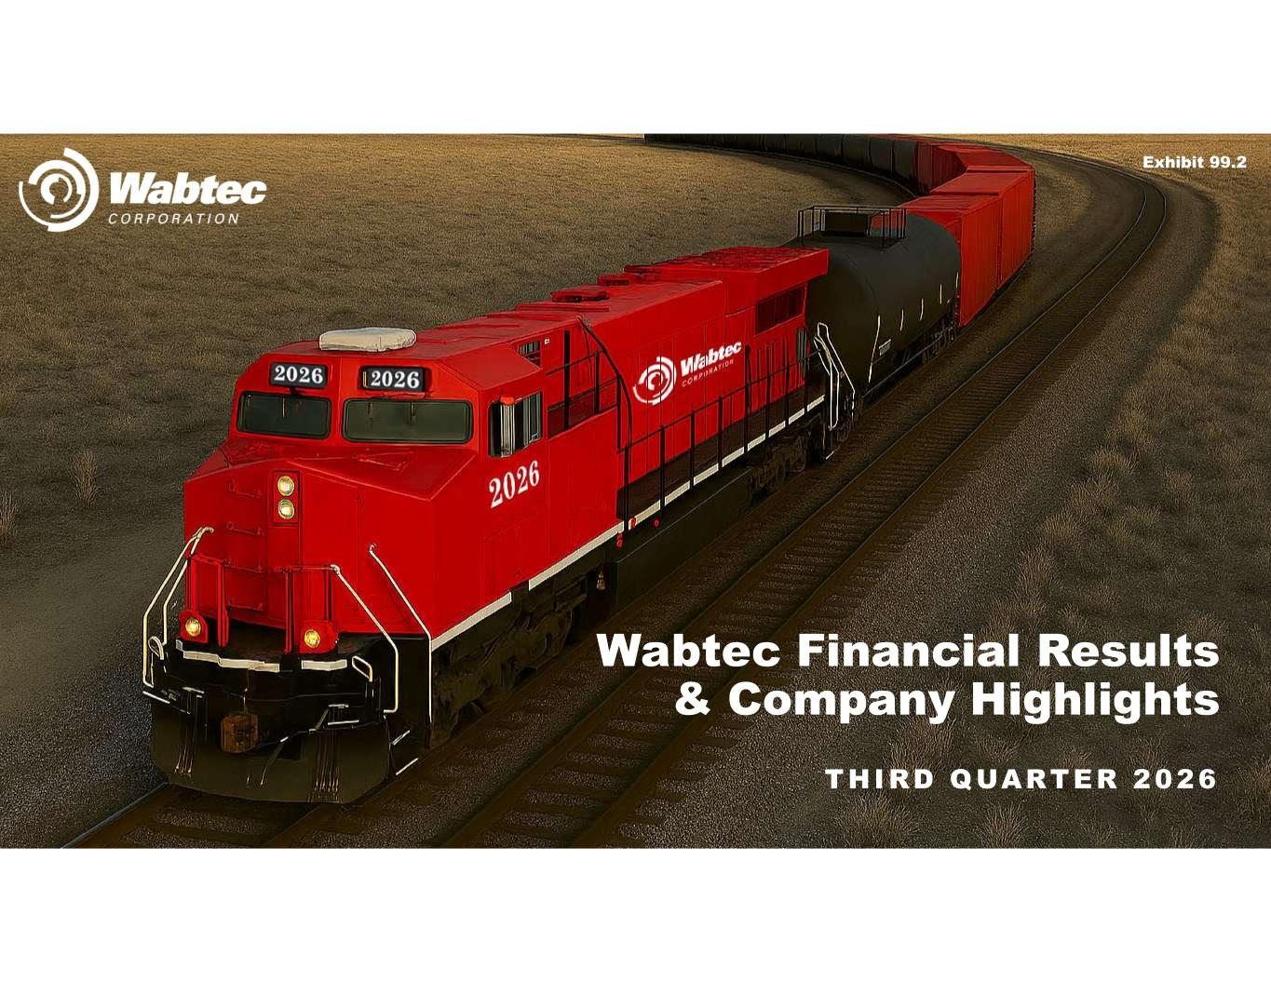

THIRD QUARTER 2026 Wabtec Financial Results & Company Highlights Exhibit 99.2

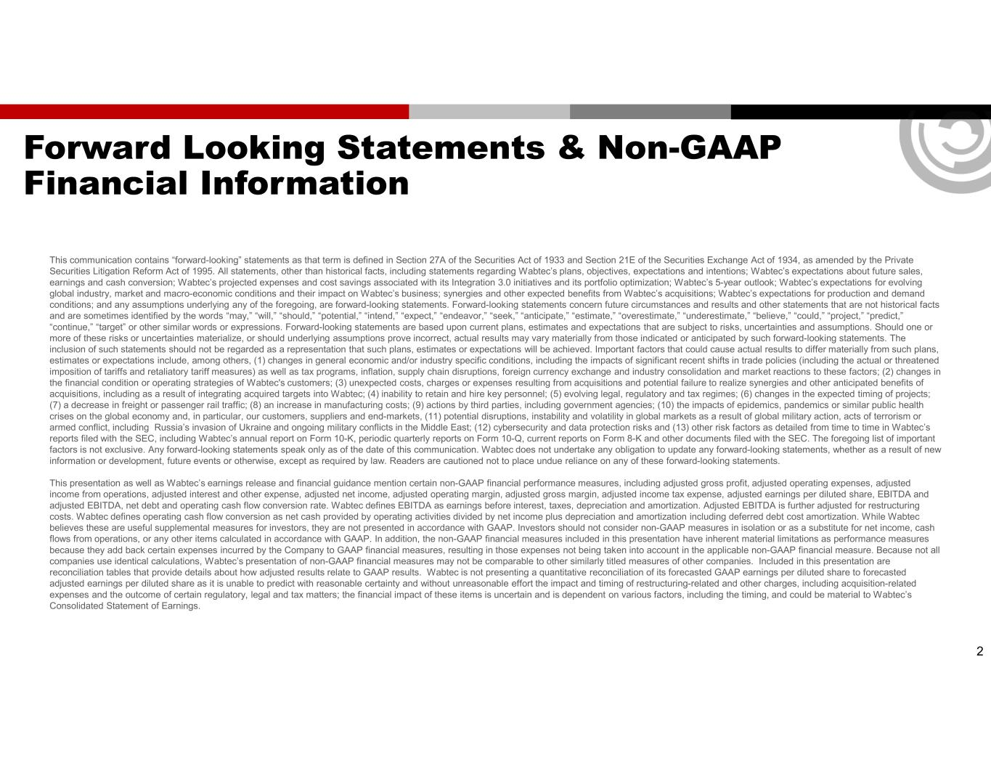
Forward Looking Statements & Non-GAAP Financial Information This communication contains “forward-looking” statements as that term is defined in Section 27A of the Securities Act of 1933 and Section 21E of the Securities Exchange Act of 1934, as amended by the Private Securities Litigation Reform Act of 1995. All statements, other than historical facts, including statements regarding Wabtec’s plans, objectives, expectations and intentions; Wabtec’s expectations about future sales, earnings and cash conversion; Wabtec’s projected expenses and cost savings associated with its Integration 3.0 initiatives and its portfolio optimization; Wabtec’s 5-year outlook; Wabtec’s expectations for evolving global industry, market and macro-economic conditions and their impact on Wabtec’s business; synergies and other expected benefits from Wabtec’s acquisitions; Wabtec’s expectations for production and demand conditions; and any assumptions underlying any of the foregoing, are forward-looking statements. Forward-looking statements concern future circumstances and results and other statements that are not historical facts and are sometimes identified by the words “may,” “will,” “should,” “potential,” “intend,” “expect,” “endeavor,” “seek,” “anticipate,” “estimate,” “overestimate,” “underestimate,” “believe,” “could,” “project,” “predict,” “continue,” “target” or other similar words or expressions. Forward-looking statements are based upon current plans, estimates and expectations that are subject to risks, uncertainties and assumptions. Should one or more of these risks or uncertainties materialize, or should underlying assumptions prove incorrect, actual results may vary materially from those indicated or anticipated by such forward-looking statements. The inclusion of such statements should not be regarded as a representation that such plans, estimates or expectations will be achieved. Important factors that could cause actual results to differ materially from such plans, estimates or expectations include, among others, (1) changes in general economic and/or industry specific conditions, including the impacts of significant recent shifts in trade policies (including the actual or threatened imposition of tariffs and retaliatory tariff measures) as well as tax programs, inflation, supply chain disruptions, foreign currency exchange and industry consolidation and market reactions to these factors; (2) changes in the financial condition or operating strategies of Wabtec's customers; (3) unexpected costs, charges or expenses resulting from acquisitions and potential failure to realize synergies and other anticipated benefits of acquisitions, including as a result of integrating acquired targets into Wabtec; (4) inability to retain and hire key personnel; (5) evolving legal, regulatory and tax regimes; (6) changes in the expected timing of projects; (7) a decrease in freight or passenger rail traffic; (8) an increase in manufacturing costs; (9) actions by third parties, including government agencies; (10) the impacts of epidemics, pandemics or similar public health crises on the global economy and, in particular, our customers, suppliers and end-markets, (11) potential disruptions, instability and volatility in global markets as a result of global military action, acts of terrorism or armed conflict, including Russia’s invasion of Ukraine and ongoing military conflicts in the Middle East; (12) cybersecurity and data protection risks and (13) other risk factors as detailed from time to time in Wabtec’s reports filed with the SEC, including Wabtec’s annual report on Form 10-K, periodic quarterly reports on Form 10-Q, current reports on Form 8-K and other documents filed with the SEC. The foregoing list of important factors is not exclusive. Any forward-looking statements speak only as of the date of this communication. Wabtec does not undertake any obligation to update any forward-looking statements, whether as a result of new information or development, future events or otherwise, except as required by law. Readers are cautioned not to place undue reliance on any of these forward-looking statements. This presentation as well as Wabtec’s earnings release and financial guidance mention certain non-GAAP financial performance measures, including adjusted gross profit, adjusted operating expenses, adjusted income from operations, adjusted interest and other expense, adjusted net income, adjusted operating margin, adjusted gross margin, adjusted income tax expense, adjusted earnings per diluted share, EBITDA and adjusted EBITDA, net debt and operating cash flow conversion rate. Wabtec defines EBITDA as earnings before interest, taxes, depreciation and amortization. Adjusted EBITDA is further adjusted for restructuring costs. Wabtec defines operating cash flow conversion as net cash provided by operating activities divided by net income plus depreciation and amortization including deferred debt cost amortization. While Wabtec believes these are useful supplemental measures for investors, they are not presented in accordance with GAAP. Investors should not consider non-GAAP measures in isolation or as a substitute for net income, cash flows from operations, or any other items calculated in accordance with GAAP. In addition, the non-GAAP financial measures included in this presentation have inherent material limitations as performance measures because they add back certain expenses incurred by the Company to GAAP financial measures, resulting in those expenses not being taken into account in the applicable non-GAAP financial measure. Because not all companies use identical calculations, Wabtec’s presentation of non-GAAP financial measures may not be comparable to other similarly titled measures of other companies. Included in this presentation are reconciliation tables that provide details about how adjusted results relate to GAAP results. Wabtec is not presenting a quantitative reconciliation of its forecasted GAAP earnings per diluted share to forecasted adjusted earnings per diluted share as it is unable to predict with reasonable certainty and without unreasonable effort the impact and timing of restructuring-related and other charges, including acquisition-related expenses and the outcome of certain regulatory, legal and tax matters; the financial impact of these items is uncertain and is dependent on various factors, including the timing, and could be material to Wabtec’s Consolidated Statement of Earnings. 2


3 RAFAEL SANTANA Chairman & Chief Executive Officer JOHN OLIN Executive Vice President & Chief Financial Officer KYRA YATES Vice President, Investor Relations Today’s Participants

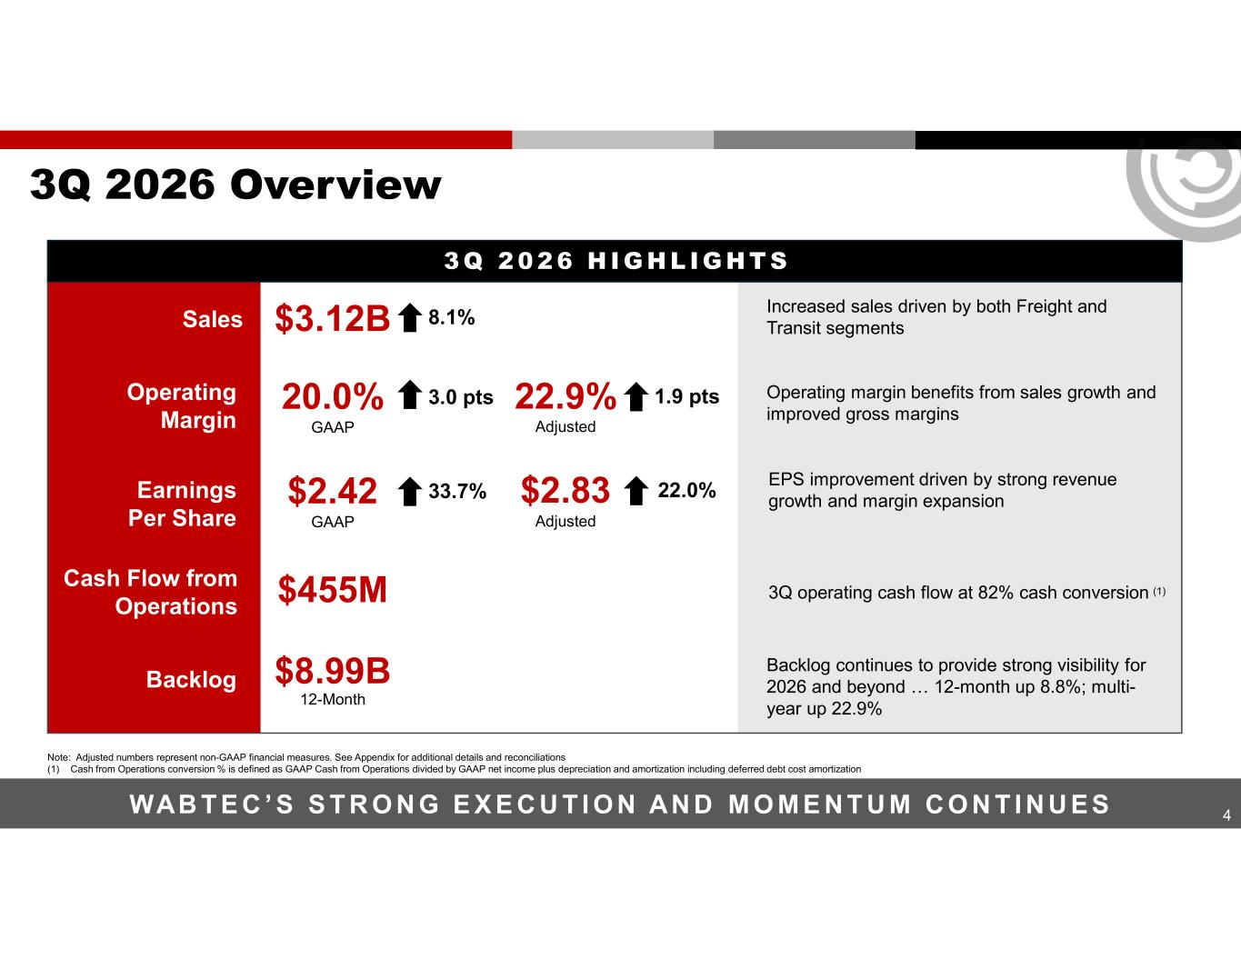
4 3Q 2026 Overview WAB T E C ’ S S T R O N G E X E C U T I O N AN D M O M E N T U M C O N T I N U E S Sales Increased sales driven by both Freight and Transit segments Operating margin benefits from sales growth and improved gross margins EPS improvement driven by strong revenue growth and margin expansion 3Q operating cash flow at 82% cash conversion (1) Backlog continues to provide strong visibility for 2026 and beyond … 12-month up 8.8%; multi- year up 22.9% Cash Flow from Operations $455M Backlog $8.99B 12-Month Operating Margin 20.0% GAAP 3.0 pts 22.9% Adjusted 1.9 pts Earnings Per Share $2.42 GAAP 33.7% $2.83 Adjusted 22.0% $3.12B 8.1% 3 Q 2 0 2 6 H I G H L IG H T S Note: Adjusted numbers represent non-GAAP financial measures. See Appendix for additional details and reconciliations (1) Cash from Operations conversion % is defined as GAAP Cash from Operations divided by GAAP net income plus depreciation and amortization including deferred debt cost amortization

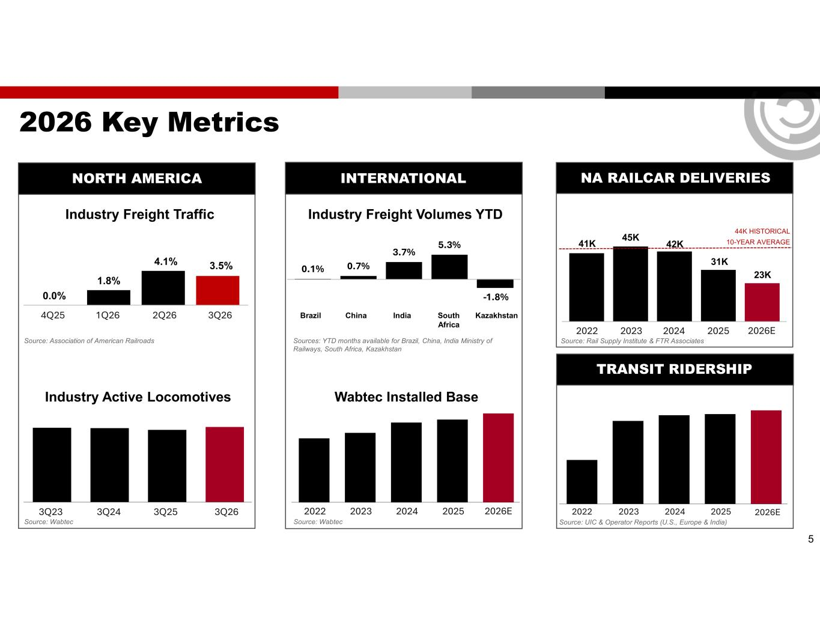
0.0% 1.8% 4.1% 3.5% 5 2026 Key Metrics 4Q25 1Q26 2Q26 3Q26 Industry Active Locomotives 3Q23 3Q24 3Q25 3Q26 Source: Association of American Railroads Source: Wabtec Industry Freight Traffic Source: UIC & Operator Reports (U.S., Europe & India) 2022 2023 2024 2025 Wabtec Installed Base 2022 2023 2024 2025 Industry Freight Volumes YTD Sources: YTD months available for Brazil, China, India Ministry of Railways, South Africa, Kazakhstan Brazil China India South Africa Kazakhstan Source: Wabtec TRANSIT RIDERSHIP NORTH AMERICA INTERNATIONAL NA RAILCAR DELIVERIES Source: Rail Supply Institute & FTR Associates 2022 2023 2024 2025 2026E 41K 45K 42K 31K 44K HISTORICAL 10-YEAR AVERAGE 23K 2026E 2026E 0.1% 0.7% 3.7% 5.3% -1.8%

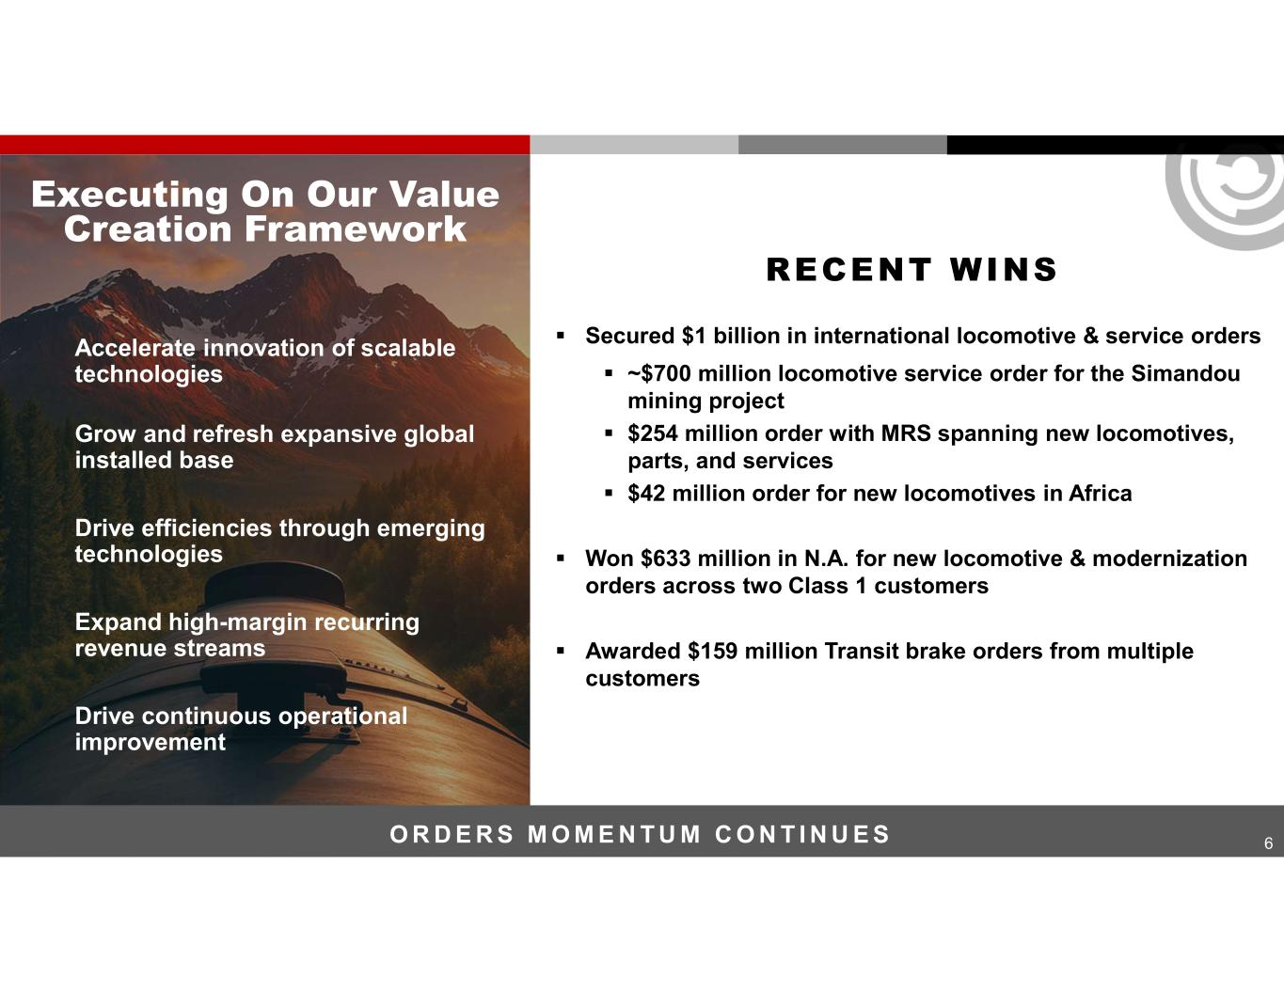
6 RECENT WINS Accelerate innovation of scalable technologies Grow and refresh expansive global installed base Drive efficiencies through emerging technologies Expand high-margin recurring revenue streams Drive continuous operational improvement Executing On Our Value Creation Framework O R D E R S M O M E N T U M C O N T I N U E S ▪ Secured $1 billion in international locomotive & service orders ▪ ~$700 million locomotive service order for the Simandou mining project ▪ $254 million order with MRS spanning new locomotives, parts, and services ▪ $42 million order for new locomotives in Africa ▪ Won $633 million in N.A. for new locomotive & modernization orders across two Class 1 customers ▪ Awarded $159 million Transit brake orders from multiple customers

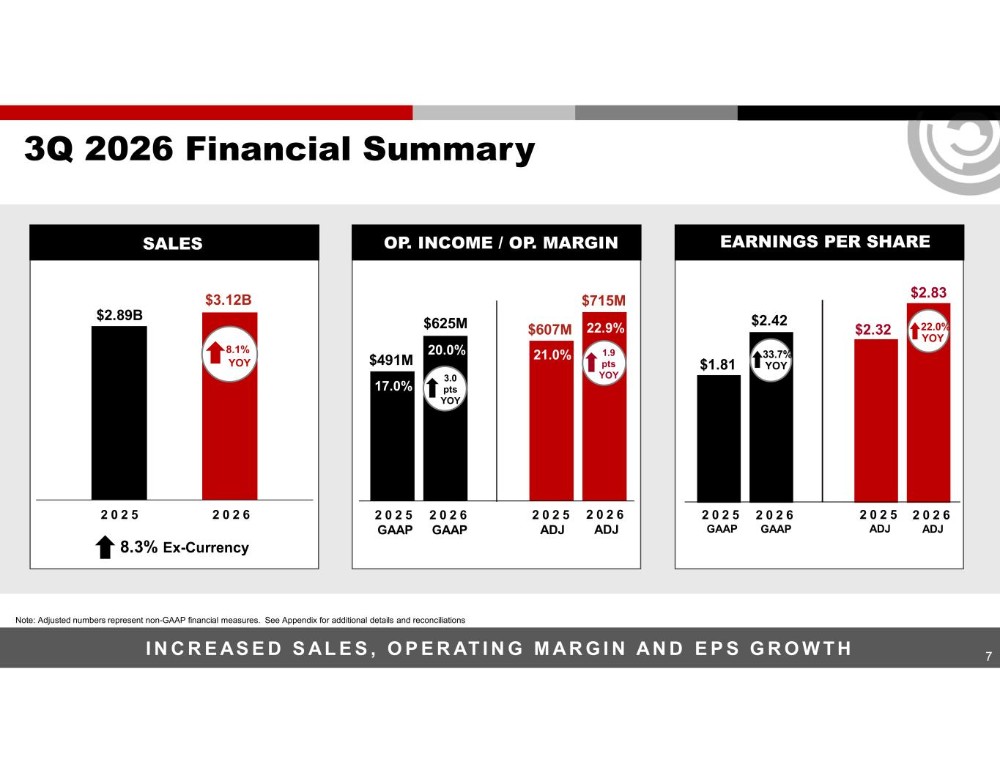
$1.81 $2.42 $2.32 $2.83 7 3Q 2026 Financial Summary I N C R E AS E D S AL E S , O P E R AT I N G M AR G I N AN D E P S G R O W T H Note: Adjusted numbers represent non-GAAP financial measures. See Appendix for additional details and reconciliations 2 0 2 5 GAAP 2 0 2 6 GAAP 2 0 2 5 ADJ 2 0 2 6 ADJ $491M 17.0% 20.0% $607M 21.0% $715M 22.9%$625M 2 0 2 5 2 0 2 6 2 0 2 5 GAAP 2 0 2 6 GAAP 2 0 2 5 ADJ 2 0 2 6 ADJ $3.12B $2.89B 8.1% YOY 33.7% YOY 22.0% YOY 8.3% Ex-Currency OP. INCOME / OP. MARGIN EARNINGS PER SHARESALES 3.0 pts YOY 1.9 pts YOY

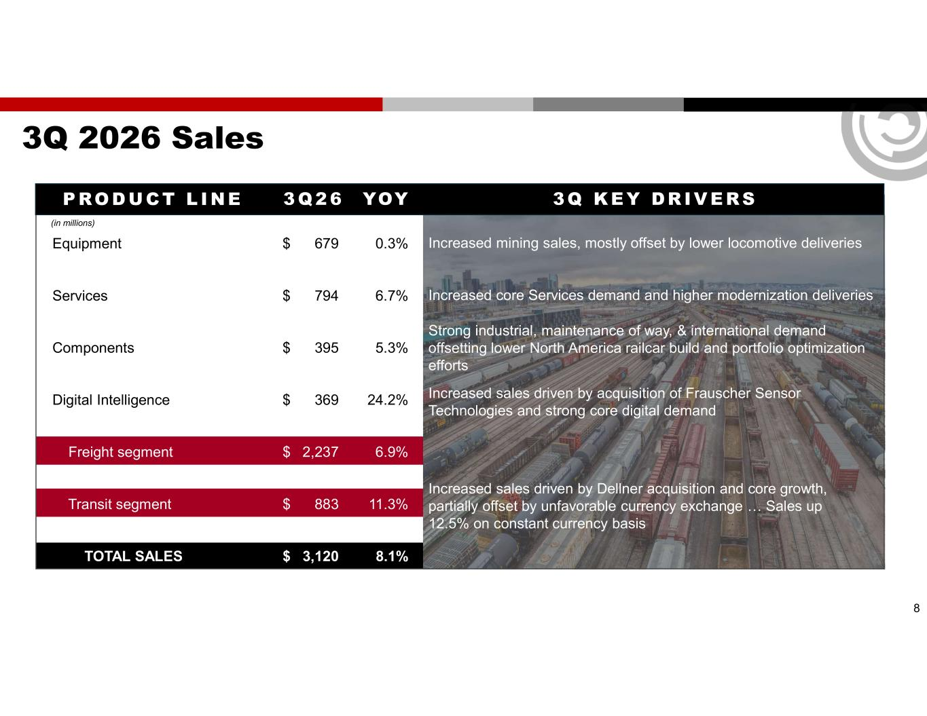
3Q 2026 Sales P RO D U CT L I N E 3 Q 2 6 YOY 3Q K E Y DR IV E RS (in millions) Equipment $ 679 0.3% Services $ 794 6.7% Components $ 395 5.3% Digital Intelligence $ 369 24.2% Freight segment $ 2,237 6.9% Transit segment $ 883 11.3% TOTAL SALES $ 3,120 8.1% Increased core Services demand and higher modernization deliveries Increased mining sales, mostly offset by lower locomotive deliveries Strong industrial, maintenance of way, & international demand offsetting lower North America railcar build and portfolio optimization efforts Increased sales driven by acquisition of Frauscher Sensor Technologies and strong core digital demand Increased sales driven by Dellner acquisition and core growth, partially offset by unfavorable currency exchange … Sales up 12.5% on constant currency basis 8

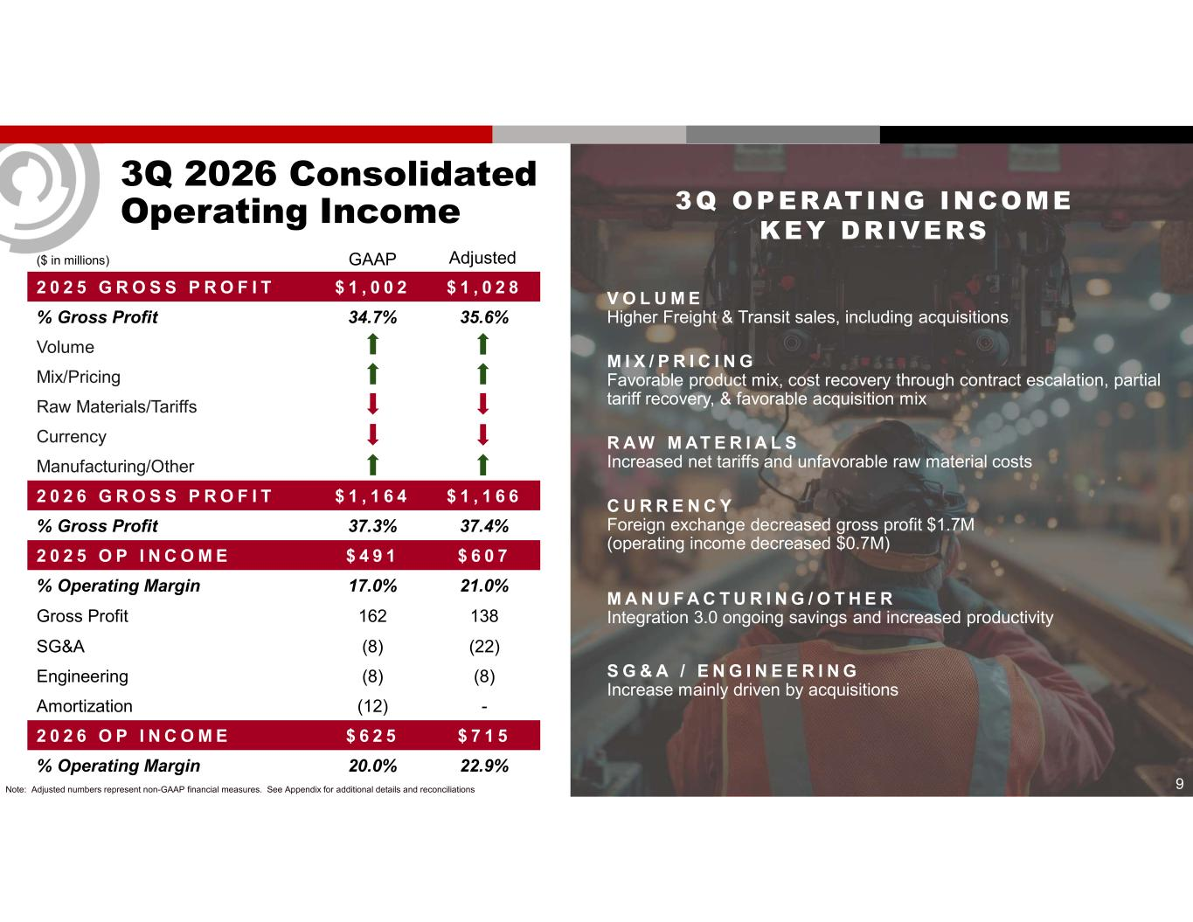
9 3Q 2026 Consolidated Operating Income ($ in millions) $ 1 , 0 2 8$ 1 , 0 0 22 0 2 5 G R O S S P R O F I T 35.6%34.7%% Gross Profit Volume Mix/Pricing Raw Materials/Tariffs Currency Manufacturing/Other $ 1 , 1 6 6$ 1 , 1 6 42 0 2 6 G R O S S P R O F I T 37.4%37.3%% Gross Profit $ 6 0 7$ 4 9 12 0 2 5 O P I N C O M E 21.0%17.0%% Operating Margin 138162Gross Profit (22)(8)SG&A (8)(8)Engineering -(12)Amortization $ 7 1 5$ 6 2 52 0 2 6 O P I N C O M E 22.9%20.0%% Operating Margin GAAP Adjusted Note: Adjusted numbers represent non-GAAP financial measures. See Appendix for additional details and reconciliations V O L U M E Higher Freight & Transit sales, including acquisitions M I X / P R I C I N G Favorable product mix, cost recovery through contract escalation, partial tariff recovery, & favorable acquisition mix R AW M AT E R I A L S Increased net tariffs and unfavorable raw material costs C U R R E N C Y Foreign exchange decreased gross profit $1.7M (operating income decreased $0.7M) M A N U F A C T U R I N G / O T H E R Integration 3.0 ongoing savings and increased productivity S G & A / E N G I N E E R I N G Increase mainly driven by acquisitions 3Q OPERATING INCOME KEY DRIVERS

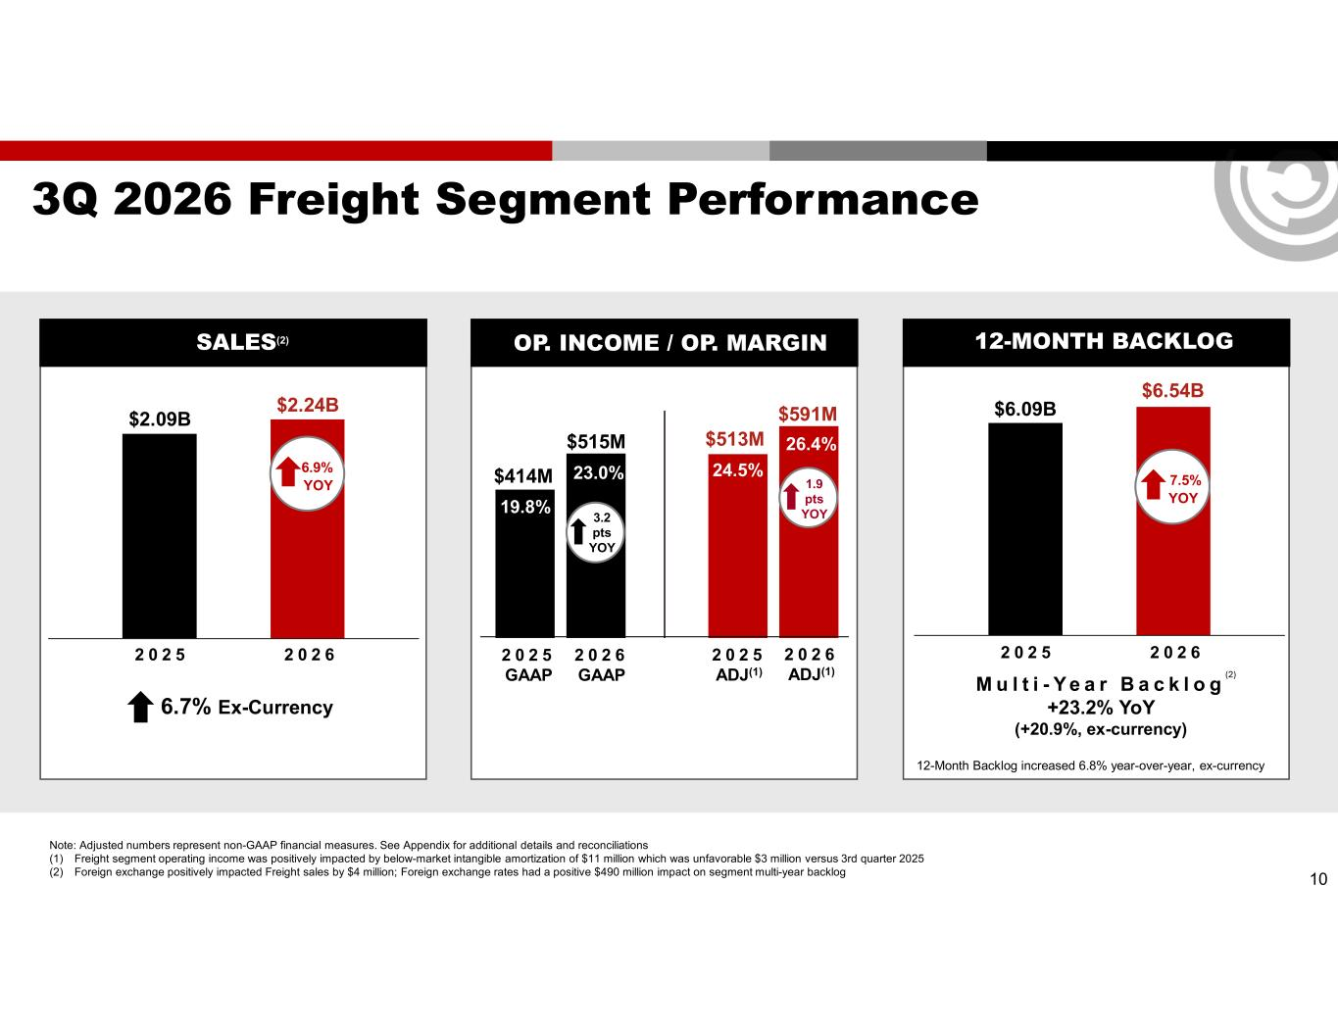
10 3Q 2026 Freight Segment Performance 2 0 2 5 GAAP 2 0 2 6 GAAP 2 0 2 5 ADJ(1) 2 0 2 6 ADJ(1) $414M 23.0% 19.8% $513M 24.5% $591M 26.4%$515M 2 0 2 5 2 0 2 6 $2.24B $2.09B 6.9% YOY 2 0 2 5 2 0 2 6 $6.54B $6.09B 7.5% YOY Note: Adjusted numbers represent non-GAAP financial measures. See Appendix for additional details and reconciliations (1) Freight segment operating income was positively impacted by below-market intangible amortization of $11 million which was unfavorable $3 million versus 3rd quarter 2025 (2) Foreign exchange positively impacted Freight sales by $4 million; Foreign exchange rates had a positive $490 million impact on segment multi-year backlog 12-Month Backlog increased 6.8% year-over-year, ex-currency M u l t i - Y e a r B a c k l o g +23.2% YoY (+20.9%, ex-currency) 6.7% Ex-Currency OP. INCOME / OP. MARGIN 12-MONTH BACKLOGSALES(2) 3.2 pts YOY 1.9 pts YOY (2)

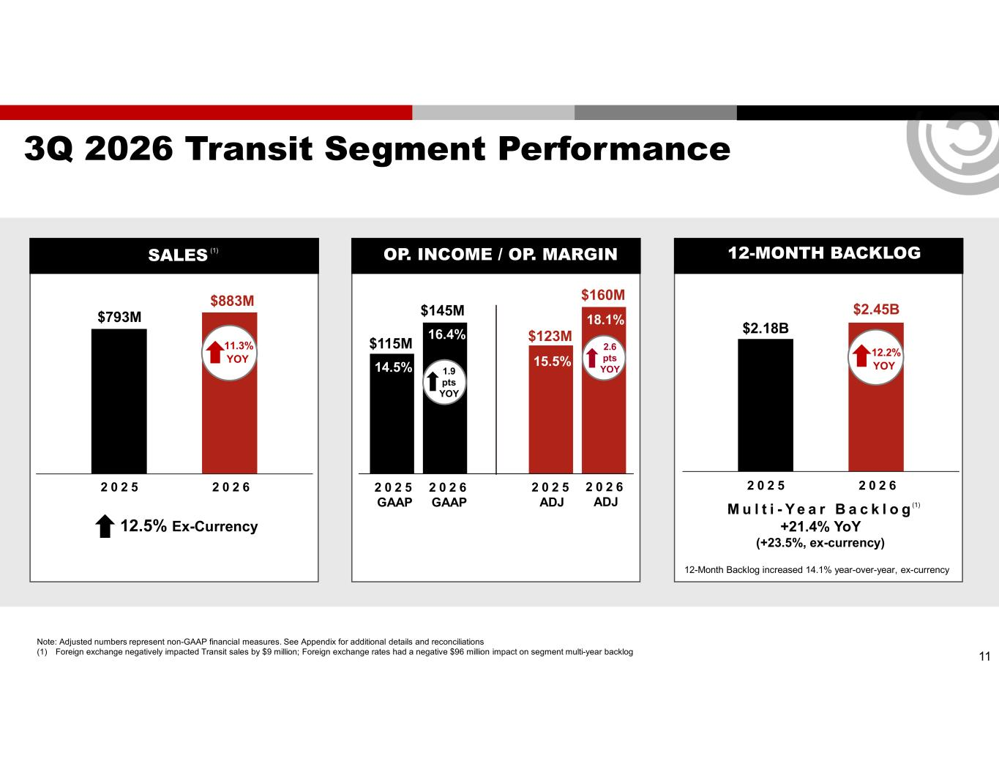
11 3Q 2026 Transit Segment Performance 2 0 2 5 GAAP 2 0 2 6 GAAP 2 0 2 5 ADJ 2 0 2 6 ADJ 2 0 2 5 2 0 2 6 2 0 2 5 2 0 2 6 12-Month Backlog increased 14.1% year-over-year, ex-currency M u l t i - Y e a r B a c k l o g +21.4% YoY (+23.5%, ex-currency) 12.5% Ex-Currency OP. INCOME / OP. MARGIN 12-MONTH BACKLOGSALES $115M 14.5% 16.4% $123M 15.5% $160M 18.1% $145M $883M $793M 11.3% YOY $2.45B $2.18B 12.2% YOY Note: Adjusted numbers represent non-GAAP financial measures. See Appendix for additional details and reconciliations (1) Foreign exchange negatively impacted Transit sales by $9 million; Foreign exchange rates had a negative $96 million impact on segment multi-year backlog 1.9 pts YOY 2.6 pts YOY (1) (1)

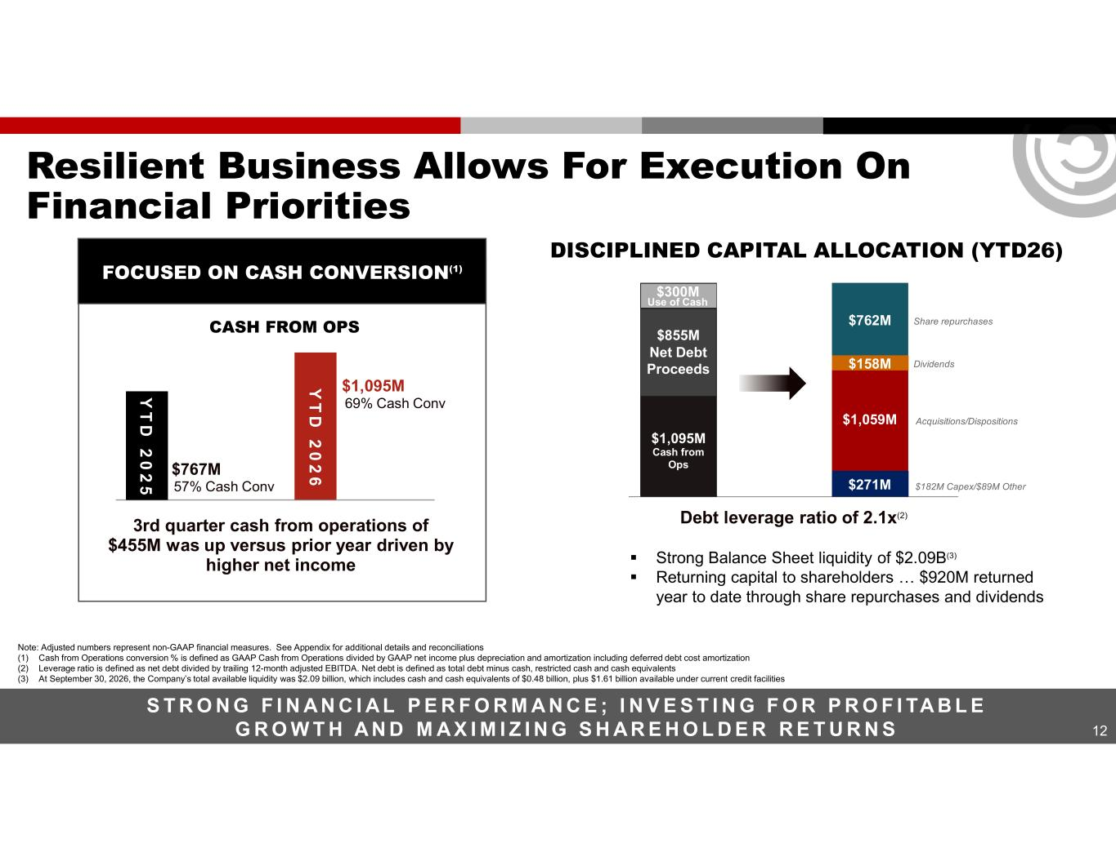
12 Resilient Business Allows For Execution On Financial Priorities S T R O N G F I N A N C I A L P E R F O R M A N C E ; I N V E S T I N G F O R P R O F I TA B L E G R O W T H A N D M A X I M I Z I N G S H A R E H O L D E R R E T U R N S 3rd quarter cash from operations of $455M was up versus prior year driven by higher net income 57% Cash Conv $767M $1,095MY T D 2 0 2 6 69% Cash Conv Y T D 2 0 2 5 Debt leverage ratio of 2.1x(2) FOCUSED ON CASH CONVERSION(1) DISCIPLINED CAPITAL ALLOCATION (YTD26) $1,095M Cash from Ops $1,059M $182M Capex/$89M Other Dividends$158M $271M $762M $855M Net Debt Proceeds Acquisitions/Dispositions Share repurchases ▪ Strong Balance Sheet liquidity of $2.09B(3) ▪ Returning capital to shareholders … $920M returned year to date through share repurchases and dividends Note: Adjusted numbers represent non-GAAP financial measures. See Appendix for additional details and reconciliations (1) Cash from Operations conversion % is defined as GAAP Cash from Operations divided by GAAP net income plus depreciation and amortization including deferred debt cost amortization (2) Leverage ratio is defined as net debt divided by trailing 12-month adjusted EBITDA. Net debt is defined as total debt minus cash, restricted cash and cash equivalents (3) At September 30, 2026, the Company’s total available liquidity was $2.09 billion, which includes cash and cash equivalents of $0.48 billion, plus $1.61 billion available under current credit facilities CASH FROM OPS $300M Use of Cash

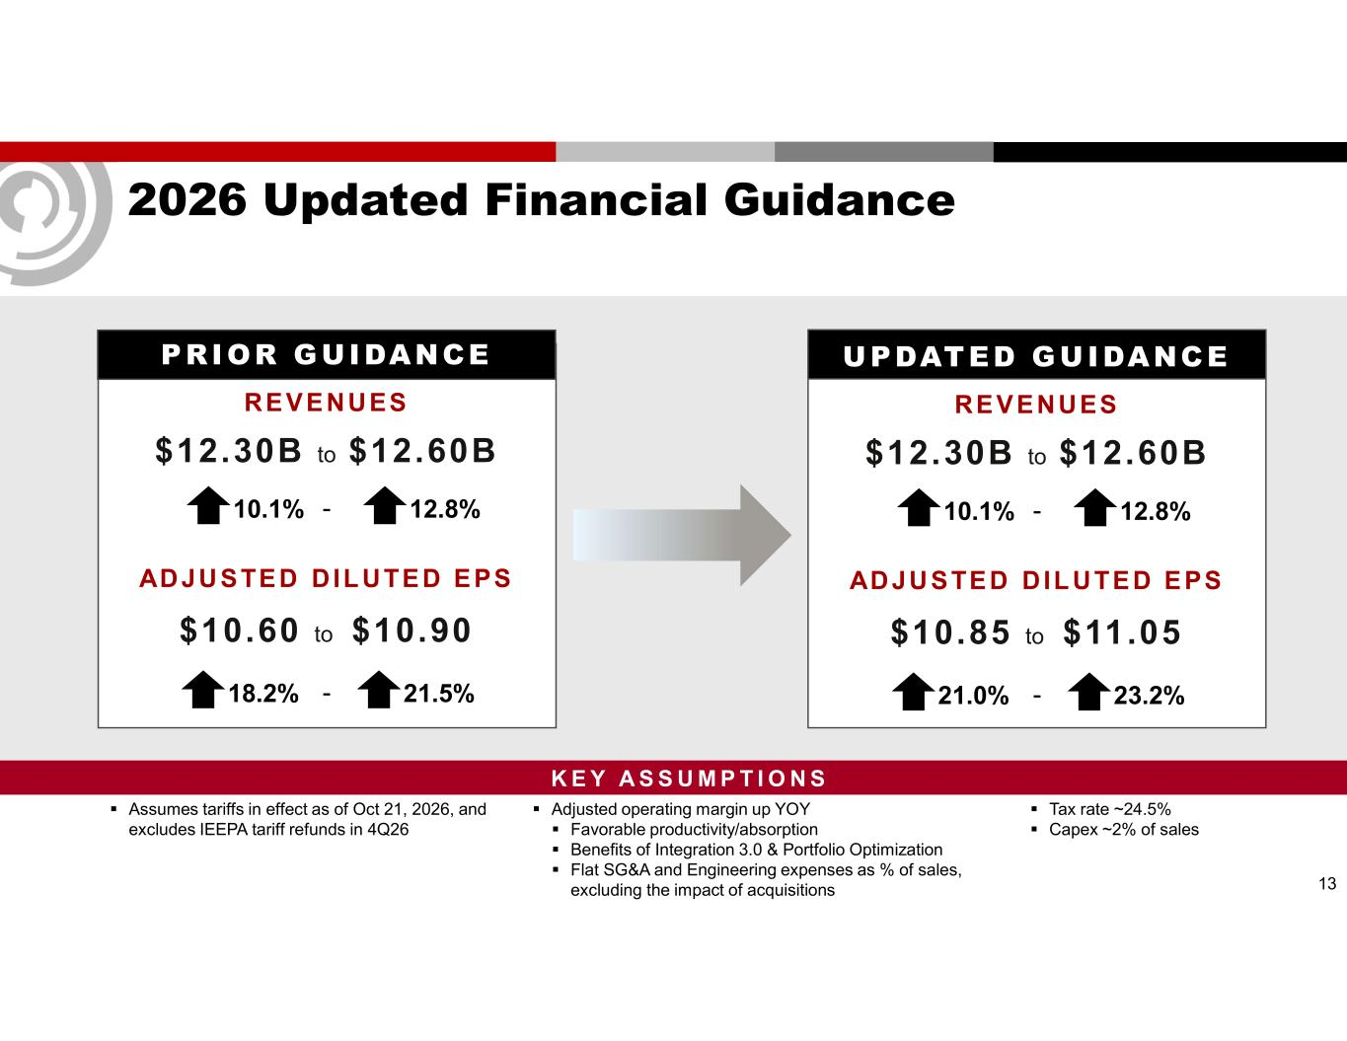
2026 Updated Financial Guidance PRIOR GUIDANCE REVENUES $12.30B to $12.60B ADJUSTED DIL UTED EPS $10.60 to $10.90 10.1% 12.8% 18.2% 21.5%- - 13 ▪ Assumes tariffs in effect as of Oct 21, 2026, and excludes IEEPA tariff refunds in 4Q26 UPDATED GUIDANCE REVENUES $12.30B to $12.60B ADJUSTED DIL UTED EPS $10.85 to $11.05 10.1% 12.8% 21.0% 23.2%- - ▪ Tax rate ~24.5% ▪ Capex ~2% of sales ▪ Adjusted operating margin up YOY ▪ Favorable productivity/absorption ▪ Benefits of Integration 3.0 & Portfolio Optimization ▪ Flat SG&A and Engineering expenses as % of sales, excluding the impact of acquisitions K E Y A S S U M P T I O N S

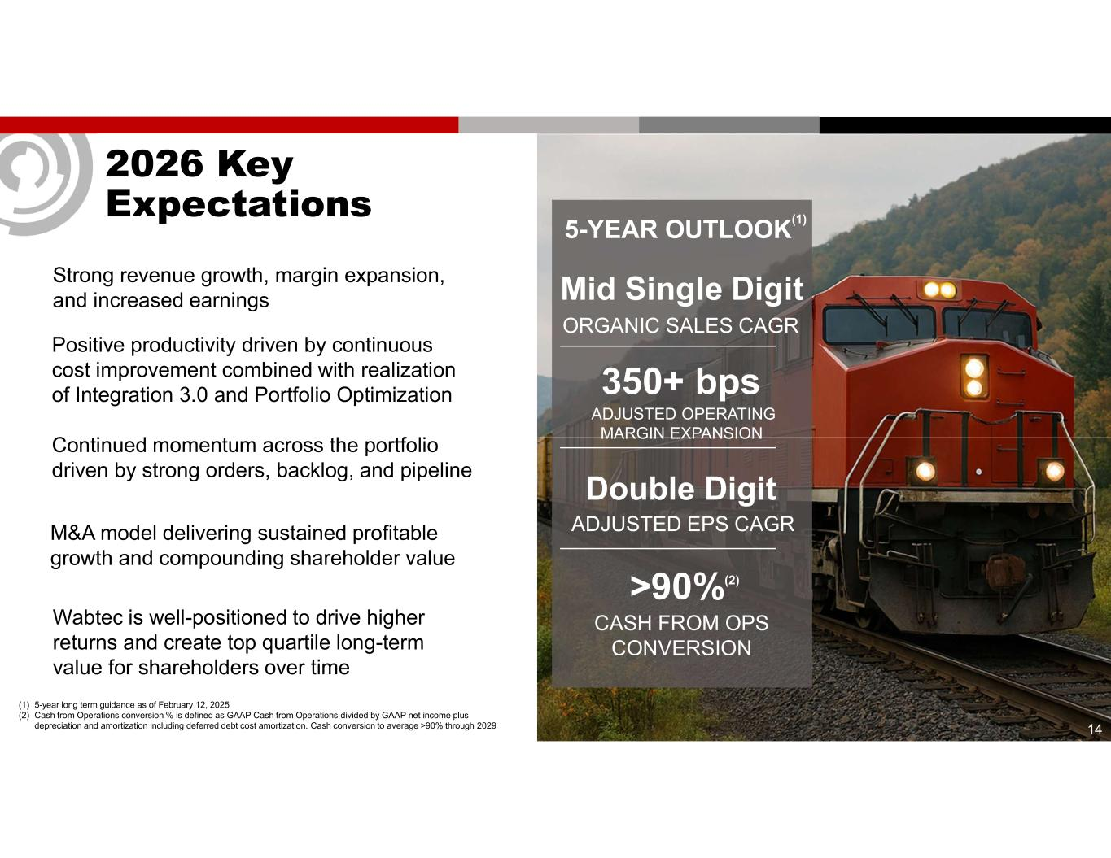
14 2026 Key Expectations Continued momentum across the portfolio driven by strong orders, backlog, and pipeline Positive productivity driven by continuous cost improvement combined with realization of Integration 3.0 and Portfolio Optimization Wabtec is well-positioned to drive higher returns and create top quartile long-term value for shareholders over time Strong revenue growth, margin expansion, and increased earnings 5-YEAR OUTLOOK (1) Mid Single Digit ORGANIC SALES CAGR Double Digit ADJUSTED EPS CAGR >90%(2) CASH FROM OPS CONVERSION 350+ bps ADJUSTED OPERATING MARGIN EXPANSION (1) 5-year long term guidance as of February 12, 2025 (2) Cash from Operations conversion % is defined as GAAP Cash from Operations divided by GAAP net income plus depreciation and amortization including deferred debt cost amortization. Cash conversion to average >90% through 2029 M&A model delivering sustained profitable growth and compounding shareholder value

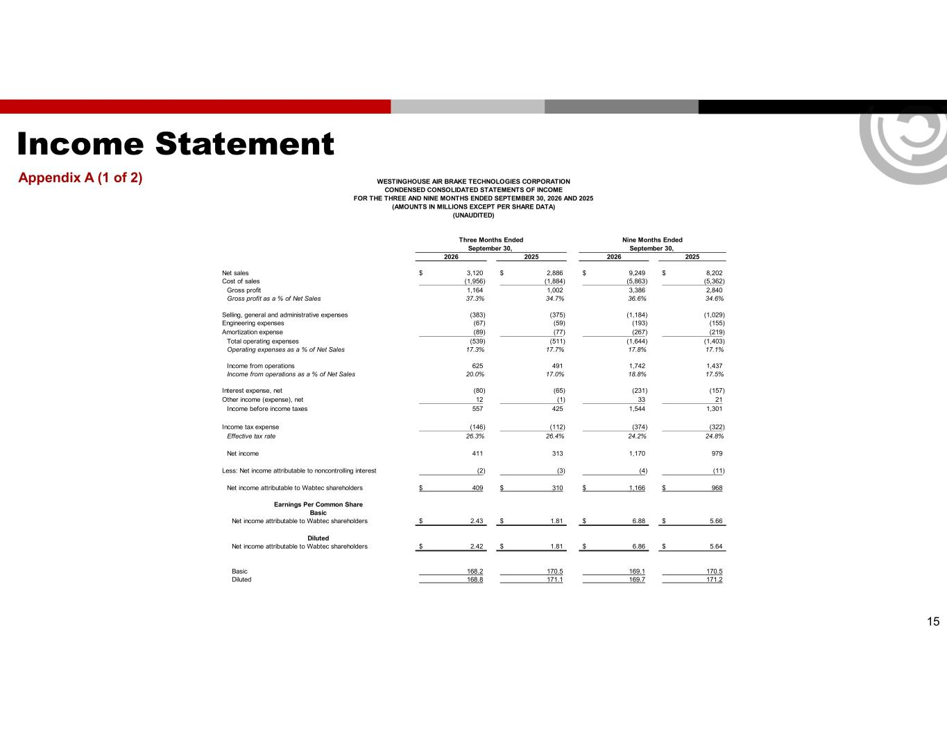
Income Statement Appendix A (1 of 2) 15 2026 2025 2026 2025 Net sales 3,120$ 2,886$ 9,249$ 8,202$ Cost of sales (1,956) (1,884) (5,863) (5,362) Gross profit 1,164 1,002 3,386 2,840 Gross profit as a % of Net Sales 37.3% 34.7% 36.6% 34.6% Selling, general and administrative expenses (383) (375) (1,184) (1,029) Engineering expenses (67) (59) (193) (155) Amortization expense (89) (77) (267) (219) Total operating expenses (539) (511) (1,644) (1,403) Operating expenses as a % of Net Sales 17.3% 17.7% 17.8% 17.1% Income from operations 625 491 1,742 1,437 Income from operations as a % of Net Sales 20.0% 17.0% 18.8% 17.5% Interest expense, net (80) (65) (231) (157) Other income (expense), net 12 (1) 33 21 Income before income taxes 557 425 1,544 1,301 Income tax expense (146) (112) (374) (322) Effective tax rate 26.3% 26.4% 24.2% 24.8% Net income 411 313 1,170 979 Less: Net income attributable to noncontrolling interest (2) (3) (4) (11) Net income attributable to Wabtec shareholders 409$ 310$ 1,166$ 968$ Earnings Per Common Share Basic Net income attributable to Wabtec shareholders 2.43$ 1.81$ 6.88$ 5.66$ Diluted Net income attributable to Wabtec shareholders 2.42$ 1.81$ 6.86$ 5.64$ Basic 168.2 170.5 169.1 170.5 Diluted 168.8 171.1 169.7 171.2 September 30, September 30, Three Months Ended Nine Months Ended WESTINGHOUSE AIR BRAKE TECHNOLOGIES CORPORATION CONDENSED CONSOLIDATED STATEMENTS OF INCOME FOR THE THREE AND NINE MONTHS ENDED SEPTEMBER 30, 2026 AND 2025 (AMOUNTS IN MILLIONS EXCEPT PER SHARE DATA) (UNAUDITED)

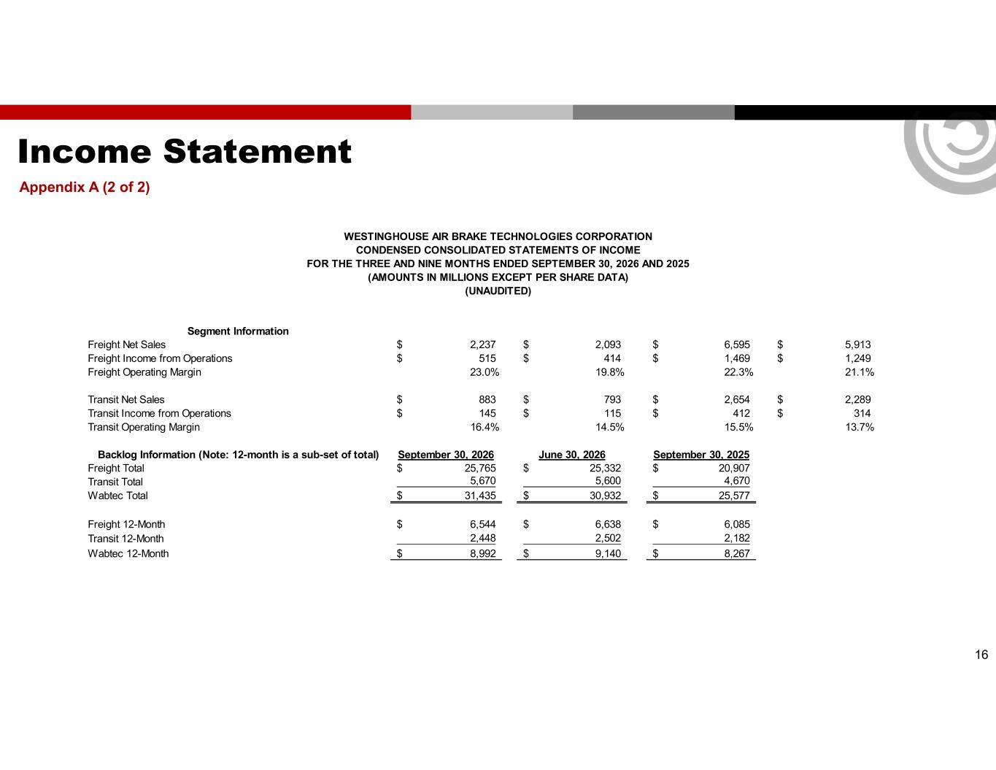
Income Statement Appendix A (2 of 2) 16 Segment Information Freight Net Sales 2,237$ 2,093$ 6,595$ 5,913$ Freight Income from Operations 515$ 414$ 1,469$ 1,249$ Freight Operating Margin 23.0% 19.8% 22.3% 21.1% Transit Net Sales 883$ 793$ 2,654$ 2,289$ Transit Income from Operations 145$ 115$ 412$ 314$ Transit Operating Margin 16.4% 14.5% 15.5% 13.7% Backlog Information (Note: 12-month is a sub-set of total) September 30, 2026 June 30, 2026 September 30, 2025 Freight Total 25,765$ 25,332$ 20,907$ Transit Total 5,670 5,600 4,670 Wabtec Total 31,435$ 30,932$ 25,577$ Freight 12-Month 6,544$ 6,638$ 6,085$ Transit 12-Month 2,448 2,502 2,182 Wabtec 12-Month 8,992$ 9,140$ 8,267$ WESTINGHOUSE AIR BRAKE TECHNOLOGIES CORPORATION CONDENSED CONSOLIDATED STATEMENTS OF INCOME FOR THE THREE AND NINE MONTHS ENDED SEPTEMBER 30, 2026 AND 2025 (AMOUNTS IN MILLIONS EXCEPT PER SHARE DATA) (UNAUDITED)

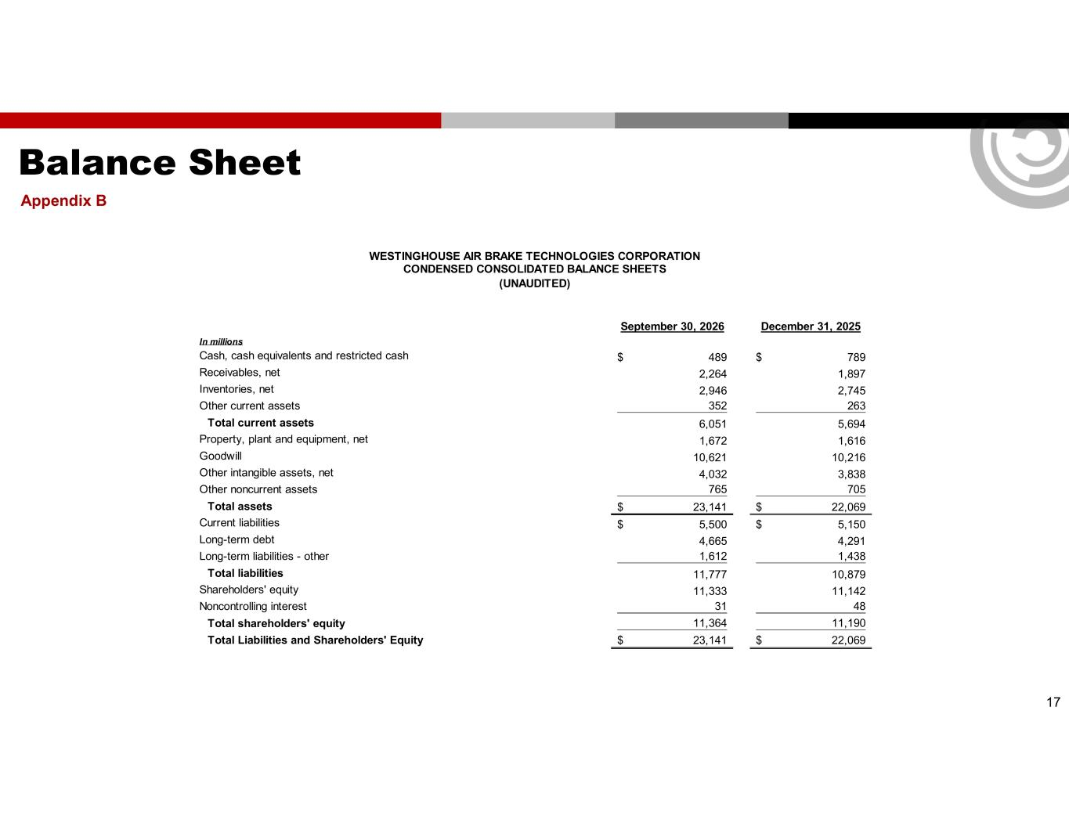
Balance Sheet Appendix B 17 September 30, 2026 December 31, 2025 In millions Cash, cash equivalents and restricted cash 489$ 789$ Receivables, net 2,264 1,897 Inventories, net 2,946 2,745 Other current assets 352 263 Total current assets 6,051 5,694 Property, plant and equipment, net 1,672 1,616 Goodwill 10,621 10,216 Other intangible assets, net 4,032 3,838 Other noncurrent assets 765 705 Total assets 23,141$ 22,069$ Current liabilities 5,500$ 5,150$ Long-term debt 4,665 4,291 Long-term liabilities - other 1,612 1,438 Total liabilities 11,777 10,879 Shareholders' equity 11,333 11,142 Noncontrolling interest 31 48 Total shareholders' equity 11,364 11,190 Total Liabilities and Shareholders' Equity 23,141$ 22,069$ WESTINGHOUSE AIR BRAKE TECHNOLOGIES CORPORATION CONDENSED CONSOLIDATED BALANCE SHEETS (UNAUDITED)

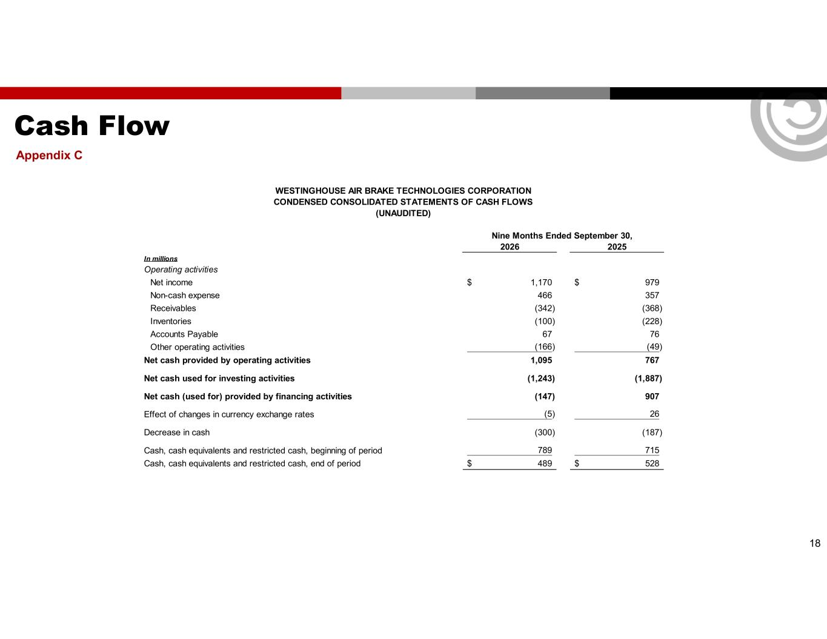
Cash Flow Appendix C 18 2026 2025 In millions Operating activities Net income 1,170$ 979$ Non-cash expense 466 357 Receivables (342) (368) Inventories (100) (228) Accounts Payable 67 76 Other operating activities (166) (49) Net cash provided by operating activities 1,095 767 Net cash used for investing activities (1,243) (1,887) Net cash (used for) provided by financing activities (147) 907 Effect of changes in currency exchange rates (5) 26 Decrease in cash (300) (187) Cash, cash equivalents and restricted cash, beginning of period 789 715 Cash, cash equivalents and restricted cash, end of period 489$ 528$ WESTINGHOUSE AIR BRAKE TECHNOLOGIES CORPORATION CONDENSED CONSOLIDATED STATEMENTS OF CASH FLOWS (UNAUDITED) Nine Months Ended September 30,

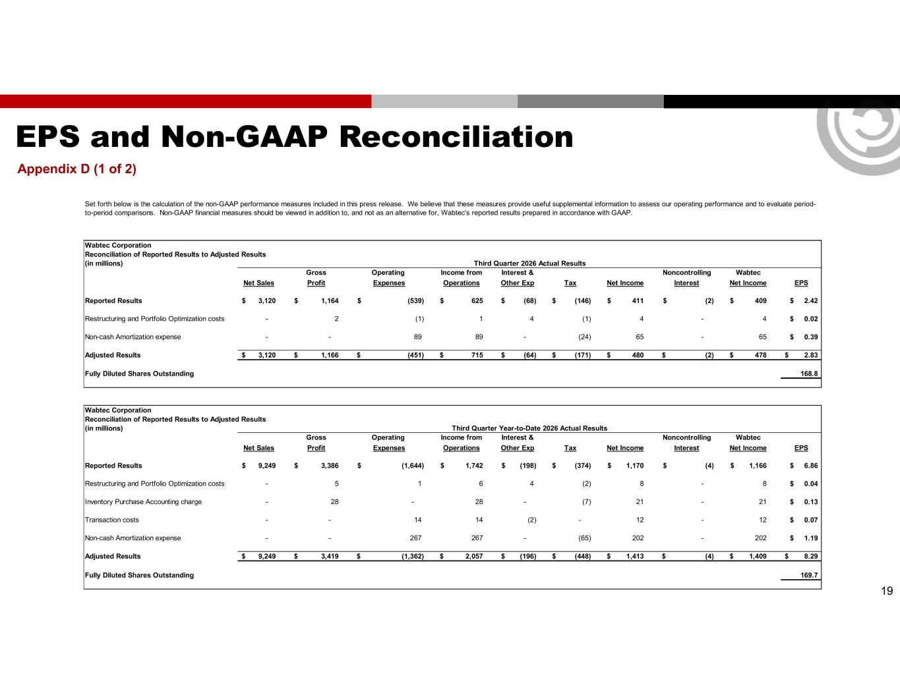
EPS and Non-GAAP Reconciliation Appendix D (1 of 2) 19 Wabtec Corporation Reconciliation of Reported Results to Adjusted Results (in millions) Gross Operating Income from Interest & Noncontrolling Wabtec Net Sales Profit Expenses Operations Other Exp Tax Net Income Interest Net Income EPS Reported Results 3,120$ 1,164$ (539)$ 625$ (68)$ (146)$ 411$ (2)$ 409$ 2.42$ Restructuring and Portfolio Optimization costs - 2 (1) 1 4 (1) 4 - 4 0.02$ Non-cash Amortization expense - - 89 89 - (24) 65 - 65 0.39$ Adjusted Results 3,120$ 1,166$ (451)$ 715$ (64)$ (171)$ 480$ (2)$ 478$ 2.83$ Fully Diluted Shares Outstanding 168.8 Wabtec Corporation Reconciliation of Reported Results to Adjusted Results (in millions) Gross Operating Income from Interest & Noncontrolling Wabtec Net Sales Profit Expenses Operations Other Exp Tax Net Income Interest Net Income EPS Reported Results 9,249$ 3,386$ (1,644)$ 1,742$ (198)$ (374)$ 1,170$ (4)$ 1,166$ 6.86$ Restructuring and Portfolio Optimization costs - 5 1 6 4 (2) 8 - 8 0.04$ Inventory Purchase Accounting charge - 28 - 28 - (7) 21 - 21 0.13$ Transaction costs - - 14 14 (2) - 12 - 12 0.07$ Non-cash Amortization expense - - 267 267 - (65) 202 - 202 1.19$ Adjusted Results 9,249$ 3,419$ (1,362)$ 2,057$ (196)$ (448)$ 1,413$ (4)$ 1,409$ 8.29$ Fully Diluted Shares Outstanding 169.7 Set forth below is the calculation of the non-GAAP performance measures included in this press release. We believe that these measures provide useful supplemental information to assess our operating performance and to evaluate period- to-period comparisons. Non-GAAP financial measures should be viewed in addition to, and not as an alternative for, Wabtec's reported results prepared in accordance with GAAP. Third Quarter 2026 Actual Results Third Quarter Year-to-Date 2026 Actual Results

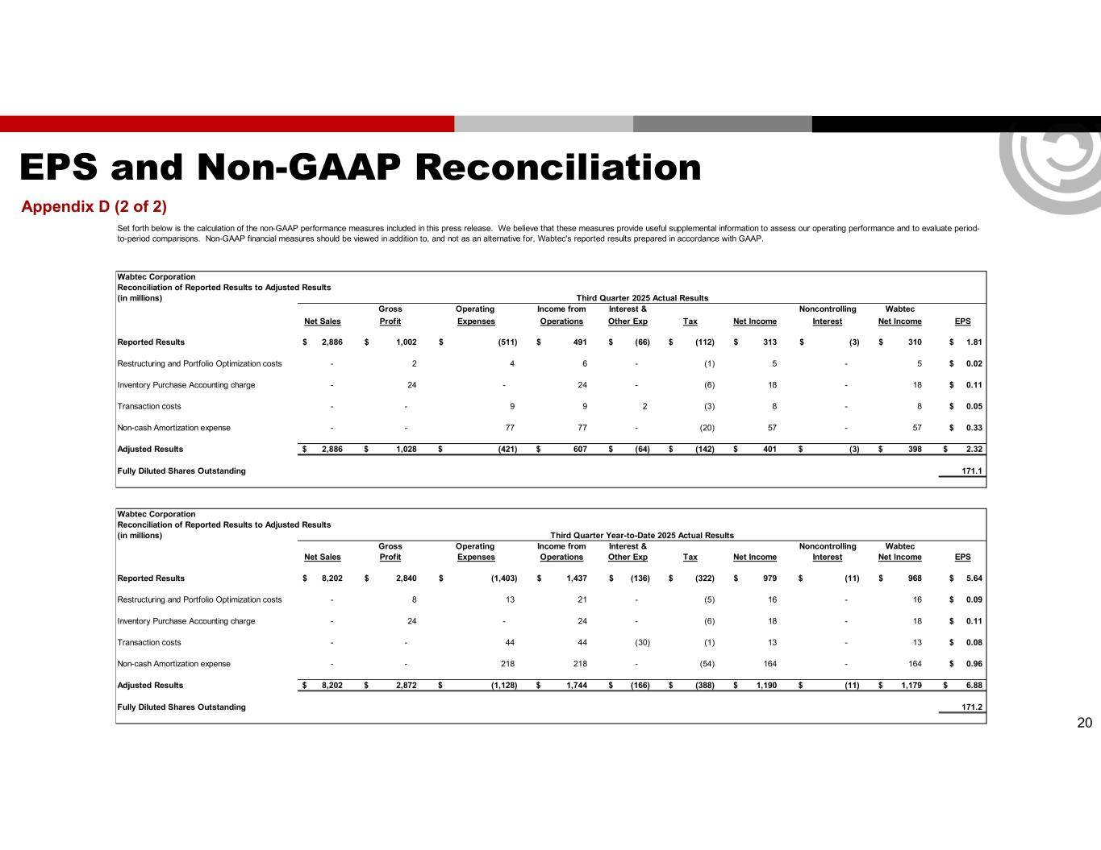
EPS and Non-GAAP Reconciliation Appendix D (2 of 2) 20 Wabtec Corporation Reconciliation of Reported Results to Adjusted Results (in millions) Gross Operating Income from Interest & Noncontrolling Wabtec Net Sales Profit Expenses Operations Other Exp Tax Net Income Interest Net Income EPS Reported Results 2,886$ 1,002$ (511)$ 491$ (66)$ (112)$ 313$ (3)$ 310$ 1.81$ Restructuring and Portfolio Optimization costs - 2 4 6 - (1) 5 - 5 0.02$ Inventory Purchase Accounting charge - 24 - 24 - (6) 18 - 18 0.11$ Transaction costs - - 9 9 2 (3) 8 - 8 0.05$ Non-cash Amortization expense - - 77 77 - (20) 57 - 57 0.33$ Adjusted Results 2,886$ 1,028$ (421)$ 607$ (64)$ (142)$ 401$ (3)$ 398$ 2.32$ Fully Diluted Shares Outstanding 171.1 Wabtec Corporation Reconciliation of Reported Results to Adjusted Results (in millions) Gross Operating Income from Interest & Noncontrolling Wabtec Net Sales Profit Expenses Operations Other Exp Tax Net Income Interest Net Income EPS Reported Results 8,202$ 2,840$ (1,403)$ 1,437$ (136)$ (322)$ 979$ (11)$ 968$ 5.64$ Restructuring and Portfolio Optimization costs - 8 13 21 - (5) 16 - 16 0.09$ Inventory Purchase Accounting charge - 24 - 24 - (6) 18 - 18 0.11$ Transaction costs - - 44 44 (30) (1) 13 - 13 0.08$ Non-cash Amortization expense - - 218 218 - (54) 164 - 164 0.96$ Adjusted Results 8,202$ 2,872$ (1,128)$ 1,744$ (166)$ (388)$ 1,190$ (11)$ 1,179$ 6.88$ Fully Diluted Shares Outstanding 171.2 Third Quarter Year-to-Date 2025 Actual Results Set forth below is the calculation of the non-GAAP performance measures included in this press release. We believe that these measures provide useful supplemental information to assess our operating performance and to evaluate period- to-period comparisons. Non-GAAP financial measures should be viewed in addition to, and not as an alternative for, Wabtec's reported results prepared in accordance with GAAP. Third Quarter 2025 Actual Results

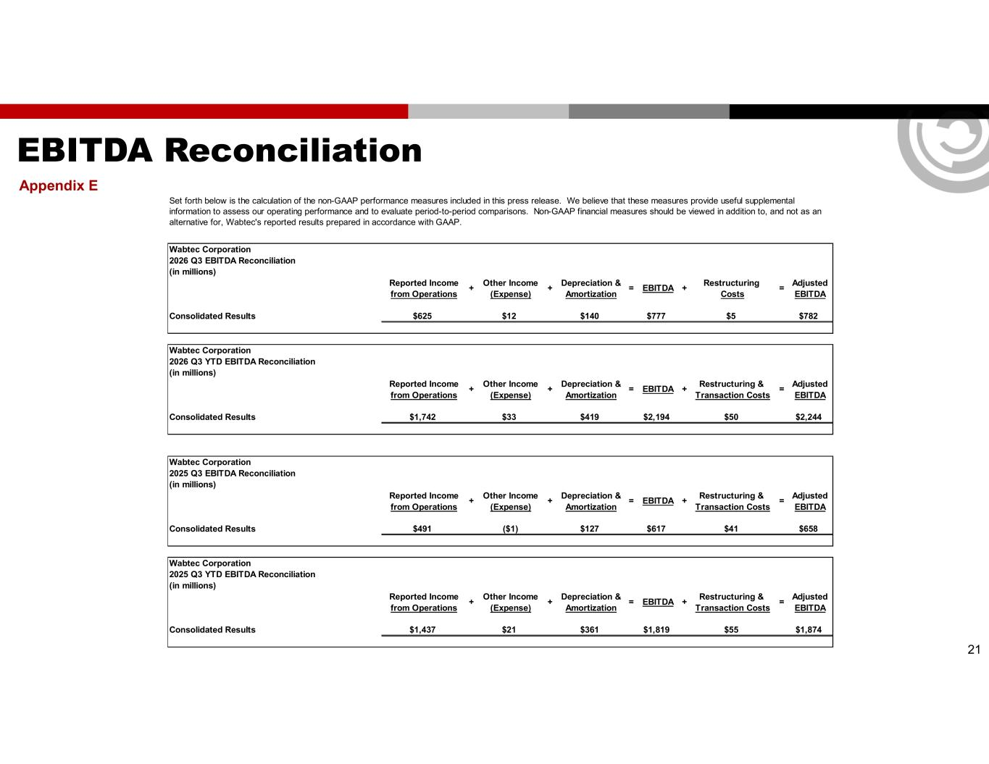
EBITDA Reconciliation Appendix E 21 Wabtec Corporation 2026 Q3 EBITDA Reconciliation (in millions) Reported Income Other Income Depreciation & Restructuring Adjusted from Operations (Expense) Amortization Costs EBITDA Consolidated Results $625 $12 $140 $777 $5 $782 Wabtec Corporation 2026 Q3 YTD EBITDA Reconciliation (in millions) Reported Income Other Income Depreciation & Restructuring & Adjusted from Operations (Expense) Amortization Transaction Costs EBITDA Consolidated Results $1,742 $33 $419 $2,194 $50 $2,244 Wabtec Corporation 2025 Q3 EBITDA Reconciliation (in millions) Reported Income Other Income Depreciation & Restructuring & Adjusted from Operations (Expense) Amortization Transaction Costs EBITDA Consolidated Results $491 ($1) $127 $617 $41 $658 Wabtec Corporation 2025 Q3 YTD EBITDA Reconciliation (in millions) Reported Income Other Income Depreciation & Restructuring & Adjusted from Operations (Expense) Amortization Transaction Costs EBITDA Consolidated Results $1,437 $21 $361 $1,819 $55 $1,874 =+ + = EBITDA + = =+ + = EBITDA + + + = EBITDA + Set forth below is the calculation of the non-GAAP performance measures included in this press release. We believe that these measures provide useful supplemental information to assess our operating performance and to evaluate period-to-period comparisons. Non-GAAP financial measures should be viewed in addition to, and not as an alternative for, Wabtec's reported results prepared in accordance with GAAP. + + = EBITDA + =

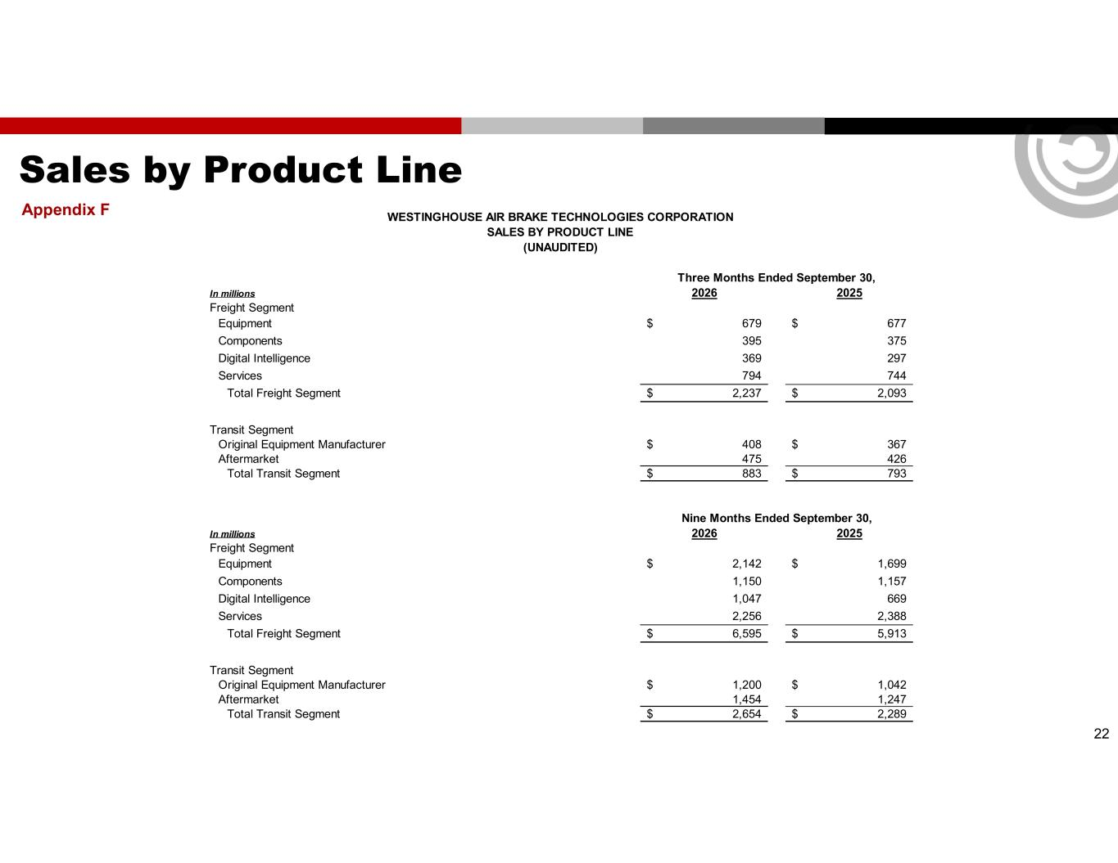
Sales by Product Line Appendix F 22 In millions 2026 2025 Freight Segment Equipment 679$ 677$ Components 395 375 Digital Intelligence 369 297 Services 794 744 Total Freight Segment 2,237$ 2,093$ Transit Segment Original Equipment Manufacturer 408$ 367$ Aftermarket 475 426 Total Transit Segment 883$ 793$ In millions 2026 2025 Freight Segment Equipment 2,142$ 1,699$ Components 1,150 1,157 Digital Intelligence 1,047 669 Services 2,256 2,388 Total Freight Segment 6,595$ 5,913$ Transit Segment Original Equipment Manufacturer 1,200$ 1,042$ Aftermarket 1,454 1,247 Total Transit Segment 2,654$ 2,289$ Nine Months Ended September 30, WESTINGHOUSE AIR BRAKE TECHNOLOGIES CORPORATION SALES BY PRODUCT LINE (UNAUDITED) Three Months Ended September 30,

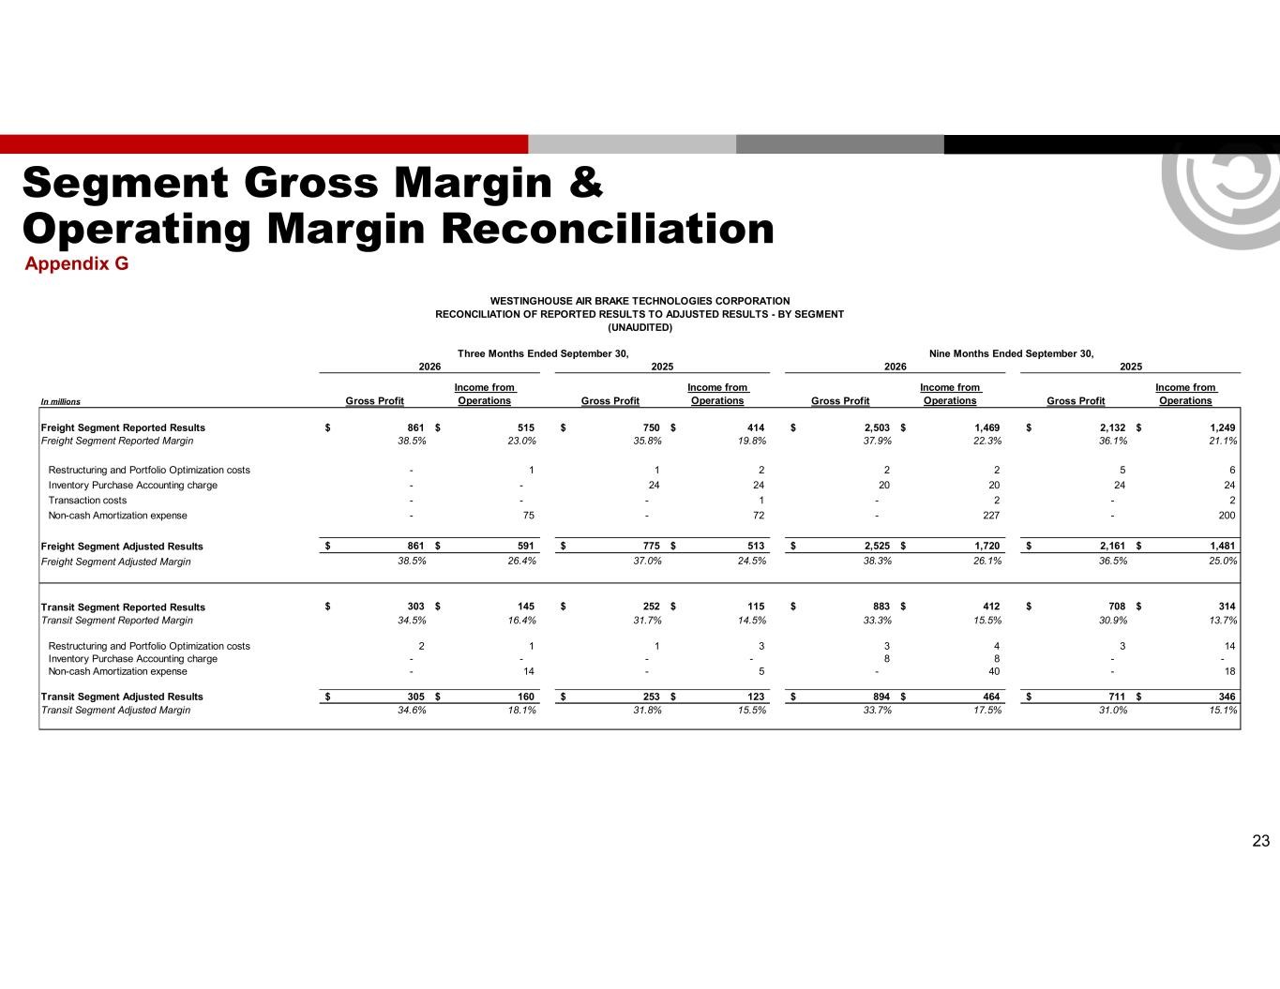
Segment Gross Margin & Operating Margin Reconciliation Appendix G 23 In millions Gross Profit Income from Operations Gross Profit Income from Operations Gross Profit Income from Operations Gross Profit Income from Operations Freight Segment Reported Results 861$ 515$ 750$ 414$ 2,503$ 1,469$ 2,132$ 1,249$ Freight Segment Reported Margin 38.5% 23.0% 35.8% 19.8% 37.9% 22.3% 36.1% 21.1% Restructuring and Portfolio Optimization costs - 1 1 2 2 2 5 6 Inventory Purchase Accounting charge - - 24 24 20 20 24 24 Transaction costs - - - 1 - 2 - 2 Non-cash Amortization expense - 75 - 72 - 227 - 200 Freight Segment Adjusted Results 861$ 591$ 775$ 513$ 2,525$ 1,720$ 2,161$ 1,481$ Freight Segment Adjusted Margin 38.5% 26.4% 37.0% 24.5% 38.3% 26.1% 36.5% 25.0% Transit Segment Reported Results 303$ 145$ 252$ 115$ 883$ 412$ 708$ 314$ Transit Segment Reported Margin 34.5% 16.4% 31.7% 14.5% 33.3% 15.5% 30.9% 13.7% Restructuring and Portfolio Optimization costs 2 1 1 3 3 4 3 14 Inventory Purchase Accounting charge - - - - 8 8 - - Non-cash Amortization expense - 14 - 5 - 40 - 18 Transit Segment Adjusted Results 305$ 160$ 253$ 123$ 894$ 464$ 711$ 346$ Transit Segment Adjusted Margin 34.6% 18.1% 31.8% 15.5% 33.7% 17.5% 31.0% 15.1% 2026 2025 2026 2025 WESTINGHOUSE AIR BRAKE TECHNOLOGIES CORPORATION RECONCILIATION OF REPORTED RESULTS TO ADJUSTED RESULTS - BY SEGMENT (UNAUDITED) Three Months Ended September 30, Nine Months Ended September 30,

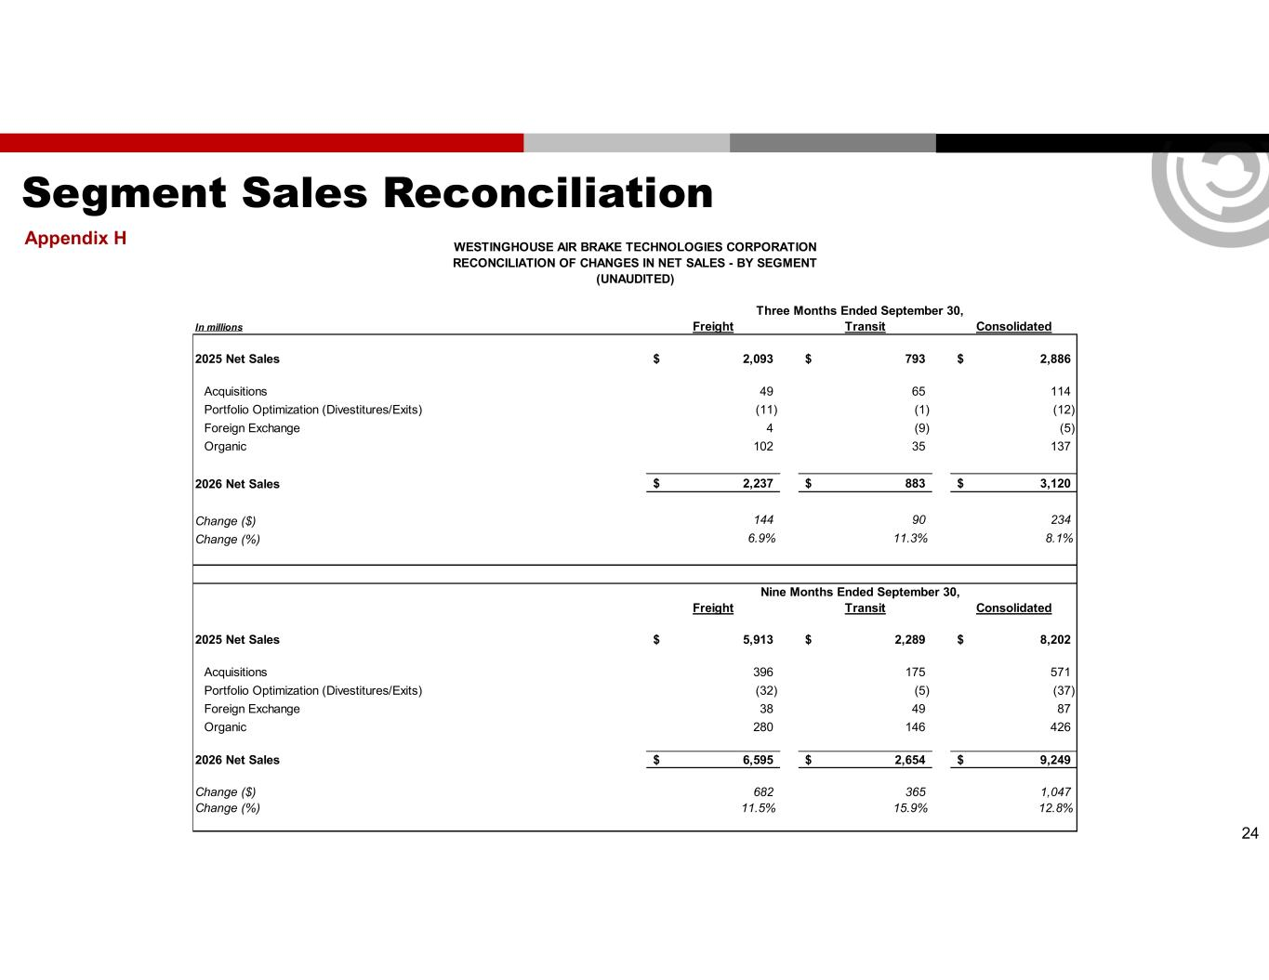
Segment Sales Reconciliation Appendix H 24 In millions Freight Transit Consolidated 2025 Net Sales 2,093$ 793$ 2,886$ Acquisitions 49 65 114 Portfolio Optimization (Divestitures/Exits) (11) (1) (12) Foreign Exchange 4 (9) (5) Organic 102 35 137 2026 Net Sales 2,237$ 883$ 3,120$ Change ($) 144 90 234 Change (%) 6.9% 11.3% 8.1% Freight Transit Consolidated 2025 Net Sales 5,913$ 2,289$ 8,202$ Acquisitions 396 175 571 Portfolio Optimization (Divestitures/Exits) (32) (5) (37) Foreign Exchange 38 49 87 Organic 280 146 426 2026 Net Sales 6,595$ 2,654$ 9,249$ Change ($) 682 365 1,047 Change (%) 11.5% 15.9% 12.8% Nine Months Ended September 30, WESTINGHOUSE AIR BRAKE TECHNOLOGIES CORPORATION RECONCILIATION OF CHANGES IN NET SALES - BY SEGMENT (UNAUDITED) Three Months Ended September 30,

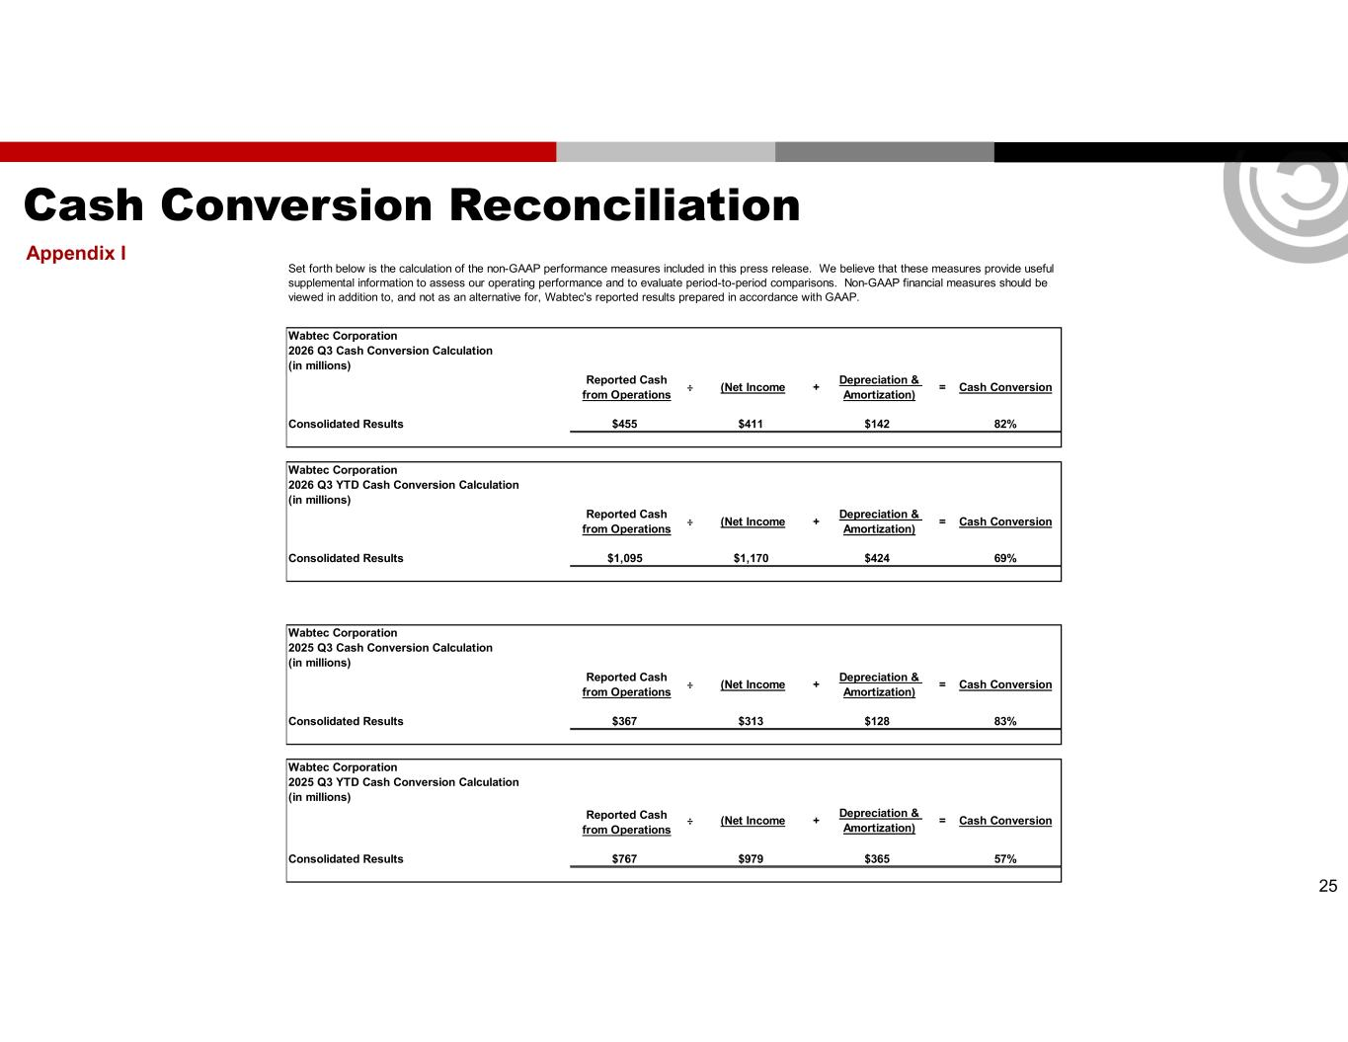
Cash Conversion Reconciliation Appendix I 25 Wabtec Corporation 2026 Q3 Cash Conversion Calculation (in millions) Reported Cash from Operations Consolidated Results $455 $411 $142 82% Wabtec Corporation 2026 Q3 YTD Cash Conversion Calculation (in millions) Reported Cash from Operations Consolidated Results $1,095 $1,170 $424 69% Wabtec Corporation 2025 Q3 Cash Conversion Calculation (in millions) Reported Cash from Operations Consolidated Results $367 $313 $128 83% Wabtec Corporation 2025 Q3 YTD Cash Conversion Calculation (in millions) Reported Cash from Operations Consolidated Results $767 $979 $365 57% Cash Conversion ÷ (Net Income + Depreciation & Amortization) = Cash Conversion ÷ (Net Income + Depreciation & Amortization) = Cash Conversion Set forth below is the calculation of the non-GAAP performance measures included in this press release. We believe that these measures provide useful supplemental information to assess our operating performance and to evaluate period-to-period comparisons. Non-GAAP financial measures should be viewed in addition to, and not as an alternative for, Wabtec's reported results prepared in accordance with GAAP. ÷ (Net Income + Depreciation & Amortization) = Cash Conversion ÷ (Net Income + Depreciation & Amortization) =

